Anthony Saieva (Narin)
an2804
Example 3:
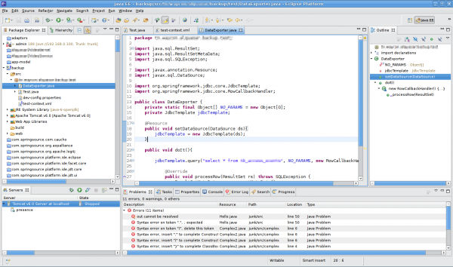

This is a screenshot from the eclipse code editor
This is a violation of aesthetic and minimalist design
While each window here might be useful at some point, the majority of the time someone is using this application they really only care about the code window and the project explorer. The other panes just clutter up the screen.
Instead the application should only show panes that matter and only bring up the auxiliary views when required. Atom takes this approach and the experience is far less cluttered.

