Anthony Saieva (Narin)

UNI: an2804

Homework 5

1) Naive Bayes
1a) Probability Tables

Y | P(Y)
+y | 4/7 = .5714
-y | 3/7 = .4286

X₁ | Y | X₁ | Y
+1 | +y | 2/4 = .5
0 | +y | 2/4 = .5
-1 | +y | 0/4 = 0
+1 | -y | 0/3 = 0
0 | -y | 1/3 = .3333
-1 | -y | 2/3 = .6667

X₂ | Y | P(X₂ | Y)
+1 | +y | ¼ = .25
0 | +y | ¼ = .25
-1 | +y | 2/4 = .5
+1 | -y | 1/3 = .3333
0 | -y | 2/3 = .6667
-1 | -y | 0/3 = 0

1b) Classification of (X₁=+1, X₂ =+1)

P(Y | X₁, X₂) = max { P(y=+y) * P(X₁ = +1 | +y) * P(X₂ = +1 | +y)
P(y=-y) * P(X₁ = +1 | -y) * P(X₂ = +1 | -y) }

P(Y | X₁, X₂) = max{ .5714 * .5 * .25 = .0714
.4286 * 0 *.3333 = 0 }
= .0714 = +y

1.c) Smoothing Probabilities for k=1

P_{smoothed}(X|Y) = c(x,y) + k / c(y) + k|x|

P_{smoothed}(X₁|+y) = 2+1/4+3 = 3/7

X₁ | Y | P_{smoothed}(X₁|Y) = c(x,y) + k / c(y) + k|x|
+1 | +y | 2+1/4+3 = 3/7
0 | +y | 2+1/4+3 = 3/7
-1 | +y | 0+1/7 = 1/7
+1 | -y | 0+1/3+3 = 1/6
0 | -y | 1+1/3+3 = 2/6
-1 | -y | 2+1/6 = 3/6

X₂ | Y | P_{smoothed}(X₂|Y) = c(x,y) + k / c(y) + k|x|
+1 | +y | 1+1/4+3 = 2/7
0 | +y | 1+1/4+3 = 2/7
-1 | +y | 2+1/4+2 = 3/7
+1 | -y | 1+1/3+3 = 2/6
0 | -y | 2+1/3+3 = 3/6
-1 | -y | 0+1/3+3 = 1/6

1.d) How to maximize +y given smoothed parameters

Y | X₁ | X₂ | +y|X₁,X₂ = P(Y)P_{smoothed}(X₁|Y)P_{smoothed}(X₂|Y)
+y | +1 | +1 | 4/7 * 3/7 * 2/7
+y | +1 | 0 | 4/7 * 3/7 * 2/7
+y | +1 | -1 | 4/7 * 3/7 * 3/7
+y | 0 | +1 | 4/7 * 3/7 * 2/7
+y | 0 | 0 | 4/7 * 3/7 * 2/7
+y | 0 | -1 | 4/7 * 3/7 * 3/7
+y | -1 | +1 | 4/7 * 1/7 * 2/7
+y | -1 | 0 | 4/7 * 1/7 * 2/7
+y | -1 | -1 | 4/7 * 1/7 * 3/7

Since we only need to look at the numerators… the two rows with 4*3*3 are the max

So to maximize +y → (X₁=+1,0; X₂=-1)
2) Perceptron

2.a) Plot the points
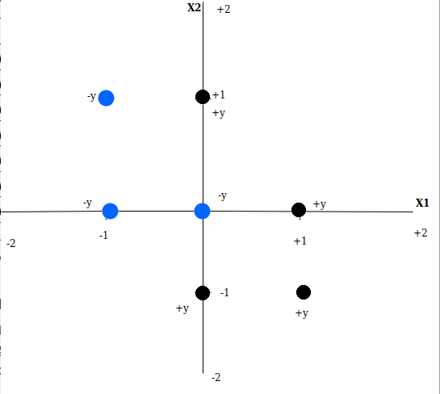
This data is not linearly separable.

2.b) Graph with weight vector and separating line

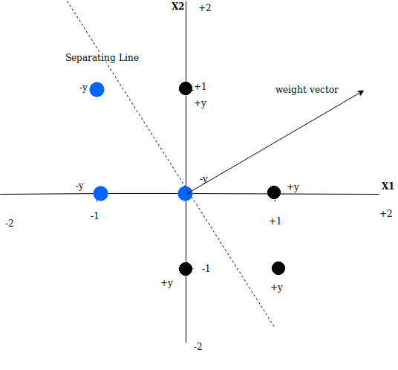
X₁ = 0; X₂ = 1; is on the positive side of the separating plane. And the activation score is 2*0 + 1*1 = 1. This is a positive activation score and would categorize the point as +y.

2.c) Find the linear and non linear options:

X₃ = 1
Not linearly separable. Simply adding a bias term shifts the weight vector along the y axis. Since there is no weight vector that can linearly separate this data set shifting the weight vector has no impact.

X₃ = |X₁|
We already know that this data is not linearly separable. By using |X₁| none of the +y points change since X₁ is non negative for all of them. The -y points will flip to the positive side of the X₁ axis. This graph is still not linearly separable.

X₃ = |X₂|
Similar to the above diagram none of the -y points will move with respect to X₃ since they are all non negative along X₂. But the +y points will flip to the positive side of the X₂ axis. If you graph X₁ and X₃ and don’t consider X₂ this becomes linearly separable.
X₃ = X₁²
In this instance since the only options are -1,0,1 this is the same as |X₁|. See answer above. I would say it’s not linearly separable but really it’s whatever the right answer to that part is.

X₃ = X₂²
In this instance since the only options are -1,0,1 this is the same as |X₂|. See answer above. I would say it is linearly separable but really it’s whatever the right answer to that part is.

X₃ = X₁² + X₂²
Another way to think about this would be grouping the points into 3 groups. Points at (0,0) points in {(+/- 1, 0),(0,+/-1)} and points in {(+/-1,+/-1)}. In this plane a lot of the points collide regardless of classification. The data isn’t linearly classifiable and if you graph this against either X₁ or X₂ with respect to X₃ points will collide in the new graph regardless of classification. Of course if you graph it in 3 dimensions the data isn’t linearly classifiable because it’s not linearly classifiable in the original 2 dimensions.

2.d) Perceptron algorithm table

Y | Ф(X) | Y(Predicted) | w
-y | (-1,1,0) | -y | (0,0,0)
-y | (0,0,0) | -y | (0,0,0)
-y | (-1,0,1) | -y | (0,0,0)
+y | (0,1,1) | -y | (0,1,1) ←update
+y | (1,-1,0) | -y | (1,0,1) ←update
+y | (0,-1,1) | +y | (1,0,1)
+y | (1,0,1) | +y | (1,0,1)

2.e) Compute the activation scores

activation = w · sample
w = (1,0,1)
<1,0,1> · <-1,1,0> = -1 = -y
<1,0,1> · (0,0,0) = 0 = -y
<1,0,1> · (-1,0,1) = 0 = -y
<1,0,1> · (0,1,1) = 1 = +y
<1,0,1> · (1,-1,0) = 1 = +y
<1,0,1> · (0,-1,1) = 1 = +y
<1,0,1> · (1,0,1) = 2 = +y

Predictions are correct which proves they are linearly separable.

3) Instance Based Learning

3.1) Compute the nearest neighbors to (.5,.5) And what they would predict

The three nearest neighbors are (0,0) (0,1) (1,0)

The euclidean distance between (.5,.5) and those points are:

E(<.5,.5>, <0,0>) = sqrt{ (.5 – 0)² + (.5 – 0)² } = sqrt{ .25 + .25 } = sqrt{.5} ←-y
E(<.5,.5>, <0,1>) = sqrt{ (.5 – 0)² + (.5 – 1)² } = sqrt{ .25 + .25 } = sqrt{.5} ←+y
E(<.5,.5>, <1,0>) = sqrt{ (.5 – 1)² + (.5 – 0)² } = sqrt{ .25 + .25 } = sqrt{.5} ←+y

Based on a majority vote we would predict that this point would be +y

3.2) Use the given alpha vector to predict a score for <.5, .5> with a kernel
α = < -1, -2, 0, 2, 1, 0, 0 >
X_{n} = < .5, .5 >

i | X_{i} | X_{i} · X_{n} | α_{i}(X_{i} · X_{n}+1)²
0 | < -1, 1> | -.5 + .5 = 0 | -1(0+1)² = -1
1 | < 0, 0 > | 0 + 0 = 0 | -2(0+1)² = -2
2 | < -1, 0 > | -.5 + 0 = -.5 | 0(-.5+1)² = 0
3 | < 0, 1 > | 0 + .5 = .5 | 2(.5+1)² = 4.5
4 | < 1, -1 > | .5 - .5 = 0 | 1(0+1)² = 1
5 | < 0, -1 > | 0 - .5 = -.5 | 0(-.5+1)² = 0
6 | < 1, 0 > | .5 + 0 = .5 | 0(.5+1)² = 0
Summing the above values:
-1 – 2 + 0 + 4.5 + 1 = 2.5 → Prediction: +y

3.3) Pick 3 stable means for the classification
K1
K2
K3
The diamonds labeled K represent 3 stable means in the feature space. Clearly all the -y points are closest to K₁, and all the +y points are closest to either K₂ or K₃. This shows there exist 3 stable means that classify the dataset correctly.

