Anthony Saieva (Narin)
an2804

AI Homework 2

1.1) Redraw this graph as a tree (you need not rewrite all constraints) by choosing a cutset of a single node. Choose the root of the tree to be the node that comes first in alphabetical order out of the remaining ones.

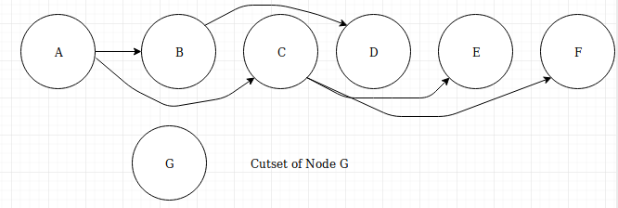
1.2) Suppose we assign the value 0 to the cutset node. List the possible domain values for all the other nodes after performing a backward pass through the tree that you drew.

After applying G = 0 Possible domains are:
A ={1,2}
B = {1,2}
C = {0,1,2}
D = {1,2}
E = {0,1,2}
F = {1,2}
G = 0

After applying a backwards pass using the tree from part 1
A ={1,2}
B = {1,2}
C = {1,2} – modified by backwards pass
D = {1,2}
E = {0,1,2}
F = {1,2}
G = 0

1.3) Suppose that we have an initial assignment to the original graph above with inconsistencies, and we want to fix it using iterative improvement. You are told that currently, (C, E, F) = (2, 2, 2). If we first consider reassigning C, what new domain value should it take? Use the LCV / min-conflicts heuristic; in other words, select a new domain value for C such that its neighbors have more flexibility for potential reassignment in later steps.

Potential Assignments:
C = 0
E = {1,2}
F = {0,1,2}

C = 1
E = {2}
F = {1,2}

When C = 0 there are more possible options for E and F in future steps which means we should choose C = 0 as our next assignment

