Anthony Saieva (Narin)
an2804
Example 2:
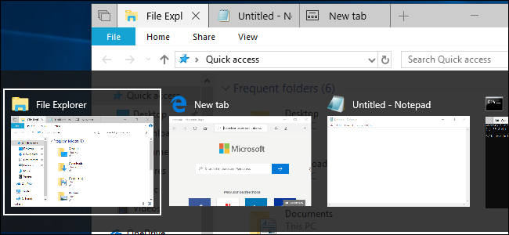

This is from Microsoft Windows
It is an example of flexibility/efficiency of use
You can switch windows by using alt+tab. I switch windows a lot and I don’t need to click on the windows to switch them. Instead I don’t need to take my hands off the keys.

