Anthony Saieva (Narin)
an2804
Example 4:
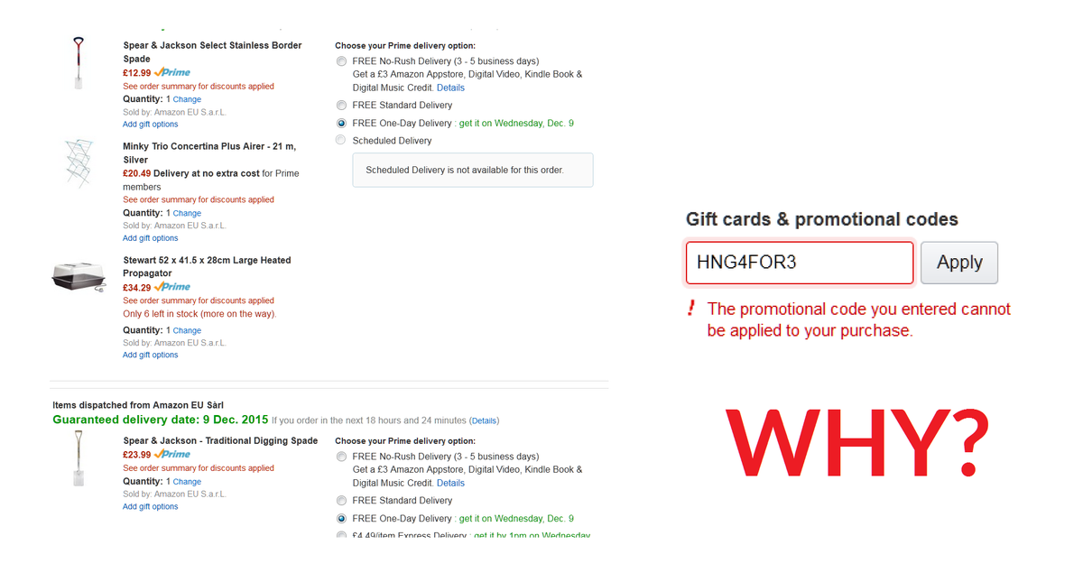

This is from Amazon.
This violates the heuristic of helping users recognize, diagnose, and recover from errors.
The error messages tells the user something is wrong, but offers no opportunity to determine what caused this error or how to fix it.
In this case the error was caused because the promotional access code the user was trying to use was valid only for products sold directly from amazon not 3rd party sellers. The error message should indicate this rather than just saying the purchase is not allowed.

