wAnthony Saieva (Narin)
an2804

AI Homework 2

1.1) Redraw this graph as a tree (you need not rewrite all constraints) by choosing a cutset of a single node. Choose the root of the tree to be the node that comes first in alphabetical order out of the remaining ones.

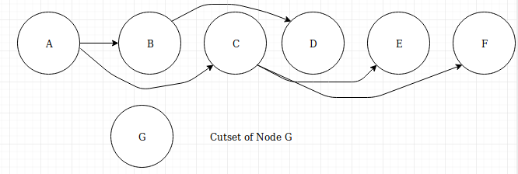
1.2) Suppose we assign the value 0 to the cutset node. List the possible domain values for all the other nodes after performing a backward pass through the tree that you drew.

After applying G = 0 Possible domains are:
A ={1,2}
B = {1,2}
C = {0,1,2}
D = {1,2}
E = {0,1,2}
F = {1,2}
G = 0

After applying a backwards pass using the tree from part 1
A ={1,2}
B = {1,2}
C = {1,2} – modified by backwards pass
D = {1,2}
E = {0,1,2}
F = {1,2}
G = 0

1.3) Suppose that we have an initial assignment to the original graph above with inconsistencies, and we want to fix it using iterative improvement. You are told that currently, (C, E, F) = (2, 2, 2). If we first consider reassigning C, what new domain value should it take? Use the LCV / min-conflicts heuristic; in other words, select a new domain value for C such that its neighbors have more flexibility for potential reassignment in later steps.

Potential Assignments:
C = 0
E = {1,2}
F = {0,1,2}

C = 1
E = {2}
F = {1,2}

When C = 0 there are more possible options for E and F in future steps which means we should choose C = 0 as our next assignment

2.1) Suppose player A wants to maximize the final value and player B wants to minimize it. Draw the minimax game tree. Be sure to distinguish the max nodes and the min nodes, and label the leaf utilities (the board values).

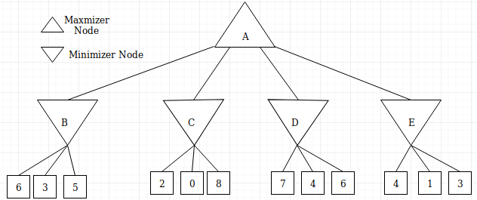

2.2) Run the minimax algorithm with α-β pruning in order to find the optimal row for player A. Following the table format below, list out in order each node visited (including leaf nodes), the values of α and β passed down to each node, and the minimax value returned. Also indicate if a subtree is pruned by noting any children skipped after a node is processed.

Step | Node | Alpha | Beta | Value | Children Skipped
0 | A | -∞ | ∞ | 4
1 | B | -∞ | ∞ | 3
2 | 6 (LEAF) | -∞ | ∞ | 6
3 | 3 (LEAF) | -∞ | 6 | 3
4 | 5 (LEAF) | -∞ | 3 | 5
5 | C | 3 | ∞ | 2 | 0, 8 because the value of this minimizer node fell below alpha
6 | 2 | 3 | ∞ | 2
7 | D | 3 | ∞ | 4
8 | 7 (LEAF) | 3 | ∞ | 7
9 | 4 (LEAF) | 3 | 7 | 4
10 | 6 (LEAF) | 3 | 4 | 6
11 | E | 4 | ∞ | 1 | Skips 3 because value falls below alpha
12 | 4 (LEAF) | 4 | ∞ | 4
13 | 1 (LEAF) | 4 | 4 | 1

3.3) Now suppose that the game is modified so that after player A selects a row, a value is randomly chosen from the selected row with equal probability and eliminated. Player B then proceeds to select a value from the remaining two numbers in the row. Redraw the new game tree after this modification. What is the expected game value and best action for A to take according to expectimax search?

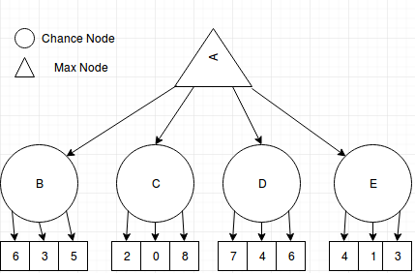

The only modification that needs to be made is calculating the value of the chance nodes. This is done with weighted averages.

Calculating weighted averages can be explained in this case as follows.
Each chance node has 3 successors. In this case with known values. For chance node n there are 3 possible successor values a, b, c where a <= b <= c

The modification states that one of these values at random will be discarded for player B to choose from. This means that the following options for B occur with a 1/3 probability.
{ a, b }
{ a, c }
{ b, c }

given that player B will always choose the lowest possible value, player B will choose a 2/3 times and b 1/3 times.
Therefore the value of the chance nodes are: 2/3(a) + 1/3(b)

The value of node B is:
3(2/3) + 5(1/3) = 3.666666

Value of C is:
0(2/3) + 2(1/3) = .666666

Value of D is:
4(2/3) + 6(1/3) = 4.66666

Value of E is:
1(2/3) + 3(1/3) = 1.66666

Since the value of D is the highest the max node still moves to the 3rd row but the expected utility is now 4.6666 instead of 4 as it would be with minimax

3.1) Draw the state transition diagram for this problem. Indicate both transition probabilities and rewards on the graph arcs.

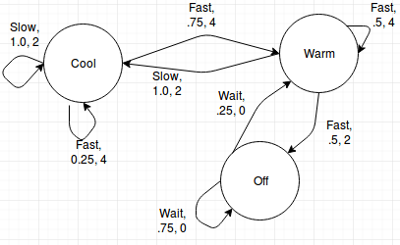

3.2) Evaluate the state values for the policy which directs the car to go slow when it's able to move (either cool or warm state) and wait when it's overheated. Explain briefly the physical intuition behind the values that you computed (why are certain values greater than or equal to each other)?

Strictly Mathematical:
V^{π}(state, action) = SUM(Transition probability(state, action) * (movement reward + discounted reward of next state))

V^{π}(cool) = 1.0(2 + .8V^{π}(cool))
V^{π}(warm) = 1.0(2 + .8V^{π}(cool)
V^{π}(off) = .25(0 + .8V^{π}(warm) ) + .75(0 + .8V^{π}(off))

Actions from warm and cool have the same value because they end in the same state and have the same movement reward.

The actions from off are different since there is 0 chance of reward and end in the warm state while the others end in the cool state.

3.3) Perform one step of policy iteration to improve the above policy, using the evaluation of the policy π. Again, briefly explain the physical intuition behind why any actions changed (or did not change).

π(cool, slow) = 2
π(cool, fast) =

3.4) Let's actually find the optimal policy using value iteration. While the values will not converge very quickly, the policy will converge after only a few steps. Perform two steps of value iteration and fill in the table below.

3.5) Assuming that the policy stops changing after the second step, what is the optimal policy? Briefly explain why it is the same or different from the policies of parts 2 and 3. If is the same as one of them, why was that one optimal? If not, what made the previous ones suboptimal?

