**Note:- not Create Ansible.cfg file only inventory file is created**

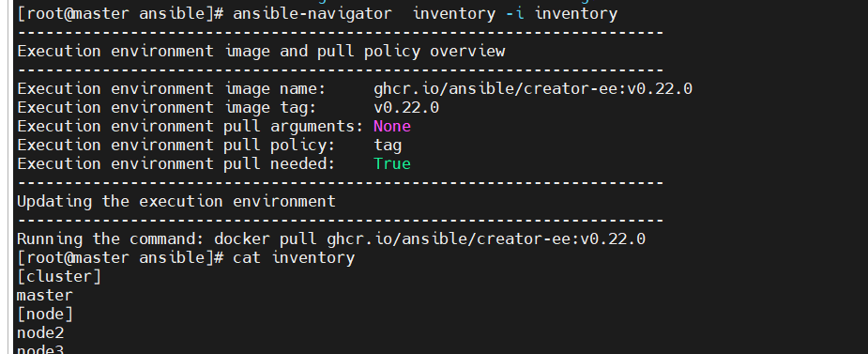

[root@master ansible]# ansible-navigator inventory -i inventory --execution-environment false

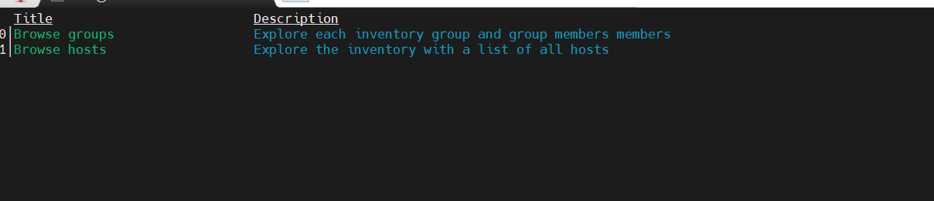

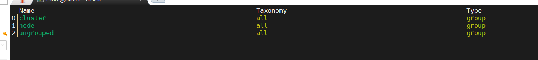

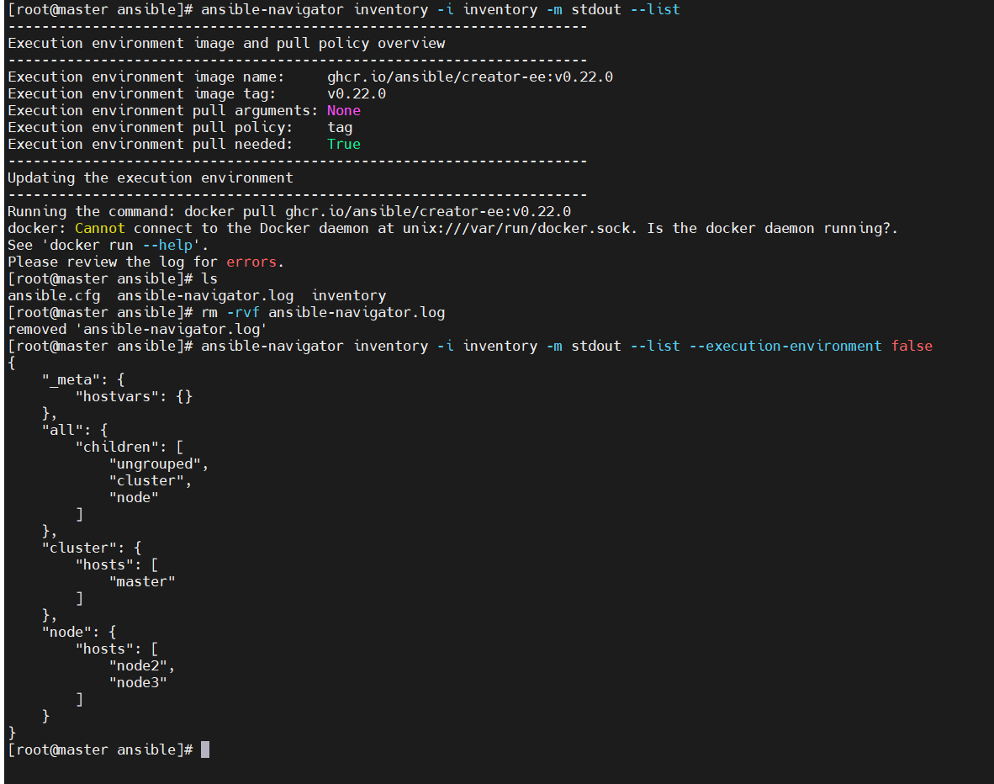

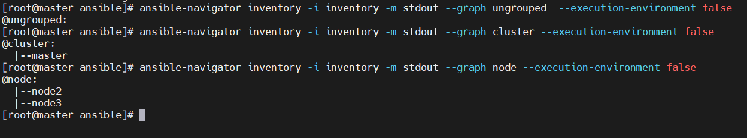

**Note:- After Creating Ansible.cfg file**

#ansible-navigator config dump --execution-environment false

