terminal project report

Artificial Intelligence

Instructor: Miss Farah Saeed

Group Members:

|  |  |  |
| --- | --- | --- |
| Asna Hammad |  | FA23-BDS-051 |
| Fizzah Farooq |  | FA23-BDS-011 |

COMSATS University Islamabad

Table of Contents

Abstract 3

1. Introduction 3

2. Proposed System 3

3. Advantages and Benefits 5

4. Scope 5

5. Modules 6

5.1 File Upload & Preprocessing 6

5.2 Grammar Checking 6

5.3 Section Detection 6

5.4 Keyword Analysis 6

5.5 Score Calculation 6

5.6 Smart Recommendations 6

5.7 Visualization Dashboard 7

5.8 Report Generator 7

6. System Limitations and Constraints 7

7. Tools and Technologies 7

8. Mockups: 8

9. Conclusion 10

10. References 11

# ****Abstract****

Resume Critic Pro is an AI-powered resume evaluation system designed to help individuals improve their resumes through automated feedback. It supports file uploads in PDF and DOCX formats and analyzes the content for grammar accuracy, structural completeness, and keyword usage. The application provides users with scores and suggestions, helping them understand their resume's strengths and weaknesses. It includes features like interactive visualizations, color-coded feedback, and downloadable reports, making it a practical tool for job seekers, students, and career coaches.

1. Introduction

In today's highly competitive job market, a well-crafted resume is often the first and most important step toward securing an interview. However, many individuals lack access to expert guidance for improving their resumes. Traditional review processes are time-consuming, and online templates often fail to provide personalized insights.

**Resume Critic Pro** addresses this challenge by offering a fast, intelligent, and user-friendly solution that provides meaningful feedback on uploaded resumes. The system leverages Natural Language Processing (NLP) and basic AI techniques to check for grammatical correctness, structural completeness, and keyword usage, making it a useful tool for self-assessment and improvement.

# ****Proposed System****

The proposed system takes a user-uploaded resume and evaluates it across several key aspects:

1. **File Upload & Text Extraction**

* Supports PDF and DOCX formats
* Uses PyMuPDF (fitz) for extracting text from PDFs
* Uses python-docx for extracting text from DOCX files

1. **Grammar & Writing Feedback**

* Utilizes language_tool_python, an interface to LanguageTool API, to check for grammar, spelling, punctuation, and writing style issues
* Highlights up to five significant errors with suggested corrections and explanations
* Computes a grammar score (0–100) by deducting points for each issue found

1. **Section Analysis**

* Checks for common resume sections like Summary, Skills, Experience, Education, Projects, Certifications
* Flags any missing sections
* Assigns a structure score (0–100) based on the number of required sections present

1. **Keyword Frequency Analysis**

* Uses Python’s re and collections.Counter libraries to extract the most frequent words
* Helps users avoid excessive repetition of weak words like "I", "my", etc.
* Outputs the top 10 most used words

1. **Scoring & Classification**

* Combines the grammar and structure scores into a final overall score (0–100)
* Categorizes resumes into:
  + Excellent (85–100): Job-ready
  + Good (70–84): Minor improvements needed
  + Needs Work (<70): Major revisions recommended

1. **Smart Suggestions**

* Based on issues found, the system suggests:
  + Adding missing sections
  + Replacing overused words
  + Making achievements quantifiable
  + Following best practices like using action verbs and bullet points

1. **Visualization & Reporting**

* Displays a pie chart using Plotly to compare grammar vs. section scores
* Uses color-coded cards for easy readability (e.g., red for problems, green for strong areas)
* Generates a downloadable .txt report that includes:
  + Grammar feedback
  + Section completeness
  + Keyword frequency
  + Scores and suggestions

# ****Advantages and Benefits****

**Fast & Automated**

Resume Critic Pro provides instant feedback without the need for manual review. As soon as a user uploads their resume, the system quickly analyzes it and presents results within seconds. This automation saves valuable time and ensures that users can revise their resumes efficiently.

**Educational**

One of the key strengths of the system is its educational value. It doesn't just highlight mistakes—it explains why something is an issue and how to fix it. By offering examples and best practices, it helps users learn how to write more professional, impactful resumes.

**Personalized**

The smart suggestions generated by Resume Critic Pro are uniquely tailored to each uploaded resume. Whether it's identifying missing sections, flagging overused personal pronouns, or recommending improvements in wording, the feedback is relevant and customized for the individual user.

**Practical Output**

Users receive a comprehensive text report that summarizes all feedback, scores, and suggestions. This report can be saved, printed, or shared with mentors, instructors, or career counselors. It serves as a useful guide for making detailed improvements offline.

**User-Friendly**

Built using Streamlit, the interface is clean, simple, and responsive. Users of all backgrounds can easily navigate the tool without any technical knowledge. Uploading a resume, viewing the analysis, and downloading the report are all handled through an intuitive design.

**Accessible Anywhere**

Resume Critic Pro is a web-based application, meaning it can be accessed from any device with an internet connection and a browser. Whether on a laptop, tablet, or smartphone, users can upload resumes and receive feedback from virtually anywhere at any time.

# ****Scope****

This system is designed for individuals and professionals who need quick and reliable resume feedback. The current scope includes:

* Upload and analysis of English-language resumes in text-based PDF or DOCX format
* Feedback based on grammar, section presence, and keyword usage
* Report generation in plain text format for offline access
* Graphical display using pie charts for comparative scoring
* Use case includes students, job seekers, and career coaches

The scope does not include evaluation of:

* Design/layout aesthetics
* Visual formatting (fonts, alignment)
* Deep content relevance (like actual job-fit matching)

# ****Modules****

## ****5.1 File Upload & Preprocessing****

* Input: Resume (PDF/DOCX)
* Output: Extracted text using PyMuPDF or python-docx

## ****5.2 Grammar Checking****

* Uses LanguageTool to detect issues
* Scores are computed based on issue severity
* Displays top 5 errors with suggested corrections

## ****5.3 Section Detection****

* Scans for common sections like Skills, Education, etc.
* Each missing section reduces the structure score

## ****5.4 Keyword Analysis****

* Tokenizes the text and counts word frequency
* Helps spot excessive use of weak words

## ****5.5 Score Calculation****

* Calculates individual and combined scores
* Final classification shown: Excellent, Good, or Needs Work

## ****5.6 Smart Recommendations****

* Uses logic rules to provide tips, e.g.: "Add quantifiable results."
* Use action verbs like managed, led, designed

## ****5.7 Visualization Dashboard****

* Displays an interactive pie chart with Plotly
* Includes score cards and suggestion cards styled with CSS

## ****5.8 Report Generator****

* Generates a .txt file summarizing all analysis
* Contains: Feedback, scores, keywords, and suggestions

# System Limitations and Constraints

**Only Text-Based Analysis:**

The system analyzes only the textual content and ignores visual formatting, design, or layout elements of the resume

**Limited Grammar Depth:**

It may miss context-based grammar issues since it focuses on general grammar, punctuation, and style using basic rules

**LanguageTool Dependency:**

The tool relies on the LanguageTool API, so any limitations or downtime of this external service can affect functionality

**No Content Relevance Check:**

It does not assess whether the resume content is relevant to a specific job role or industry

**English Only:**

Currently, the system supports only English resumes; other languages are not yet included

**Requires Internet:**

An internet connection is required to run grammar checks and display visual feedback

1. Tools and Technologies

Frontend: Streamlit + Custom CSS – For building responsive UI  
Visualization: Plotly – For pie charts and score visualizations  
Backend: Python – Core logic and processing  
PyMuPDF (fitz): Extract text from PDFs  
python-docx: Extract text from DOCX  
language_tool_python: Grammar and style analysis  
re, collections.Counter: Keyword extraction  
File Handling: tempfile, os – Manage uploaded files and clean-up  
Output: Python I/O – Generate and download text reports

# Mockups:

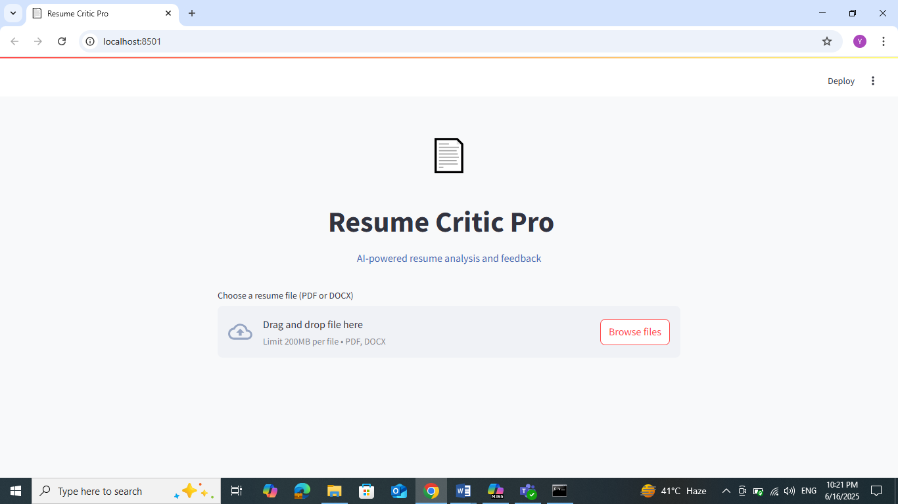

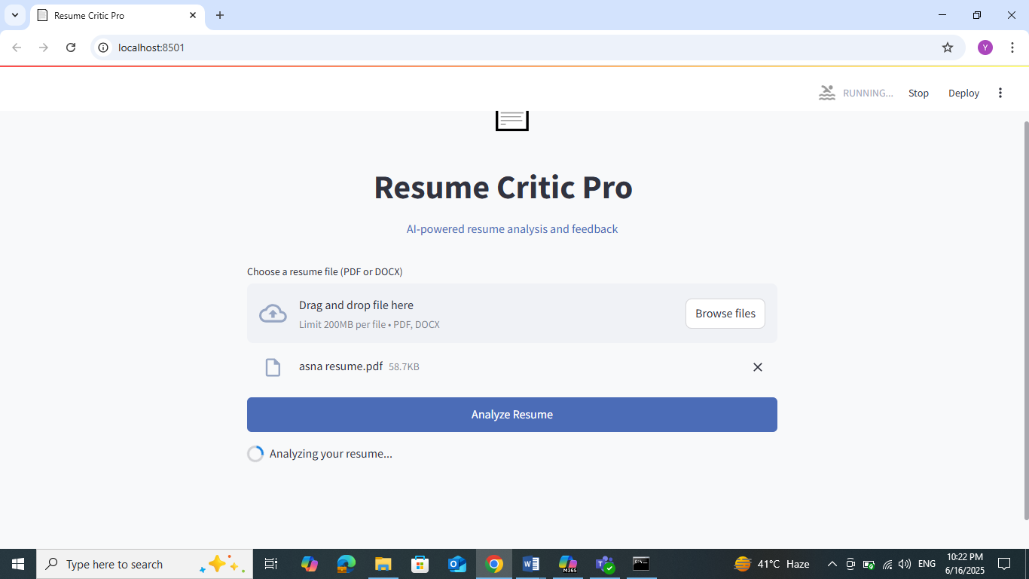

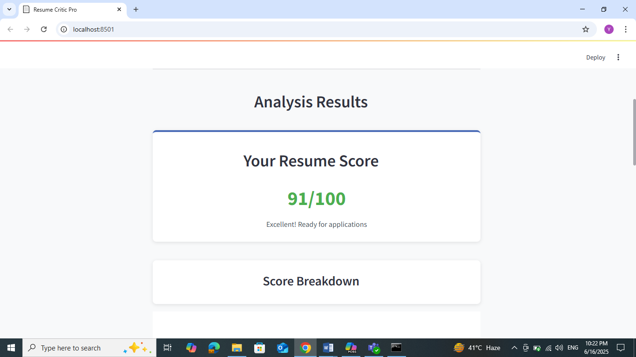

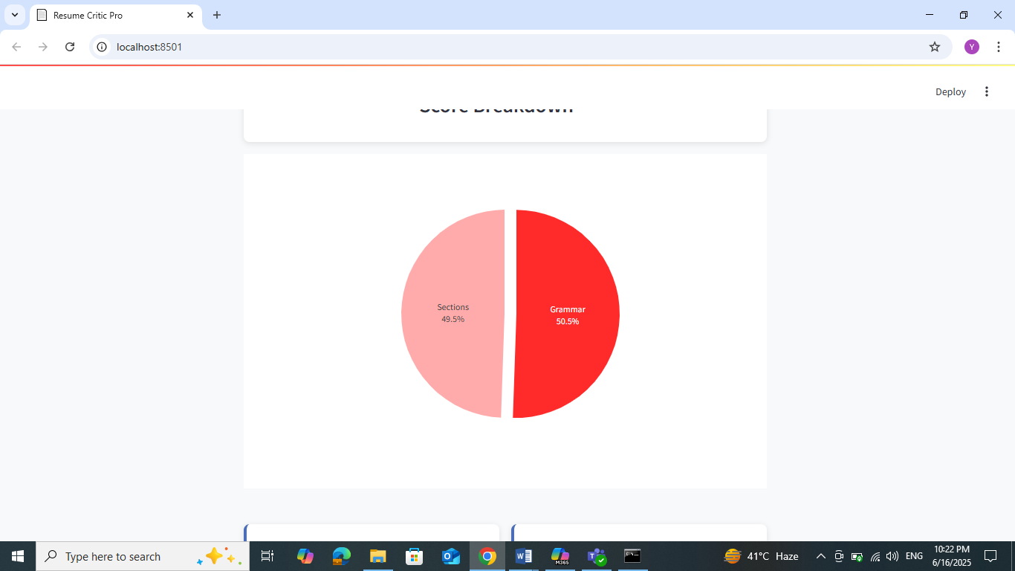

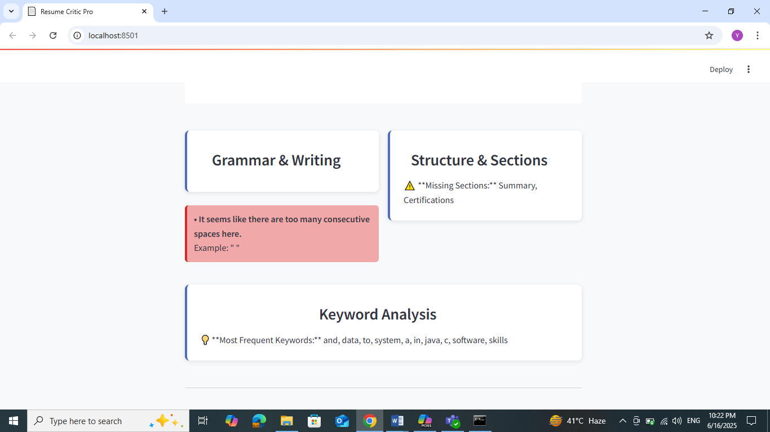

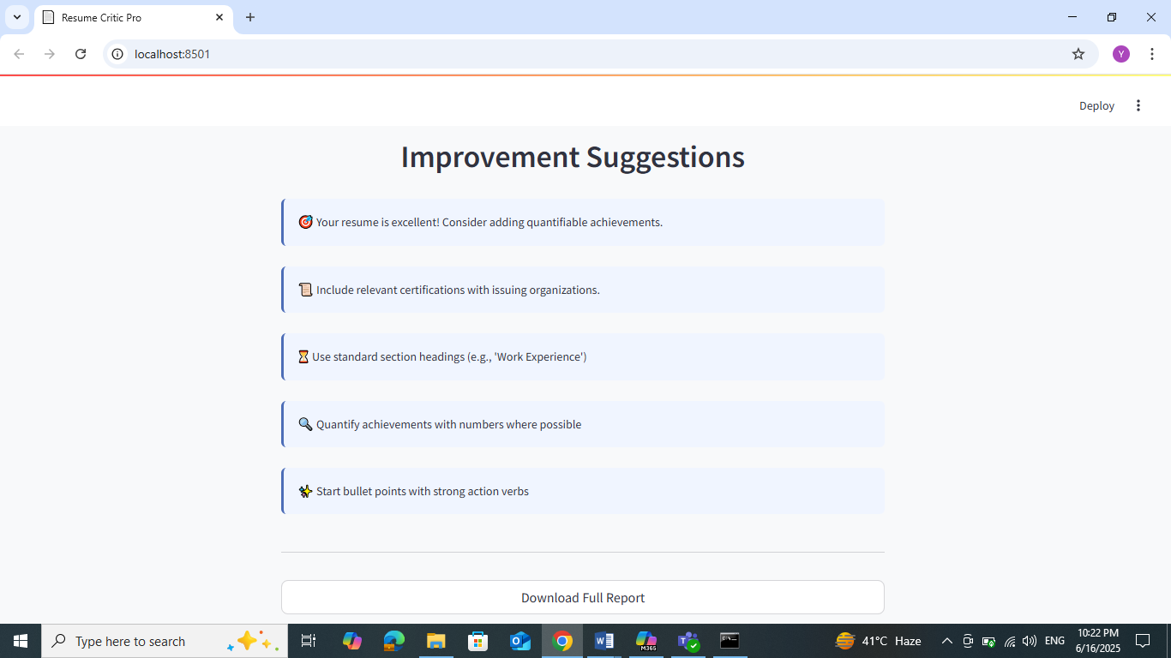

1. Conclusion

Resume Critic Pro is a powerful tool aimed at improving resume quality with the help of AI and NLP techniques. Its intuitive interface, detailed feedback, and instant scoring system make it valuable for individuals aiming to stand out in their job applications. While the system does not yet analyze resume aesthetics or semantic fit, its core functions provide crucial support for content-based improvements. The proposed future enhancements (like ATS compatibility and auto-rewriting) will further elevate its impact and usability.

1. References

LanguageTool API – Grammar and style checker. (2023). Retrieved from LanguageTool: <https://languagetool.org/dev>  
Streamlit Documentation – The fastest way to build and share data apps. (2023). Retrieved from Streamlit: <https://docs.streamlit.io>  
PyMuPDF Documentation – Python bindings for MuPDF. (2023). Retrieved from PyMuPDF: <https://pymupdf.readthedocs.io>  
python-docx Documentation – Create and update Microsoft Word .docx files. (2023). Retrieved from python-docx: <https://python-docx.readthedocs.io>  
Plotly Graphing Library – Interactive graphs in Python. (2023). Retrieved from Plotly: <https://plotly.com/python>  
collections.Counter – Python docs. (2023). Retrieved from Python Software Foundation: <https://docs.python.org/3/library/collections.html#collections.Counter>