CONTACT
asnaaslam91@gmail.com +94 770710772 linkedin.com/in/asnaaslam1 github.com/asnaaslam1

SKILLS
- Web Development
- Databases
- Programming Languages
- UI UX Design
- Graphic Design
- Lecturing
- Microsoft Office ❖ Presentation skills

LANGUAGES
- English
- Tamil
- Sinhala
- Arabic
Fathima Asna Aslam

PROFILE
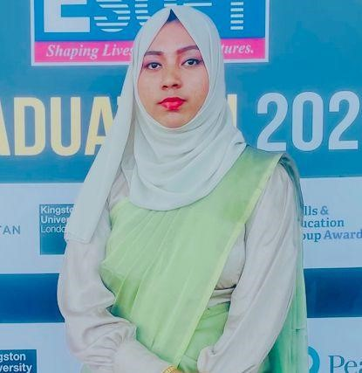




I’m an enthusiastic IT student passionate about turning ideas into innovative, user-focused solutions. I apply software engineering best practices like clean code, version control, agile methods, and test-driven development to build efficient systems. With skills in graphic design and UI/UX, I create intuitive, visually engaging interfaces. Always learning, I aim to combine technology and design to make a meaningful impact. Constantly learning and adapting, I’m excited by the opportunity to combine technology and design to make a meaningful impact.

EDUCATION
HND in Computing Software Engineering - (Reading)
Esoft Metro Campus Sep 2024 – Feb 2026
Diploma in Information Technology
Esoft Metro Campus Jan 2024 – Dec 2024
Diploma in English
Esoft Metro Campus Jan 2024 – Aug 2024
Graphic Designing
Studyz Academy Sep 2024 – Dec 2024
G.C.E A/L physical science stream
KU/Giri Madeena National School Sep 2021 – Feb 2024

WORK EXPERIENCE
Graphic Designer
INC9000 (Pvt) Ltd May 2025 – Present
Created posters, logos, and T-shirt designs using Adobe Photoshop, Illustrator, and CorelDRAW. Delivered visually appealing, print-ready graphics aligned with client needs and branding goals. Teacher AIDE
MASJIDHU THAKWA ACADAMY Feb 2023 – Dec 2024
Taught Mathematics and ICT, preparing students for Grade 8, 10, and O/L students. Developed engaging lesson plans, reinforced key concepts, and supported student success through personalized guidance.

PROJECTS

Graphic Design
Designed creative visuals including logos, posters, and T-shirt prints, as well as custom graphics for mugs, bottles, and merchandise. Skilled in Adobe Photoshop, Illustrator, and CorelDRAW to produce high-quality, print-ready designs.

Web Projects
Developed responsive and interactive websites using HTML, CSS, JavaScript, and PHP. Projects include dynamic front-end designs and functional back-end systems, with features such as admin panels, user authentication, and data-driven content display.

Desktop Applications
Built Windows-based desktop applications using C# in Visual Studio, connected to Microsoft SQL Server. These systems were designed to streamline data management and improve efficiency in small business operations.

UI/UX Design
Designed wireframes and interactive prototypes using Figma, focusing on user-centered design principles. Projects include conceptual applications for education, transport, services, and productivity tools.

REFEREES

Referees available upon request.

