

WEB TECHNOLOGIES
ASSIGNMENT # 2
COMSATS UNIVERSITY ISLAMABAD
LAHORE CAMPUS

SUBMITTED BY: ASNA EJAZ
ROLL NO: FA24-BCS-022
SUBMITTED TO: Mr. USMAN AKRAM
DATE: 27TH OCTOBER 2026;

TASK DESCRIPTION:
Assignment 2 — Your E-commerce Site: Static, Responsive Pages
Difficulty: Easy–Medium · Covers: Lectures 5–10 (CSS Fundamentals through Responsive Design and Frameworks) · Folder: assignment-2/
Task: Build the static, responsive front page and product page of your e-commerce site, modeled on your chosen reference site. No JavaScript yet — this assignment is entirely about layout, styling, and responsiveness.
You must build:
- A homepage/product listing page with a header (site name/logo, a nav bar, a cart icon that does not need to work yet) and a responsive grid of at least 8 product cards (image, name, price, an “Add to Cart” button that does not need to work yet).
- A single product detail page for one product: larger image, name, price, description, quantity selector, and an “Add to Cart” button (again, not functional yet).
- A consistent footer across both pages.
- The whole layout built with Flexbox and/or CSS Grid — no table-based layout, no absolute-positioning-everything.
- Genuine responsiveness: the layout must reflow sensibly at a phone width (~375px), a tablet width (~768px), and a desktop width, using media queries or your framework’s responsive grid classes. Screenshot all three widths for your completion PDF.
- Either Bootstrap or Tailwind (your choice) used for at least the grid/layout and the navbar — this is the framework half of Lecture 10, and it should actually be doing real work in your layout, not just be linked and unused.
SCREENSHOTS OF OUTPUT:
MOBILE LAYOUT:
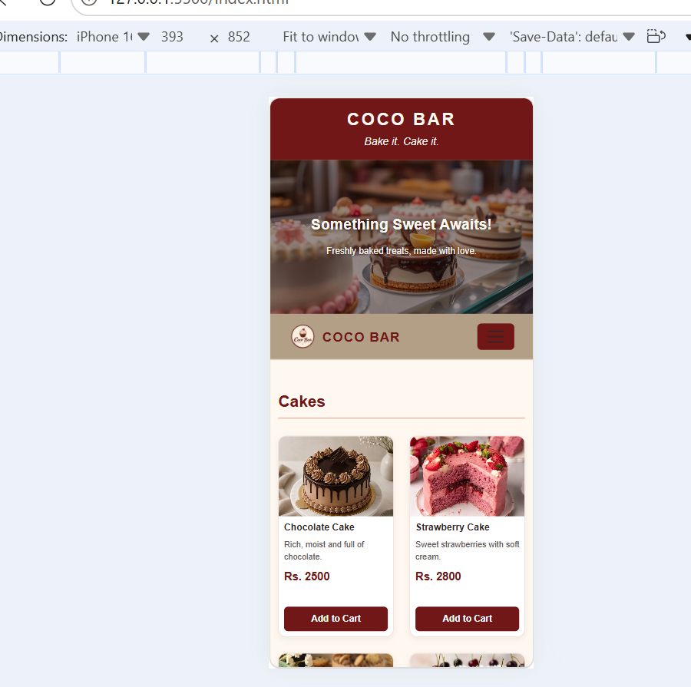
TABLET LAYOUT:
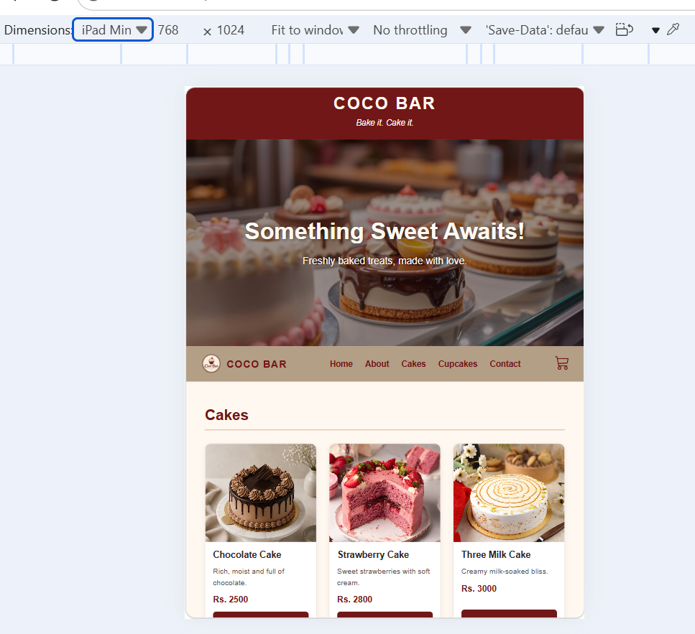
WEB LAYOUT:
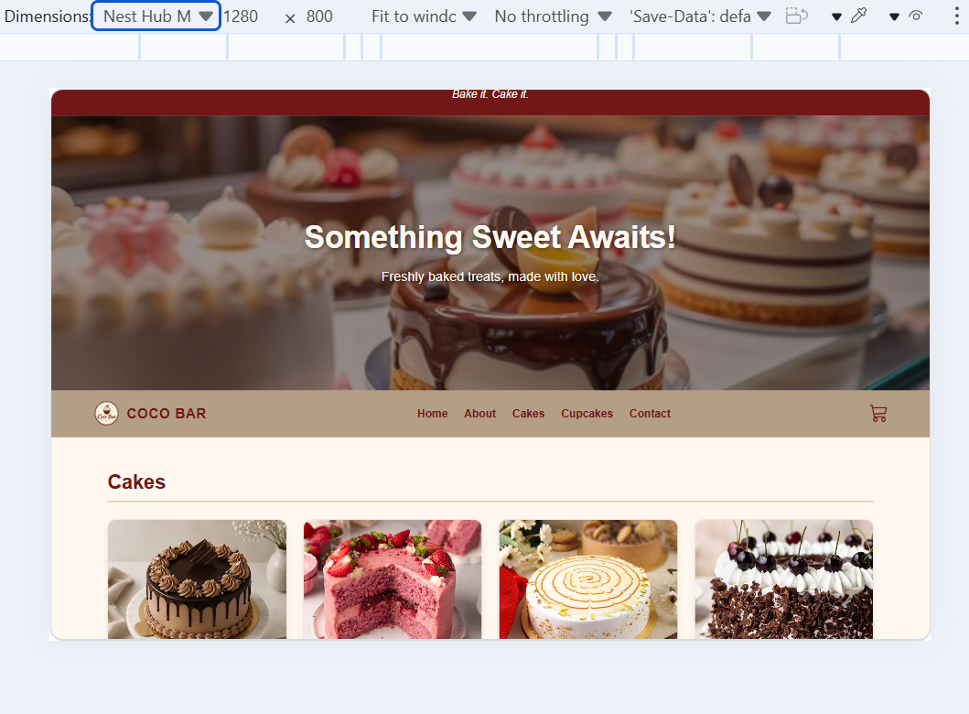

CODE:
index.html
<!doctype html>
<html lang="en">
<head>
<meta charset="UTF-8" />
<meta name="viewport" content="width=device-width, initial-scale=1.0" />
<title>COCO BAR | Bakery & Cafe</title>
<link
href="https://cdn.jsdelivr.net/npm/bootstrap@5.3.3/dist/css/bootstrap.min.css"
rel="stylesheet"
/>
<link
rel="stylesheet"
href="https://cdn.jsdelivr.net/npm/bootstrap-icons@1.11.3/font/bootstrap-icons.min.css"
/>
<link rel="stylesheet" href="style.css" />
</head>
<body>
<header>
<h1>COCO BAR</h1>
<p>Bake it. Cake it.</p>
</header>

<section class="intro" id="About">
<img src="display.jpg" alt="Display of COCO BAR bakery treats" />

<div class="intro-text">
<h2>Something Sweet Awaits!</h2>
<p>Freshly baked treats, made with love.</p>
</div>
</section>

<nav class="navbar px-3 px-lg-5">
<div class="container-fluid">
<a
class="navbar-brand d-flex align-items-center gap-2"
href="index.html"
>
<img src="coco-bar.png" alt="COCO BAR Logo" />
<span>COCO BAR</span>
</a>

<!-- 1. Hidden Checkbox (Toggle Logic) -->
<input type="checkbox" id="menu-toggle" class="menu-checkbox" />

<!-- 2. Hamburger Button (Label jo checkbox ko control kare ga) -->
<label for="menu-toggle" class="navbar-toggler">
<span class="navbar-toggler-icon"></span>
</label>

<!-- 3. Menu Links & Cart Container -->
<div class="navbar-menu" id="mainNavbar">
<ul class="navbar-nav mx-auto mb-2 mb-md-0">
<li class="nav-item">
<a class="nav-link" href="index.html">Home</a>
</li>
<li class="nav-item">
<a class="nav-link" href="#About">About</a>
</li>
<li class="nav-item">
<a class="nav-link" href="#Cakes">Cakes</a>
</li>
<li class="nav-item">
<a class="nav-link" href="#CupCakes">Cupcakes</a>
</li>
<li class="nav-item">
<a class="nav-link" href="#Contact">Contact</a>
</li>
</ul>

<a href="#menu" class="nav-link cart">
<i class="bi bi-cart3"></i>
</a>
</div>
</div>
</nav>

<main id="menu" class="container py-5">
<section class="mb-5" id="Cakes">
<h2 class="category-title">Cakes</h2>

<div class="row g-4">
<div class="col-6 col-md-4 col-lg-3">
<article class="product-card">
<a href="chocolate-cake.html">
<img src="chocolate-cake.jfif" alt="Chocolate Cake" />
</a>
<div class="product-info">
<h3>
<a href="chocolate-cake.html">Chocolate Cake</a>
</h3>
<p>Rich, moist and full of chocolate.</p>
<span class="price">Rs. 2500</span>
<button type="button">Add to Cart</button>
</div>
</article>
</div>

<div class="col-6 col-md-4 col-lg-3">
<article class="product-card">
<img src="strawberry-cake.jfif" alt="Strawberry Cake" />
<div class="product-info">
<h3>Strawberry Cake</h3>
<p>Sweet strawberries with soft cream.</p>
<span class="price">Rs. 2800</span>
<button type="button">Add to Cart</button>
</div>
</article>
</div>

<div class="col-6 col-md-4 col-lg-3">
<article class="product-card">
<img src="three-milk-cake.jfif" alt="Three Milk Cake" />
<div class="product-info">
<h3>Three Milk Cake</h3>
<p>Creamy milk-soaked bliss.</p>
<span class="price">Rs. 3000</span>
<button type="button">Add to Cart</button>
</div>
</article>
</div>

<div class="col-6 col-md-4 col-lg-3">
<article class="product-card">
<img src="black-forest-cake.jfif" alt="Black Forest Cake" />
<div class="product-info">
<h3>Black Forest Cake</h3>
<p>Chocolate-cherry rich indulgence.</p>
<span class="price">Rs. 3500</span>
<button type="button">Add to Cart</button>
</div>
</article>
</div>
</div>
</section>

<section class="mb-5" id="CupCakes">
<h2 class="category-title">Cupcakes</h2>

<div class="row g-4">
<div class="col-6 col-md-4 col-lg-3">
<article class="product-card">
<img src="caramel-cupcake.jfif" alt="Caramel Cupcake" />
<div class="product-info">
<h3>Caramel Cupcake</h3>
<p>Golden buttery sweetness.</p>
<span class="price">Rs. 400</span>
<button type="button">Add to Cart</button>
</div>
</article>
</div>

<div class="col-6 col-md-4 col-lg-3">
<article class="product-card">
<img src="chocolate-cupcake.jfif" alt="Chocolate Cupcake" />
<div class="product-info">
<h3>Chocolate Cupcake</h3>
<p>Rich cocoa decadence.</p>
<span class="price">Rs. 450</span>
<button type="button">Add to Cart</button>
</div>
</article>
</div>

<div class="col-6 col-md-4 col-lg-3">
<article class="product-card">
<img src="vanilla-cupcake.jfif" alt="Vanilla Cupcake" />
<div class="product-info">
<h3>Vanilla Cupcake</h3>
<p>Classic smooth elegance.</p>
<span class="price">Rs. 350</span>
<button type="button">Add to Cart</button>
</div>
</article>
</div>

<div class="col-6 col-md-4 col-lg-3">
<article class="product-card">
<img src="red-velvet-cupcake.jpg" alt="Red Velvet Cupcake" />
<div class="product-info">
<h3>Red Velvet Cupcake</h3>
<p>Crimson velvet luxury.</p>
<span class="price">Rs. 500</span>
<button type="button">Add to Cart</button>
</div>
</article>
</div>
</div>
</section>
</main>

<footer id="Contact">
<h3>COCO BAR</h3>
<p>Bake it. Cake it.</p>
<p>&copy; 2026 Coco Bar. All rights reserved.</p>
</footer>
</body>
</html>

chocolate-cake.html
<!doctype html>
<html lang="en">
<head>
<meta charset="UTF-8" />
<meta name="viewport" content="width=device-width, initial-scale=1.0" />
<title>Chocolate Cake | COCO BAR</title>
<link
href="https://cdn.jsdelivr.net/npm/bootstrap@5.3.3/dist/css/bootstrap.min.css"
rel="stylesheet"
/>
<link
rel="stylesheet"
href="https://cdn.jsdelivr.net/npm/bootstrap-icons@1.11.3/font/bootstrap-icons.min.css"
/>
<link rel="stylesheet" href="style.css" />
</head>

<body>
<header>
<h1>COCO BAR</h1>
<p>Bake it. Cake it.</p>
</header>

<nav class="navbar px-3 px-lg-5">
<div class="container-fluid">
<a
class="navbar-brand d-flex align-items-center gap-2"
href="index.html"
>
<img src="coco-bar.png" alt="COCO BAR Logo" />
<span>COCO BAR</span>
</a>

<!-- 1. Hidden Checkbox (Toggle Logic) -->
<input type="checkbox" id="menu-toggle" class="menu-checkbox" />

<!-- 2. Hamburger Button (Label jo checkbox ko control kare ga) -->
<label for="menu-toggle" class="navbar-toggler">
<span class="navbar-toggler-icon"></span>
</label>

<!-- 3. Menu Links & Cart Container -->
<div class="navbar-menu" id="mainNavbar">
<ul class="navbar-nav mx-auto mb-2 mb-md-0">
<li class="nav-item">
<a class="nav-link" href="index.html">Home</a>
</li>
<li class="nav-item">
<a class="nav-link" href="index.html">About</a>
</li>
<li class="nav-item">
<a class="nav-link" href="index.html">Cakes</a>
</li>
<li class="nav-item">
<a class="nav-link" href="index.html">Cupcakes</a>
</li>
<li class="nav-item">
<a class="nav-link" href="#Contact">Contact</a>
</li>
</ul>

<a href="#menu" class="nav-link cart">
<i class="bi bi-cart3"></i>
</a>
</div>
</div>
</nav>

<main class="container py-5">
<div class="row g-4 align-items-center">
<div class="col-12 col-md-6">
<img
src="chocolate-cake.jfif"
alt="Chocolate Cake"
class="img-fluid rounded"
/>
</div>

<div class="col-12 col-md-6">
<h2>Chocolate Cake</h2>
<p class="price">Rs. 2500</p>
<p>
Enjoy our rich, moist chocolate cake, made for chocolate lovers and
perfect for every celebration.
</p>
<label for="quantity" class="form-label">Quantity</label>
<select id="quantity" class="form-select mb-3">
<option value="1">1</option>
<option value="2">2</option>
<option value="3">3</option>
<option value="4">4</option>
<option value="5">5</option>
</select>

<button type="button" class="btn btn-danger">Add to Cart</button>
</div>
</div>
</main>

<footer id="Contact">
<h3>COCO BAR</h3>
<p>Bake it. Cake it.</p>
<p>&copy; 2026 Coco Bar. All rights reserved.</p>
</footer>
</body>
</html>
style.css
/* ===== Variables ===== */
:root {
--maroon: #711717;
--maroon-dark: #4d1010;
--accent: #c07854;
--sand: #b39e86;
--cream: #fff8f0;
--text: #2e2424;
--text-soft: #625454;
--line: #eadbd2;
}

/* ===== Base ===== */
html {
scroll-padding-top: 70px; /* keeps anchor targets clear of the sticky navbar */
}

body {
font-family: Arial, sans-serif;
background-color: var(--cream);
color: var(--text);
}

/* ===== Header & footer (shared look) ===== */
header,
footer {
text-align: center;
background-color: var(--maroon);
color: var(--cream);
}

header {
padding: 20px;
}

header h1 {
margin: 0;
font-size: 2rem;
letter-spacing: 3px;
font-weight: bold;
}

header p {
margin: 6px 0 0;
font-style: italic;
}

/* ===== Hero ===== */
.intro {
position: relative;
height: 400px;
overflow: hidden;
background-color: var(--maroon);
}

.intro img {
position: absolute;
inset: 0;
width: 100%;
height: 100%;
object-fit: cover;
}

.intro::before {
content: "";
position: absolute;
inset: 0;
background: rgba(35, 12, 12, 0.48);
z-index: 1;
}

.intro-text {
position: absolute;
top: 50%;
left: 50%;
transform: translate(-50%, -50%);
width: 90%;
text-align: center;
color: var(--cream);
z-index: 2;
}

.intro-text h2 {
margin-bottom: 15px;
font-size: 2.8rem;
font-weight: bold;
text-shadow: 2px 2px 6px #00000080;
}

.intro-text p {
margin: 0;
font-size: 1.2rem;
line-height: 1.6;
text-shadow: 1px 1px 4px #00000080;
}

/* ===== Navbar ===== */
.navbar {
position: sticky;
top: 0;
z-index: 1030;
background-color: var(--sand);
border-bottom: 1px solid var(--line);
}

.navbar-brand,
.navbar .nav-link {
color: var(--maroon);
font-weight: bold;
transition: color 0.2s ease;
}

.navbar-brand {
letter-spacing: 1px;
}

.navbar-brand:hover,
.navbar .nav-link:hover,
.navbar .nav-link:focus-visible {
color: var(--accent);
}

.navbar-brand img {
width: 42px;
height: 42px;
object-fit: contain;
}

.navbar .cart {
font-size: 1.7rem;
}

/* Checkbox hack: hidden but still keyboard-focusable */
.menu-checkbox {
position: absolute;
opacity: 0;
pointer-events: none;
}

.navbar-toggler {
display: inline-flex;
align-items: center;
justify-content: center;
padding: 0.25rem 0.75rem;
border: 1px solid var(--maroon);
border-radius: 0.375rem;
background-color: var(--maroon);
cursor: pointer;
}

/* Mobile: menu hidden until the checkbox is checked */
.navbar-menu {
display: none;
width: 100%;
flex-direction: column;
align-items: flex-start;
padding-top: 1rem;
}

.menu-checkbox:checked ~ .navbar-menu {
display: flex;
}

.navbar-nav {
width: 100%;
}

/* Desktop (md and up) */
@media (min-width: 768px) {
.navbar-toggler,
.menu-checkbox {
display: none;
}

.navbar-menu {
display: flex;
flex-direction: row;
align-items: center;
flex: 1 1 auto;
width: auto;
padding-top: 0;
}

.navbar-nav {
flex-direction: row;
width: auto;
gap: 1.5rem;
}
}

/* ===== Products ===== */
.category-title {
margin-bottom: 25px;
padding-bottom: 10px;
color: var(--maroon);
font-size: 1.8rem;
font-weight: bold;
border-bottom: 2px solid #e7c5b4;
}

.product-card {
height: 100%;
overflow: hidden;
border: 1px solid var(--line);
border-radius: 12px;
background-color: #fff;
box-shadow: 0 3px 10px #00000010;
transition:
transform 0.2s ease,
box-shadow 0.2s ease;
}

.product-card:hover {
transform: translateY(-4px);
box-shadow: 0 7px 18px #00000018;
}

.product-card > a {
display: block;
}

.product-card img {
display: block;
width: 100%;
height: 190px;
object-fit: cover;
}

.product-info {
display: flex;
flex-direction: column;
gap: 10px;
padding: 15px;
min-height: 190px;
}

.product-info h3 {
margin: 0;
font-size: 1.1rem;
font-weight: bold;
}

.product-info h3 a {
color: var(--text);
text-decoration: none;
}

.product-info h3 a:hover {
color: var(--maroon);
}

.product-info p {
margin: 0;
font-size: 0.9rem;
line-height: 1.5;
color: var(--text-soft);
}

.price {
color: var(--maroon);
font-size: 1.05rem;
font-weight: bold;
}

.product-info button {
margin-top: auto; /* pushes the button to the bottom of the card */
padding: 10px;
border: none;
border-radius: 6px;
background-color: var(--maroon);
color: #fff;
font-weight: bold;
transition: background-color 0.2s ease;
}

.product-info button:hover {
background-color: var(--maroon-dark);
}

/* ===== Footer ===== */
footer {
padding: 25px 15px;
margin: 8px 0;
}

footer h3 {
font-weight: bold;
}

/* ===== Tablet & mobile (keep 767px above 400px: later rule wins) ===== */
@media (max-width: 767px) {
header {
padding: 16px 10px;
}

header h1 {
font-size: 1.6rem;
}

.intro {
height: 280px;
}

.intro-text h2 {
font-size: 1.7rem;
}

.intro-text p {
font-size: 0.95rem;
}

.category-title {
font-size: 1.5rem;
}

.product-card img {
height: 145px;
}

.product-info {
padding: 10px;
min-height: 180px;
gap: 8px;
}

.product-info h3 {
font-size: 0.95rem;
}

.product-info p {
font-size: 0.82rem;
}

.product-info button {
padding: 8px 5px;
font-size: 0.85rem;
}
}

/* ===== Extra-small phones ===== */
@media (max-width: 400px) {
.intro {
height: 230px;
}

.intro-text h2 {
font-size: 1.4rem;
}

.intro-text p {
font-size: 0.85rem;
}

.product-card img {
height: 120px;
}

.product-info {
padding: 8px;
}

.product-info h3 {
font-size: 0.88rem;
}

.product-info p {
font-size: 0.78rem;
}
}

