# Lily - Notification Hub

* JMS Details

Endpoint details

1. Non-Priority SMS - <https://confluence.global.standardchartered.com/display/EDMI/Send+Push+Notification+SMS>
2. Priority SMS - <https://confluence.global.standardchartered.com/display/EDMI/Send+Push+Notification+Priority+SMS>



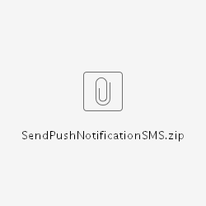



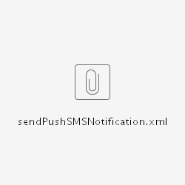



### JMS Details

SENDER NAME:- **EDMPRBRA_NOTIFY**

LDAP USER :- **rdauser**

|  |  |
| --- | --- |
| **Sender** | EDMI |
| **Destination Type** | Topic |
| **Publisher Topic to EDMI** | scbGrpFnCommExtCommSendPushNotifySMSV3ReqT > sendPushSMSNotification  scbGrpFnCommExtCommSendPushNotifyPrioritySMSV3ReqT > sendPushPrioritySMSNotification |
| **Subscription Topic from EDMI** | scbGrpFnCommExtCommSendPushNotifySMSV3ReqTTs > sendPushSMSNotification  scbGrpFnCommExtCommSendPushNotifyPrioritySMSV3ReqTTs > sendPushPrioritySMSNotification |
| **Durable Subscriber ID** | **SMS:**  scbGrpFnCommExtCommSendPushNotifySMS**RDALILY**V3ReqTTDs à Durable subscription ID for LILY    **PRIORITY SMS:**  scbGrpFnCommExtCommSendPushNotifyPrioritySMS**RDALILY**V3ReqTTs àDurable subscription ID for LILY |
|  |  |
| **JMS / JNDI Provider URL** | <wmjmsnaming://GF0D0_Jndi@10.193.63.105:6712/EDMIFramework> |
| **Connection Factory** | GroupFunctions_RDALILY_ConnectionFactory |
| **Client Group** | admin |
| **LDAP User** | PLEAESE PROVIDE US LDAP USER to be configured in EDMI. |
| **SSL security setup** | Attached .jks file, need to place under the  below folder structure at your end.  ./config/security/certs/edmigftruststore.jks (relative path is mandatory for SSL connection) |