REPORT FINAL EXAMINATION
Subject: Project
SALES CLOTHING ANALYTICS

Class | : | INS300801 Project (2023-2024)
Lecturer | : | TS. Tran Thi Oanh
Group | : | 7
Member | : | Nguyen Thị Quỳnh Anh - 21070696  Nguyen Thị Lan Anh - 21070572  Hà Thị Hồng Ánh - 21070345  Nguyễn Bích Diệp - 21070891  Đỗ Thanh Vân - 21070790

Table of contents
List of Figures 3
List of Tables 3
Executive Summary 4
Part 1. Introduction 5
1.1 About the Project 5
1.1.1 Business problem 5
1.1.2 Background 5
1.2 Project Goals/Objectives 6
1.3 Tentative users 7
1.4 Projects Scope/ Out-of-Scope 8
1.4.1 Scope 8
1.4.2 Out of Scope 8
1.5 Project Risks/Issues 9
Part 2. Dataset 10
2.1 Shopping Data 10
2.2 Sales Data 11
Part 3. Methodology and Solution 12
3.1 Customer segmentation analysis 12
3.2 Recommendation system 15
3.3 Sales prediction for specific items 15
Part 4. Implementation and Results Analysis 17
4.1 Customer segmentation and Recommendation system 17
4.2 Sales predictions on specific items 20
Part 5. Demo 25
Part 6. Discussion on Strong/Weak points 28
Part 7. Conclusion and Future Work 29
Part 8. Acknowledgements 29
Part 9. References 30
10. Contribution 33

List of Figures
Figure 1 The four products with highest sales 11
Figure 2 The snapshot of Sales dataset 12
Figure 3 Some figtures about EDA of Shopping dataset 13
Figure 4 The Elbow method 14
Figure 5 Silhouette Plot 14
Figure 6 Technical Architecture for Recommendation system 15
Figure 7 3-D Visualization 17
Figure 8 Demo 1 for input data 19
Figure 9 Demo 2 for output 19
Figure 10 Demo 3 for output 20
Figure 11 Sale Volume of Skirt 21
Figure 12 Sale Volume of Dress 22
Figure 13 Sale Volume of Blouse 23
Figure 14 Sale Volume of Shirt 24
Figure 15 Snapshot of Login/Sign up page 25
Figure 16 Snapshot of Home page 25
Figure 17 Snapshot of the Dataset page 26

List of Tables
Table 1: Definition of variables in dataset 11

Executive Summary
Data analysis is no longer a novelty because scientific research has shown that in a few years, data analysis has increased from 17% in 2018 to 59% in 2020. Data analysis has become an important tool for businesses of all sizes and in many different sectors. Applying data analytics can bring huge competitive benefits to companies in the same industry. However, a recent survey also shows that many businesses, especially small and medium-sized enterprises, still do not fully utilize the data they have full access to. Using data to optimize revenue remains a challenge for these businesses. Up to 60% to 73% of the total data in a business is still not used for effective analysis.

“Turning data into revenue is no longer reserved for large companies” - With technological advancements, we propose an integrated tool for potential customer analysis that aligns with business goals and analyzes demand trends for products being sold to optimize manufacturing processes, distribution, and enhance competitiveness.

The project was driven by the need to understand and adapt to changing consumer behaviors and technological advancements in commerce. Our goal is to provide integrated analytics tools with multiple features based on input data. We envision a landscape where brands can proactively adjust their business operations to adapt to consumer needs, optimize, and drive profitability.

Part 1. Introduction

1.1 About the Project

1.1.1 Business problem
A company often faces the challenges of product management and the effectiveness of their online marketing strategy. The data they obtain about products and customer data, is collected from a variety of sources. However, brands will find it difficult to combine and analyze this data in a comprehensive way to come up with accurate and effective marketing strategies.

1.1.2 Background
We all know products and customers are the two most important influencing factors of the entire survival and development plan of the business. Every decision and activity that a business is concerned with is related to meeting customer needs through the provision of appropriate products or services. Consumer and product choices will influence distribution, customer service, marketing, pricing, and market positioning. Identifying the right products and customers helps businesses optimize operations, increase competitive advantage, and establish a solid foundation for sustainable growth.

To begin implementing the project, we identified the Sales & Marketing department as playing a pivotal role in leveraging customer segmentation and product sales information to build effective strategies for the future. This project focuses primarily on helping the Sales & Marketing department increase reach, increase customer engagement, and generate profits. Therefore, in addition to the two parts of customer and product analysis, we can propose implementing a recommendation system. After selecting valuable information, the recommendation system can apply that information to predict user preferences and trends and recommend personalized favorite products.

1.2 Project Goals/Objectives
Customer segmentation method
By gathering customer information and analyzing their purchasing data over different time periods, businesses are able to grasp the attributes that influence the shopping behavior of individual customers. Consequently, this therefore allows the company to effectively segment its customer base into smaller groups based on certain similarities.This approach empowers businesses to make accurate and tailored selections of products and services for each segmented group of customers.

Recommendation method
The system's objective is to offer recommendations to businesses based on input keyword indications about details like name, age, or others. Based on the customer's past purchases with the attributes entered and other consumer data, the system will recommend products that the customer can buy for the company. The system assists businesses in identifying potential products for individual customers, and predicting their future purchases. This information helps determine the specific characteristics and attributes of products that will attract different customer groups.

Sales prediction for specific item
In order to effectively target every client, this strategy assists firms in planning their financial management, investments, marketing tactics, and product updates. By accurately predicting the demand for specific products, businesses can ensure an adequate supply to meet customer needs and reduce inventory issues. This approach enables businesses to devise effective sales strategies and pricing decisions, ultimately making the most appropriate choices. By leveraging these techniques, businesses can optimize their marketing efforts, cater to customer preferences, and drive sales growth.

User-friendly Website
Services are a vital component of every company. We would like to design the website impressively with its visually appealing and beautiful design. Users will find it quite easy to navigate and engage with the website once they get access to it. A website with comprehensive and precise information, including client registration details and product details, will be made available by the project.

1.3 Tentative users
Business
- The Marketing Team aims to promote the clothing brand effectively to attract a diverse range of customers by utilizing customer segmentation data to create targeted marketing campaigns. They leverage advanced analytics and market insights to design impactful advertising strategies, ensuring the brand reaches and resonates with various customer segments.
- The Management Team focuses on tracking and analyzing clothing sales trends to optimize pricing strategies. They also use sales predictions to forecast demand and manage inventory efficiently.
- The Technology Development Team strives to integrate recommendation methods into the website and app to enhance user experience, continuously improving recommendation algorithms based on user feedback and data analytics.
- The Product Research Team needs comprehensive market data and customer feedback to identify emerging fashion trends and understand customer preferences. They utilize information such as sales data, customer reviews, and user behavior analytics to identify popular trends, gauge customer satisfaction, and pinpoint areas for product improvement to meet market demands.

Customer
- Customers who seek a user-friendly interface for seamless navigation and shopping experience on the platform.
- Fashion-conscious individuals who are in the research phase of their shopping journey, looking for detailed information about available clothing items, including prices, styles, sizes, and customer reviews.
- Budget-conscious shoppers who are concerned about finding affordable clothing options and taking advantage of promotions or discounts.
- Shoppers with specific clothing needs, such as size, material, and style preferences

1.4 Projects Scope/ Out-of-Scope

1.4.1 Scope
The project needs to be completed within the allowed scope of the business: budget, time, and quality. With the customer's requirements for the project, we have conducted an analysis to accurately determine the goals and have a report evaluating the diagram as well as analyzing the resources needed for the project.
- Analyze and design a customer segmentation system and recommendation system. We performed data preprocessing, designed and analyzed the system architecture, and selected models for the customer segmentation and recommendation system.
- develop a potential customer segmentation system by identifying the optimal number of clusters and then building the K-means model. We evaluated the customer segmentation model and visualized the cluster distribution to test the model integration and fine-tune the best model.
- build a recommendation system model for product recommendations to customers.
- analyze and design a sales prediction model. We processed data to predict sales and designed the system architecture. In this part, we just focus on some specific items that are most popular.
- present the results and evaluate the model.
- build and develop a user-friendly web system for users. The system must ensure the security of customer data and comply with regulations such as GDPR regarding data privacy.

1.4.2 Out of Scope
Tasks such as comprehensive market research, business system development, and direct sales execution extend beyond the defined boundaries of the project.
Therefore, although these activities are important to the greater success of the business, they are not part of the project goals and outcomes.

1.5 Project Risks/Issues
Uncertainty about market demand: Consumer tastes and needs can change suddenly due to many factors such as social trends, new technology, or economic and political events. Therefore, prediction models based on historical data may not be able to keep up with these changes, leading to inaccurate predictions.
Data quality risks: Data from e-commerce platforms may be incomplete,
inaccurate, or inconsistent, affecting the quality of analysis. For example, missing important data points or being inconsistent in format, units of measurement, or time, making it difficult to synthesize and analyze the data.
Past Data Deviation: Relying solely on historical data analysis to predict future outcomes is risky as past trends may no longer apply, leading to deviations from expected results.
Legal risks: May create security holes or violate customer privacy. Using
ML/AI in analytics requires processing large amounts of data, including sensitive information. Any security breach can lead to data loss, damage to business reputation, and even violate legal regulations on data security.
Technology risk: ML/AI algorithms may not be as effective as expected
in predicting fashion trends or optimizing prices. The significant risk is that technology is evolving rapidly, which may cause current systems and models to quickly become obsolete.
Risk accepted by the market: Businesses use results and have difficulty
receiving information to apply to the market. When too much expectation is placed on trend predictions that do not match the actual tastes or needs of customers, businesses can face negative reactions from customers

Part 2. Dataset

2.1 Shopping Data
We are utilizing an extensive and thorough dataset on the sales of every product over a four-month period. Our thorough in-dept analysis is based on significant features that this dataset offers. The market's sales performance, consumer preferences, and sales patterns through the variables about which we gather insights from the dataset.
The following attributes
Name | Type | Describe
Date | Date | The store's sales period from the beginning of January to the beginning of May.
Order | ID | Provide the order number for each order sold during the day.
Item Purchase | Text | Name of product for sale
Sales | Number | Quantity sales of each product
Review Rating | Number | Indicates the number of sales of the product
Shipping Type | Text | Name type of shipping
Discount Applied | Text | Indicates whether the order applies a discount or not (result is YES/NO)
Promo Code Used | Text | Indicate whether the order has a promotion code applied or not (result is YES/NO)
Table 1: Definition of variables in dataset
Although the data has many different attributes , we concentrated on extracting the most important information. The information has the following properties and can be in JSON, CSV, or another format. The data set contains 1654 rows, 8 columns.

2.2 Sales Data
We discovered that the four goods with the greatest sales revenue were determined by examining the data set. We have made the decision to continue predicting on the subset of data that results from extracting the data for those four goods into a different data collection.

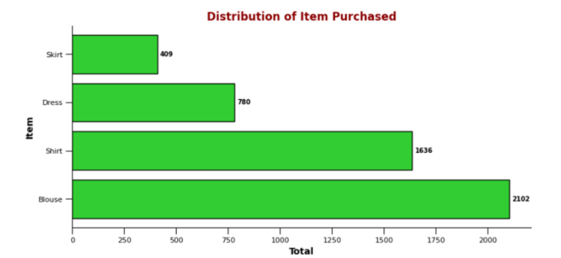
Figure 1 The four products with highest sales
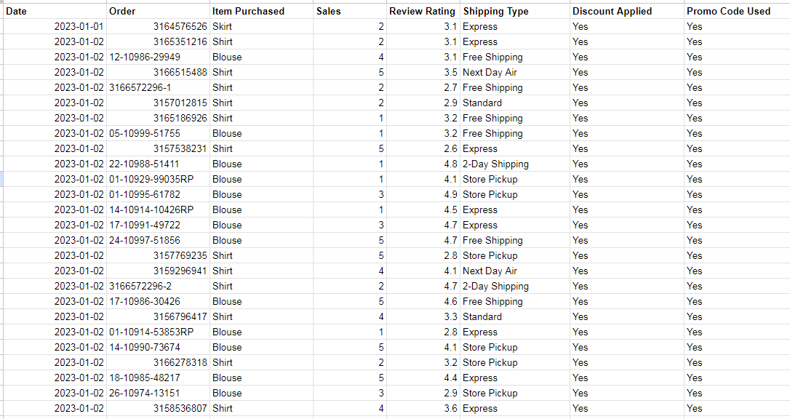
Figure 2 The snapshot of Sales dataset

Part 3. Methodology and Solution

3.1 Customer segmentation analysis

With a dataset recording transactions containing information about customers, products, and purchasing behavior of a clothing store, our aim is to convert transaction data to help segment customers into distinct groups using the K-means clustering algorithm. Machine learning systems and other techniques will optimize the model, enabling it to understand and label characteristics for customer groups. To better understand our approach, we'll delve into how we execute it.

After searching, evaluating, and selecting a suitable dataset, we'll proceed to normalize the data, remove noise, handle missing values, and transform the data to create clean and sensible data for subsequent steps. In K-means clustering, the algorithm is sensitive to both the scale of data and the presence of outliers, as they can significantly influence the position of centroids, potentially leading to incorrect cluster assignments.

Next, we perform Exploratory Data Analysis to understand how values are distributed and identify outliers or anomalous values. The correlation matrix evaluates the degree of correlation between attribute variables, using a heatmap to visually represent the correlation matrix, helping identify variables strongly related to each other. By executing these steps, we'll gain a comprehensive overview of the data, better understanding factors influencing customer purchasing decisions. This will greatly assist in building predictive models or making strategic business decisions.

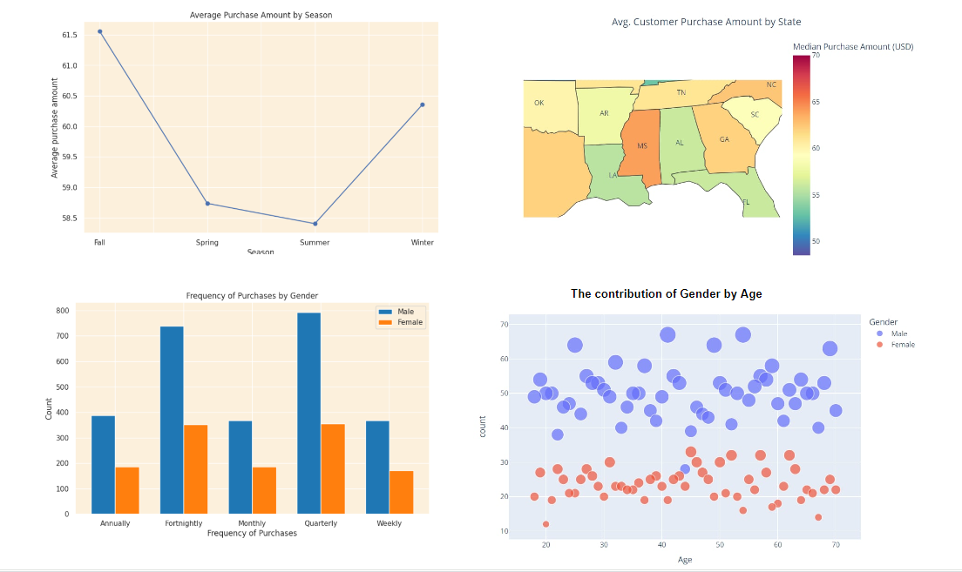
Figure 3 Some figtures about EDA of Shopping dataset

To begin building the K-means model, we proceed with determining the appropriate number of clusters (k) using the Elbow method. It involves iterating through the data, generating clusters for various values of k. The k-means algorithm calculates the sum of squared distances between each data point and its assigned cluster centroid, known as the inertia or WCSS score.
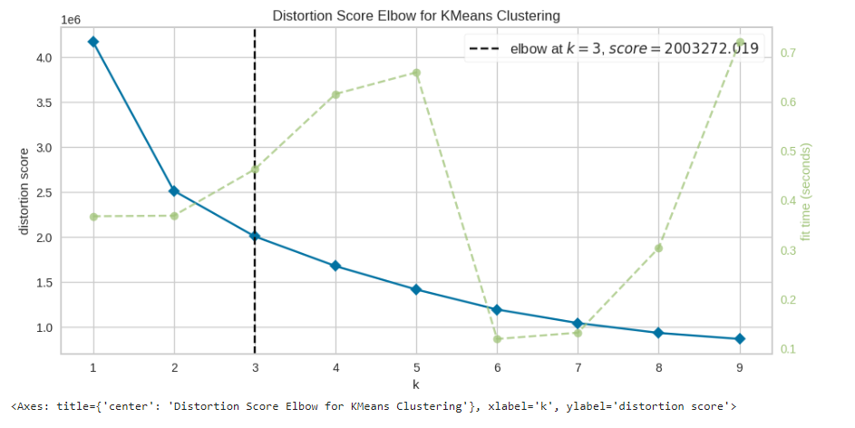
Figure 4 The Elbow method

The optimal value of k for the model is 3, but to choose the best k within this range, we can employ Silhouette analysis, another cluster quality evaluation method. Based on Silhouette scores, 3 is indeed the most suitable number of clusters for this data. Additionally, we apply the K-means clustering algorithm to segment customers into different clusters based on their purchasing behaviors and other characteristics.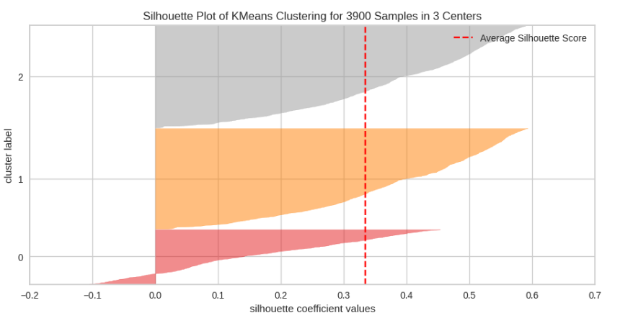
Figure 5 Silhouette Plot

3.2 Recommendation system
The recommendation system will suggest products to customers based on the purchasing patterns prevalent in their respective clusters. From the customer segmentation group, the system can analyze customer characteristics and classify them into the most suitable cluster. Then, the system will craft personalized recommendations, suggesting the top three products popular within their cluster that they have not yet purchased. For the outlier group, a basic approach could be to recommend random products, as a starting point to engage them.

The system will use data on ratings or purchase history from multiple users to identify similarities between them. Based on these similarities, the system can recommend products to a user based on the items that similar users have liked or purchased in the past.
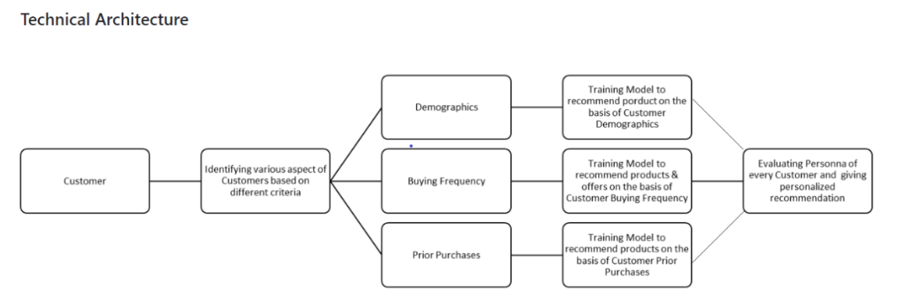
Figure 6 Technical Architecture for Recommendation system

3.3 Sales prediction for specific items
From a time-series dataset of specific items that have been sold, we developed a sales prediction model based on Long Short-Term Memory (LSTM) networks and the time-series dataset. The methodology for developing this sales prediction model involves leveraging the power of recurrent neural networks (RNNs) designed to capture and analyze sequential patterns in time-series data.

We divided the dataset into four different entities, specifically the most popular items in the store. We built the model based on five months of previous sales data, including 1,654 rows and eight columns. Our sales prediction model was trained on historical sales data, encompassing details such as ratings and discount prices of each product. During the model-building process, we tested neural networks such as LSTM, ARIMA, and other neural networks. We had to address the issue of low accuracy in the sales prediction model by changing parameters to optimize the model. We evaluated the model using metrics such as Mean Squared Error (MSE), Root Mean Squared Error (RMSE), and Mean Absolute Error (MAE).

The outcome of this model will include forecasting the daily sales volume for the upcoming 1-2 months. This prediction will be utilized to support and cater to the sales and marketing departments.

Part 4. Implementation and Results Analysis

4.1 Customer segmentation and Recommendation system
After building the Clustering model based on demographic characteristics and purchasing behavior, we have identified three main customer groups with distinct features. The 3D visualization below provides an overall view of the distribution of each customer group based on age, purchase frequency, and spending.
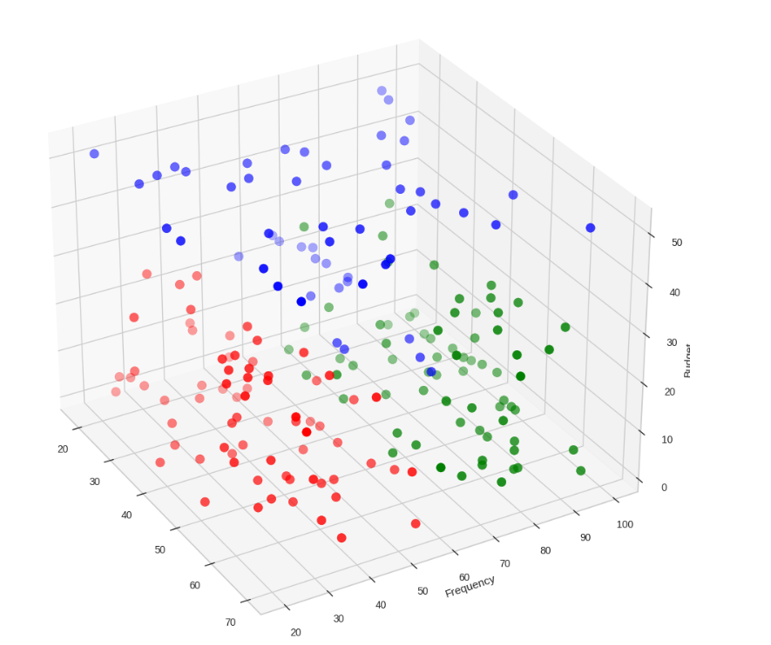

Figure 7 3-D Visualization

In reality, at this business unit, customer clustering is often categorized into three types: hot customers, warm customers, and cold customers.

Cluster 0: Customers with very high frequency of purchasing
This cluster represents the "hot" customer group - those who are highly active and frequently make purchases. They are crucial for the business as they contribute significantly to revenue. Strategies to retain and grow this group may include loyalty programs, exclusive offers, and personalized marketing campaigns. These customers may respond well to rewards for frequent purchases and personalized experiences.

Cluster 1: Customers with restricted financial condition and low frequency of purchasing
This cluster comprises the "cold" customer group, who may be price-sensitive and make fewer purchases. This group presents an opportunity for the business to increase engagement and conversion rates. Strategies for this group may include targeted discounts, flexible payment options, and highlighting high-value products. Building trust and demonstrating value can encourage these customers to shop more frequently.

Cluster 2: Customers with high financial condition and low frequency of purchasing
This cluster includes the "warm" customer group, individuals with higher financial capabilities but less frequent purchasing habits. They may be selective in their purchases and only buy when they perceive high value in a product. This group has the potential to generate higher revenue per purchase. Strategies to target this group may involve premium products, exclusive access to new items, and emphasizing quality and exclusivity in personalized marketing. Encouraging these customers to shop more frequently can be effective through introducing unique or limited-edition products.
These customer clustering strategies provide a framework for developing targeted marketing and sales approaches tailored to each group's characteristics and behaviors. By understanding and catering to the specific needs of different clusters, businesses can optimize customer engagement, loyalty, and ultimately, revenue.

Next, we proceed to deploy the product onto the web and build the recommendation system. When a customer's information is entered, the system will identify the appropriate cluster and display products that are suitable for that individual - these products will be the most popular and highly rated items among other buyers.

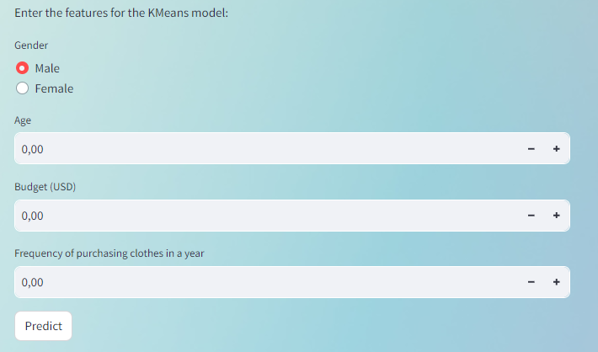
Figure 8 Demo 1 for input data


Figure 9 Demo 2 for output
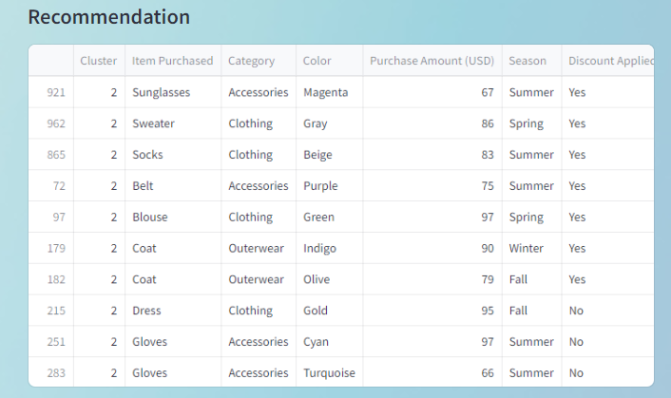
Figure 10 Demo 3 for output

4.2 Sales predictions on specific items
After undergoing a training period with a five-month dataset, the model is now capable of forecasting daily product sales for the upcoming 1-2 months. The implementation of such a model empowers the marketing team to make informed decisions and tailor their strategies based on predicted sale modeling . They can choose marketing strategies that are appropriate to predicted sales given by model, in order to reach sales KPI and maximize the sale volume as possible. This strategic approach enables marketers to optimize budget allocation, ensuring that resources are directed towards the most promising channels and campaigns.

- The result of prediction for Skirt
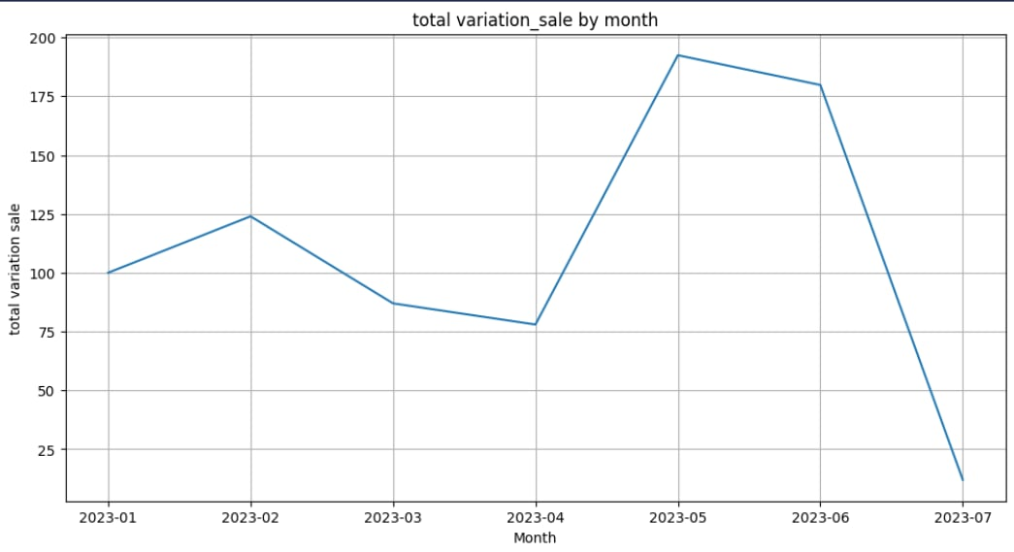
Figure 11 Sale Volume of Skirt
Comment:
- Shirt sales are the lowest of the four products, with a predicted peak of 20 units in July.
- Skirt's sales projections range from 50 to 200 units per month.
- Sales are expected to peak in May and June, at 200 and 175 units, respectively.
- Predicted sales are lowest in April and July, at 75 and nearly 25 units, respectively.
- Based on the chart, it can be predicted that Skirt sales will be highest in summer and lowest in winter. This may be because skirts are more commonly worn in warm weather. Additionally, dress sales may increase during months with special events, such as weddings or holidays.

2. The result of prediction for Dress

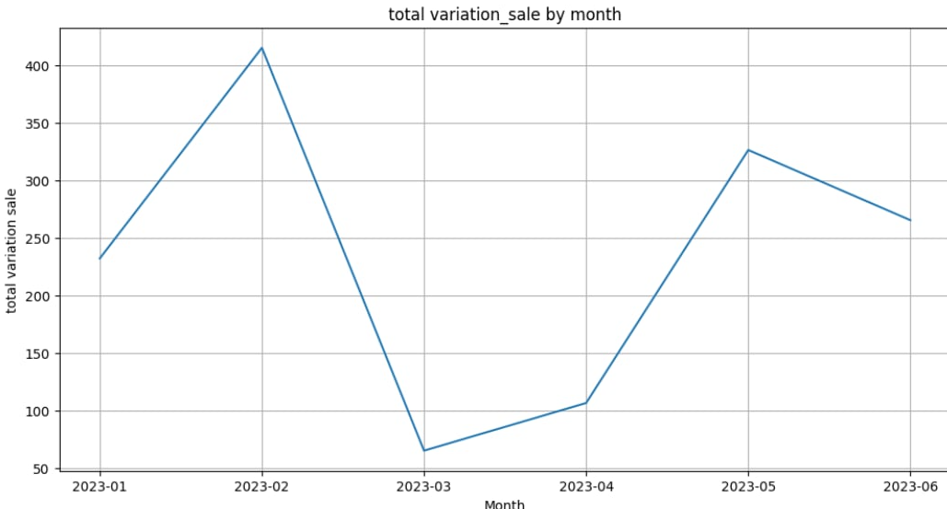
Figure 12 Sale Volume of Dress
Comment:
- Dress sales projections range from 50 to 400 units per month.
- Sales are expected to peak in February and May, at 400 and 350 units, respectively.
- Sales are expected to be lowest in March and April, at around 70 and 100 units, respectively.
- The chart shows high volatility in forecast sales, with the difference between the highest and lowest being around 300 units. This shows that Dress sales can be significantly affected by a number of factors, such as weather, fashion trends, special events and marketing campaigns.

3. The result of prediction for Blouse

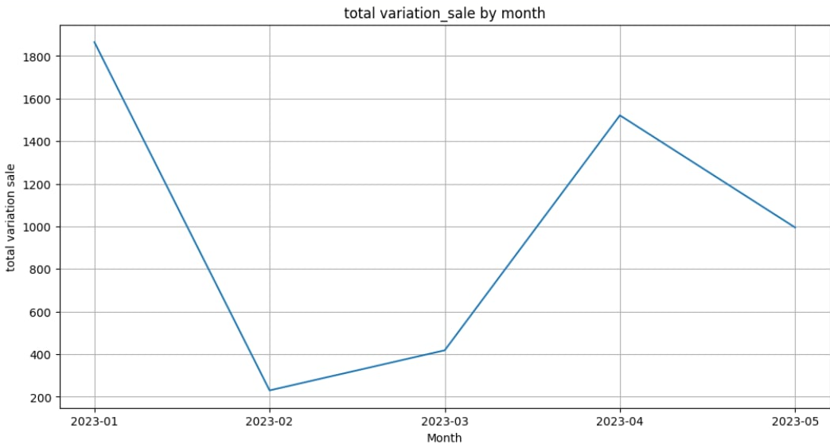
Figure 13 Sale Volume of Blouse
Comment:
- Blouse sales tend to be the highest of the four products, with a predicted peak of 1800 units in January.
- Blouse's sales projections range from 200 to more than 1,800 units per month.
- Sales are expected to peak in January and May, at 1,800 and 1,500 units, respectively.
- Sales are predicted to be lowest in February and March, with a range of 200 - 400 units.
- The chart shows predicted Blouse sales hovering around 1,600 units. This level of volatility is quite high, suggesting that Blouse sales can be significantly affected by many factors.
4. The result of prediction for Shirt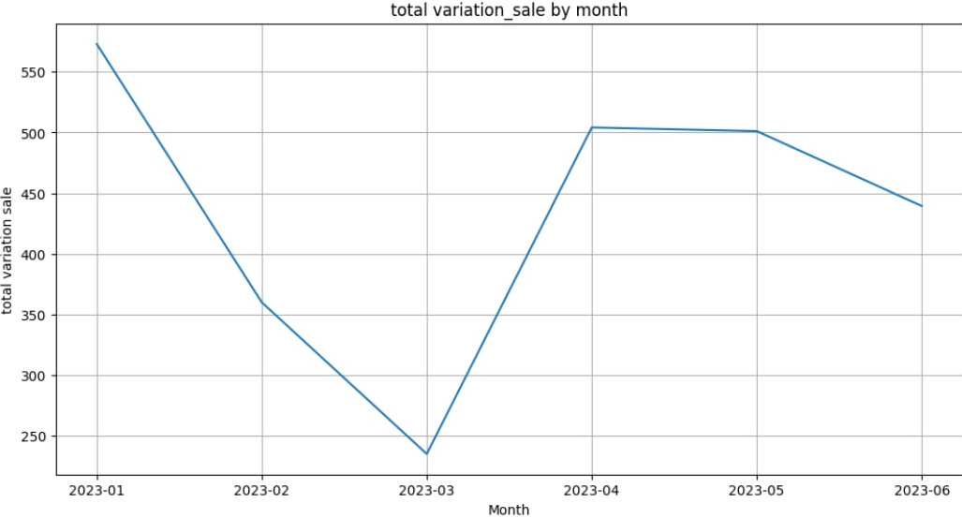
Figure 14 Sale Volume of Shirt

Comment:
The chart shows Shirt's predicted sales by month in 2023. Overall, the chart shows that Shirt sales fluctuate significantly by month, with the difference between the highest month and lowest month being 300 units. Sales tend to increase from March to June, peaking in January at a forecast of more than 550 units and gradually decreasing. The lowest level was below 250 units in March.
This increasing trend may be due to increased demand for Shirt shopping in the summer when the weather is hot.

Part 5. Demo
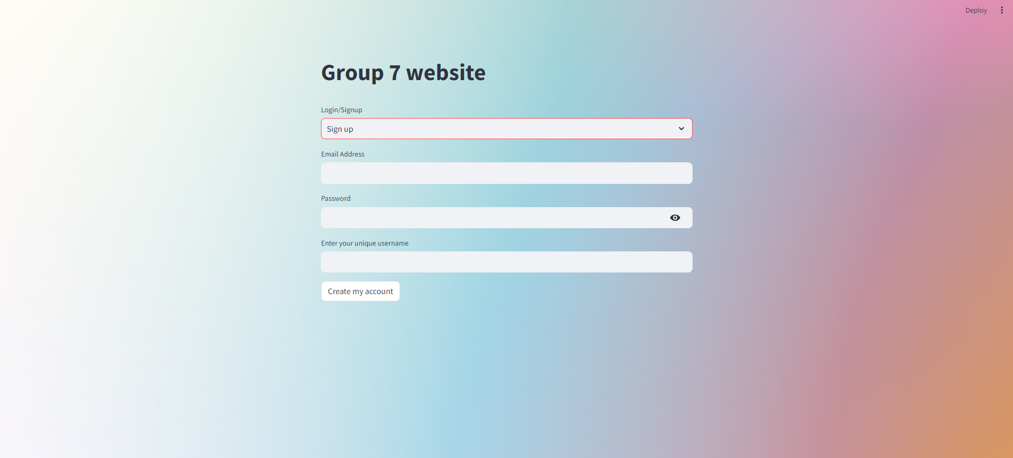
Figure 15 Snapshot of Login/Sign up page

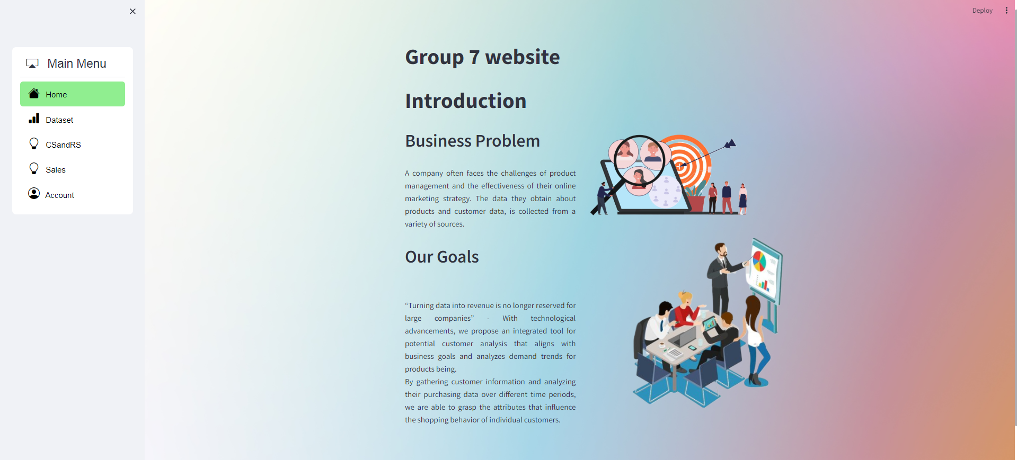
Figure 16 Snapshot of Home page
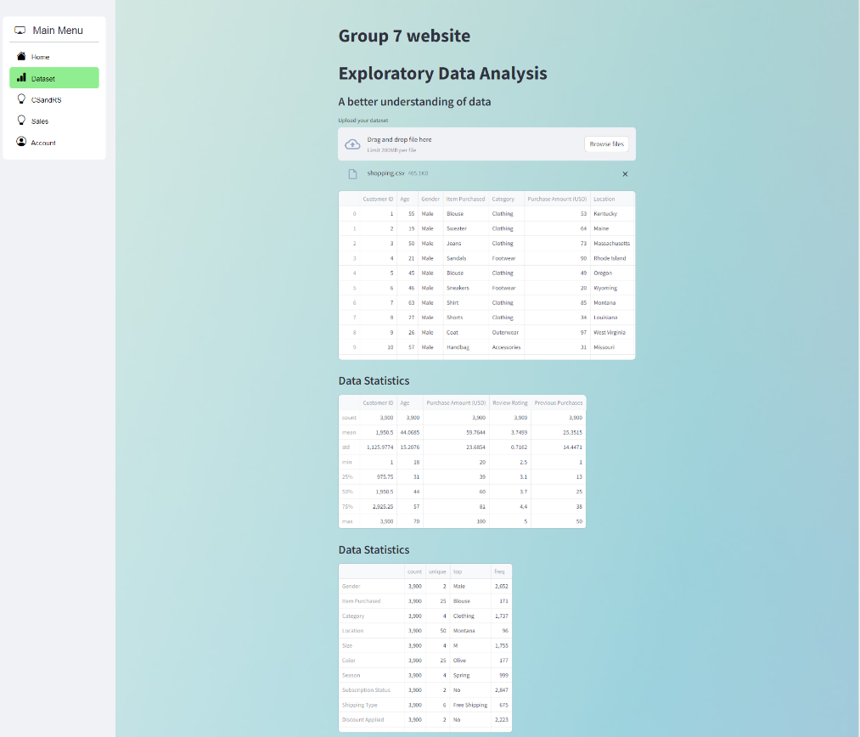
Figure 17 Snapshot of the Dataset page

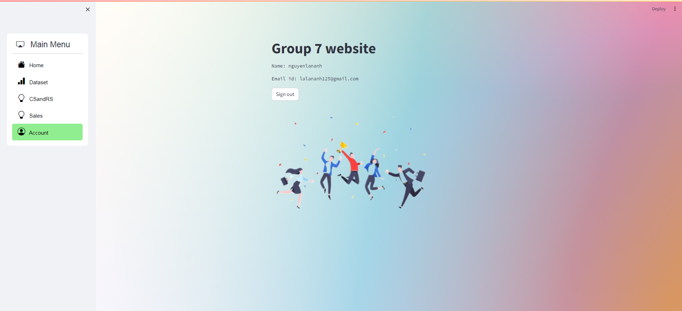
Figure 18 Snapchat of Account page
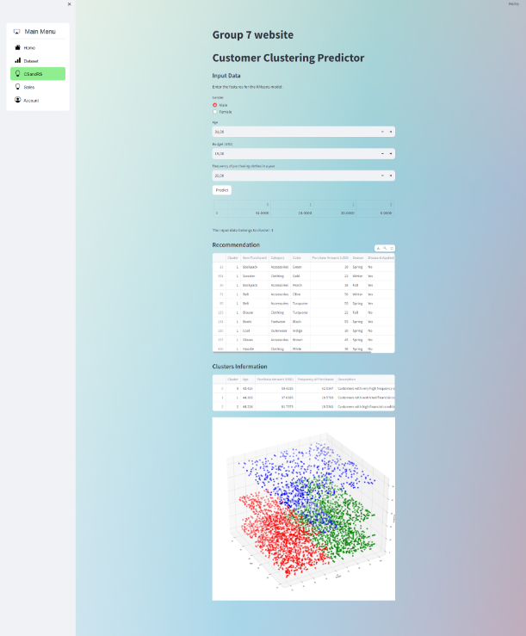
Figure 19 Snapshot of Customer segmentation and Recommendation system

Part 6. Discussion on Strong/Weak points
Strong points
Evaluating performance by comparing actual sales with forecast sales, businesses can evaluate their performance, identify areas for improvement, and implement strategies to drive business growth.

The project helps the Marketing department build a feasible Marketing plan which is very important. By improving your consumers' purchasing experience and personalizing their purchasing journey, you can significantly increase their happiness and loyalty.

The project allows businesses to develop strategic strategies and manage finances more effectively by properly predicting customer desires. This proactive approach allows companies to make the best decisions while optimizing their capital investment.

Ultimately, these initiatives help increase sales and expand the number of choices available to customers. Addressing customers' individual needs and increasing customer engagement by giving them access to items tailored to their preferences.

Weak points
Uncertainties, external variables such as market changes, unforeseen circumstances, etc., can have an effect that the company cannot control.

The emphasis on information security can lead to a lack of thorough and accurate data collection, which can reduce the accuracy of forecasts.

There will still be differences between reality, which cannot be completely accurate.

Part 7. Conclusion and Future Work
Our project provides essential analytical tools to assist the Marketing department in making better decisions for business development in the future. We design a website that integrates multiple models and analysis features simultaneously, making it user-friendly.Our project stands out with the necessary tools, combining advanced technologies and future scalability to serve multiple brands. The sales prediction and customer segmentation models make it a practical and effective tool to support Marketing strategy development.The utility of the project extends beyond mere data analysis to include a recommendation model that can be integrated with sales systems or websites to display product suggestions during the shopping process.
However, there are still some limitations that can be improved. One of the main challenges the authors faced was the lack of rich data sources provided, which limited the effectiveness of our work.We will proceed with analysis and development to improve the system and refine the functions, as well as build a website.

Part 8. Acknowledgements
We extend our sincere gratitude to our supervisor, Assoc.Prof. Dr. Tran Thi Oanh, for her invaluable guidance and support throughout our project. Her expertise and insights were instrumental in selecting the appropriate topic and implementing a model for our study. We are grateful for her mentorship, patience, and the time she dedicated to reviewing our work, providing constructive feedback, and shaping our project direction.
Besides that, especially thanks for their encouragement and understanding from teammates. This project benefited immensely from the collective contributions of each individual, and each member's involvement has been instrumental in its successful completion.
Collectively, the contributions of Assoc.Prof. Dr. Tran Thi Oanh and our friends have been crucial in shaping the success of our research project. We are deeply grateful for their support and collaboration throughout this journey.

Part 9. References

1. Hamed Jahani, R. J. &. D. I., 2023. Data science and big data analytics: a systematic review of methodologies used in the supply chain and logistics research. [Online]
Available at: https://link.springer.com/article/10.1007/s10479-023-05390-7

2. JEFF BARRETT, C. B. D. @., 2018. Up to 73 Percent of Company Data Goes Unused for Analytics. Here's How to Put It to WorkTargeting the right areas and using the right technology can save your bottom line.. [Online]
Available at: https://www.inc.com/jeff-barrett/misusing-data-could-be-costing-your-business-heres-how.html

3. Pandey, S., 2022. How To Motivate Your Team For Better Performance In Your Project?. [Online]
Available at: https://www.projectcentral.com/blog/motivate-project-team/
4. Arya, V. (2024) Article 2: Introduction to Customer Success: Topic 3: The role of customer segmentation in tailoring customer success strategies., LinkedIn. Available at: https://www.linkedin.com/pulse/article-2-introduction-customer-success-topic-3-role-tailoring-arya-vorxf (Accessed: 20 May 2024).
5. Author links open overlay panelYogesh K. Dwivedi a et al. (2020) Setting the future of digital and social media marketing research: Perspectives and Research Propositions, International Journal of Information Management. Available at: https://www.sciencedirect.com/science/article/pii/S0268401220308082 (Accessed: 09 May 2024).
6. Pandey, S. (2022) How to motivate your team for Better Performance In Your Project, Project Central. Available at: https://www.projectcentral.com/blog/motivate-project-team/ (Accessed: 16 May 2024).
7. Anaplan (2024) The beginner’s guide to sales forecasting. Available at: https://www.anaplan.com/blog/sales-forecasting-guide/?fbclid=IwAR0kgx8jWzz3chMy3YsI6NHVrfnmW-fx6KqFZoMd72KIw966NaljYibSHYw (Accessed: 14 May 2024)

8. Minh Nguyen What is Sales forecasting? 6 methods commonly used to build sales forecasts. Available at: https://pms.edu.vn/sales-forecast-la-gi/ (Accessed: 13 April 2024).

9. PangoCDP (2023) 10 criteria for customer segmentation to increase conversion rates (Customer Segmentation). Available at: https://www.linkedin.com/pulse/10-ti%C3%AAu-ch%C3%AD-ph%C3%A2n-nh%C3%B3m-kh%C3%A1ch-h%C3%A0ng-gi%C3%BAp-t%C4%83ng-t%E1%BB%B7-l%E1%BB%87-chuy%E1%BB%83n-%C4%91%E1%BB%95i-customer/ (Accessed: 13 April2024).

10. Ren (2022) User Authentication Methods. Available at: https://viblo.asia/p/cac-phuong-phap-xac-thuc-nguoi-dung-4dbZNRDQZYM (Accessed: 14 May 2024).
11. Pham Dinh Khanh (2019) Bài 15 - collaborative và content-based filtering. Available at: https://phamdinhkhanh.github.io/2019/11/04/Recommendation_Compound_Part1.html (Accessed: 15 April 2024).

12. Vijay Kanade AI Researcher (2023) What Is Linear Regression? Types, Equation, Examples, and Best Practices for 2022. Available at:
More, M. (2023, March 27). 8 Sales Forecasting Methods For Predicting Revenue. ThoughtSpot. Retrieved June 9, 2024, from https://www.thoughtspot.com/data-trends/analytics/sales-forecasting-methods

13. Frost, A. (2023, July 10). The Ultimate Guide to Sales Forecasting. HubSpot Blog. Retrieved June 9, 2024, from https://blog.hubspot.com/sales/sales-forecasting
Gould, B. (2023, November 28). Top 8 Sales Forecasting Methods + How to Pick One (2024). Scratchpad. Retrieved June 9, 2024, from https://www.scratchpad.com/blog/sales-forecasting-methods

14. Jain, S. (2024, March 20). Linear Regression in Machine learning. GeeksforGeeks. Retrieved June 9, 2024, from https://www.geeksforgeeks.org/ml-linear-regression/
Hartje, E. (n.d.). 8 Sales forecasting techniques to predict revenue. Avoma. Retrieved June 9, 2024, from https://www.avoma.com/blog/sales-forecasting-techniques

15. Everything you need to Know about Linear Regression. (n.d.). Analytics Vidhya. Retrieved June 9, 2024, from https://www.analyticsvidhya.com/blog/2021/10/everything-you-need-to-know-about-linear-regression/
16. Bevans, R. (2020, February 19). Simple Linear Regression | An Easy Introduction & Examples. Scribbr. Retrieved June 9, 2024, from https://www.scribbr.com/statistics/simple-linear-regression/

17. Pici, M., & Barker, S. (2021, July 2). 8 Proven Sales Forecasting Methods for Greater Accuracy. GTMnow. Retrieved June 9, 2024, from https://gtmnow.com/sales-forecasting-methods/

Part 10. Contribution

Name | Sections | Comment | Performance | Distribution
Nguyễn Thị Lan Anh | - Leader  - Plan and control work processes  - Find and evaluate datasets  - Build Customer Segmentation and Recommendation System models  - Design Back end and Front end for the website  - Write reports for each main section ( Methodology and Implementation) | Completes all assigned tasks with responsibility and efficiency. Her proactive contributions and collaborative spirit, and effective leadership significantly enhance team success | 100% | 24%
Hà Thị Hồng Ánh | - Research information and support for building a recommendation system model  - Data set processing, including data cleaning, handling missing values, etc.  - Build and evaluate a sales prediction model  - Write a report on the Project Goals and Strong/Weak points  - Write a report on the Dataset  - Design slides | Standout contributors within our team, consistently delivering outstanding results. Their efficiency, collaboration, and positive impact significantly contribute to the team's success. | 100% | 20%
Nguyễn Thị Quỳnh Anh | - Research information and support for developing the Customer Segmentation model  - Clean and normalize the dataset  - Develop content for Part I (About the Project  - Design the report | Complete tasks with the desired result. Support your teammates whenever possible. | 100% | 20%
Đỗ Thanh Vân | - Find, evaluate and finalize the most suitable data set for the project  - Build EDA for dataset  - Build Sales prediction model  - Write report about Tentative users  - Support write report about Sales prediction model | Completed tasks but still need reminders quite often, indicating room for improvement in efficiency. Team spirit appears lacking, but you're willing to help when needed. | 95% | 18%
Nguyễn Bích Diệp | - Research information and support for building the Sales Prediction model  - Provide assistance with code for converting data into numerical format  - Write the Introduction section of the report, covering Scope, Out of Scope, and Risks  - Develop content for the Project Goals section | Completed tasks but still need reminders quite often, indicating room for improvement in efficiency. Team spirit appears lacking, but you're willing to help when needed. | 95% | 18%

