EDUPRO
Instructor Performance and Course Quality Evaluation
A Data-Driven Exploratory Analysis and Streamlit Dashboard

Research Paper / Project Report
Python • Pandas • NumPy • Matplotlib • Seaborn • Streamlit

Abstract
This project presents a data-driven framework for evaluating instructor performance and course quality on the EduPro online learning platform. Three datasets—Teachers, Courses, and Transactions—were analyzed, containing 60 instructors, 60 courses, and 10,000 transaction records. Exploratory analysis examined instructor ratings, teaching experience, expertise, course ratings, and transaction-based enrollment patterns. The average teacher rating was 3.12 and the average course rating was 3.10. Years of experience and teacher rating had a correlation of 0.5980, indicating a moderate positive association. Marketing and Machine Learning had the highest mean teacher ratings among the expertise groups. Teacher rating and course rating had an approximately zero correlation (-0.0016), while teacher rating and transaction-based enrollment counts had a correlation of 0.3183. A Streamlit dashboard was developed to present the principal KPIs and visual analyses.
Keywords: EduPro, instructor performance, course quality, exploratory data analysis, ratings, experience, enrollment, Streamlit

1. Introduction
Online education platforms depend on instructor quality and course quality to support learner satisfaction and platform credibility. Ratings provide measurable indicators of perceived performance, while transaction records provide information about demand. This project integrates these sources to examine instructor performance and course quality using exploratory data analysis and interactive visualization.
The analysis focuses on the overall rating distribution, the relationship between teaching experience and instructor ratings, differences across expertise areas, the relationship between instructor and course ratings, and the association between instructor ratings and transaction-based enrollment counts.

2. Problem Statement
EduPro needs a structured analytical approach to identify instructors and expertise areas associated with stronger observed performance, understand whether teaching experience is related to ratings, examine whether instructor and course ratings move together, and assess whether higher-rated instructors are associated with greater transaction-based demand.

3. Objectives
- Evaluate the overall distribution and average level of instructor ratings.
- Measure the overall average course rating.
- Examine the relationship between YearsOfExperience and TeacherRating.
- Compare average TeacherRating across Expertise groups.
- Examine the relationship between TeacherRating and CourseRating.
- Examine the relationship between TeacherRating and transaction-based enrollment counts.
- Present key performance indicators and analytical visuals through a Streamlit dashboard.

4. Dataset Description
The analysis notebook loads Teachers.csv, Courses.csv, and Transactions.csv from the project data directory. The notebook reports 60 teachers, 60 courses, and 10,000 transaction records. It also reports zero missing values in the checked fields.
Dataset | Rows | Columns | Main fields
Teachers | 60 | 7 | TeacherID, TeacherName, Age, Gender, Expertise, YearsOfExperience, TeacherRating
Courses | 60 | 8 | CourseID, CourseName, CourseCategory, CourseType, CourseLevel, CoursePrice, CourseDuration, CourseRating
Transactions | 10,000 | 7 | TransactionID, UserID, CourseID, TransactionDate, Amount, PaymentMethod, TeacherID

5. Methodology
Data loading: Load the three CSV files using Pandas.
Structural inspection: Inspect shapes, sample records, columns, and data types.
Data quality assessment: Check missing values in the three datasets.
Rating analysis: Create the teacher-rating distribution and calculate average teacher and course ratings.
Experience analysis: Plot YearsOfExperience against TeacherRating and calculate their correlation.
Expertise analysis: Group teachers by Expertise and calculate mean TeacherRating.
Teacher-course integration: Merge teacher, transaction, and course information using TeacherID and CourseID and calculate the TeacherRating/CourseRating correlation.
Enrollment analysis: Count transaction records by TeacherID, merge counts with teacher data, and calculate the TeacherRating/Enrollments correlation.
Dashboard presentation: Present the main KPIs and charts through the Streamlit application.

6. Exploratory Data Analysis

6.1 Teacher Rating Distribution
A histogram with 10 bins was created for TeacherRating to visualize the distribution of ratings among the 60 teachers. The same analysis is presented in the Streamlit dashboard as the Teacher Rating Distribution.
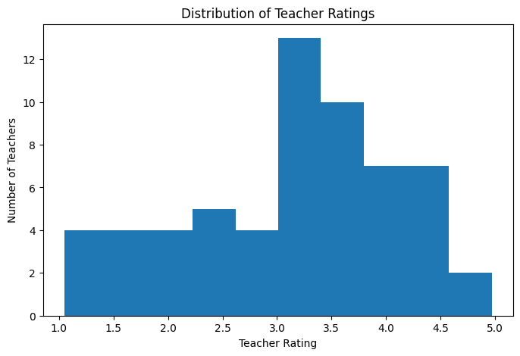
Figure 1. Teacher rating distribution from the analysis notebook.

6.2 Experience versus Teacher Rating
A scatter plot was used to compare YearsOfExperience and TeacherRating. The Pearson correlation reported by the notebook is 0.5980353983. This represents a moderate positive association in the observed instructor data. It should be interpreted as correlation, not proof that experience causes higher ratings.

6.3 Expertise-wise Performance
Mean teacher ratings by expertise were:
Expertise | Mean Teacher Rating
Marketing | 4.290
Machine Learning | 4.234
Programming | 3.950
Cybersecurity | 3.469
Finance | 3.265
Artificial Intelligence | 3.173
Digital Marketing | 3.050
Data Science | 3.030
Project Management | 2.664
Web Development | 2.514
Design | 2.290
Business | 2.245

7. Key Performance Indicators
KPI | Observed value | Meaning
Average Teacher Rating | 3.12 | Overall instructor-rating benchmark
Average Course Rating | 3.10 | Overall course-rating benchmark
Experience Impact Score | 0.5980 | YearsOfExperience/TeacherRating correlation
Teacher–Course Rating Correlation | -0.0016 | Almost no linear association in analyzed merged data
Enrollment Influence Ratio | 0.3183 | TeacherRating/transaction-count correlation

8. Relationship Analysis

8.1 Experience and Instructor Performance
The 0.5980 correlation indicates a moderate positive relationship between teaching experience and teacher rating in this dataset. This is the strongest reported correlation in the notebook.

8.2 Instructor Rating and Course Rating
The merged analysis produced a TeacherRating/CourseRating correlation of -0.00157699. This is effectively zero, indicating no meaningful linear association between the two rating variables in the analyzed merged sample.

8.3 Instructor Rating and Enrollment
Enrollment counts were constructed by grouping transactions by TeacherID. The resulting TeacherRating/Enrollments correlation was 0.31828685, indicating a positive but relatively weak-to-moderate association.

9. Streamlit Dashboard
The project includes a Streamlit dashboard that presents the principal KPIs and visual analytics. The deployed application is available online.
Deployed application: https://edupro-instructor-performance-vjvfqcbz5dgmezofuurdyr.streamlit.app/

10. Key Findings
- The average teacher rating is 3.12 and the average course rating is 3.10.
- YearsOfExperience and TeacherRating have a moderate positive correlation of 0.5980.
- Marketing has the highest mean teacher rating at 4.29, followed by Machine Learning at 4.234.
- Business has the lowest mean teacher rating at 2.245, followed by Design at 2.29.
- TeacherRating and CourseRating have an approximately zero linear correlation (-0.0016).
- TeacherRating and transaction-based Enrollments have a positive correlation of 0.3183.

11. Recommendations
- Use expertise-wise analysis to identify areas where strong teaching practices can be studied and shared.
- Investigate lower-rated expertise groups to understand possible instructional or course-design issues.
- Use experience-rating patterns as one input for instructor development rather than as a standalone decision rule.
- Monitor ratings and transaction-based demand together to identify quality and demand patterns.
- Extend future analysis with learner feedback, completion, engagement, and review-text data where available.
- Repeat the analysis periodically to monitor changes in instructor and course performance.

12. Limitations
- The analysis uses a snapshot of 60 teachers, 60 courses, and 10,000 transactions.
- Correlation does not establish causation.
- Transaction counts by TeacherID are used as an enrollment proxy and should not automatically be interpreted as unique learners or completions.
- The notebook does not establish statistical significance, causal effects, or multivariate regression relationships.
- No qualitative learner-review text was analyzed.

13. Conclusion
This project provides a practical data-driven framework for evaluating instructor performance and course quality on EduPro. The analysis combines teacher, course, and transaction data to generate KPIs and relationships that can be communicated through an interactive Streamlit dashboard. The observed data show a moderate positive association between teaching experience and teacher rating, little linear association between teacher and course ratings, and a positive association between teacher rating and transaction-based enrollment counts. Expertise-level differences also highlight areas of relatively stronger and weaker observed instructor ratings. The framework can be extended with richer learner and engagement data for deeper evaluation.

14. References and Project Sources
- EduPro project dataset: Teachers.csv.
- EduPro project dataset: Courses.csv.
- EduPro project dataset: Transactions.csv.
- EduPro project analysis notebook: analysis.ipynb.
- EduPro Streamlit dashboard: deployed project application.

Appendix A: Core Outputs
Measure | Value
Teachers shape | (60, 7)
Courses shape | (60, 8)
Transactions shape | (10000, 7)
Average Teacher Rating | 3.12
Average Course Rating | 3.10
YearsOfExperience ↔ TeacherRating | 0.5980353983
TeacherRating ↔ CourseRating | -0.0015769900
TeacherRating ↔ Enrollments | 0.3182868451

