|  |  |  |
| --- | --- | --- |
| Assessment report | Tues, Dec 17 | PDF showing some initial analysis of your data. Max 2 pages. Show me if this dataset was worth pursuing and what research questions you can ask of it. Imagine this report will be given to a data science lead who asked you to complete this exploratory project. Write for that audience. |

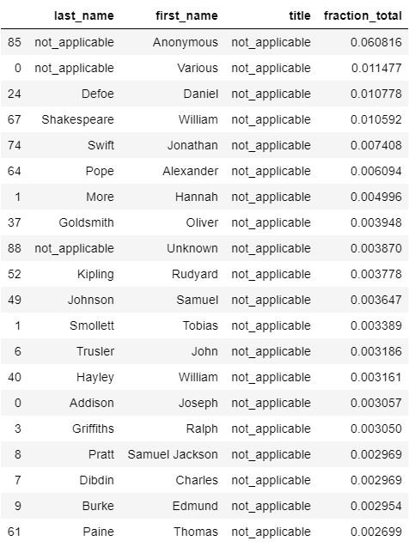

Fig 1. Top 20 authors of final dataset

this was a good pilot program for gathering and standardizing catalog data, but as of right now the results are insufficient for further application in other research.