**Bilateral Filter**

import cv2

import math

import numpy as np

import matplotlib.pyplot as plt

img = cv2.imread("rubiks_cube.png",cv2.IMREAD_GRAYSCALE)

plt.imshow(cv2.cvtColor(img,0))

plt.show()

im_H = img.shape[0]

im_W = img.shape[1]

def gaussian(sigma,img,ksize,padding):

gfilter = np.zeros((ksize,ksize),np.float32)

div = (sigma*sigma)*2

for i in range(-padding,padding+1):

for j in range(-padding,padding+1):

gfilter[i+padding,j+padding] = math.exp(-((i**2+j**2)/div))

return gfilter

ksize = 5

padding = (ksize-1)//2

img = cv2.copyMakeBorder(img, padding, padding, padding, padding, cv2.BORDER_REPLICATE)

output_H = (im_H + ksize-1)

output_W = (im_W + ksize-1)

result = np.zeros((output_H,output_W),np.float32)

sigma = 5

div = (sigma*sigma)*2

gaussian_filter = gaussian(sigma,img,ksize,padding)

for x in range(padding,output_H-padding):

for y in range(padding,output_W-padding):

a = 0, fil = 0,normalization = 0

ip = img[x,y]

for i in range(-padding,padding+1):

for j in range(-padding,padding+1):

iq = img[x-i,y-j]

fil = gaussian_filter[i+padding,j+padding]*(math.exp(-(((ip-iq)**2)/div)))

normalization += fil

a += fil*img[x-i,y-j]

result[x,y] = a/normalization

plt.imshow(cv2.cvtColor(result,0))

plt.show()

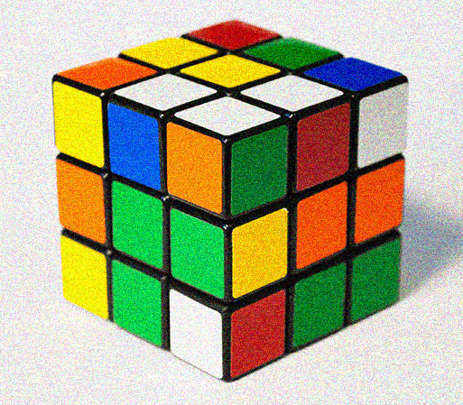 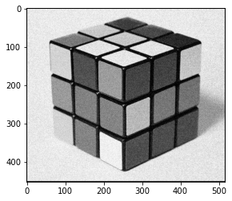

Fig1.1: Input image Fig1.2: Output Image

**Gaussian Filter**

import cv2

import math

import numpy as np

import matplotlib.pyplot as plt

img = cv2.imread("lena.png",cv2.IMREAD_GRAYSCALE)

plt.imshow(cv2.cvtColor(img,0))

plt.show()

im_H = img.shape[0]

im_W = img.shape[1]

def gaussian(sigma,img,ksize,padding):

gfilter = np.zeros((ksize,ksize),np.float32)

div = (sigma*sigma)*2

for i in range(-padding,padding+1):

for j in range(-padding,padding+1):

gfilter[i+padding,j+padding] = math.exp(-((i**2+j**2)/div))

return gfilter

ksize = 7

padding = (ksize-1)//2

img = cv2.copyMakeBorder(img, padding, padding, padding, padding, cv2.BORDER_REPLICATE)

output_H = (im_H + ksize-1)

output_W = (im_W + ksize-1)

result = np.zeros((output_H,output_W),np.float32)

sigma = 5

div = (sigma*sigma)*2

gaussian_filter = gaussian(sigma,img,ksize,padding)

for x in range(padding,output_H-padding):

for y in range(padding,output_W-padding):

a = 0, normalize = 0

for i in range(-padding,padding+1):

for j in range(-padding,padding+1):

a += gaussian_filter[i+padding,j+padding]*img[x-i,y-j]

normalize += gaussian_filter[i+padding,j+padding]

result[x,y] = a/normalize

result[x,y] /= 255

plt.imshow(cv2.cvtColor(result,0))

plt.show()

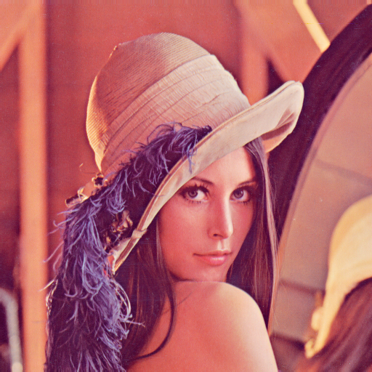 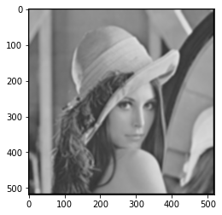

Fig 2.1: Input Image Fig 2.2: Output Image

**Mean Filter**

import cv2

import math

import numpy as np

import matplotlib.pyplot as plt

img = cv2.imread("rubiks_cube.png",cv2.IMREAD_GRAYSCALE)

im_H = img.shape[0]

im_W = img.shape[1]

ksize = 5

padding = (ksize-1)//2

img = cv2.copyMakeBorder(img, padding, padding, padding, padding, cv2.BORDER_REPLICATE)

output_H = (im_H + ksize-1)

output_W = (im_W + ksize-1)

result = np.zeros((output_H,output_W),np.float32)

div = ksize*ksize

for x in range(padding,output_H-padding):

for y in range(padding,output_W-padding):

a = 0

for i in range(-padding,padding+1):

for j in range(-padding,padding+1):

a += img[x-i,y-j]

result[x,y] = a/div

result[x,y] = result[x,y]/255

print(result)

plt.imshow(cv2.cvtColor(result,0))

plt.show()

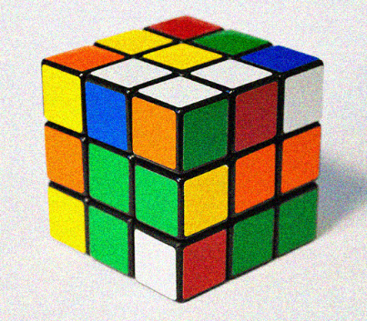 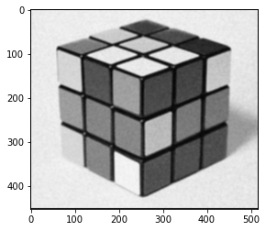

Fig 3.1: Input Image Fig 3.2: Output Image

**Median Filter**

import cv2

import math

import numpy as np

import matplotlib.pyplot as plt

#take input image

img = cv2.imread("cameraman.jpg",cv2.IMREAD_GRAYSCALE)

plt.imshow(cv2.cvtColor(img,0))

plt.show()

im_H = img.shape[0]

im_W = img.shape[1]

ksize = 5

padding = (ksize-1)//2

img = cv2.copyMakeBorder(img, padding, padding, padding, padding, cv2.BORDER_REPLICATE)

output_H = (im_H + ksize-1)

output_W = (im_W + ksize-1)

result = np.zeros((output_H,output_W),np.float32)

div = ksize*ksize

median = div//2

for x in range(padding,output_H-padding):

for y in range(padding,output_W-padding):

a = []

for i in range(-padding,padding+1):

for j in range(-padding,padding+1):

a.append(img[x-i,y-j])

a.sort()

result[x,y] = a[median]/255

print(result)

plt.imshow(cv2.cvtColor(result,0))

plt.show()

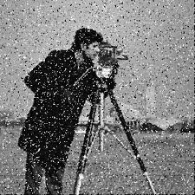 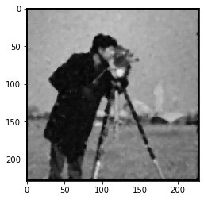

Fig4.1: Input Image Fig 4.2: Output Image

**Sobel Filter**

import cv2

import math

import numpy as np

import matplotlib.pyplot as plt

img = cv2.imread("rubiks_cube.png",cv2.IMREAD_GRAYSCALE)

im_H = img.shape[0]

im_W = img.shape[1]

ksize = 3

padding = (ksize-1)//2

img = cv2.copyMakeBorder(img, padding, padding, padding, padding, cv2.BORDER_REPLICATE)

output_H = (im_H + ksize-1)

output_W = (im_W + ksize-1)

gx = np.zeros((output_H,output_W),np.float32)

gy = np.zeros((output_H,output_W),np.float32)

g = np.zeros((output_H,output_W),np.float32)

hx = np.array(([1,0,-1],[2,0,-2],[1,0,-1]),np.float32)

hy = np.array(([-1,-2,-1],[0,0,0],[1,2,1]),np.float32)

for x in range(padding,output_H-padding):

for y in range(padding,output_W-padding):

a = 0, b = 0

for i in range(-padding,padding+1):

for j in range(-padding,padding+1):

a += hx[i+padding,j+padding]*img[x-i,y-j]

b += hy[i+padding,j+padding]*img[x-i,y-j]

gx[x,y] = a

gy[x,y] = b

g[x,y] = np.sqrt(a**2+b**2)

cv2.normalize(g, g, 0, 255, cv2.NORM_MINMAX)

g = np.round(g).astype(np.uint8)

plt.imshow(cv2.cvtColor(g,0))

plt.show()

 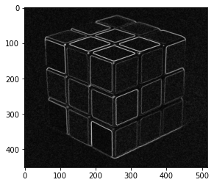

Fig 5.1: Input Image Fig 5.2: Output Image

**Prewitt Filter**

import cv2

import math

import numpy as np

import matplotlib.pyplot as plt

img = cv2.imread("rubiks_cube.png",cv2.IMREAD_GRAYSCALE)

im_H = img.shape[0]

im_W = img.shape[1]

ksize = 3

padding = (ksize-1)//2

img = cv2.copyMakeBorder(img, padding, padding, padding, padding, cv2.BORDER_REPLICATE)

output_H = (im_H + ksize-1)

output_W = (im_W + ksize-1)

gx = np.zeros((output_H,output_W),np.float32)

gy = np.zeros((output_H,output_W),np.float32)

g = np.zeros((output_H,output_W),np.float32)

hx = np.array(([-1,0,1],[-1,0,1],[-1,0,1]),np.float32)

hy = np.array(([-1,-1,-1],[0,0,0],[1,1,1]),np.float32)

for x in range(padding,output_H-padding):

for y in range(padding,output_W-padding):

a = 0, b = 0

for i in range(-padding,padding+1):

for j in range(-padding,padding+1):

a += hx[i+padding,j+padding]*img[x-i,y-j]

b += hy[i+padding,j+padding]*img[x-i,y-j]

gx[x,y] = a

gy[x,y] = b

g[x,y] = np.sqrt(a**2+b**2)

cv2.normalize(g, g, 0, 255, cv2.NORM_MINMAX)

g = np.round(g).astype(np.uint8)

plt.imshow(cv2.cvtColor(g,0))

plt.show()

 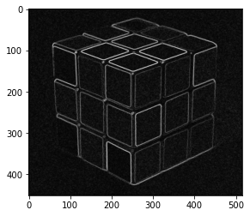

Fig 6.1: Input Image Fig 6.2: Output Image

**Scharr Filter**

import cv2

import math

import numpy as np

import matplotlib.pyplot as plt

img = cv2.imread("rubiks_cube.png",cv2.IMREAD_GRAYSCALE)

im_H = img.shape[0]

im_W = img.shape[1]

ksize = 3

padding = (ksize-1)//2

img = cv2.copyMakeBorder(img, padding, padding, padding, padding, cv2.BORDER_REPLICATE)

output_H = (im_H + ksize-1)

output_W = (im_W + ksize-1)

gx = np.zeros((output_H,output_W),np.float32)

gy = np.zeros((output_H,output_W),np.float32)

g = np.zeros((output_H,output_W),np.float32)

hx = np.array(([-3,0,3],[-10,0,10],[-3,0,3]),np.float32)

hy = np.array(([3,10,3],[0,0,0],[-3,-10,-3]),np.float32)

for x in range(padding,output_H-padding):

for y in range(padding,output_W-padding):

a = 0, b = 0

for i in range(-padding,padding+1):

for j in range(-padding,padding+1):

a += hx[i+padding,j+padding]*img[x-i,y-j]

b += hy[i+padding,j+padding]*img[x-i,y-j]

gx[x,y] = a

gy[x,y] = b

g[x,y] = np.sqrt(a**2+b**2)

cv2.normalize(g, g, 0, 255, cv2.NORM_MINMAX)

g = np.round(g).astype(np.uint8)

plt.imshow(cv2.cvtColor(g,0))

plt.show()

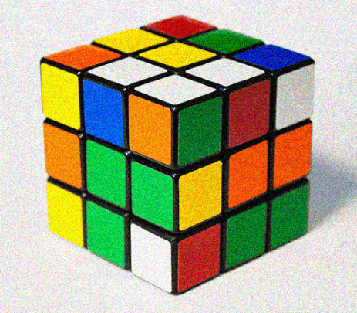 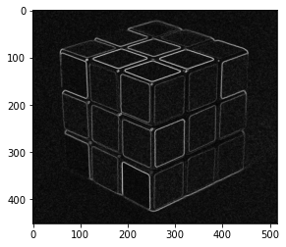

Fig 7.1: Input Image Fig 7.2: Output Image

**Robert Filter**

import cv2

import math

import numpy as np

import matplotlib.pyplot as plt

img = cv2.imread("rubiks_cube.png",cv2.IMREAD_GRAYSCALE)

im_H = img.shape[0]

im_W = img.shape[1]

ksize = 2

padding = (ksize-1)

img = cv2.copyMakeBorder(img, padding, padding, padding, padding, cv2.BORDER_REPLICATE)

output_H = (im_H + ksize-1)

output_W = (im_W + ksize-1)

gx = np.zeros((output_H,output_W),np.float32)

gy = np.zeros((output_H,output_W),np.float32)

g = np.zeros((output_H,output_W),np.float32)

hx = np.array(([1,0],[0,-1]),np.float32)

hy = np.array(([0,1],[-1,0]),np.float32)

for x in range(padding,output_H-padding):

for y in range(padding,output_W-padding):

a = 0, b = 0

for i in range(ksize):

for j in range(ksize):

a += hx[i,j]*img[x-i,y-j]

b += hy[i,j]*img[x-i,y-j]

gx[x,y] = a

gy[x,y] = b

g[x,y] = np.sqrt(a**2+b**2)

cv2.normalize(g, g, 0, 255, cv2.NORM_MINMAX)

g = np.round(g).astype(np.uint8)

plt.imshow(cv2.cvtColor(g,0))

plt.show()

 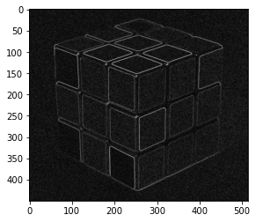

Fig 8.1: Input Image Fig 8.2: Output Image

**Laplacian Version 1**

import cv2

import math

import numpy as np

import matplotlib.pyplot as plt

img = cv2.imread("lena.png",cv2.IMREAD_GRAYSCALE)

im_H = img.shape[0]

im_W = img.shape[1]

ksize = 3

padding = (ksize-1)//2

img = cv2.copyMakeBorder(img, padding, padding, padding, padding, cv2.BORDER_REPLICATE)

output_H = (im_H + ksize-1)

output_W = (im_W + ksize-1)

result = np.zeros((output_H,output_W),np.float32)

laplacian = np.array(([0,-1,0],[-1,4,-1],[0,-1,0]),np.float32)

for x in range(padding,output_H-padding):

for y in range(padding,output_W-padding):

a = 0

for i in range(-padding,padding+1):

for j in range(-padding,padding+1):

a += laplacian[i+padding,j+padding]*img[x-i,y-j]

result[x,y] = a

cv2.normalize(result, result, 0, 255, cv2.NORM_MINMAX)

result = np.round(result).astype(np.uint8)

plt.imshow(cv2.cvtColor(result,0))

plt.show()

 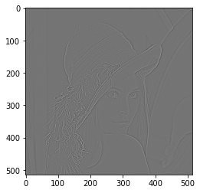

Fig 9.1: Input Image Fig 9.2: Ouput Image

**Laplacian Version 2**

import cv2

import math

import numpy as np

import matplotlib.pyplot as plt

img = cv2.imread("lena.png",cv2.IMREAD_GRAYSCALE)

im_H = img.shape[0]

im_W = img.shape[1]

ksize = 3

padding = (ksize-1)//2

img = cv2.copyMakeBorder(img, padding, padding, padding, padding, cv2.BORDER_REPLICATE)

output_H = (im_H + ksize-1)

output_W = (im_W + ksize-1)

result = np.zeros((output_H,output_W),np.float32)

laplacian = np.array(([-1,-1,-1],[-1,8,-1],[-1,-1,-1]),np.float32)

for x in range(padding,output_H-padding):

for y in range(padding,output_W-padding):

a = 0

for i in range(-padding,padding+1):

for j in range(-padding,padding+1):

a += laplacian[i+padding,j+padding]*img[x-i,y-j]

result[x,y] = a

cv2.normalize(result, result, 0, 255, cv2.NORM_MINMAX)

result = np.round(result).astype(np.uint8)

plt.imshow(cv2.cvtColor(result,0))

plt.show()

 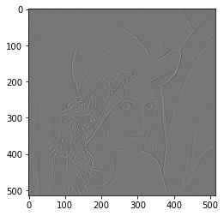

Fig 10.1: Input Image Fig 10.2: Output Image