Histogram Equalization

import cv2

import numpy as np

import matplotlib.pyplot as plt

img = cv2.imread('histogram.jpg',0)

plt.imshow(cv2.cvtColor(img,0))

plt.show()

plt.title(label="Histogram of Input Image",fontsize=20,color="black")

plt.hist(img.ravel(),256,[0,256])

plt.show()

im_H = img.shape[0]

im_W = img.shape[1]

frame = im_H * im_W

output = np.zeros((im_H,im_W))

icount = np.zeros(256)

for i in range(im_H):

for j in range(im_W):

intensity = img[i,j]

icount[intensity] += 1

pdf = icount/frame

cdf = np.zeros(256)

cdf[0] = pdf[0]

for i in range(1,256):

cdf[i] = cdf[i-1]+pdf[i]

for i in range(im_H):

for j in range(im_W):

intensity = img[i,j]

output[i,j] = np.round(255*cdf[intensity])

plt.title(label="CDF of Input Image", fontsize=20,color="black")

plt.plot(cdf)

plt.show()

output = output.astype(np.uint8)

icounto = np.zeros(256)

for i in range(im_H):

for j in range(im_W):

intensity = output[i,j]

icounto[intensity] += 1

pdfo = icounto/frame

cdfo = np.zeros(256)

cdfo[0] = pdfo[0]

for i in range(1,256):

cdfo[i] = cdfo[i-1]+pdfo[i]

plt.imshow(cv2.cvtColor(output,0))

plt.show()

plt.title(label="Histogram of Output Image",fontsize=20,color="black")

plt.hist(output.ravel(),256,[0,256])

plt.show()

plt.title(label="CDF of Output Image",fontsize=20,color="black")

plt.plot(cdfo)

plt.show()

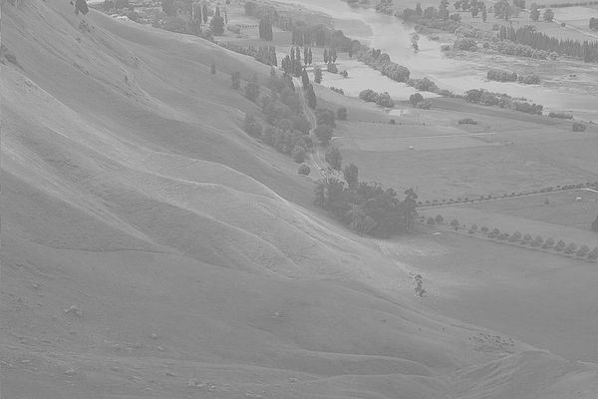 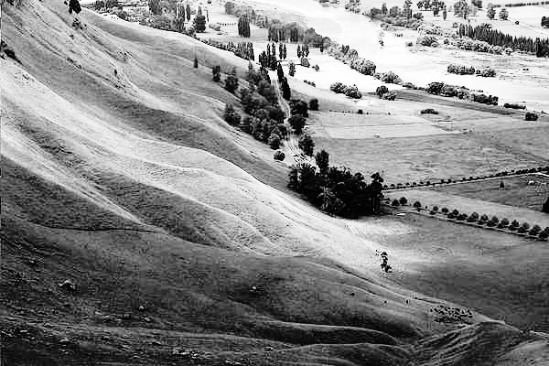

Fig 1.1: Input Image Fig 1.2: Output Image

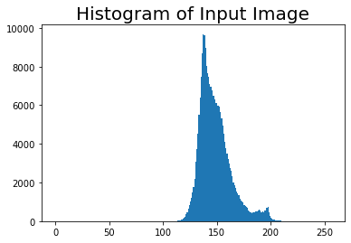 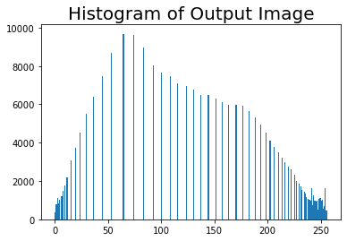

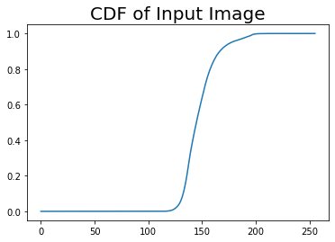 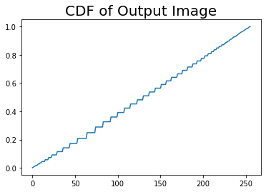

Histogram Matching(Specification)

import cv2

import numpy as np

import matplotlib.pyplot as plt

def search(a,arr):

for i in range(256):

if(a == arr[i]):

return i

elif (a < arr[i]):

b = arr[i]

c = arr[i-1]

if((b-a)>(a-c)):

return i-1

else:

return i

return 255

def gaussian(miu,sigma):

variance = sigma*sigma

constant = 1/(np.sqrt(2*3.1416)*sigma)

g = np.empty(shape=256)

for i in range (256):

g[i] = np.exp(-((i-miu)**2)/(2*variance))*constant

return g

u1,sigma1 = [int(x) for x in input('Enter the values of miu1 and sigma1:').split()]

u2,sigma2 = [int(x) for x in input('Enter the values of miu2 and sigma2:').split()]

img = cv2.imread("histogram.jpg",cv2.IMREAD_GRAYSCALE)

im_H = img.shape[0]

im_W = img.shape[1]

frame = im_H*im_W

intensities = np.zeros(256)

cdf = np.zeros(256,np.float32)

output = np.zeros((im_H,im_W),np.uint8)

for i in range(im_H):

for j in range(im_W):

intensities[img[i,j]] += 1

pdf = intensities/frame

cdf[0] = pdf[0]

for i in range(1,len(pdf)):

cdf[i] = cdf[i-1] + pdf[i]

cdf *= 255

g1 = gaussian(u1, sigma1)

g2 = gaussian(u2,sigma2)

g = g1 + g2

frameg = np.sum(g)

pdfg = g/frameg

cdfg = np.zeros(256)

cdfg[0] = pdfg[0]

for i in range(1,len(pdf)):

cdfg[i] = cdfg[i-1] + pdfg[i]

cdfg *= 255

cdfg = np.round(cdfg).astype(np.uint8)

for i in range(im_H):

for j in range(im_W):

a = np.round(cdf[img[i,j]])

b = search(a,cdfg)

output[i,j] = b

 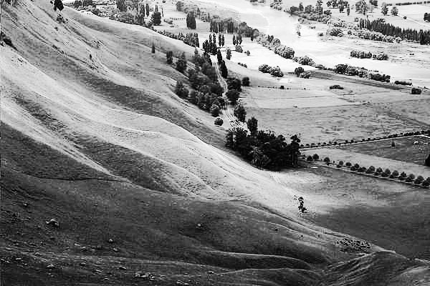

Fig 2.1: Input Image Fig 2.2: Output Image

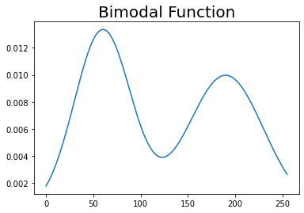 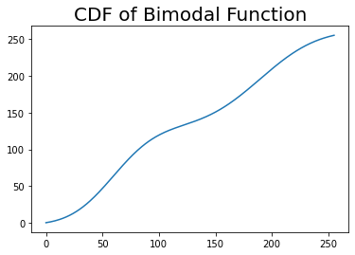

miu1 = 60, sigma1 = 30, miu2 = 190 sigma2 = 40

 