Skeleton

import cv2

import numpy as np

import matplotlib.pyplot as plt

img = cv2.imread('skeleton.bmp',0)

im_H = img.shape[0]

im_W = img.shape[1]

thres_img = np.ones((im_H,im_W))

for i in range(im_H):

for j in range(im_W):

if(img[i,j]>=170):

thres_img[i,j] = 0

kernel = np.array(([1,1,1],[1,1,1],[1,1,1]),np.uint8)

ksize = kernel.shape[0]

padding = 1

thres_img=cv2.copyMakeBorder(thres_img,padding,padding,padding,padding,cv2.BORDER_CONSTANT,value=0)

output_H = im_H + ksize - 1

output_W = im_W + ksize – 1

skeleton = np.zeros((output_H,output_W),np.uint8)

AerodeB = thres_img

for p in range(10):

op = cv2.morphologyEx(AerodeB, cv2.MORPH_OPEN, kernel)

diff = AerodeB - op

for i in range(output_H):

for j in range(output_W):

if(diff[i,j]==1):

skeleton[i,j]=1

AerodeB = cv2.erode(AerodeB,kernel)

if(AerodeB.max()==0):

break

plt.imshow(skeleton, 'gray')

plt.show()

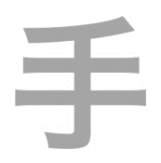 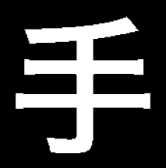 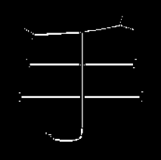

Fig1: Input Image Fig2: Image after Threshold Fig3: Skeleton