**Assignment-1**

## Name**: Aditya Soam**

## Subgroup: **3C25**

## Roll number: **102303353**

Q1: Questions on Basic NumPy Array

1. Reverse the NumPy array: arr = np.array([1, 2, 3, 6, 4, 5])
2. Flatten the NumPy arr: array1 = np.array([[1, 2, 3], [2, 4, 5], [1, 2, 3]]) using any two NumPy in-built methods
3. Compare the following numpy arrays:

arr1 = np.array([[1, 2], [3, 4]]) arr2 = np.array([[1, 2], [3, 4]])

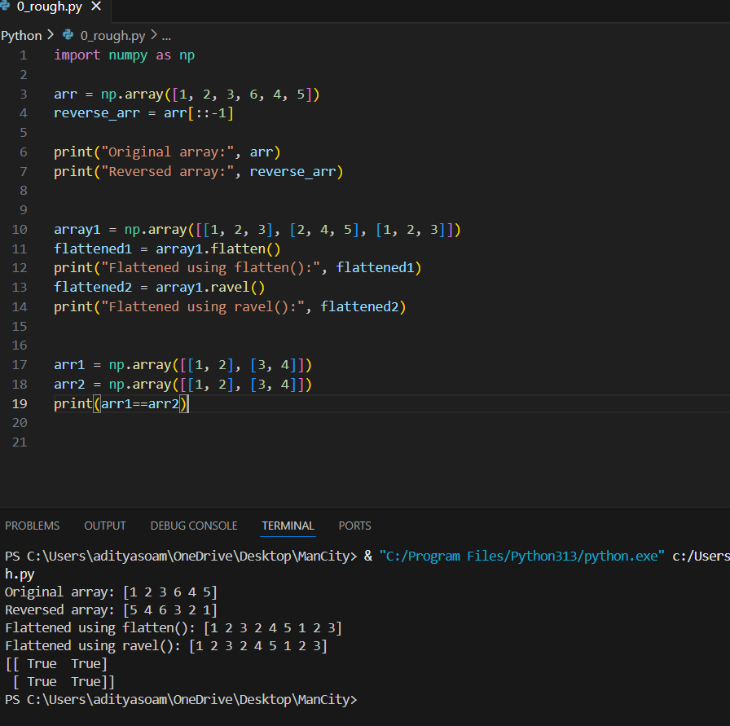

1. Find the most frequent value and their indice(s) in the following arrays:
   1. x = np.array([1,2,3,4,5,1,2,1,1,1])
   2. y = np.array([1, 1, 1, 2, 3, 4, 2, 4, 3, 3, ])

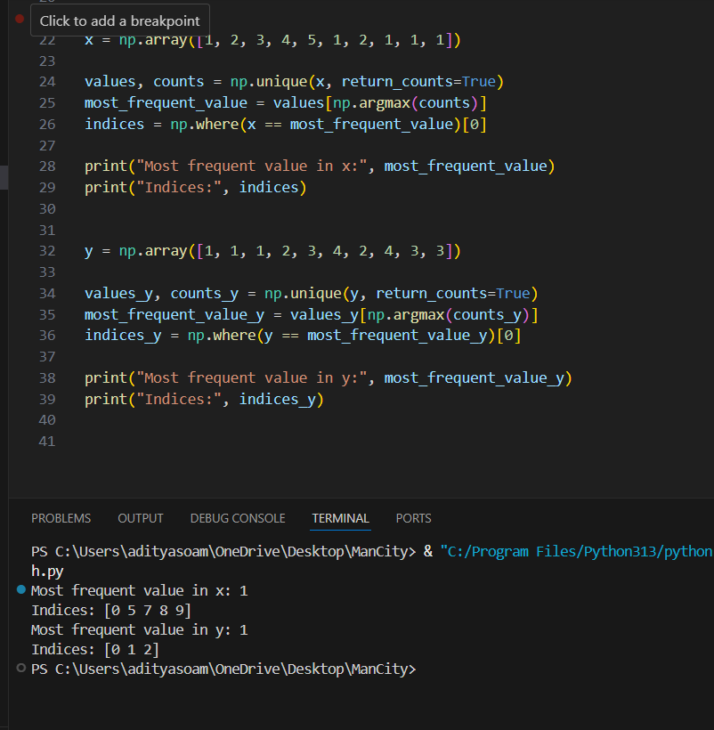

1. For the array gfg = np.matrix('[4, 1, 9; 12, 3, 1; 4, 5, 6]'), find
   1. Sum of all elements
   2. Sum of all elements row-wise
   3. Sum of all elements column-wise

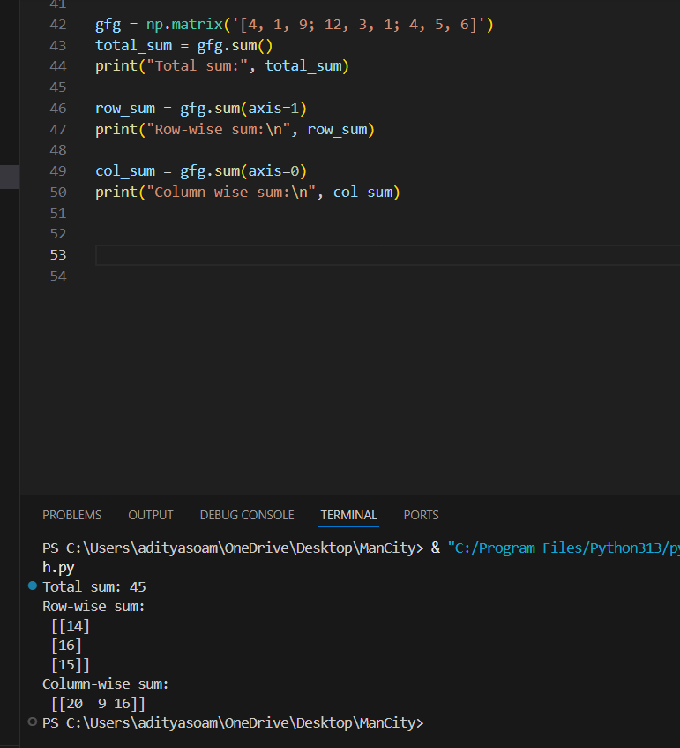

1. For the matrix: n_array = np.array([[55, 25, 15],[30, 44, 2],[11, 45, 77]]), find
   1. Sum of diagonal elements
   2. Eigen values of matrix
   3. Eigen vectors of matrix
   4. Inverse of matrix
   5. Determinant of matrix

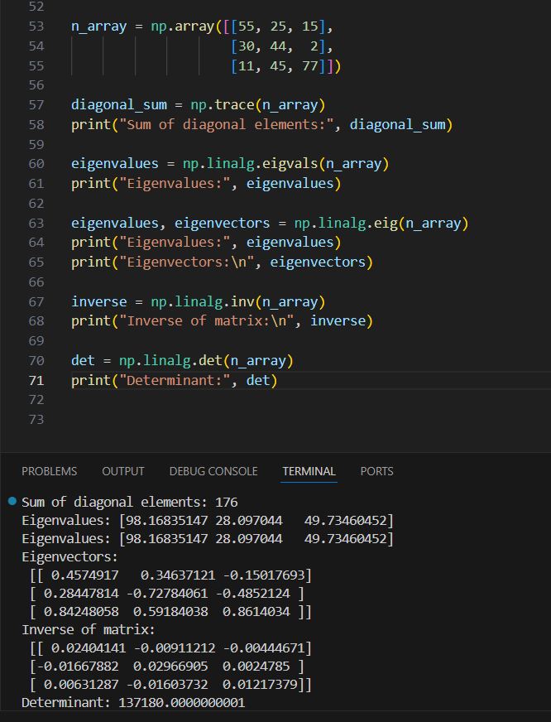

1. Multiply the following matrices and also find covariance between matrices using NumPy: i. p = [[1, 2], [2, 3]] q = [[4, 5], [6, 7]]

ii. p = [[1, 2], [2, 3], [4, 5]] q = [[4, 5, 1], [6, 7, 2]]

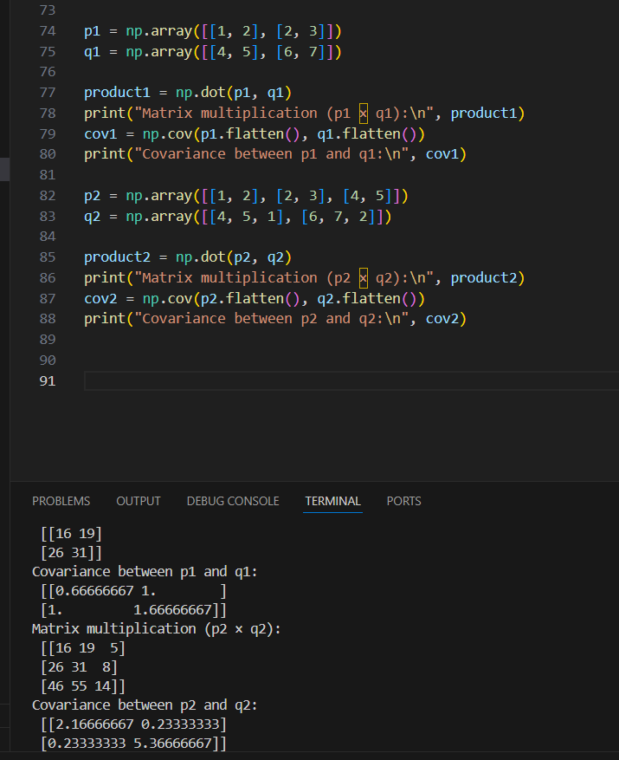

Q2: Based on NumPy Mathematics and Statistics

1. For the array: array = np.array([[1, -2, 3],[-4, 5, -6]])
   1. Find element-wise absolute value
   2. Find the 25th, 50th, and 75th percentile of flattened array, for each column, for each row. iii. Mean, Median and Standard Deviation of flattened array, of each column, and each row

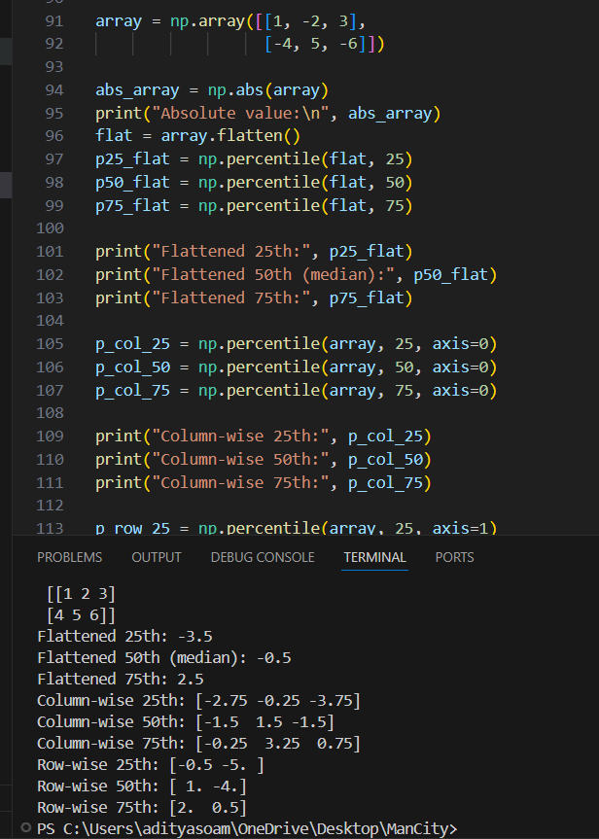

1. For the array: a = np.array([-1.8, -1.6, -0.5, 0.5,1.6, 1.8, 3.0]). Find floor, ceiling and truncated value, rounded values

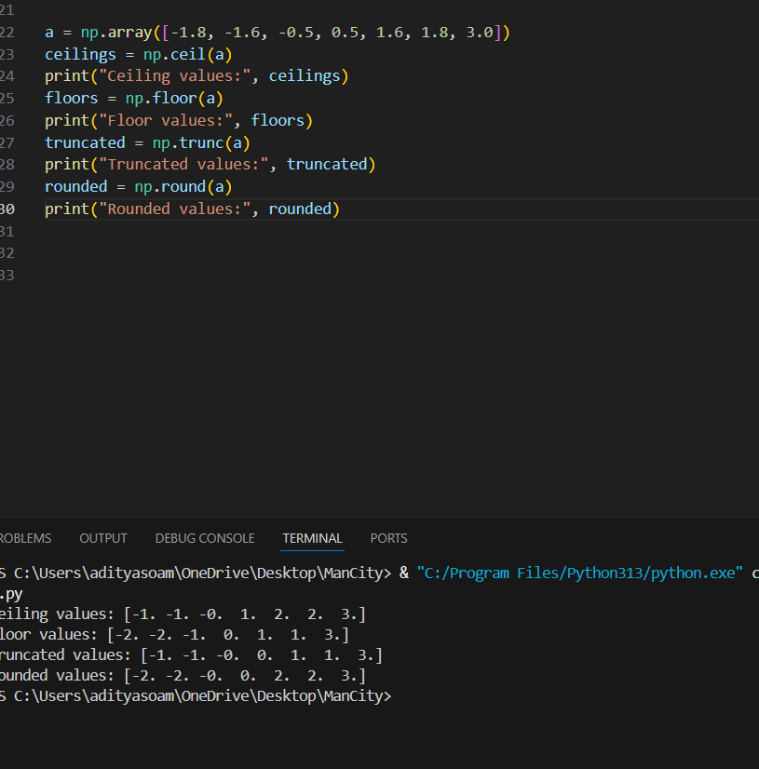

Q3: Based on Searching and Sorting

1. For the array: array = np.array([10, 52, 62, 16, 16, 54, 453]), find
   1. Sorted array
   2. Indices of sorted array
   3. 4 smallest elements
   4. 5 largest elements
2. For the array: array = np.array([1.0, 1.2, 2.2, 2.0, 3.0, 2.0]), find
   1. Integer elements only
   2. Float elements only

