Chemical Bonding Poster Task
Year 9 Science · Materials: Chemical bonding · Summative assessment
Student name
Date given | [date]
Due date | [date]
How to hand in | Paper or model poster: hand to your teacher. Digital poster or recordings: submit on Google Classroom.
Weighting | [__]% of your Science grade
Outcomes | SC5-MAT-01 · SC5-WS-05 · SC5-WS-08

What is this task about?
You will make a poster that shows the three types of chemical bonding: ionic, covalent and metallic.
For each bond type you will show it with a diagram and explain it: what the bond is and what happens to the valence electrons.

What you need to do
- Choose how you will make your poster. See "Choose how you show it" on the next page.
- Choose an example substance for each bond type. Use the list in "What each bond needs".
- Part A: Show it. Make a labelled diagram for each bond type. (9 marks)
- Part B: Explain it. Next to each diagram, explain the bond and what happens to the valence electrons. (6 marks)
- Check your work with the checklist at the end of this booklet.
- Hand in your poster by the due date.

Marks at a glance
Part | What you do | Marks
A: Show it (diagrams) | 3 diagrams × 3 marks | 9
B: Explain it (explanations) | 3 explanations × 2 marks | 6
Total |  | 15

Choose how you show it
You can choose how you make your poster. Every option is marked with the same rubric, so pick the one that best shows what you know. You can mix options, for example a paper poster with recorded explanations.
Part of the task | Your options
Poster format | - Paper poster: A3 paper.  - Digital poster: one A3 page in Canva, PowerPoint or Google Slides.  - Model board: a physical model (e.g. counters, beads, play-dough or a molecular model kit) on a board, photographed and labelled.
Part A: Diagrams | - Draw by hand on paper.  - Draw digitally with shapes or a stylus (Google Drawings, PowerPoint, Canva, a tablet).  - Build a model, photograph it and add labels. Labels can be handwritten, typed or printed.
Part B: Explanations | - Write next to each diagram.  - Type it. You can use speech-to-text (dictation).  - Record an audio or video explanation (up to 1 minute per bond). Add a QR code or link to your poster, or submit it on Google Classroom.  - Explain it live to your teacher. Your teacher will record your answer using the rubric.

Rules for every option
- Your diagrams must be made by you. Do not copy or paste images from the internet.
- Label everything clearly, and use a key if you use symbols (e.g. ● and × for electrons).
- Your teacher may ask you a quick question about your poster to check your understanding.

How to label a diagram
This is an example only: one atom, not a bond. It shows the kind of labels and key your diagrams need.
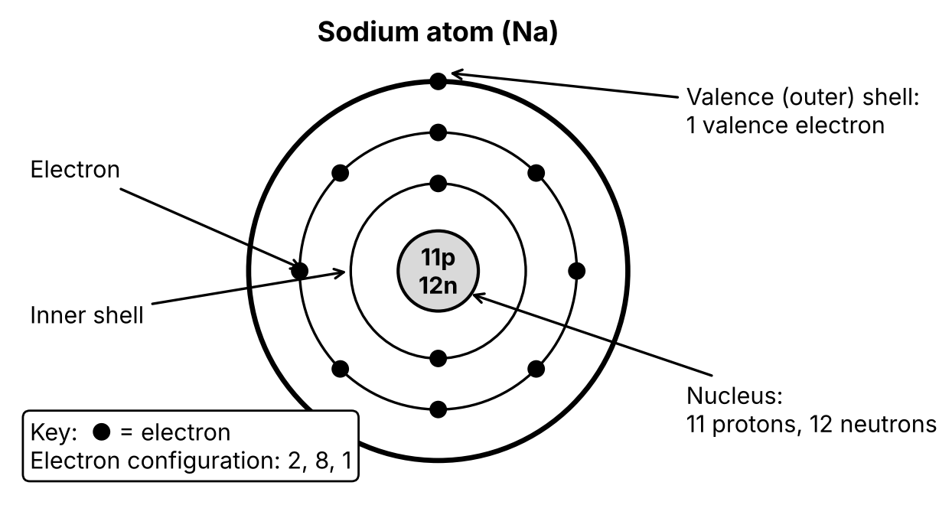

What each bond needs
Use this table to plan. Each row matches the marking rubric.
Bond type | Part A: My diagram shows…  (3 marks) | Part B: My explanation says…  (2 marks) | Examples you could choose
Ionic | - a metal atom and a non-metal atom, with all their electron shells  - an arrow showing valence electron(s) transferred from the metal to the non-metal  - the ions formed, with their charges (e.g. Na⁺, Cl⁻) and full valence shells  - clear labels and a key | - what an ionic bond is  - the metal gives (transfers) valence electrons to the non-metal, forming a positive and a negative ion  - the ions are held together by electrostatic attraction | - sodium chloride (NaCl)  - magnesium oxide (MgO)  - lithium fluoride (LiF)
Covalent | - two non-metal atoms, with all their electron shells  - the shared pair(s) of electrons where the shells overlap  - that each atom now has a full valence shell  - clear labels and a key (e.g. ● electrons from one atom, × from the other) | - what a covalent bond is  - non-metal atoms share pairs of valence electrons, so each atom has a full valence shell | - chlorine (Cl₂)  - hydrogen chloride (HCl)  - water (H₂O)  - methane (CH₄)
Metallic | - many metal ions (cations) in a regular pattern; at least 6  - valence electrons spread out between the ions as a "sea" of delocalised electrons  - clear labels and a key (e.g. metal ion, delocalised electron) | - what a metallic bond is  - metal atoms lose their valence electrons, which become delocalised (free to move) around the metal ions  - the positive ions and the sea of electrons attract each other | - sodium (Na)  - magnesium (Mg)  - aluminium (Al)

Word bank
Use these words in your labels and explanations. You can add notes or the word in your own language.
Word | My notes or my language
atom
ion: cation (+) and anion (−)
metal / non-metal
valence electron
valence (outer) shell
full valence shell
transfer
shared pair
delocalised
electrostatic attraction

Checkpoints
Bring your work to each checkpoint. Your teacher will give you feedback before the due date.
# | What to bring | Date | Teacher check
1 | Your chosen poster format, your 3 example substances and a first draft of one diagram | [date] | ☐
2 | Drafts of all three diagrams | [date] | ☐
3 | Finished poster and explanations (hand in) | [due date] | ☐

Getting help
- Ask your teacher at any time, in class or by message on Google Classroom.
- If you have a learning plan (e.g. an IEP), your adjustments apply to this task: for example extra time, a reader or scribe, or rest breaks.
- This booklet is on OneNote. Use Immersive Reader to have it read aloud or translated.
- If something is making it hard to finish on time, talk to your teacher before the due date.

Before you hand in
Tick each box. Every box links to marks in the rubric.
Bond type | I have…
Ionic | - a metal and a non-metal atom with all shells  - an arrow showing electron transfer  - the ions with charges and full valence shells  - labels and a key  - explained transfer and electrostatic attraction
Covalent | - two non-metal atoms with all shells  - shared pair(s) shown in the overlap  - full valence shells for both atoms  - labels and a key  - explained sharing of valence electrons
Metallic | - at least 6 metal ions in a pattern  - a sea of delocalised electrons between the ions  - labels and a key  - explained delocalised electrons and attraction to the ions
Whole poster | - my name on it  - used my own diagrams (nothing copied from the internet)  - linked or submitted any recordings

Marking rubric
Your work is marked the same way whatever format you choose.

Part A: Show it (diagrams), 9 marks
SC5-MAT-01: describe types of chemical bonds, including ionic, covalent and metallic bonds · SC5-WS-05: selects and uses a range of tools to process and represent data
Bond type | Evidence the marker looks for | 3 marks  Extensive | 2 marks  Sound | 1 mark  Basic | 0 marks  Elementary | Mark
Ionic | - Correct particles: a metal and a non-metal atom, and the ions formed with charges  - Labels and key: clear and correct  - Electron behaviour: transfer of valence electron(s) shown; full valence shells on both ions | All 3 pieces of evidence correct. | 2 pieces correct. e.g. correct atoms and labels, but the transfer is shown in the wrong direction. | 1 piece correct. e.g. correct atoms, but no transfer or ions shown. | None of the evidence shown. | /3
Covalent | - Correct particles: two non-metal atoms  - Labels and key: clear and correct  - Electron behaviour: shared pair(s) in the overlap; full valence shells on both atoms | All 3 pieces of evidence correct. | 2 pieces correct. e.g. correct atoms and labels, but the wrong number of shared electrons. | 1 piece correct. e.g. correct atoms, but no shared pair shown. | None of the evidence shown. | /3
Metallic | - Correct particles: many metal cations in a regular arrangement  - Labels and key: clear and correct  - Electron behaviour: a sea of delocalised valence electrons between and around the cations | All 3 pieces of evidence correct. | 2 pieces correct. e.g. correct ions and labels, but electrons shown attached to single ions. | 1 piece correct. e.g. metal ions drawn, but no delocalised electrons. | None of the evidence shown. | /3
Part A total: /9
Teacher feedback
What went well: | Next step:

Part B: Explain it (explanations), 6 marks
SC5-MAT-01: describe types of chemical bonds · SC5-WS-08: communicates scientific arguments with evidence, using scientific language and terminology in a range of communication forms
Written, typed, recorded and spoken explanations are marked against the same criteria. Spelling and grammar are not assessed; correct use of the scientific terms is.
Bond type | 2 marks: Comprehensive  Accurate definition and explanation using correct scientific terms. Includes: | 1 mark: Sound  Mostly correct, with a minor mistake or a missing part | 0 marks: Elementary | Mark
Ionic | - a metal atom transfers valence electron(s) to a non-metal atom  - this forms a positive ion (cation) and a negative ion (anion)  - the ions are held together by electrostatic attraction | e.g. describes the transfer but not the attraction, or the direction of transfer is wrong. | Incorrect or missing. | /2
Covalent | - two non-metal atoms share pairs of valence electrons  - sharing gives each atom a full valence shell | e.g. says electrons are "given" instead of shared, or does not mention non-metals. | Incorrect or missing. | /2
Metallic | - metal atoms lose their valence electrons, which become delocalised (free to move)  - the delocalised electrons form a "sea" around the positive metal ions (cations), and they attract each other | e.g. mentions a sea of electrons but not the metal cations or the attraction. | Incorrect or missing. | /2
Part B total: /6
Total and grade
A: 12–15 marks | B: 11 marks | C: 9–10 marks | D: 8 marks | E: 0–7 marks
Extensive understanding of chemical bonding and practical skills. | Thorough understanding of chemical bonding and practical skills. | Sound understanding of chemical bonding and practical skills. | Basic understanding of chemical bonding and practical skills. | Elementary understanding of chemical bonding and practical skills.
Total: /15 Grade: ______

