Q. What is Scalability in System Design?
https://www.youtube.com/watch?v=TXJP0gzCXFQ

Scalability:
Ability of system to handle more users/load.
The system should not slow down when traffic increases.

Two types:
- Vertical scaling (increase server power)
- Horizontal scaling (add more servers)
Used to avoid system crash
Important for large applications

Q. Monolith vs Microservices simple explanation?
https://www.youtube.com/watch?v=rv4LlmLmVWk

Q. What is Load Balancer simple explanation?
https://www.youtube.com/watch?v=sCR3SAVdyCc

Load Balancer is used to distribute the user’s requests (Load) among the multiple servers to handle it so that a single server should not be overloaded by upcoming users requests/traffic. So, it enhances the performance of our application.
It distributes the traffic in round robin fashion or randomly on the basis of some algorithm.

Types: Round Robin, Least Connections?
https://www.youtube.com/watch?v=0suOpFXXAj0

Difference between L4 vs L7?
https://www.youtube.com/watch?v=S4GsSTb4hxs&t=209s

L4: Transport layer Load balancer = Network Load balancer
It handles trafiic based on IP addresses and TCP/IP ports. It is used in non HTTP/S traffic for internal network load balancing.

L7: Application layer Load balancer = Application Load balancer
It handles trafiic based on the content of the message. It is used in HTTP/S traffic.

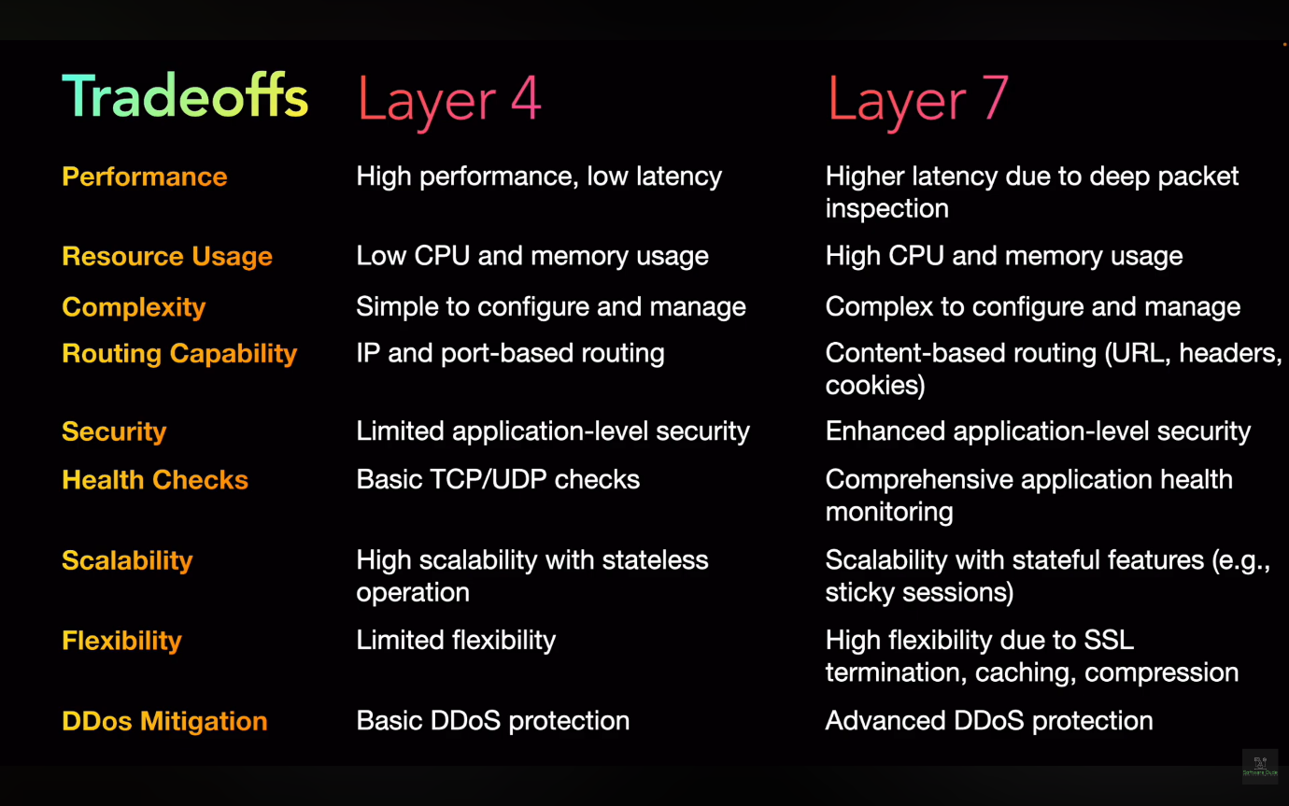

Q. What is Caching in System Design simple explanation?
https://www.youtube.com/watch?v=xBTGln828Ps

Caching (System Design)
- Caching is a technique to store frequently used data temporarily
- It helps reduce latency and improves performance

How it works:
- First request → fetch from DB/server (slow)
- Response stored in cache
- Next requests → served from cache (fast)
- When data updates → cache is invalidated/updated

What can be cached:
- API responses
- Database query results
- Images, HTML, CSS

Types of Cache:
1. In-Memory / Local Cache
- Stored inside application/server memory
- Very fast
- Example: Memcached

2. Distributed Cache
- Shared across multiple servers
- Used in scalable systems
- Example: Redis

When to use:
- Read-heavy systems
- Frequently accessed data
- Mostly static or rarely changing data

CDN (Content Delivery Network):
- Stores static content closer to users geographically
- Reduces latency

Example:
- User in India gets data from India server instead of USA

Caching is a technique to store frequently accessed data temporarily so that future requests can be served faster instead of hitting the database again.

Q. What is Database Indexing simple explanation?
https://www.youtube.com/watch?v=xXtig5uLQS4

“Indexing is a technique used to improve query performance by creating a data structure on specific columns, allowing the database to quickly locate rows instead of scanning the entire table.”

- Indexing is a technique to improve the speed of data retrieval
- It helps avoid full table scan

How it works:
- Without index → database scans each row (slow)
- With index → database uses a data structure (like B-Tree) to find data quickly

Key Points:
- Created on column(s) used in WHERE, JOIN, ORDER BY
- Improves read/query performance
- Uses extra storage

Trade-offs:
- Slows down INSERT, UPDATE, DELETE (because index also needs update)

When to use:
- Large tables
- Read-heavy systems
- Frequently searched columns

When NOT to use:
- Small tables
- Write-heavy systems

Example:
- Searching netWorth = 4000
- Without index → linear scan
- With index → fast lookup using index structure

Types of indexes (just awareness):
- Primary Index
- Secondary Index
- Composite Index

