МІНІСТЕРСТВО ОСВІТИ І НАУКИ УКРАЇНИ

НАЦІОНАЛЬНИЙ ТЕХНІЧНИЙ УНІВЕРСИТЕТ УКРАЇНИ

«КИЇВСЬКИЙ ПОЛІТЕХНІЧНИЙ ІНСТИТУТ»

Веб-орієнтована розробка програмного забезпечення

Лабораторна робота №1. Використання програмних пакетів для розробки HTML-структур.

*Виконав студент гр. ІС-72*

*Фрідріхсон М. А.*

Київ

НТУУ «КПІ»

2018

**Завдання:** Створіть сайт з обраної самостійно тематики.

*Хід виконання:*

1. Створіть п’ять HTML-документів, пов’яжіть їх між собою

посиланнями.

1. Використайте теги DIV, SPAN, P, H1, H2, H3, A, UL, OL, LI, TABLE,

TR, TD для виділення окремих структурних елементів HTML-сторінки.

1. Використайте теги IMG, A, MAP для додавання на HTML-сторінки

зображень, посилань та карт посилань із них.

1. Перегляньте сайт через локальну файлову систему. Викладіть ваш сайт

на Github.

1. Порівняйте способи доступу до HTML-сторінок через локальну

файлову систему і через інтернет. При потребі підкоригуйте роботу

посилань.

**Код документів:**

*index.html:*

<!DOCTYPE html>

<html>

<head>

<title>Lab 1</title>

</head>

<body>

<h1>Animals</h1>

<h3>Select an <span style="color:red">animal</span> you want to know more about</h3>

<ul>

<li>

<a href="lion.html">

<img src="https://upload.wikimedia.org/wikipedia/commons/thumb/7/73/Lion_waiting_in_Namibia.jpg/800px-Lion_waiting_in_Namibia.jpg"/>Lion

</a>

</li>

<li>

<a href="tiger.html">

<img src="https://upload.wikimedia.org/wikipedia/commons/thumb/3/3b/Royal_Bengal_Tiger_at_Kanha_National_Park.jpg/800px-Royal_Bengal_Tiger_at_Kanha_National_Park.jpg"/>Tiger

</a>

</li>

<li>

<a href="zebra.html">

<img src="https://upload.wikimedia.org/wikipedia/commons/thumb/e/e3/Plains_Zebra_Equus_quagga.jpg/800px-Plains_Zebra_Equus_quagga.jpg"/>Zebra

</a>

</li>

<li>

<a href="cheetah.html">

<img src="https://upload.wikimedia.org/wikipedia/commons/thumb/3/36/Cheetah_%28Acinonyx_jubatus%29_female_2.jpg/800px-Cheetah_%28Acinonyx_jubatus%29_female_2.jpg"/>Cheetah

</a>

</li>

</ul>

<h2>Info</h2>

<table>

<tr>

<th>Animal</th>

<th>Habitat</th>

<th>Lifespan</th>

<th>Endangered</th>

</tr>

<tr>

<td>Lion</td>

<td>Africa</td>

<td>10-14 years</td>

<td><span style="color: green">No</span></td>

</tr>

<tr>

<td>Tiger</td>

<td>Asia</td>

<td>20-26 years</td>

<td><span style="color: red">Yes</span></td>

</tr>

<tr>

<td>Zebra</td>

<td>Africa</td>

<td>20-30 years</td>

<td><span style="color: green">No</span></td>

</tr>

<tr>

<td>Cheetah</td>

<td>Africa</td>

<td>10-12 years</td>

<td><span style="color: red">Yes</span></td>

</tr>

</table>

</body>

</html>

*cheetah.html:*

<!DOCTYPE html>

<html>

<head>

<title>Animals</title>

</head>

<body>

<h1>Cheetah</h1>

<p>The <span style="color: red">cheetah</span> is a large cat of the subfamily Felinae that occurs in Southern, North and East Africa, and a few localities in Iran. The species is IUCN Red Listed as vulnerable, as it suffered a substantial decline in its historic range in the 20th century due to habitat loss, poaching, illegal pet trade, and conflict with humans. By 2016, the global cheetah population has been estimated at approximately 7,100 individuals in the wild. Several African countries have taken steps to improve cheetah conservation measures.</p>

<div>

<img src="https://cdn.britannica.com/01/152301-120-9ABF227D.jpg">

</div>

<h2>5 fastest animals on the planet</h2>

<ol>

<li>Marlin</li>

<li>Pronghorn Antelope</li>

<li>Sail Fish</li>

<li style="color:red">Cheetah</li>

<li>Spur-Winged Goose</li>

</ol>

<div>

<p>Choose an animal to read about:</p>

<img src="animal-map.jpg" width=400px usemap="#animal-map"/>

<map name="animal-map">

<area shape="rect" coords="0 0 100 100" href="lion.html">

<area shape="rect" coords="100 0 200 100" href="tiger.html">

<area shape="rect" coords="200 0 300 100" href="zebra.html">

<area shape="rect" coords="300 0 400 100" href="cheetah.html">

</map><br/>

<a href="index.html">Home page</a>

</div>

</body>

</html>

*lion.html:*

<!DOCTYPE html>

<html>

<head>

<title>Animals</title>

</head>

<body>

<h1>Lion</h1>

<p>The <span style="color: red">lion</span> (Panthera leo) is a species in the cat family (Felidae); it is a muscular, deep-chested cat with a short, rounded head, a reduced neck and round ears, and a hairy tuft at the end of its tail. The lion is sexually dimorphic; males are larger than females with a typical weight range of 150 to 250 kg (330 to 550 lb) for the former and 120 to 182 kg (265 to 400 lb) for the latter. Male lions have a prominent mane, which is the most recognisable feature of the species. A lion pride consists of a few adult males, related females and cubs. Groups of female lions typically hunt together, preying mostly on large ungulates. The species is an apex and keystone predator, although they scavenge when opportunities occur. Some lions have been known to hunt humans, although the species typically does not.</p>

<div>

<img src="https://kids.nationalgeographic.com/content/dam/kids/photos/animals/Mammals/H-P/lion-male-roar.adapt.945.1.jpg">

</div>

<div>

<p>Choose an animal to read about:</p>

<img src="animal-map.jpg" width=400px usemap="#animal-map"/>

<map name="animal-map">

<area shape="rect" coords="0 0 100 100" href="lion.html">

<area shape="rect" coords="100 0 200 100" href="tiger.html">

<area shape="rect" coords="200 0 300 100" href="zebra.html">

<area shape="rect" coords="300 0 400 100" href="cheetah.html">

</map><br/>

<a href="index.html">Home page</a>

</div>

</body>

</html>

*tiger.html:*

<!DOCTYPE html>

<html>

<head>

<title>Animals</title>

</head>

<body>

<h1>Tiger</h1>

<p>The <span style="color: red">tiger</span> (Panthera tigris) is the largest cat species, most recognizable for its pattern of dark vertical stripes on reddish-orange fur with a lighter underside. The species is classified in the genus Panthera with the lion, leopard, jaguar and snow leopard. It is an apex predator, primarily preying on ungulates such as deer and bovids. It is territorial and generally a solitary but social predator, often requiring large contiguous areas of habitat that support its prey requirements. This, coupled with the fact that it is indigenous to some of the more densely populated places on Earth, has caused significant conflicts with humans.</p>

<div>

<img src="https://c402277.ssl.cf1.rackcdn.com/photos/907/images/hero_small/sumatran-tiger-hero_92514619.jpg?1345581518">

</div>

<div>

<p>Choose an animal to read about:</p>

<img src="animal-map.jpg" width=400px usemap="#animal-map"/>

<map name="animal-map">

<area shape="rect" coords="0 0 100 100" href="lion.html">

<area shape="rect" coords="100 0 200 100" href="tiger.html">

<area shape="rect" coords="200 0 300 100" href="zebra.html">

<area shape="rect" coords="300 0 400 100" href="cheetah.html">

</map><br/>

<a href="index.html">Home page</a>

</div>

</body>

</html>

*zebra.html:*

<!DOCTYPE html>

<html>

<head>

<title>Animals</title>

</head>

<body>

<h1>Zebra</h1>

<p><span style="color: red">Zebras</span> are several species of African equids (horse family) united by their distinctive black and white striped coats. Their stripes come in different patterns, unique to each individual. They are generally social animals that live in small harems to large herds. Unlike their closest relatives, horses and donkeys, zebras have never been truly domesticated.</p>

<div>

<img src="https://animals.sandiegozoo.org/sites/default/files/2016-08/hero_zebra_animals.jpg">

</div>

<div>

<p>Choose an animal to read about:</p>

<img src="animal-map.jpg" width=400px usemap="#animal-map"/>

<map name="animal-map">

<area shape="rect" coords="0 0 100 100" href="lion.html">

<area shape="rect" coords="100 0 200 100" href="tiger.html">

<area shape="rect" coords="200 0 300 100" href="zebra.html">

<area shape="rect" coords="300 0 400 100" href="cheetah.html">

</map><br/>

<a href="index.html">Home page</a>

</div>

</body>

</html>

**Скріншоти результатів роботи:**

*index.html:*

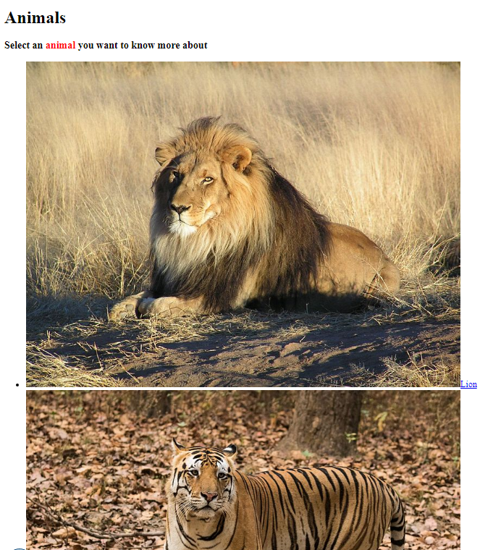

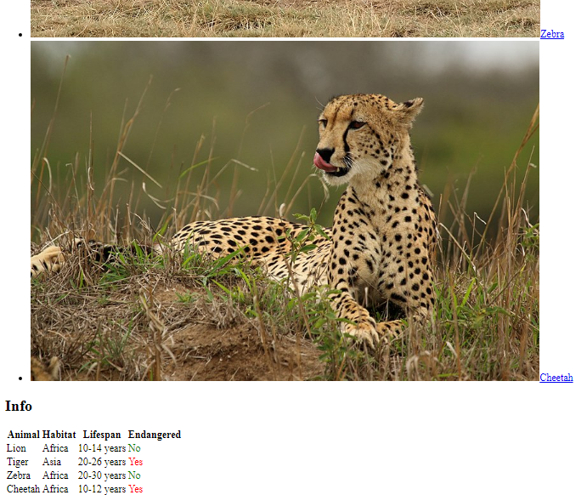

*cheetah.html:*

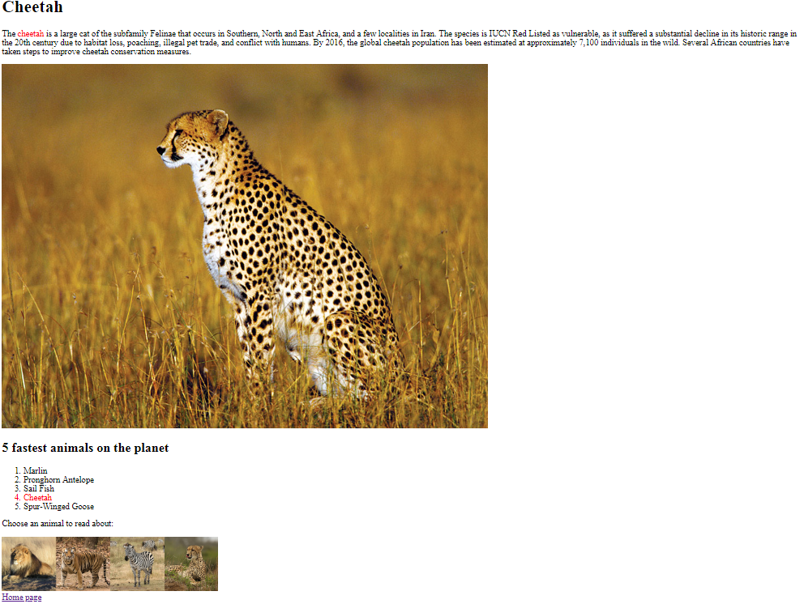

*lion.html:*

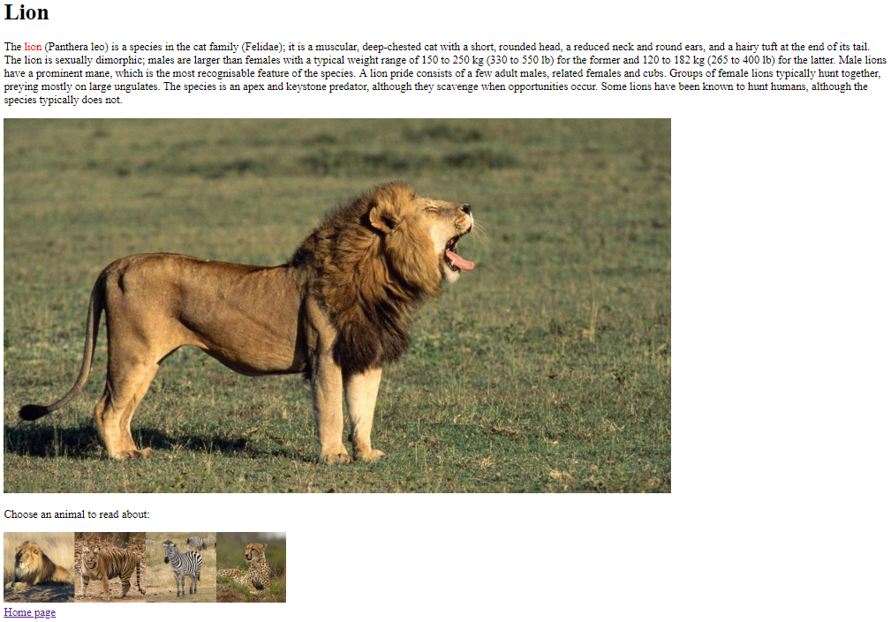

*tiger.html:*

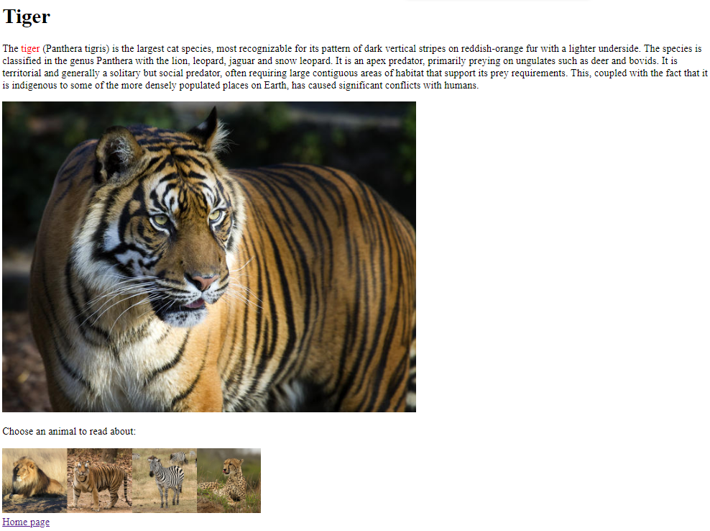

*zebra.html*

