WHERE Restricting Sorting



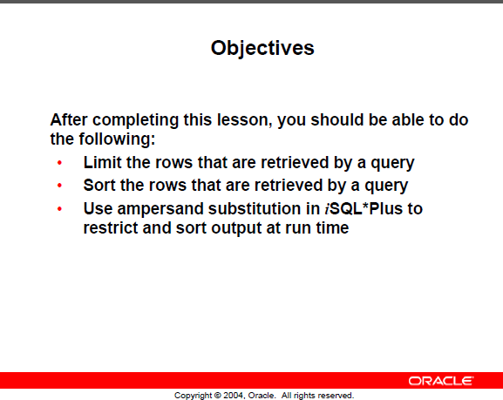

Limiting rows --- WHERE

Here are 7 of the 20 employees in the EMPLOYEE table

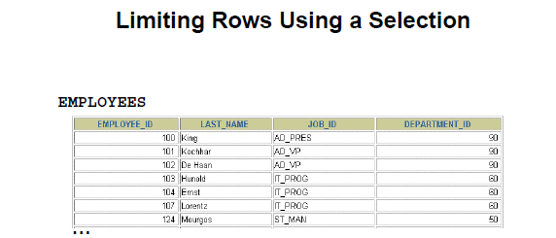

**PROBLEM: 🡺 Show those in department 90 only**

Result should be

|  |  |  |  |
| --- | --- | --- | --- |
| **EMPLOYEE_ID** | **LAST_NAME** | **FIRST_NAME** | **DEPARTMENT_ID** |
| 100 | King | Steven | 90 |
| 101 | Kochhar | Neena | 90 |
| 102 | De Haan | Lex | 90 |

General Format of WHERE

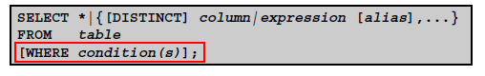

WHERE 🡺 follows the FROM

Solving the problem.

**PROBLEM: 🡺 Show those in department 90 only**

**SELECT employee_id, last_name, job_id, department_id**

**FROM employees**

**WHERE department_id = 90;**

**Another style when there list is harder to read**

**SELECT employee_id,**

**last_name,**

**job_id,**

**department_id**

**FROM employees**

**WHERE department_id = 90;**

WHERE with Character strings and Dates





**SELECT last_name, job_id, department_id**

**FROM employees**

**WHERE last_name = ‘Whalen’; 🡸 single quotes – exact case**

|  |  |  |
| --- | --- | --- |
| **LAST_NAME** | **JOB_ID** | **DEPARTMENT_ID** |
| Whalen | AD_ASST | 10 |

WHERE clause

**Compares** – values in a column,

Literal

Arithmetic expressions

Functions (more later)

Date format can be

1 customized – later chapter

2 Default changed

**NEEDS** 1 Column name

2 Comparison condition

3 Column Name, constant or list of values

**Date Sample**

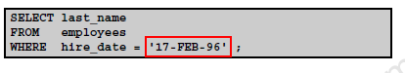

'2016/01/31'🡸in ibm db2

Comparison Operators and Conditions

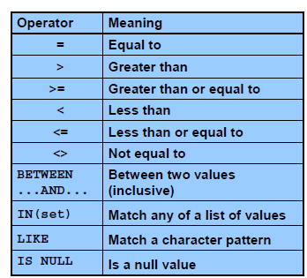

NOTE:🡺 != and ^= can also represent not equal

Samples:

**Salary less than 3000 or a salary equal to 3000**

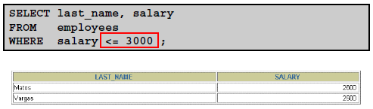

**BETWEEN**

**RANGE of SALARIES 🡺 BETWEEN**

The values are INCLUSIVE of the start and end value limits



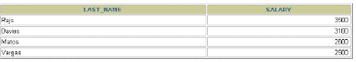

**RANGE of Character values such as name**

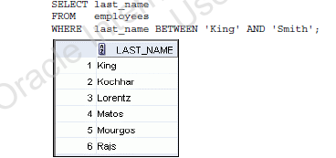

**IN**

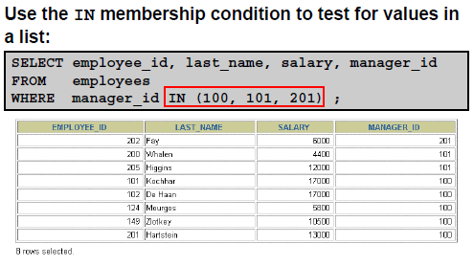

Show rows that match on any manager ID that are in the list shown.

Later with subqueries this becomes more useful

**PROBLEM: You don’t know the exact spelling of a name**

**OR**

**You are seeking a search condition**

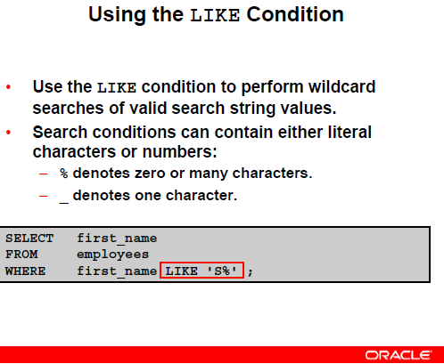

WILD CARD values

**Sample with a year**



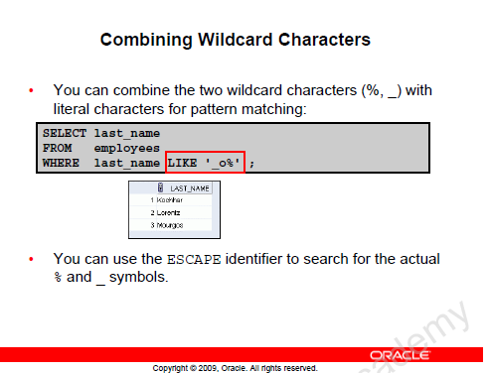

**Looking for job IDs that have a underscore in the name.**

**Helps find an EXACT match**

**SELECT last_name, job_id**

**FROM employees**

**WHERE job_id LIKE ‘%SA\_%’ ESCAPE ‘\’**

**Defined the \ as an escape identifier**

**Means looking for 1 anything or nothing in front**

**2 SA followed by _ the underscore**

**3 Followed by anything or nothing**

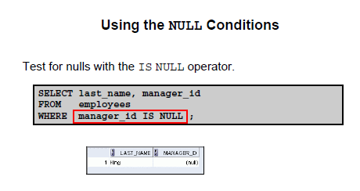

**You cannot be equal to a non-existent value**

**MUST use IS**

**Try a SELECT for those who do not have a commission_pct value**

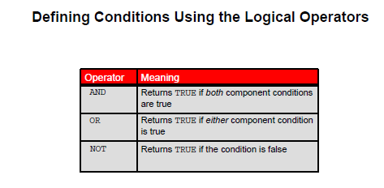

**EXAMPLES:**

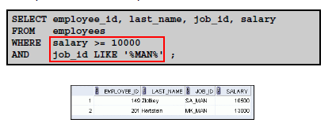

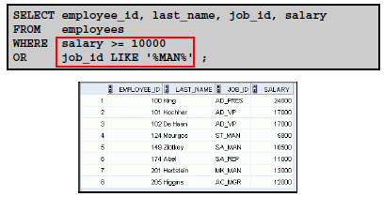

**More complicated example:**

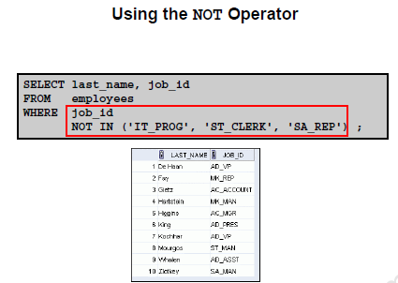

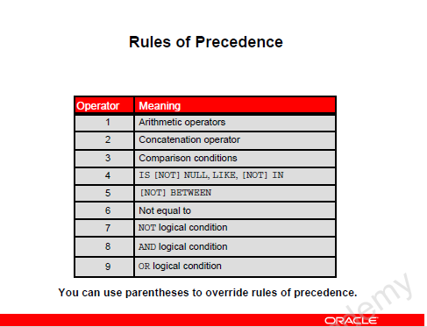

**EXAMPLE:**

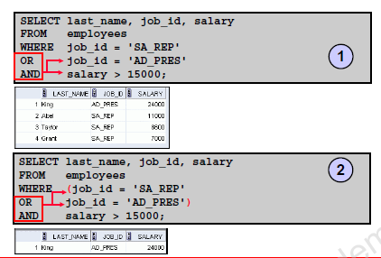

By adding the bracketing, it changes the resulting output.

Should use bracketing often

Asks for AD_PRES and a salary above 15,000

OR

A job_id of SA_REP

**SORTING**

**PROBLEM: List all employees in order of their department ID**

**SELECT \***

**FROM employees**

**ORDER BY department_id;**

**ORDER BY 🡸 is the LAST statement always**

**Another:**

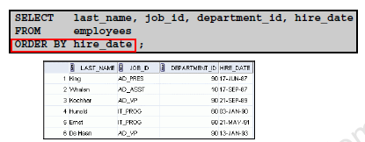

**Sorting Descending order**

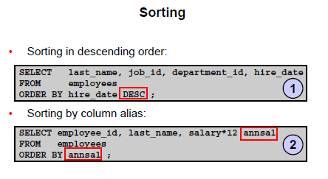

**DEFAULT is ASC**

**You can use it but most don’t bother**

**2 You can sort on a column that is not being displayed**

**SELECT employee_name**

**FROM employees**

**ORDER BY department_id;**

**NOTE: You can order by with an alias**

**ANOTHER SORTING EXAMPLE**

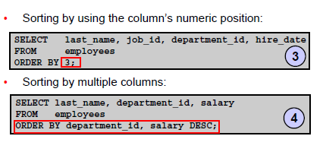

3 Specifies the numeric position in the SELECT🡪 - in this case the 3rd column or department_id

4 Shows sorting on two different fields in different directions

By default the department_id is sorted lowest value to highest (ASC)

The salary is sorted WITHIN each department in DESC order (highest to lowest)