Assignment 3 (7%)

Total : 60 marks.

Please work in **groups** of max 3 and min 2 to complete this Assignment. This Assignment is worth 7% of the total course grade and will be evaluated through your written submission, as well as the Assignment demo in the class worth 3%. During the Assignment demo, group members are randomly selected to present the answers to each of the lab questions. Group members not present during the Assignment demo will lose the demo mark. Individual submission will have penalty of 10%.

1. Add this declaration on the top of your file.

We, ------------(mention your names), declare that the attached assignment is our own work in accordance with the Seneca Academic Policy. No part of this assignment has been copied manually or electronically from any other source (including web sites) **or distributed to other students.**

1. Specify what each member has done towards the completion of this work:

|  |  |  |
| --- | --- | --- |
|  | Name | Task(s) |
| 1 | ABIODUN OKE |  |
| 2 | SERGES DAMBOU |  |
| 3 | ADITI PATEL |  |
| 4 |  |  |

Solve the following using tables provided for labs like employees, departments, etc. Copy the commands under each question and also the screen shots of the result. For instance, if you create a view the result will be view is created. Take the screen shot and copy under the command. One member in the group upload the document on BlackBoard.

1. Display department number, department name, and the number of employees working in each department that has the highest number of employees. Use subquery only. (5 marks)

**ANSWER:**

**SELECT D.DEPARTMENT_ID, D.DEPARTMENT_NAME, COUNT(E.EMPLOYEE_ID)**

**FROM DEPARTMENTS D JOIN EMPLOYEES E**

**ON D.DEPARTMENT_ID = E.DEPARTMENT_ID**

**GROUP BY D.DEPARTMENT_ID, D.DEPARTMENT_NAME**

**HAVING COUNT(E.EMPLOYEE_ID)= (SELECT MAX( COUNT(E1.EMPLOYEE_ID))**

**FROM EMPLOYEES E1**

**GROUP BY DEPARTMENT_ID);**

**OUTPUT:**

**DEPARTMENT_ID DEPARTMENT_NAME COUNT(E.EMPLOYEE_ID)**

**------------- ------------------------------ ---------------------------------------**

**50 Shipping 5**

1. Display all the employees who were hired on the day of the week on which the highest number of employees were hired. List the first name and last name columns together with a space in between. Label the column as Full Name and label day as day of the week. Use subquery only. (5 marks)

**ANSWER:**

**SELECT FIRST_NAME||''||LAST_NAME as "Full Name",to_char(hire_date,'Day') Day**

**FROM EMPLOYEES**

**WHERE to_char(hire_date,'Day') = (SELECT to_char(hire_date,'Day')**

**FROM EMPLOYEES**

**GROUP BY to_char(hire_date,'Day')**

**HAVING COUNT(*)=(SELECT MAX(COUNT(*))**

**FROM EMPLOYEES**

**GROUP BY to_char(hire_date,'Day')));**

**OUTPUT:**

**Full Name DAY**

**--------------------------------------------- ---------**

**BruceErnst Tuesday**

**KevinMourgos Tuesday**

**TrennaRajs Tuesday**

**JonathonTaylor Tuesday**

**ShelleyHiggins Tuesday**

**WilliamGietz Tuesday**

**6 rows selected**

1. Department 50 needs access to its employee data. Create a view named DEPT50 that contains the employee nuOmbers, employee last names, and department numbers for all employees in department 50. They have requested that you label the view columns EMPNO, EMPLOYEE, and DEPTNO. For security purposes, do not allow an employee to be reassigned to another department through the view. (5 marks)

**ANSWER:**

**CREATE VIEW DEPT50 AS**

**(SELECT EMPLOYEE_ID "EMPNO", LAST_NAME "EMPLOYEE", DEPARTMENT_ID "DEPTNO"**

**FROM EMPLOYEES**

**WHERE DEPARTMENT_ID = 50)**

**WITH CHECK OPTION CONSTRAINT EMP_DEPT_50;**

**OUTPUT:**

**EMPNO EMPLOYEE DEPTNO**

**---------- ------------------------- ----------**

**124 Mourgos 50**

**141 Rajs 50**

**142 Davies 50**

**143 Matos 50**

**144 Vargas 50**

1. Create a view named emp_hired that has the names and hire dates for all employees who were hired before their managers, along with their manager’s names and hire dates. Label the columns Employee, Emp Hired, Manager, and Mgr Hired, respectively. (5 marks)

**ANSWER:**

**CREATE VIEW EMP_HIRED AS**

**(SELECT E.FIRST_NAME||' '||E.LAST_NAME "Emloyee", E.HIRE_DATE "Emp Hired",**

**M.MANAGER_ID "Manager", M.HIRE_DATE "Mgr Hired"**

**FROM EMPLOYEES E INNER JOIN EMPLOYEES M**

**ON E.MANAGER_ID = M.EMPLOYEE_ID**

**WHERE E.HIRE_DATE < M.HIRE_DATE**

**);**

**View EMP_HIRED created.**

**OUTPUT:**

**Emloyee Emp Hired Manager Mgr Hired**

**---------------------------------------------- --------- ---------- ---------**

**Jennifer Whalen 87-09-17 100 89-09-21**

**Alexander Hunold 90-01-03 100 93-01-13**

**Trenna Rajs 95-10-17 100 99-11-16**

**Curtis Davies 97-01-29 100 99-11-16**

**Randall Matos 98-03-15 100 99-11-16**

**Peter Vargas 98-07-09 100 99-11-16**

**Ellen Abel 96-05-11 100 00-01-29**

**Jonathon Taylor 98-03-24 100 00-01-29**

**Kimberely Grant 99-05-24 100 00-01-29**

**9 rows selected**

1. The Date base Administrator needs you to create a table, which has a primary key constraint, but she wants to name the index to have a different name than the constraint. Create the Locations_Index table based on the following table instance chart. Name the index for the PRIMARY KEY column as LOCATIONS_PK_IDX. (5 marks)

|  |  |  |
| --- | --- | --- |
| Column Name | Deptno | Dname |
| Primary key | Yes |  |
| Data Type | Number | VARCHAR2 |
| Length | 4 | 30 |

**ANSWER:**

**CREATE TABLE DEPT60 (**

**Deptno NUMBER(4) CONSTRAINT DEPT_ID_NO NOT NULL,**

**Dname VARCHAR2(30)**

**);**

**Table DEPT60 created.**

**CREATE INDEX LOCATION_PK_IDX ON DEPT60 (Deptno);**

**ALTER TABLE DEPT60**

**ADD CONSTRAINT LOCATION_PK_IDX PRIMARY KEY (Deptno);**

**Table DEPT60 altered**.

**OUTPUT:**

1. Create a report of a list of employees who are up for review in March; so you are requested to do the following: (5 marks)

Write a query to display the last names, month of the date of hire, and hire date of those employees who have been hired in the month of March, irrespective of the year of hire.

**ANSWER:**

**SELECT FIRST_NAME||' '||LAST_NAME, TO_CHAR(HIRE_DATE, 'MONTH'), HIRE_DATE**

**FROM EMPLOYEES**

**WHERE TO_CHAR(HIRE_DATE, 'FMMONTH') = 'MARCH';**

**OUTPUT:**

**FIRST_NAME||''||LAST_NAME TO_CHAR(H HIRE_DATE**

**---------------------------------------------- --------- ---------**

**Randall Matos MARCH 98-03-15**

**Jonathon Taylor MARCH 98-03-24**

1. The Accounting department requires an analysis on maximum and minimum salaries by job, manager, and department. They have asked you to do the following: (5 marks)

Write a query to display the following groupings:

Department_id, job_id

Job_id, manager_id

**ANSWER:**

**SELECT DEPARTMENT_ID, JOB_ID, MANAGER_ID, MAX(SALARY), MIN(SALARY)**

**FROM EMPLOYEES**

**GROUP BY**

**GROUPING SETS**

**( (DEPARTMENT_ID, JOB_ID),**

**(JOB_ID, MANAGER_ID)**

**);**

**OUTPUT:**

**DEPARTMENT_ID JOB_ID MANAGER_ID MAX(SALARY) MIN(SALARY)**

**------------- ---------- ---------- --------------------------------------- ---------------------------------------**

**AC_MGR 101 12000 12000**

**ST_MAN 100 5800 5800**

**MK_MAN 100 13000 13000**

**AD_PRES 24000 24000**

**AD_ASST 101 4400 4400**

**IT_PROG 102 9000 9000**

**IT_PROG 103 6000 4200**

**AC_ACCOUNT 205 8300 8300**

**AD_VP 100 17000 17000**

**ST_CLERK 124 3500 2500**

**SA_REP 149 11000 7000**

**SA_MAN 100 10500 10500**

**MK_REP 201 6000 6000**

**110 AC_ACCOUNT 8300 8300**

**90 AD_VP 17000 17000**

**50 ST_CLERK 3500 2500**

**80 SA_REP 11000 8600**

**50 ST_MAN 5800 5800**

**80 SA_MAN 10500 10500**

**110 AC_MGR 12000 12000**

**90 AD_PRES 24000 24000**

**60 IT_PROG 9000 4200**

**20 MK_MAN 13000 13000**

**SA_REP 7000 7000**

**10 AD_ASST 4400 4400**

**20 MK_REP 6000 6000**

**26 rows selected**

1. Create the EMP table based on the structure of the EMPLOYEES table. Include only the EMPLOYEE_ID, FIRST_NAME, LAST_NAME, SALARY, and JOB_ID columns for departments 90,80,60, and 50. Name the columns in your new table NO, FIRST_NAME, LAST_NAME, SALARY, and JOB_TITLE, respectively. (5 marks)

**ANSWER:**

**CREATE TABLE EMP AS**

**(SELECT EMPLOYEE_ID "NO", FIRST_NAME, LAST_NAME, SALARY, JOB_ID "JOB_TITLE"**

**FROM EMPLOYEES**

**WHERE DEPARTMENT_ID IN (90, 80, 60, 50));**

**OUTPUT:**

**NO FIRST_NAME LAST_NAME SALARY JOB_TITLE**

**---------- -------------------- ------------------------- ---------- ----------**

**124 Kevin Mourgos 5800 ST_MAN**

**141 Trenna Rajs 3500 ST_CLERK**

**142 Curtis Davies 3100 ST_CLERK**

**143 Randall Matos 2600 ST_CLERK**

**144 Peter Vargas 2500 ST_CLERK**

**103 Alexander Hunold 9000 IT_PROG**

**104 Bruce Ernst 6000 IT_PROG**

**107 Diana Lorentz 4200 IT_PROG**

**149 Eleni Zlotkey 10500 SA_MAN**

**174 Ellen Abel 11000 SA_REP**

**176 Jonathon Taylor 8600 SA_REP**

**100 Steven King 24000 AD_PRES**

**101 Neena Kochhar 17000 AD_VP**

**102 Lex De Haan 17000 AD_VP**

1. (15 marks)

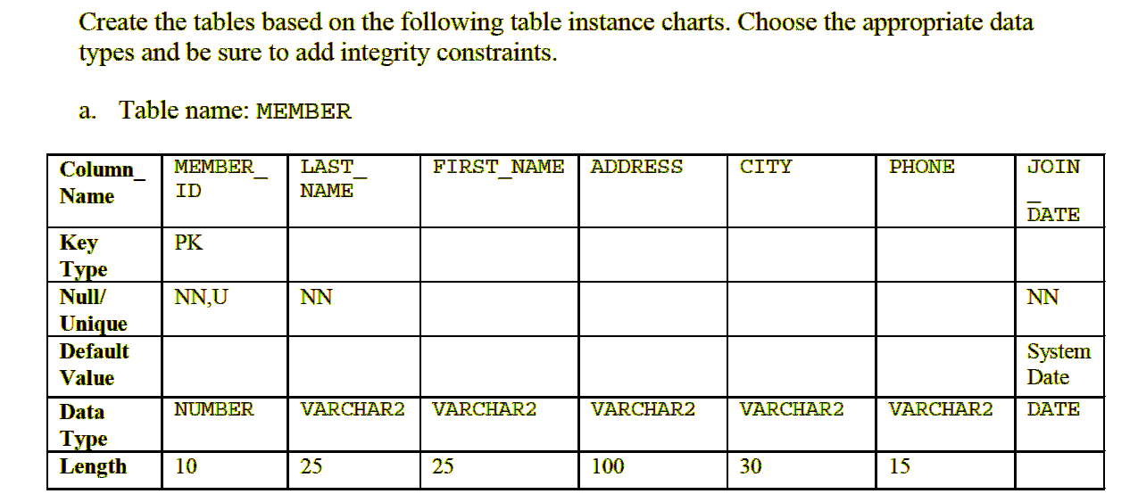

**ANSWER:**

**CREATE TABLE MEMBER (**

**MEMBER_ID NUMBER(10) NOT NULL PRIMARY KEY,**

**LAST_NAME VARCHAR2(25) NOT NULL,**

**FIRST_NAME VARCHAR2(25),**

**ADDRESS VARCHAR2(100),**

**CITY VARCHAR2(30),**

**PHONE VARCHAR2(15),**

**JOIN_DATE DATE DEFAULT (SYSDATE) NOT NULL );**

**OUTPUT:**

**Name Null Type**

**---------- -------- -------------**

**MEMBER_ID NOT NULL NUMBER(10)**

**LAST_NAME NOT NULL VARCHAR2(25)**

**FIRST_NAME VARCHAR2(25)**

**ADDRESS VARCHAR2(100)**

**CITY VARCHAR2(30)**

**PHONE VARCHAR2(15)**

**JOIN_DATE NOT NULL DATE**

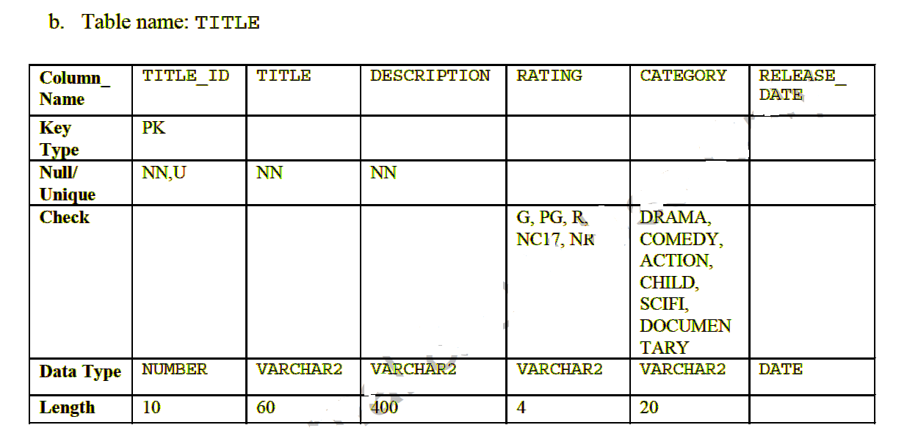

**ANSWER:**

**CREATE TABLE TITLE**

**(**

**TITLE_ID NUMBER(10) NOT NULL PRIMARY KEY,**

**TITLE VARCHAR2(60) NOT NULL ,**

**DESCRIPTION VARCHAR2(100) NOT NULL ,**

**RATING VARCHAR2(4) CONSTRAINT RATING_CK CHECK(RATING IN('G','PG','R','NC17','NR')),**

**CATEGORY VARCHAR2(20) CONSTRAINT CATEG_CK CHECK (CATEGORY IN ('DRAMA',**

**'COMEDY','ACTION','CHILD','SCIFI','DOCUMENTARY')),**

**RELEASE_DATE DATE);**

**Table TITLE created.**

**OUTPUT:**

**Name Null Type**

**------------ -------- -------------**

**TITLE_ID NOT NULL NUMBER(10)**

**TITLE NOT NULL VARCHAR2(60)**

**DESCRIPTION NOT NULL VARCHAR2(100)**

**RATING VARCHAR2(4)**

**CATEGORY VARCHAR2(20)**

**RELEASE_DATE DATE**

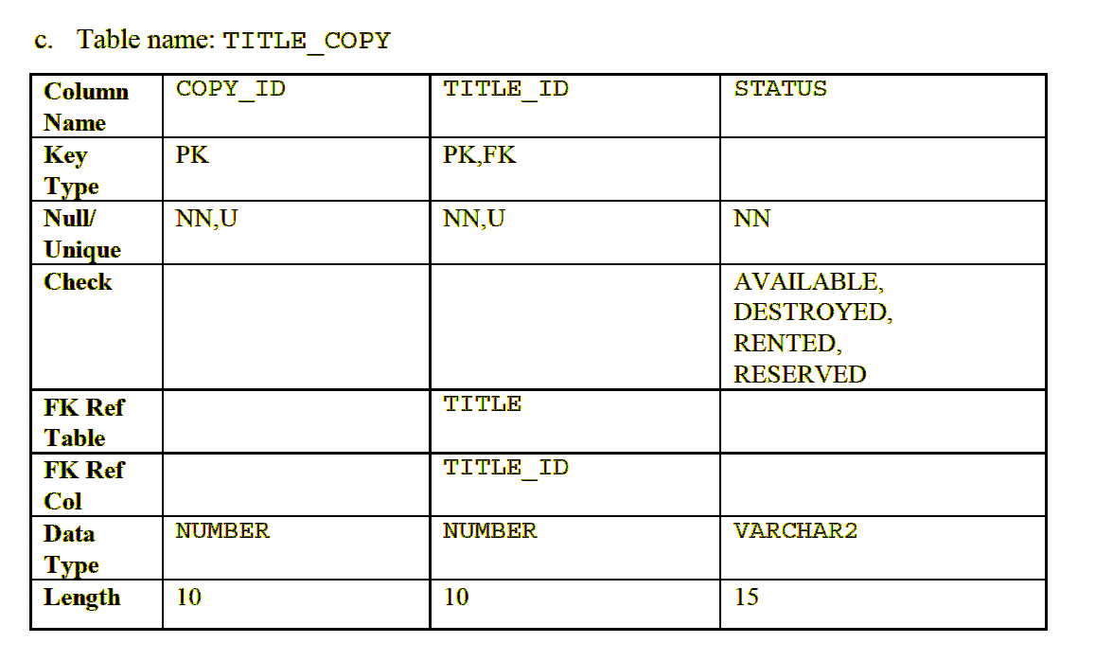

**ANSWER:**

**CREATE TABLE TITLE_COPY (**

**COPY_ID NUMBER(10) NOT NULL,**

**TITLE_ID NUMBER(10) NOT NULL UNIQUE CONSTRAINT TITLE_ID_FK REFERENCES TITLE(TITLE_ID),**

**STATUS VARCHAR2(15) NOT NULL CONSTRAINT STATUS_CK CHECK(STATUS IN ('AVAILABLE', 'DESTROYED', 'RENTED', 'RESERVED')),**

**PRIMARY KEY (COPY_ID, TITLE_ID)**

**);**

**Table TITLE_COPY created.**

**OUTPUT:**

1. **Name Null Type**
2. **-------- -------- ------------**
3. **COPY_ID NOT NULL NUMBER(10)**
4. **TITLE_ID NOT NULL NUMBER(10)**
5. **STATUS NOT NULL VARCHAR2(15)**
6. (5 marks)

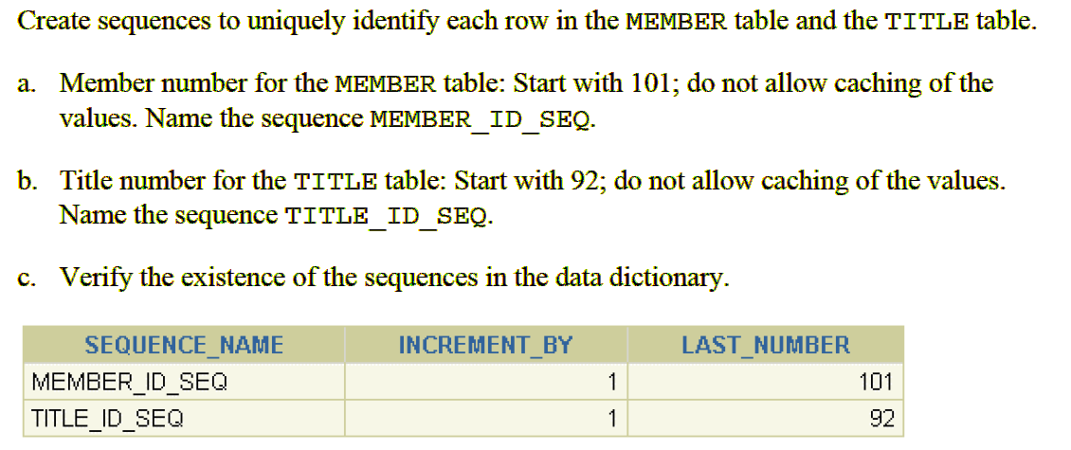

ANSWER:

A.

**CREATE SEQUENCE MEMBER_ID_SEQ**

**INCREMENT BY 1**

**START WITH 101**

**MAXVALUE 9999**

**NOCACHE**

**NOCYCLE;B.**

B.

**CREATE SEQUENCE TITLE_ID_SEQ**

**INCREMENT BY 1**

**START WITH 92**

**MAXVALUE 9999**

**NOCACHE**

**NOCYCLE;;**

C.

**SELECT SEQUENCE_NAME, INCREMENT_BY, LAST_NUMBER**

**FROM user_sequences**

**WHERE sequence_name IN ('MEMBER_ID_SEQ', 'TITLE_ID_SEQ');**

**OUTPUT:**

**SEQUENCE_NAME INCREMENT_BY LAST_NUMBER**

**--------------------------------- ------------------------------ --------------------------**

**MEMBER_ID_SEQ 1 101**

**TITLE_ID_SEQ 1 92**