Name : Asoke Rathnayake

Email : [asokerathnayake@gmail.com](mailto:asokerathnayake@gmail.com) / asoke.rathnayake@dialog.lk

GIThub Link :

<https://github.com/asokerathnayake/CGPT>

Notebook name :

Asoke_Rathnayake_ChatGPT_Project_Final.ipynb

**What is your Project Title?**  
Travel Attraction Q & A Companion in Sinhala

**What is the natural language problem you were trying to solve?**

The user can ask questions on Points of interest and attractions, places to visit in cities and countries in English and the response will be returned in Sinhala. Because when we search via the web it does not provide a specific clear answer most of the search results will be in English or translated content will not be meaningful as well.

**Provide the NLP task type(s) of your problem that can be classified.**

Q&A + Translation.

Question and answer with Translation.

**Briefly Mention the Solution Approach.**

Allow users to input the travel, attraction and point of interest-related questions with cities and countries in the English language. And also added a system prompt specifying travel-related terms to narrow and more subject-specific prompts. Then it will help to clear quality-specific answers. I’ve limited the number of token use, Then I’ve translate the answer to Sinhala translation API (Lingvanex).

**The reason to allow English input** : most of the users can type some of the simple questions in English, but sometimes the response/answer will be a bit complex to understand.

**How this technically works**: user can ask any questions in English and the response will be sent to the English-to-Sinhala translation service lingvanex via API call and returns the Sinhala-translated answer to users with an English answer.

**The reason for using lingvanex translation service**: As per my experience OpenAI Sinhala translation isn’t meaningful enough to understand. But lingvanex Sinhala translation is more meaningful and clear. It’s almost accurate and meaningful than Google Sinhala translation as well. They are having good LLM and they have a offline enterprise translation service as well. Ans also lingvanex is much cheaper than comparing with Google.

**What is the system prompt you to provide to the language model?**

You are an AI Traveling attractions Expert. Your goal is to provide clever descriptive answers about the travel-related details, points of interest around and attractions in that location.\n"

**Sample Screen.**

I’ve developed the application in Node-Red and attaching a screenshot. However, I’ve added the same code in Python notebooks as well.

Flow

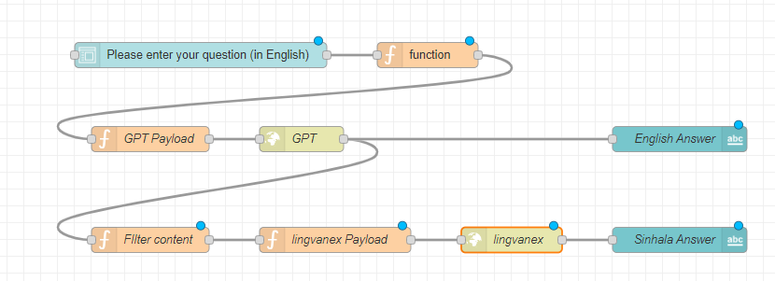

App Screen

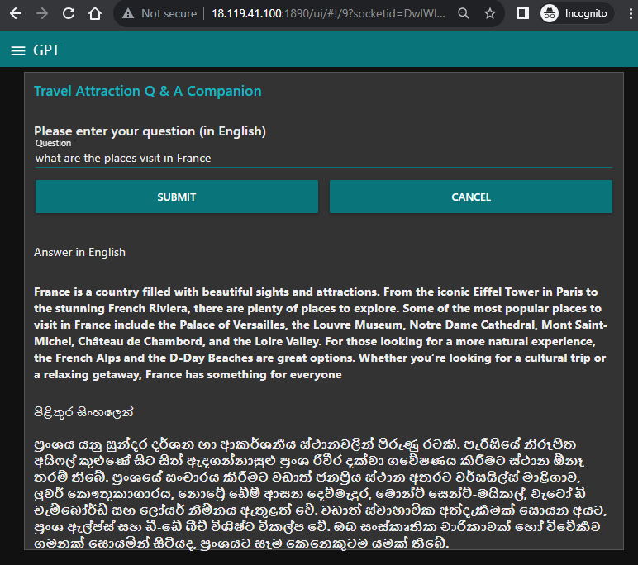

**Future Improvement**: Allow users to input the question in Sinhala.