Online Ticketing System

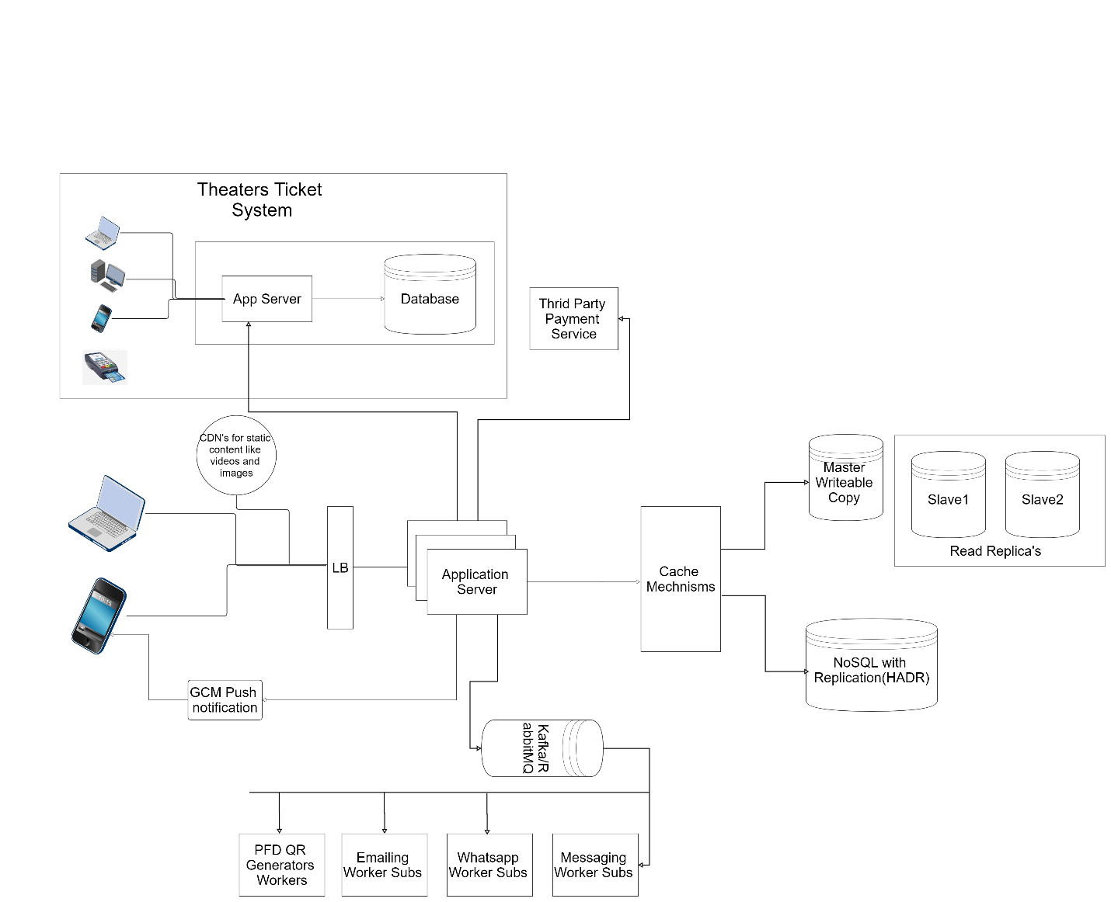

Non-functional requirements to implement:

• Flow charts connecting core systems and theatres’ IT systems

• Data modelling diagrams

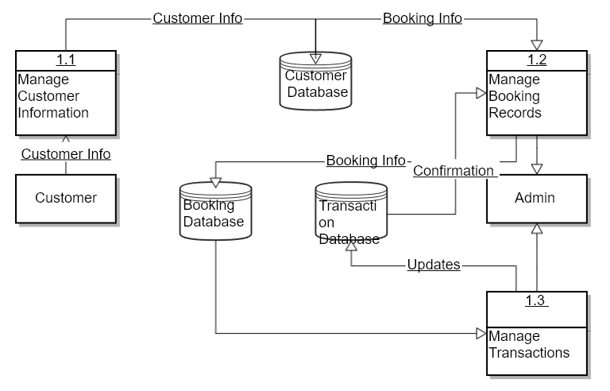

• How to handle transactions for a show with limited availability of seats against a high volume of

booking requests?

How would you design the architecture for this landscape that achieves the following most

optimally?

o Seats’ inventories are flowing from theatres to the booking platform.

o Bookings flowing to physical theatres’ IT system.

o Theatres scale the seat&#39;s capacity with minimal downtime.

o Integrate with numerous theatres with no control over their IT landscape

o Design a booking cancellation system and update theatres seat inventory in real-time.

o Enable continuous improvement of platform and business without impacting existing

ones.

o Enabling future omnichannel use cases and prepare to onboard thousands of theatres

• Which technologies will you choose for which scenarios?

o Your technologies selection should be around booking platform and integration with

thousands of theatres.

o What databases will you choose and why?

• How will you scale to multiple cities, countries and guarantee platform availability of 99.99%?

o Structure it around incrementally rolling out the platform and choice of cloud

technologies to handle the scale and simplicity.

o What cloud technologies will you choose to handle failover and provide resiliency

• What are the security measures you will implement?

o How will you avoid fraud bookings?

o How will you integrate securely with the payment gateway?

• What are the monitoring technologies you will implement?

o How will you ensure the availability of systems using monitoring tools

o What alerts will you be implementing?

o What monitoring KPIs do you recommend for the booking platforms and integration

components?