DTC Data Preparation
Direct to Customer is a functionality where the supplier delivers the items direct to end customer where there is no involvement of stock management by WMS/Store. But stock updates along with customer order details are updated in Merchandising system.
Data for DTC functionality is prepared like RTLOG files, and these DTC files are prepared whenever any data refresh happens in VPT environment.
Below are the steps to be followed to prepare DTC files.
- Historical (roughly for a period of 15 days to 1 month) Production cut files to be requested from Gustavo.Queiroz@asos.com / Elias.Souza@asos.com / Juliano.Mazzetto@asos.com
- Unzip the folder and save all DTC_*.dat.done files in local machine.
NOTE: * in the file name is the datetimestamp of the files generated.
- Connect VPT RMS host through WINSCP following below steps.
  - Open WINSCP application.
  - Click on New Site
  - In File Protocol select SFTP
  - In ‘Host Name’ field enter RMS host ID (10.98.101.47)
  - Enter Port number as 22
  - Enter username and password
  - Click on Login Button.
  - Click on Continue button
  - In the next pop-up window click on YES button.
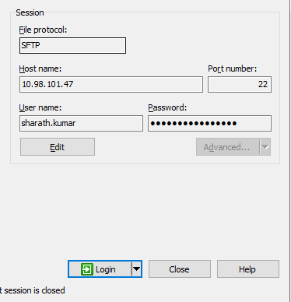

- Create a Directory in home directory
- In the left panel open the local machine path where DTC files are saved
- Move files from local machine to RMS newly created directory
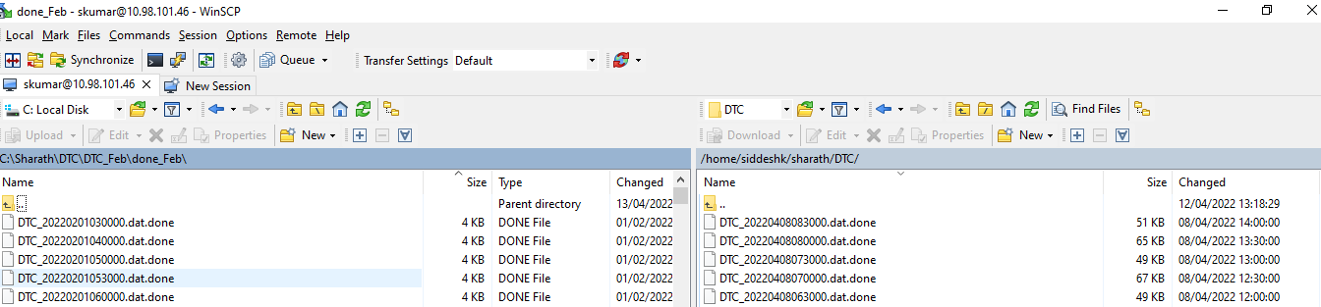

- Open Mobaxterm application and in top left corner Click on Session.
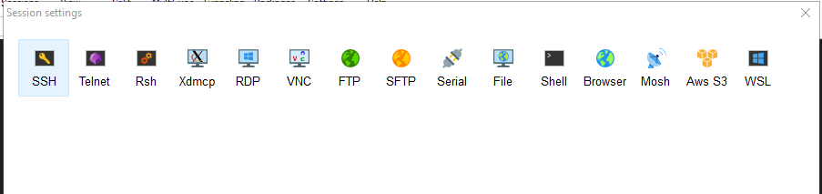
- In Session Settings, Click on SSH and in Basic SSH Settings, Enter Remote Host number (10.98.101.47) and click on Specify username checkbox
- Remove <default> username and enter your login username and click on OK button

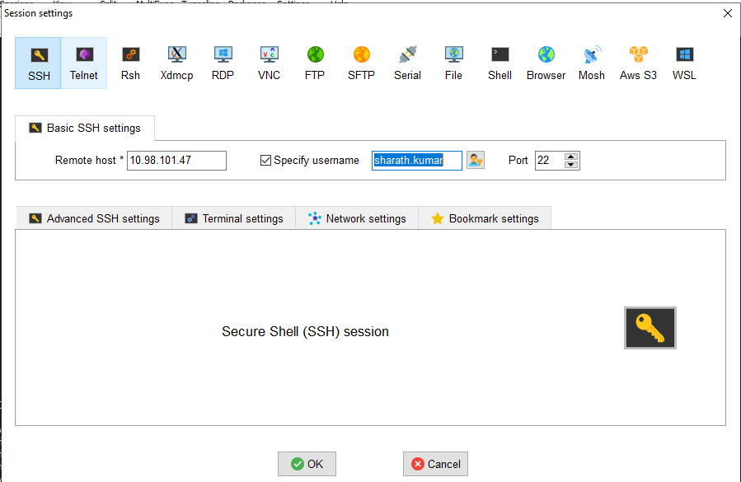

- In the session enter the password (entered password is not visible)
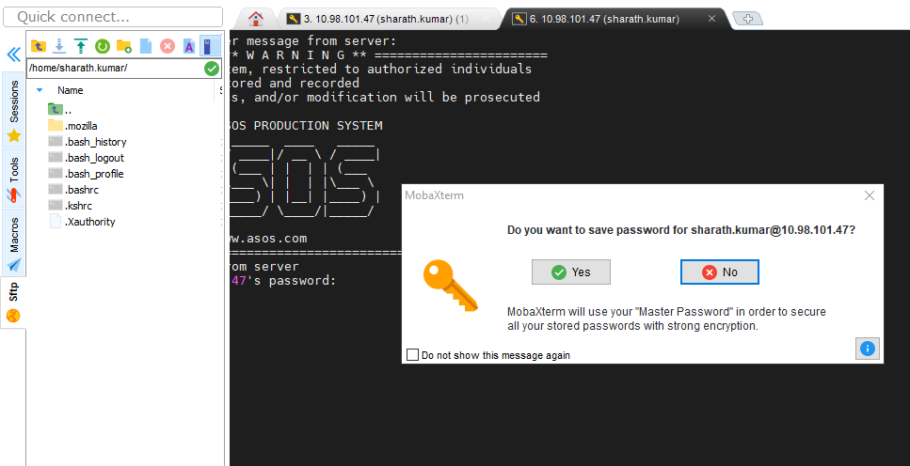

- Click on NO button.
- Once logged in, the screen looks like below.

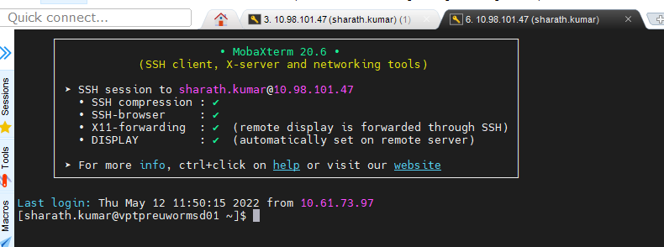

- Run the SUDO script to have the permission to run jobs
sudo su - oracle
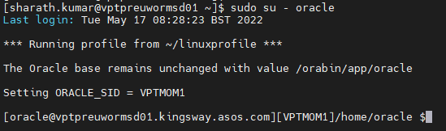
- Go to the path where DTC files were saved in step 6 with cd command

- List all the DTC files which are moved to the directory in step 6 with ls -lrt command
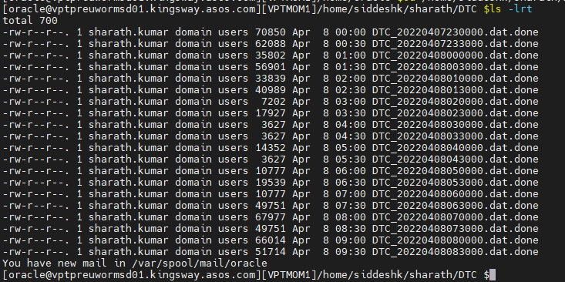
- Select all the files from the directory and paste it in Notepad ++ workpad
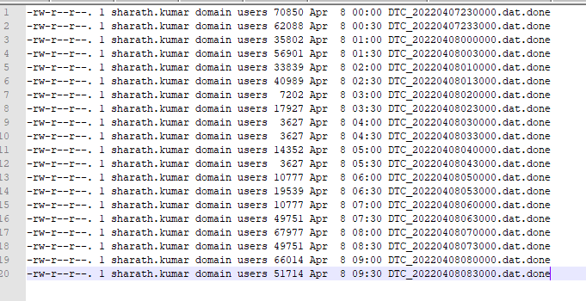
- Remove all the details except DTC_*.dat (where * is datetimestamp of files)

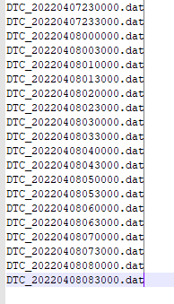
- Change file datestamp to vdate (from PERIOD table) in NOTEPAD++

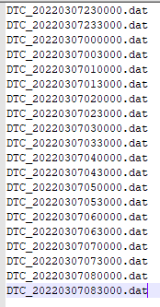
- Rename the DTC files in unix box directory with the name as changed in step 18.

mv <old file name> <new file name>
ex: mv DTC_20220407230000.dat.done DTC_20220307230000.dat
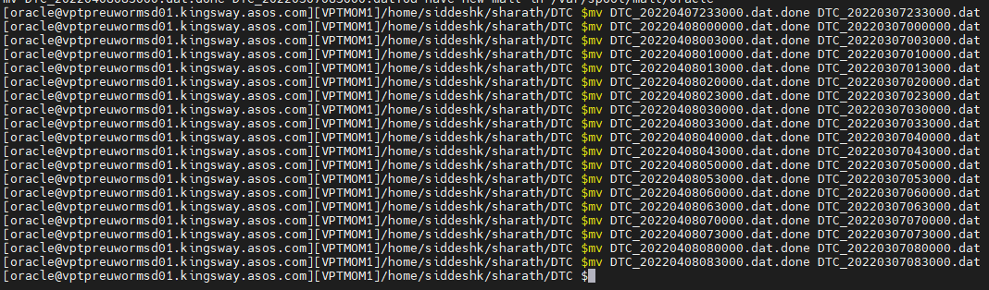

- Validate whether the files are renamed by using ls -lrt command in the same directory.

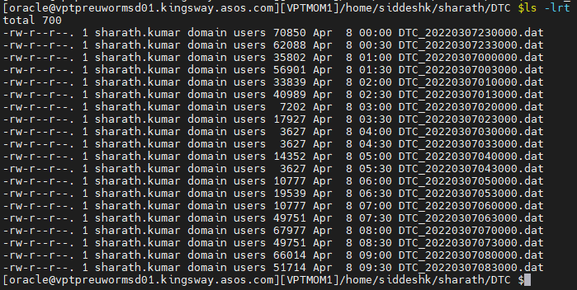

- Change all the dates within each of the files to vdate (from PERIOD table) by using below command.

sed -i ‘s/<old date>/<new date>/g’ DTC_*.dat
ex: sed -i 's/20220201/20220307/g' DTC_*.dat

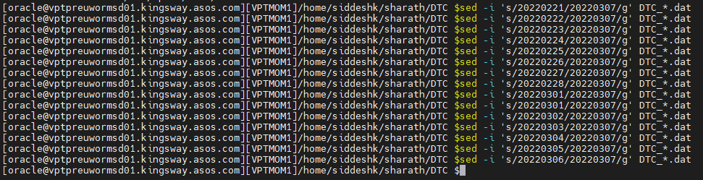
- Open some random files and validate that the dates are changed to vdate.
- Move the files from the directory where the DTC files were edited to the below directory.
/asos/oracle/vpt/data/inbound/Integration/sales/dtc/pending/DTC_Files
Under the above /DTC_Files directory, there are 17, 19 and 0 directories. Files under 17 and 19 are used for Intra-day jobs and files under 0 directory is used for Overnight Job.
NOTE: When the files are ready and while moving to /asos/* directory, place files according to respective directory.
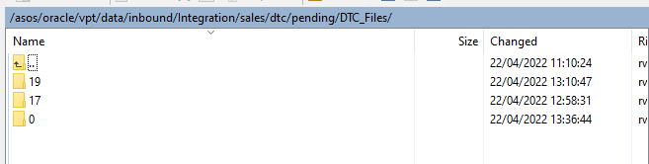
mv <current directory where DTC files are saved/*.*> < /asos/oracle/vpt/data/inbound/Integration/sales/dtc/pending/DTC_Files/*>
NOTE 1: /*.* will move all the files from the given directory
/* is the directory (like 17, 19 or 0) in which files to be moved.
NOTE 2: The transaction count in each of the file or in each of the transaction under DTC* files can be viewed by using grep -o 'THEAD' DTC_*.dat | wc -l. Increase or decrease the file count in the directory to achieve the expected transaction count for the given hour (17/19/0).

- Validate that the moved files are properly copied to new destination directory.
- Before running DTC Intra Day Job (WF.DTC_SALES_INTRADAY), move the files from /asos/oracle/vpt/data/inbound/Integration/sales/dtc/pending/DTC_Files/17
Or
/asos/oracle/vpt/data/inbound/Integration/sales/dtc/pending/DTC_Files/19
To
/asos/oracle/vpt/data/inbound/Integration/sales/dtc/pending

Before running DTC Intra Night (WF.DTC_SALES_INTRANIGHT), move the files from
/asos/oracle/vpt/data/inbound/Integration/sales/dtc/pending/DTC_Files/0
To
/asos/oracle/vpt/data/inbound/Integration/sales/dtc/pending
Follow below steps to achieve this step.
- Select all the files from the directory.
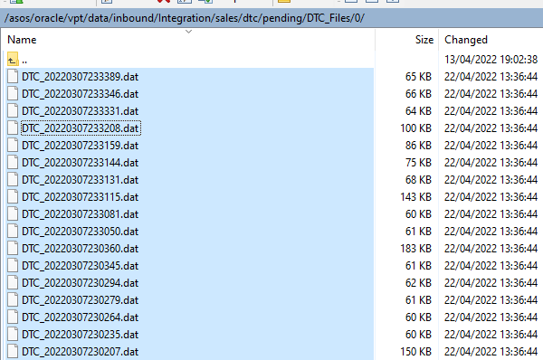
- Right click on the mouse and select Duplicate from the list
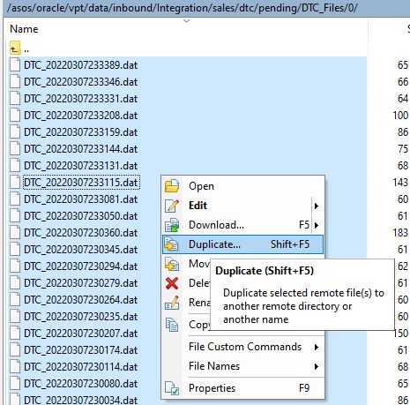
- In the Duplicate window, remove the existing Target Remote Path and enter the below path.
/asos/oracle/vpt/data/inbound/Integration/sales/dtc/pending/*.*
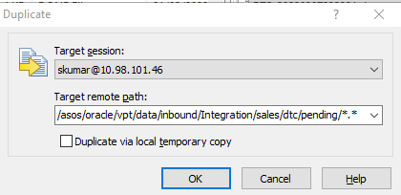

- Click on OK on the Confirm window.
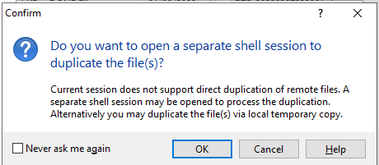

- Once the copying is done, validate whether the files are moved to “/asos/oracle/vpt/data/inbound/Integration/sales/dtc/pending/” directory.
