Intra-Day Jobs Run
Intraday jobs are the batches which are run on ad-hoc basis in between the day. These jobs are run at regular interval to reduce the volume of data to process on Overnight jobs.
Jobs are run through a scheduling tool called” Automic”. This is a job scheduler tool where jobs are scheduled to run at specific interval and given sequence with respective parameter configurations set in Automic. Jobs are run from respective Unix box where the jobs are called from Automic. The same tool will capture logs and error messages of each jobs by which user can rely on single tool for all unix box activities to run a job.
Below are the Intra-day jobs which are run in parallel.
RMS/RPM Jobs.
RESA_INTRA_DAY_CHAIN (17th Hour)
S_RPM_INTRA_DAY
NB_ITEM_SHIPPING_RESTRICTION
NB_TCKTDNLD
NB_INTRA_DAY_EMAIL_ORDER_TO_ADDTOQ_CHAIN
TRANSFER_UPLOAD_PROCESS
NB_INTRA_DAY_AUTOPO_CHAIN
WF.DTC_SALES_INTRADAY
Dashboard Jobs.
DASH_ACT_STK_INTRA_DAY
DASH_TSF_DISC_INTRA_DAY
DASH_INTRA_DAY
DASH_PO_INTRA_DAY
DASH_OPTION_INTRA_DAY
DASH_PRICE_INTRA_DAY
DASH_PRICE_CONFLICT

Pre-requisites before running the Intra-day jobs.
- Flashback of VPT environment to be completed
- After Flashback run TRANSFER_UPLOAD_PROCESS script in sql developer as attached below.
- Move the RTLOG files of 17th hour from
/asos/oracle/vpt/data/inbound/Integration/sales/rtlog/pending/Archive/ResA_day/17/
to “/asos/oracle/vpt/data/inbound/Integration/sales/rtlog/pending”
- Move the DTC files of 17th hour from
“/asos/oracle/vpt/data/inbound/Integration/sales/dtc/pending/DTC_Files/17”
to “/asos/oracle/vpt/data/inbound/Integration/sales/dtc/pending”
Below are the steps to run Intra-day jobs in Automic tool:

- Login to Automic tool with the URL below.
  - URL: https://npdpreunortlgw.services.kingsway.asos.com/awi/
  - Connection: BATCH(NON_PROD)
  - Client: 800
  - Name: Username
  - Department: ASOS
  - Password: User password
  - Click on Login button

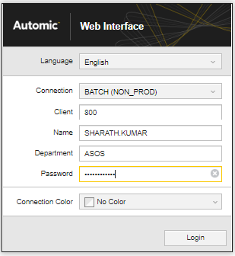
- Once logged in, in the home page, Black tool bar, under search section  enter the job name and select.
- In the search section enter the job name “RESA_INTRA_DAY_CHAIN” and Click on the first result
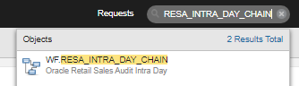
- Job page is opened as below.
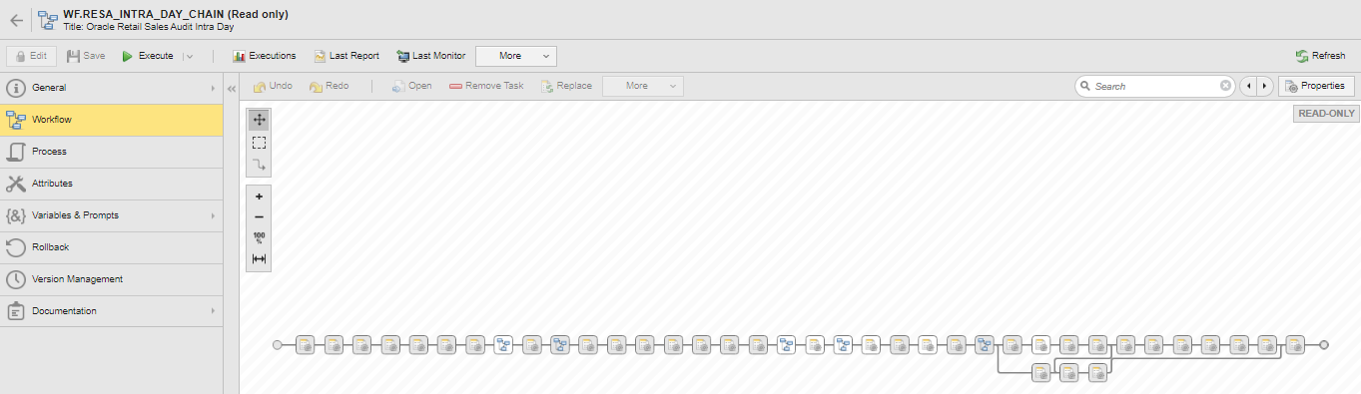
- Click on “Execute” button or select “Execute Once” from the Execute button drop down.
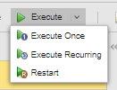
- Once Execute is clicked, a confirmation is window is popped up. Click on Execute In the pop-up window as well.
- Once Execute is clicked in confirmation pop-up, batch gets started to run at the backend and same can be viewed in Execution option.
- In the job page, click on “Executions” to see the previous and current runs with their start time, end time, activation time and status.
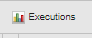
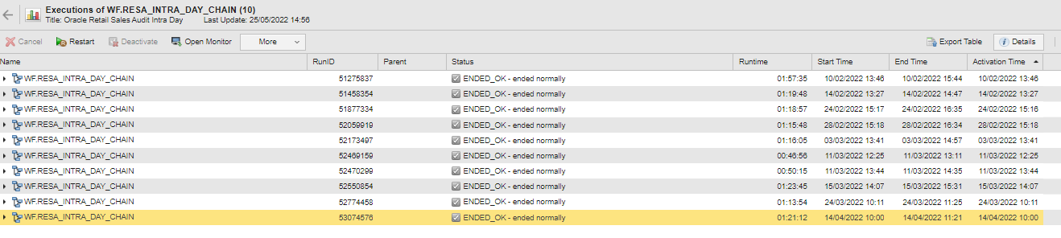
- Under these Executions window, user can expand each workflow to view each sub-workflow/sub-jobs with their runtimes and status.
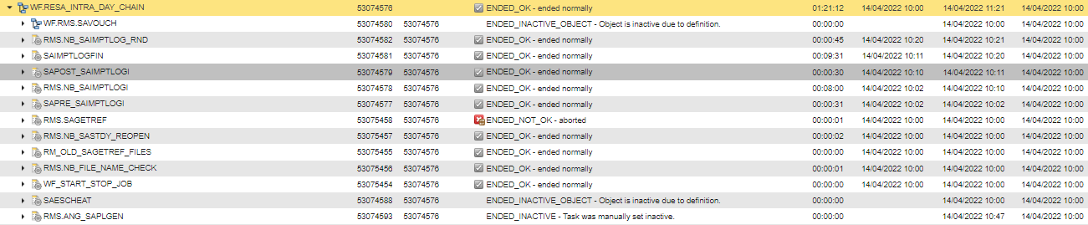

- Repeat Steps 3-9 to run other Intra Day jobs as below.

WF.S_RPM_INTRA_DAY
NB_ITEM_SHIPPING_RESTRICTION
NB_TCKTDNLD
NB_INTRA_DAY_EMAIL_ORDER_TO_ADDTOQ_CHAIN
TRANSFER_UPLOAD_PROCESS
NB_INTRA_DAY_AUTOPO_CHAIN
WF.DTC_SALES_INTRADAY
DASH_ACT_STK_INTRA_DAY
DASH_TSF_DISC_INTRA_DAY
DASH_INTRA_DAY
DASH_PO_INTRA_DAY
DASH_OPTION_INTRA_DAY
DASH_PRICE_INTRA_DAY

- Once all the jobs are started keep monitoring the jobs in “Process Monitoring” section.
<Screenshot>
- Monitor each Workflow while it is running and if there are any failures/long running analyze and intimate team in VPT Batch channel

DTC Intra Chain Job for 19th Hour:

Once all the above (step 10) jobs are completed, user has to start the DTC 19th Hour job (WF.DTC_SALES_INTRADAY)

- Move the files from 19th hour (/asos/oracle/vpt/data/inbound/Integration/sales/dtc/pending/DTC_Files/19) and
“/asos/oracle/vpt/data/inbound/Integration/sales/dtc/pending”
- In the search section enter the job name “WF.DTC_SALES_INTRADAY” and Click on the first result
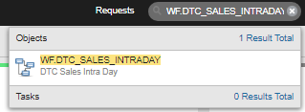
- Job page is opened as below.
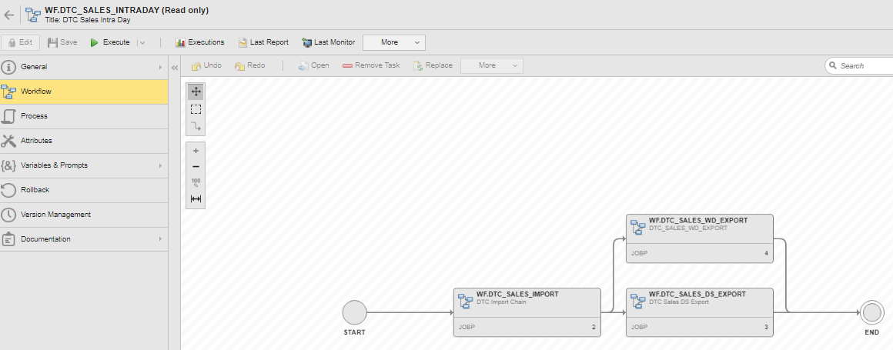
- Click on “Execute” button or select “Execute Once” from the Execute button drop down.

- Once Execute is clicked, a confirmation is window is popped up. Click on Execute In the pop-up window as well.

- Once Execute is clicked in confirmation pop-up, batch gets started to run at the backend and same can be viewed in Execution option.

- Once WF job is started keep monitoring the jobs in “Process Monitoring” section.
<Screenshot>

- Monitor each job in Workflow while it is running and if there are any failures/long running analyze and intimate team in VPT Batch channel

ReSA Intra Chain Jobs from 18th-23rd hours:

Once all the above (step 10) jobs are completed, user has to start the ReSA 18-19th Hour job (WF.RESA_INTRA_NIGHT_CHAIN)

- Move the files from 18th hour (/asos/oracle/vpt/data/inbound/Integration/sales/rtlog/pending/Archive/ResA_day/18/) and
19th hour (/asos/oracle/vpt/data/inbound/Integration/sales/rtlog/pending/Archive/ResA_day/19/)
And late transaction
(/asos/oracle/vpt/data/inbound/Integration/sales/rtlog/pending/Archive/Late_Transactions/18-19) files to
“/asos/oracle/vpt/data/inbound/Integration/sales/rtlog/pending/”
- In the search section enter the job name “WF.RESA_INTRA_NIGHT_CHAIN” and Click on the first result
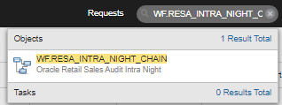
- Job page is opened as below.
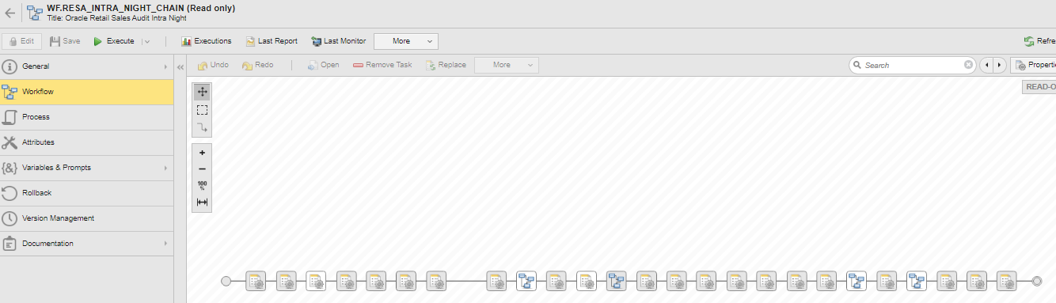
- Click on “Execute” button or select “Execute Once” from the Execute button drop down.

- Once Execute is clicked, a confirmation is window is popped up. Click on Execute In the pop-up window as well.

- Once Execute is clicked in confirmation pop-up, batch gets started to run at the backend and same can be viewed in Execution option.

- Once WF job is started keep monitoring the jobs in “Process Monitoring” section.
<Screenshot>

- Monitor each job in Workflow while it is running and if there are any failures/long running analyze and intimate team in VPT Batch channel

Once 18th-19th hour jobs are completed, user has to start the ReSA 20-21st Hour job (WF.RESA_INTRA_DAY_CHAIN.EXTRA)

- Move the files from 20th hour (/asos/oracle/vpt/data/inbound/Integration/sales/rtlog/pending/Archive/ResA_day/20/) and
21st hour (/asos/oracle/vpt/data/inbound/Integration/sales/rtlog/pending/Archive/ResA_day/21/)
And late transaction
(/asos/oracle/vpt/data/inbound/Integration/sales/rtlog/pending/Archive/Late_Transactions/20-21) files to
“/asos/oracle/vpt/data/inbound/Integration/sales/rtlog/pending/”
- In the search section enter the job name “WF.RESA_INTRA_DAY_CHAIN.EXTRA” and Click on the first result
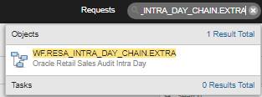
- Job page is opened as below.
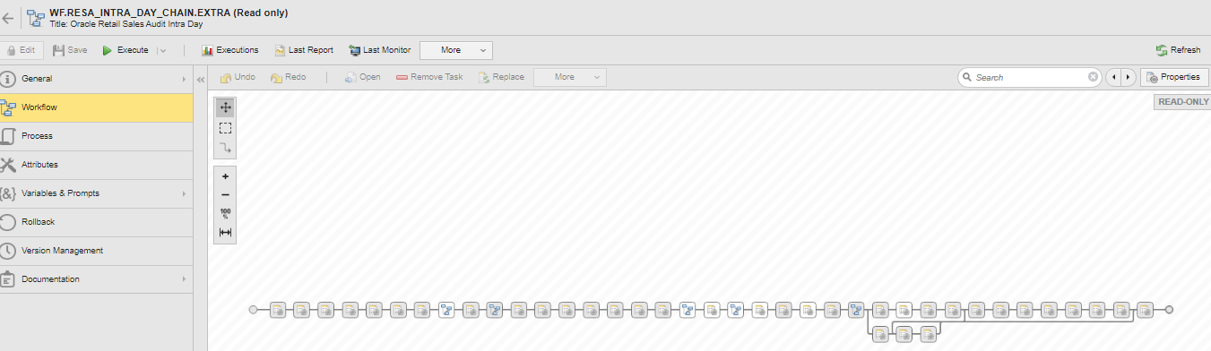
- Click on “Execute” button or select “Execute Once” from the Execute button drop down.

- Once Execute is clicked, a confirmation is window is popped up. Click on Execute In the pop-up window as well.

- Once Execute is clicked in confirmation pop-up, batch gets started to run at the backend and same can be viewed in Execution option.

- Once WF job is started keep monitoring the jobs in “Process Monitoring” section.
<Screenshot>

- Monitor each job in Workflow while it is running and if there are any failures/long running analyze and intimate team in VPT Batch channel

Once 20th-21st hour jobs are completed, user has to start the ReSA 22-23rd Hour job (WF.RESA_IMPORT_CHAIN)

- Move the files from 22nd hour (/asos/oracle/vpt/data/inbound/Integration/sales/rtlog/pending/Archive/ResA_day/22/) and
23rd hour (/asos/oracle/vpt/data/inbound/Integration/sales/rtlog/pending/Archive/ResA_day/23/)
And late transaction
(/asos/oracle/vpt/data/inbound/Integration/sales/rtlog/pending/Archive/Late_Transactions/22-23) files to
“/asos/oracle/vpt/data/inbound/Integration/sales/rtlog/pending/”
- In the search section enter the job name “WF.RESA_IMPORT_CHAIN” and Click on the first result
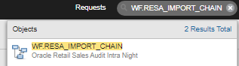

- Job page is opened as below.
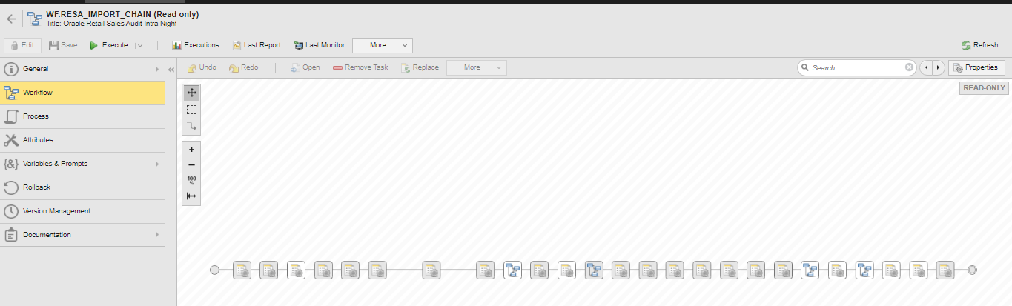
- Click on “Execute” button or select “Execute Once” from the Execute button drop down.

- Once Execute is clicked, a confirmation is window is popped up. Click on Execute In the pop-up window as well.

- Once Execute is clicked in confirmation pop-up, batch gets started to run at the backend and same can be viewed in Execution option.

- Once WF job is started keep monitoring the jobs in “Process Monitoring” section.
<Screenshot>

- Monitor each job in Workflow while it is running and if there are any failures/long running analyze and intimate team in VPT Batch channel

