Overnight Jobs Run
Overnight Jobs are the batches which are run at the end of the day. These jobs are mainly run when none of the users are using UI. These overnight jobs are like rollup jobs for the closure of the given day. All transactions, stock ledger and inventory related rollups are done in Overnight workflow.
Data clean up, data sync to Dashboards are done in Overnight jobs.

Below are the important workflows under Overnight main workflow.
WF.RMS.BATCH
WF.RPM_INTRA_DAY_LAST_CHAIN
PHASE_0
PHASE_1
PHASE_2
PHASE_3
AD_HOC
WF.RPM_ADHOC
WF.AD_HOC_RPAS
RPM_BATCH
NB_SAL_RET_PROCESS
RMS.EXTRACT_MASTER_TO_INTG
RMS_EXTRACT_TO_IAP
RMS.RMS_RPAS_MSTR_FILES_OUTBOUND_FTP_TO_RPAS
JOBP.RMS_RPAS_TRANSACTIONAL_DATA
WF.RMS.NB_PHASE_3_INVENTORY
WF.RMS.NB_EXPORT_SNAPSHOT
WF.RD.NB_FIF_GL_PO_REFRESH
PHASE_4
WF.RMSE_RPAS_EXTRACT
WF.PHASE_4.RPAS
WF.RMS.PHASE_8
DATE_SET
WF.RD.DASH_INTAKE
WF.RESA_PURGE

Pre-requisites before running the Intra-day jobs.

- All Intra Day jobs to be run along with ReSA Peak hour sales from 17th-23rd hours.
- Move the RTLOG files of 0th hour from
“/asos/oracle/vpt/data/inbound/Integration/sales/rtlog/pending/Archive/ResA_day/0/”
to “/asos/oracle/vpt/data/inbound/Integration/sales/rtlog/pending”
- Move the DTC files of 0th hour from
“/asos/oracle/vpt/data/inbound/Integration/sales/dtc/pending/DTC_Files/0”
to “/asos/oracle/vpt/data/inbound/Integration/sales/dtc/pending”
Below are the steps to run Intra-day jobs in Automic tool:

- Login to Automic tool with the URL below.
  - URL: https://npdpreunortlgw.services.kingsway.asos.com/awi/
  - Connection: BATCH(NON_PROD)
  - Client: 800
  - Name: Username
  - Department: ASOS
  - Password: User password
  - Click on Login button

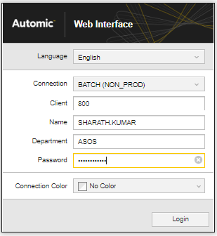
- Once logged in, in the home page, Black tool bar, under search section  enter the job name and select.
- In the search section enter the job name “WF.RMS.BATCH” and Click on the first result
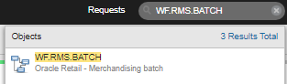
- Job page is opened as below.
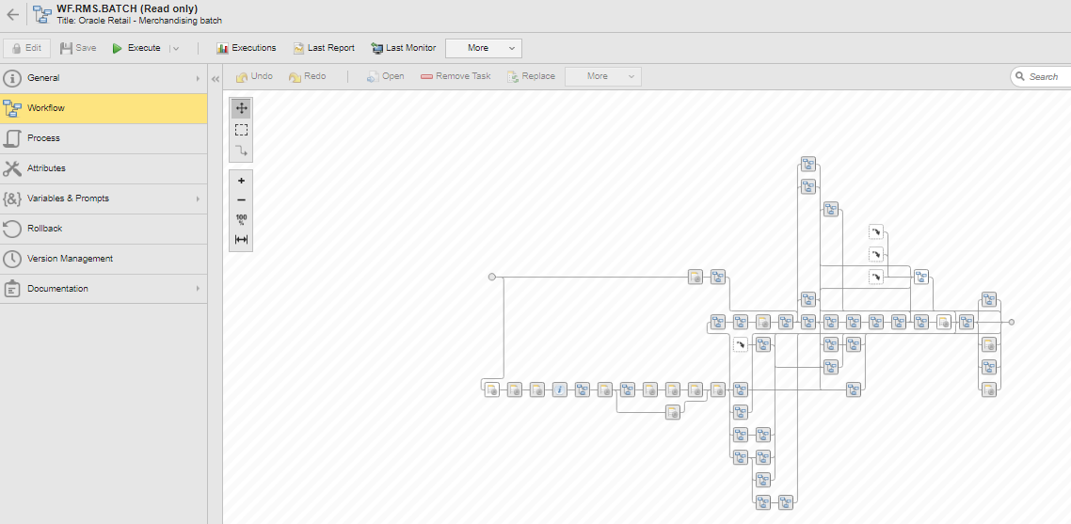
- Click on “Execute” button or select “Execute Once” from the Execute button drop down.
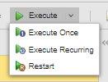
- Once Execute is clicked, a confirmation is window is popped up. Click on Execute In the pop-up window as well.
- Once Execute is clicked in confirmation pop-up, batch gets started to run at the backend and same can be viewed in Execution option.
- In the job page, click on “Executions” to see the previous and current runs with their start time, end time, activation time and status.
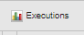
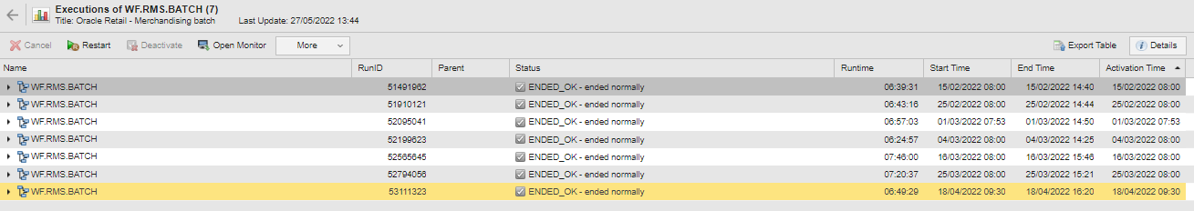
- Under these Executions window, user can expand each workflow to view each sub-workflow/sub-jobs with their runtimes and status.
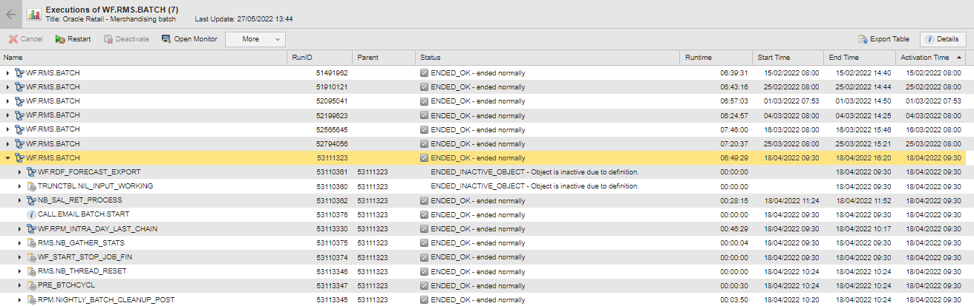

Once the RMS.BATCH job is in Active status and RPM.INTRA_DAY_LAST_CHAIN job is active please follow below steps to make some jobs Inactive.

- Make the job NB_SAEXPWEBDEP_PURGE in PHASE_0 Inactive.
  - Open the WMS.RMS.BATCH job page while the Job is active.
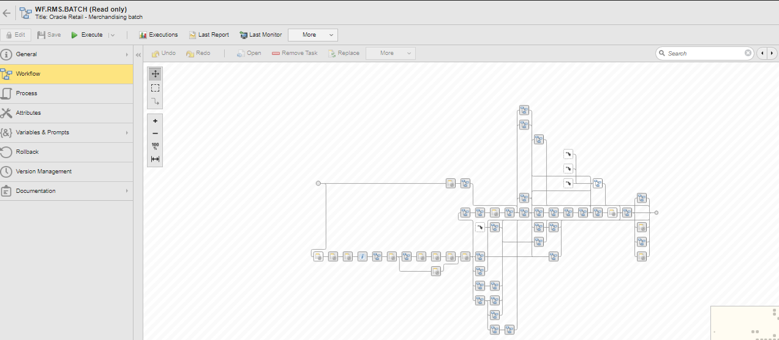
  - In the Search tab under the Job page look for PHASE_0. Job would be highlighted in the Job Page.
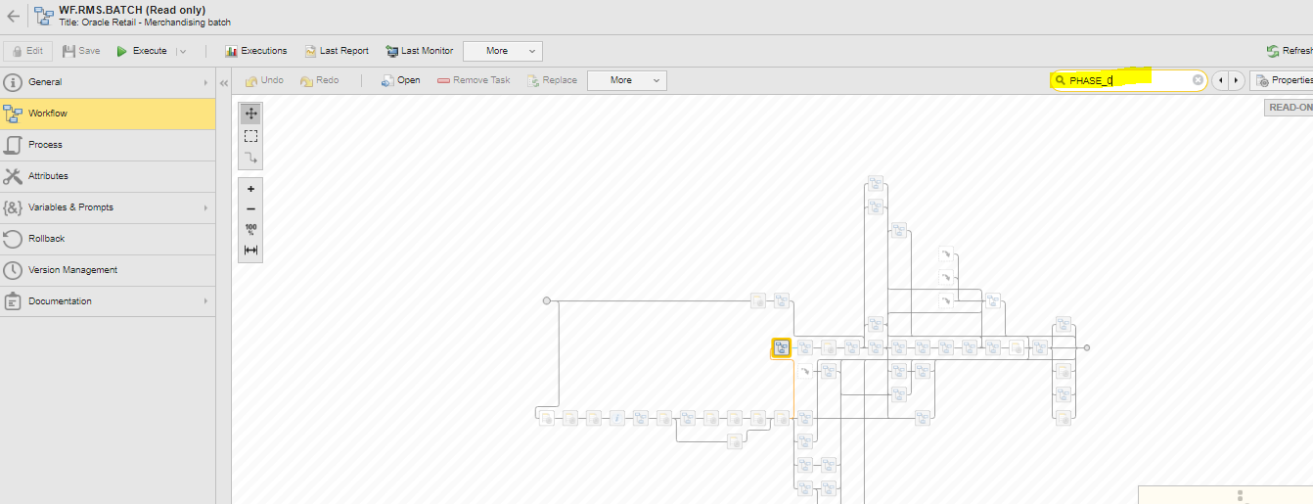
  - Select Phase_0 job and right click and select Open Monitor
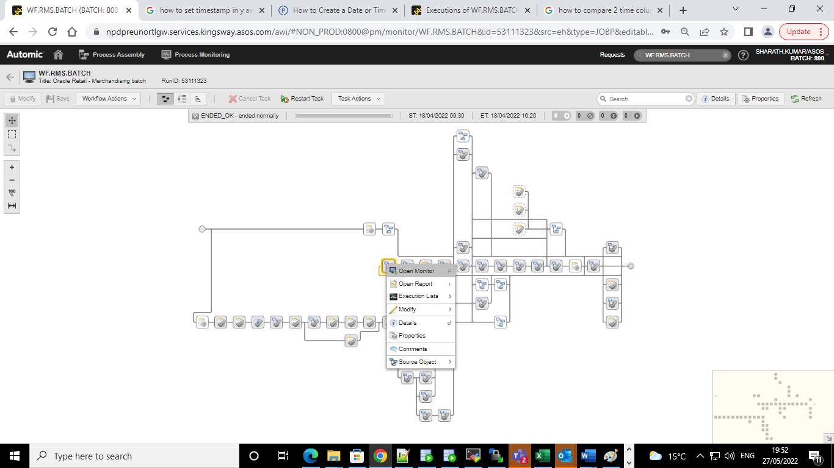
  - Once Open Monitor is selected, Phase_0 Job page is opened.
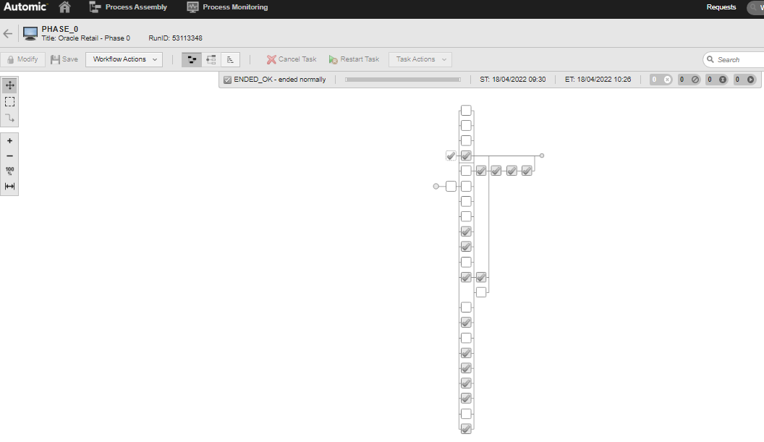
  - Search for the Job NB_SAEXPWEBDEP_PURGE in Phase_0 Job Page. Job will be highlighted in the Job page.
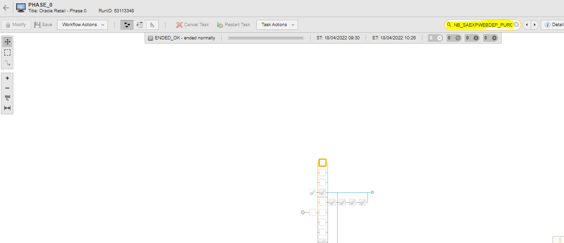
  - Select the job NB_SAEXPWEBDEP_PURGE and right click and Navigate to Modify -> Set to Inactive. Click on Inactive if any pop-up window is displayed. Job is set Inactive.
- Make the job ANG_SAPLGEN in PHASE_1.RESA Inactive.
  - Open the WMS.RMS.BATCH job page while the Job is active.

  - In the Search tab under the Job page look for PHASE_1. Job would be highlighted in the Job Page.
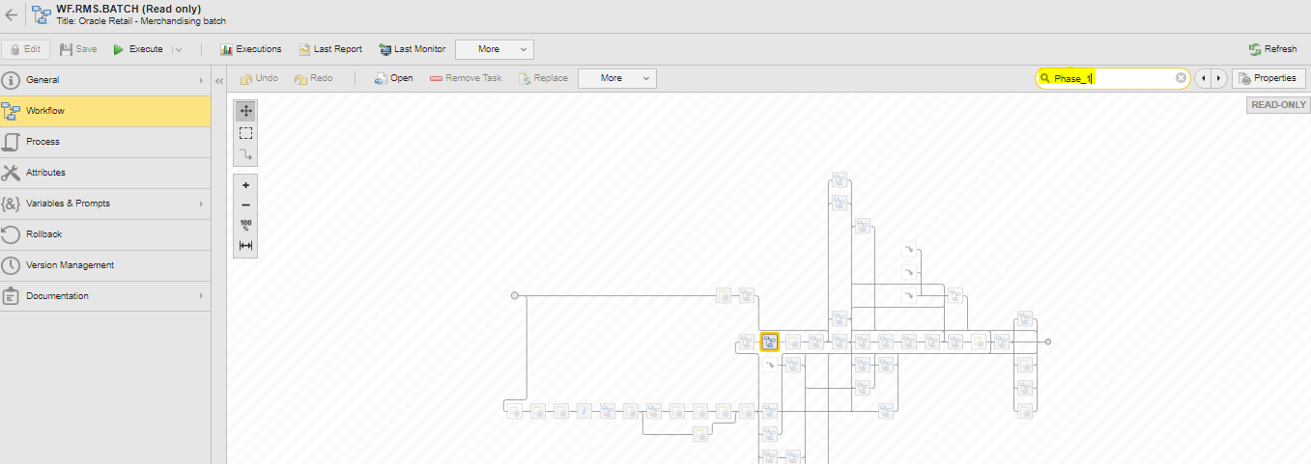
  - Select Phase_1 job and right click and select Open Monitor
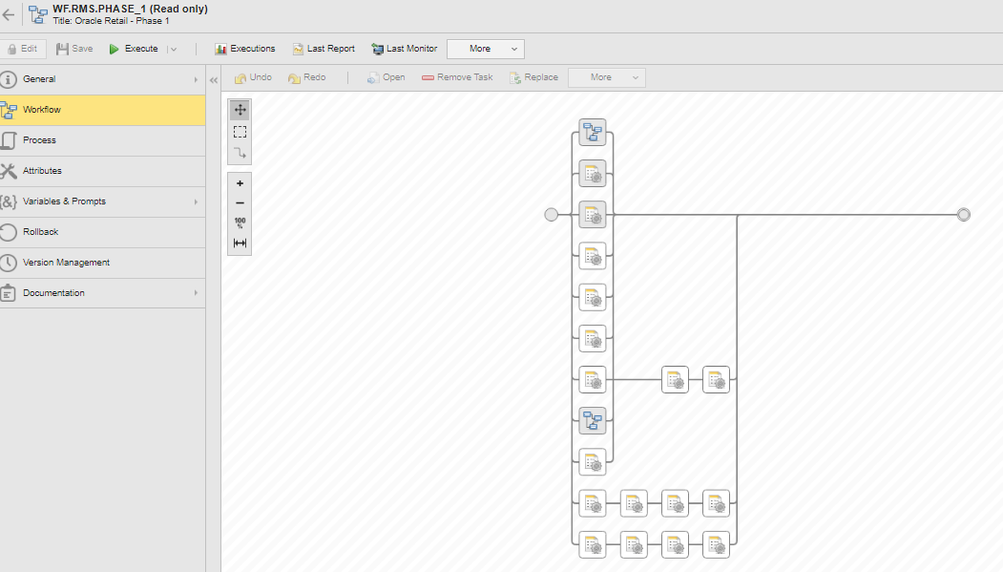
  - Search for the Job RESA in Phase_1 Job Page. Job will be highlighted in the Job page
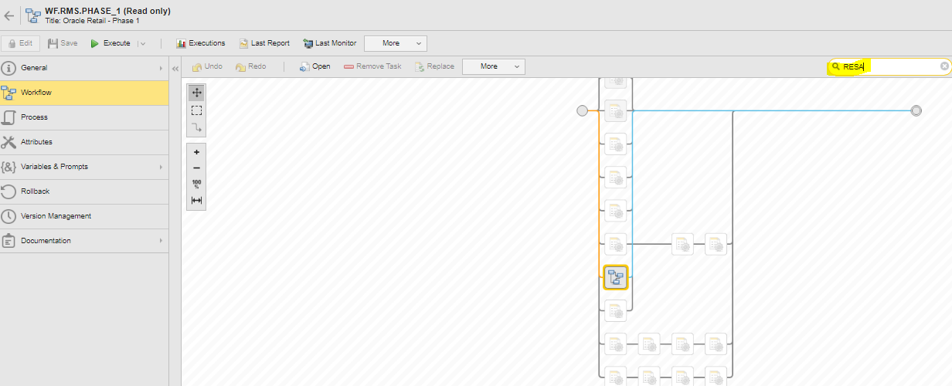
  - Select RESA job and right click and select Open Monitor
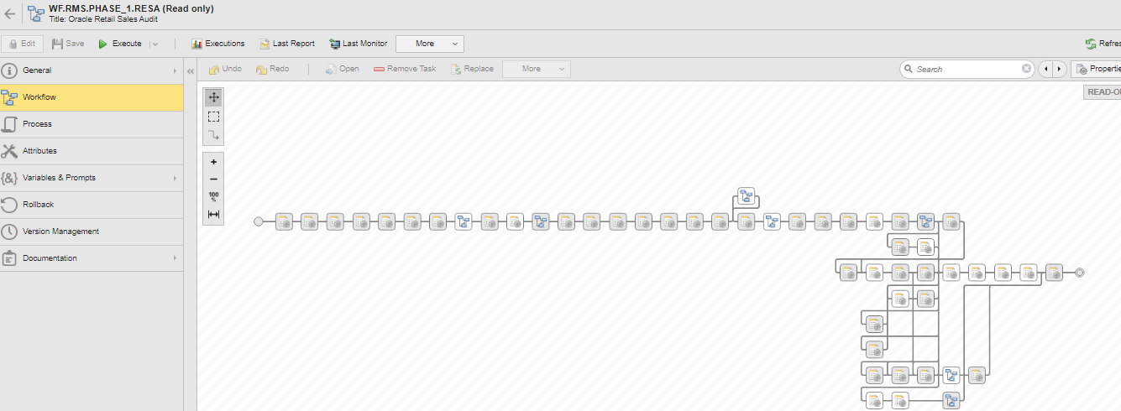
  - Search for the Job RMS.ANG_SAPLGEN in RESA Job Page. Job will be highlighted in the Job page
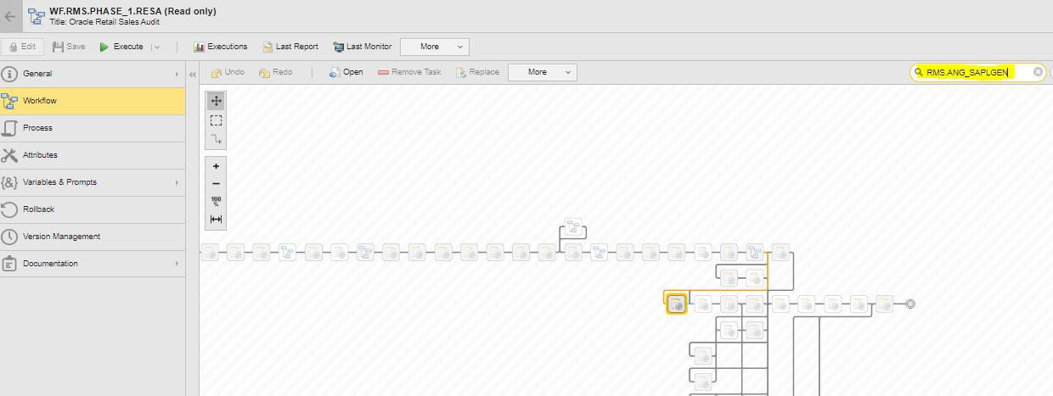
  - Select the job RMS.ANG_SAPLGEN and right click and Navigate to Modify -> Set to Inactive. Click on Inactive if any pop-up window is displayed. Job is set Inactive

- Make the job NB_SIZEPROF_INTG_INBOUND_TO_RMS and NB_SIZEPROF_UPLOAD in PHASE_4.RPAS Inactive.
  - Open the WMS.RMS.BATCH job page while the Job is active.

  - In the Search tab under the Job page look for PHASE_4.RPAS Job would be highlighted in the Job Page
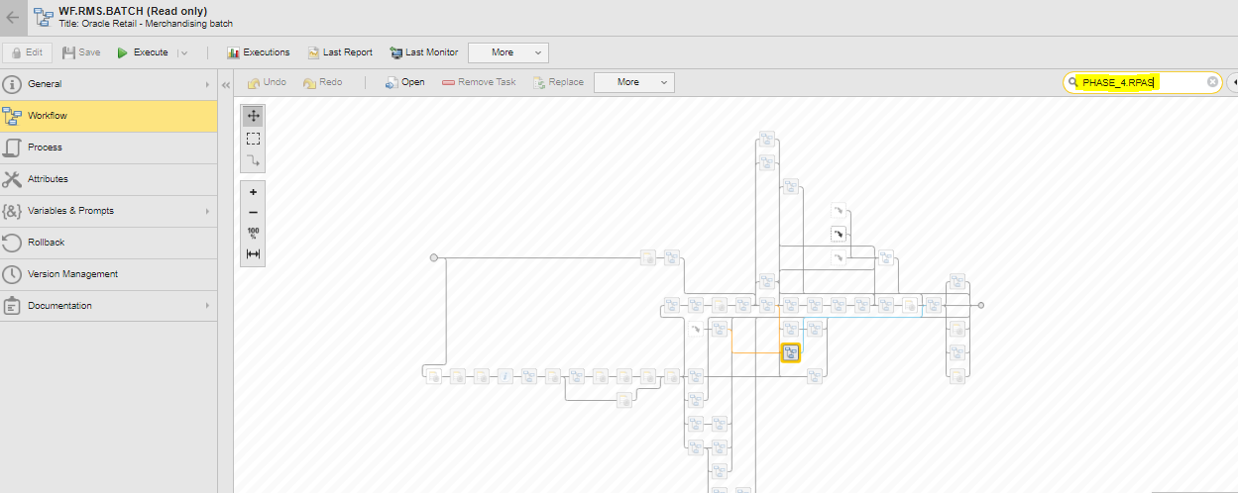
  - Select PHASE_4.RPAS job and right click and select Open Monitor
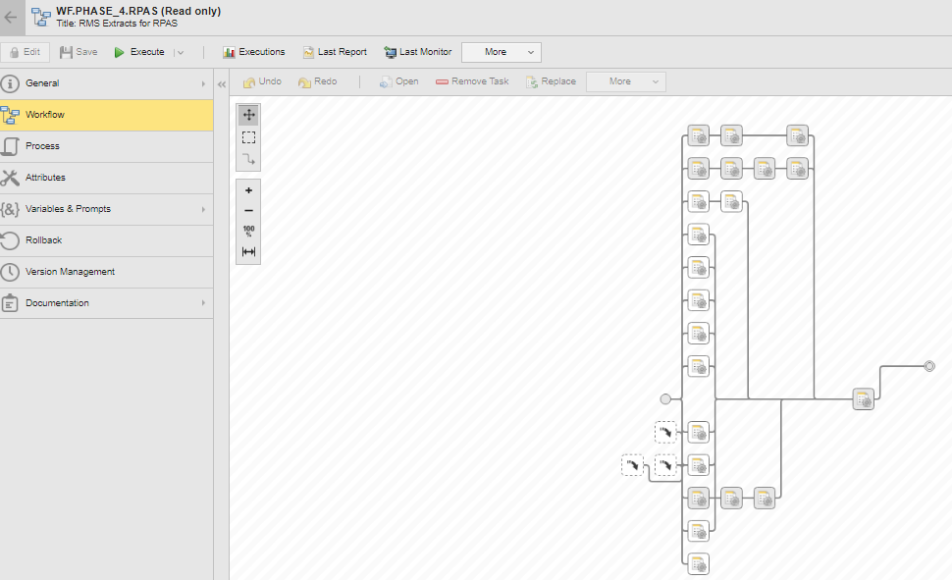
  - Search for the Job NB_SIZEPROF_INTG_INBOUND_TO_RMS in PHASE_4.RPAS Job Page. Job will be highlighted in the Job page
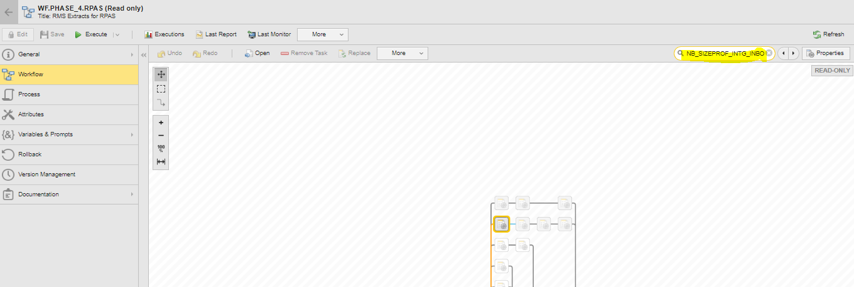
  - Select the job NB_SIZEPROF_INTG_INBOUND_TO_RMS and right click and Navigate to Modify -> Set to Inactive. Click on Inactive if any pop-up window is displayed. Job is set Inactive
  - Search for the Job NB_SIZEPROF_UPLOAD in PHASE_4.RPAS Job Page. Job will be highlighted in the Job page
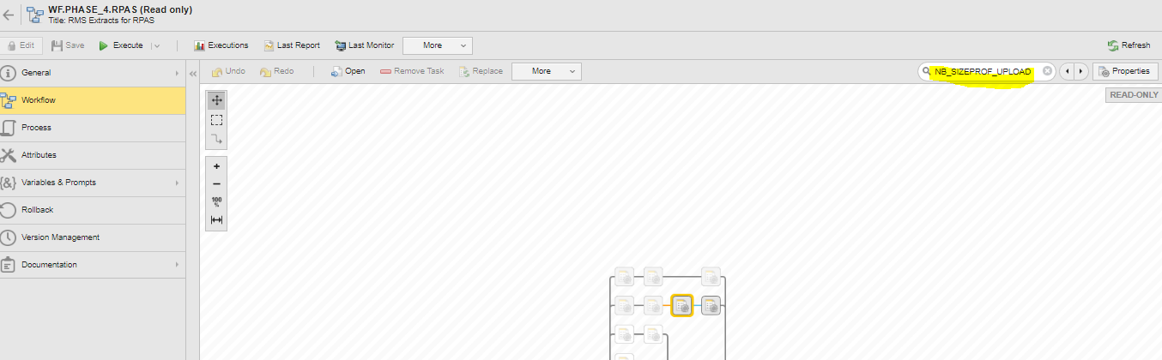
  - Select the job NB_SIZEPROF_UPLOAD and right click and Navigate to Modify -> Set to Inactive. Click on Inactive if any pop-up window is displayed. Job is set Inactive

- Make the job S_CLEARANCE_RESET in DATE_SET Inactive.
  - Open the WMS.RMS.BATCH job page while the Job is active.

  - In the Search tab under the Job page look for DATE_SET Job would be highlighted in the Job Page
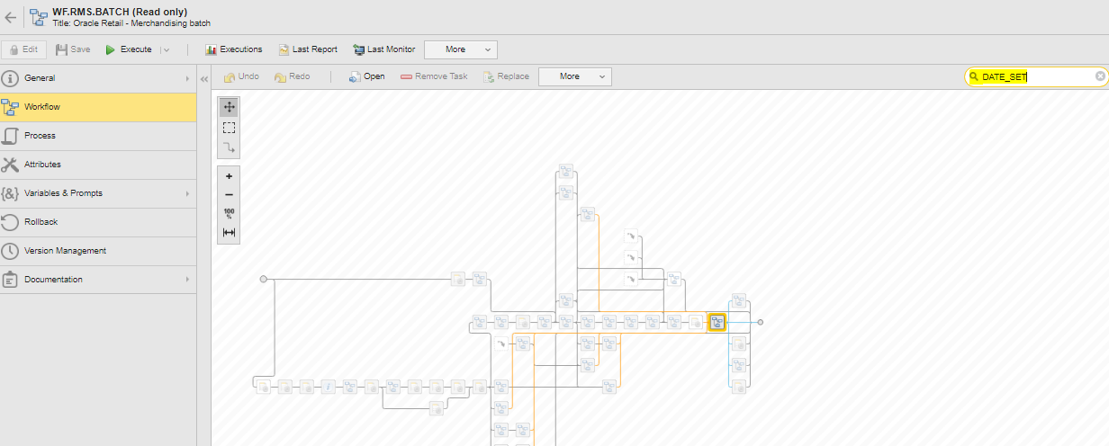
  - Select DATE_SET job and right click and select Open Monitor
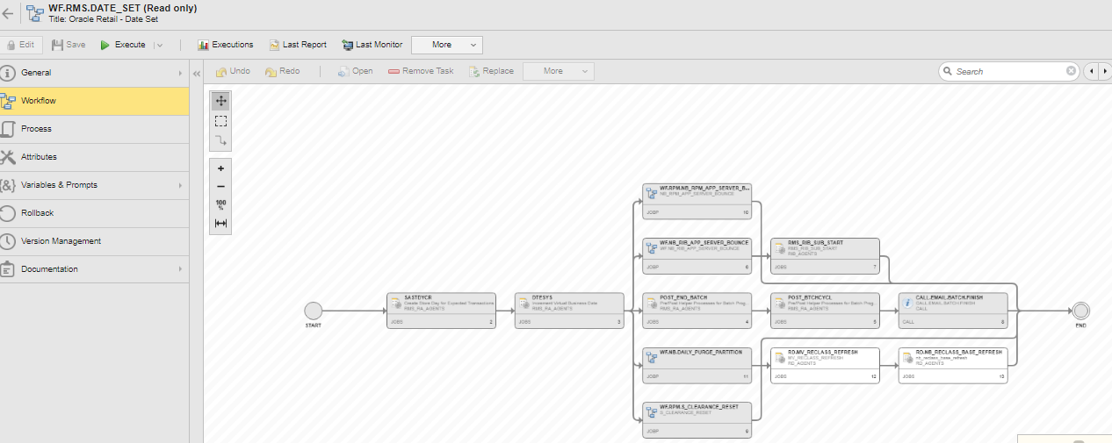
  - Search for the Job WF.RPM.S_CLEARANCE_RESET in DATE_SET Job Page. Job will be highlighted in the Job page
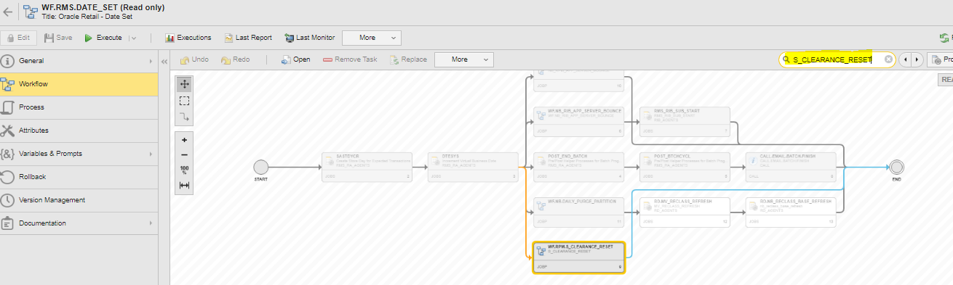
  - Select the job WF.RPM.S_CLEARANCE_RESET and right click and Navigate to Modify -> Set to Inactive. Click on Inactive if any pop-up window is displayed. Job is set Inactive

Once the RPM.INTRA_DAY_LAST_CHAIN job is completed and WF.RPM.NB_RPM_APP_SERVER_BOUNCE is active please follow below steps
- When WF.RPM.NB_RPM_APP_SERVER_BOUNCE is active, get into the job page by Right Click -> Open Monitor.
- In the WF.RPM.NB_RPM_APP_SERVER_BOUNCE job page jobs like NB_RPM_SERVER_RESTART_APP1 and NB_RPM_SERVER_RESTART_APP2 will be in waiting for predecessor status.
- Select the Job NB_RPM_SERVER_RESTART_APP1, right click select Modify and select Ignore Precondition option. Once it is done, batch will be in Active status.
- Select the Job NB_RPM_SERVER_RESTART_APP2, right click select Modify and select Ignore Precondition option. Once it is done, batch will be in Active status.

After an hour of WF.RMS.Batch start time, user must initiate STOCK_BUCKET_CORRECTION jobs for all 9 Fulfillment centers.

Below are the steps to initiate Stock Bucket correction jobs.

- In the Search section enter the job name WF.RMS.NB_STOCK_BUCKET_CORRECTION_PARENT and select the item.
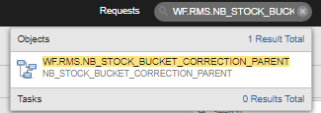
- After the job is selected from Search section, Job page is opened.
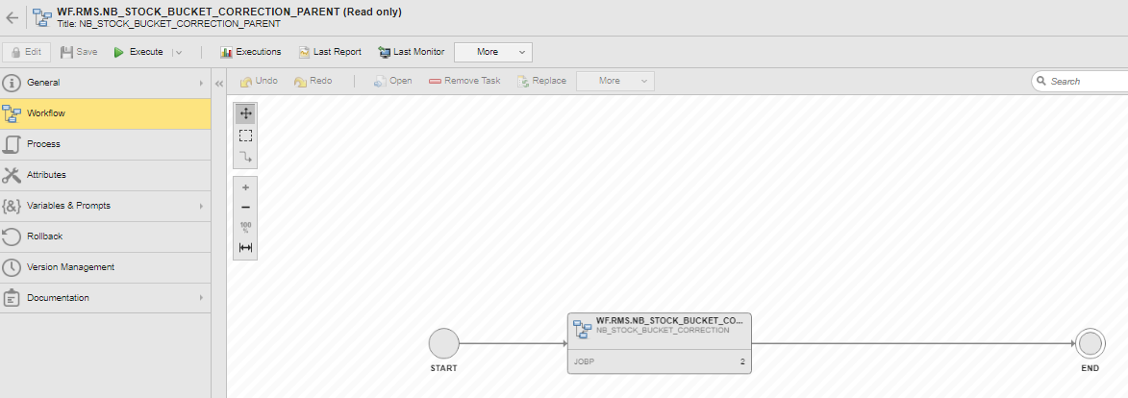
- Click on “Execute” button or select “Execute Once” from the Execute button drop down.

- Once Execute is clicked, a confirmation is window is popped up. Click on Execute In the pop-up window as well.
- Once Execute is clicked in confirmation pop-up, an Input required pop up is displayed in the screen.
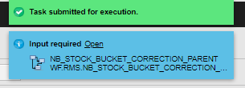
- Click on “Open” link in Input required pop up window.
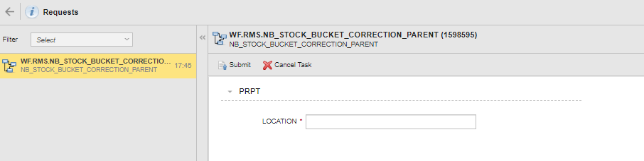
- In the Location field enter the FC number 1001 and click on Submit. WF.RMS.NB_STOCK_BUCKET_CORRECTION_PARENT job is active.
- Go to Process Monitoring and select the Job, right click and select Open Monitor.
- In the Job page, select the job WF.RMS.NB_STOCK_BUCKET_CORRECTION.
- Right click on the job and navigate Modify -> Ignore Preconditions.
- Once the option is selected, WF.RMS.NB_STOCK_BUCKET_CORRECTION job is active.

Repeat Steps 1-11 for the FCs, 3001 and 4001 respectively. Once these 3 FCs are completed then repeat step 1-11 again for the FCs, 1011, 1014, 1015, 4012, 4013 and 6001 respectively.

In Phase_0 we need to skip this job if it is long running “RMS.NB_INANCTIVE_STYLES”.

In Phase_1 we need to skip this job if it long running “RMS.NB_RTSA_RESA_RECOVERY_KNOWN_ERRORS”.

Once the WF.RMS.Phase_2 is started, monitor the job RMS.SALESPROCESS. This job will run for a while and then it will fail (This is known issue and it is with Oracle for the fix) and wholePhase_2 chain will be blocked. To unblock the job, follow below steps.
- Select the job RMS.SALESPROCESS. Right Click and Navigate Modify -> Unblock task
- On the pop window click on Unblock.
- Once Unblocked, Phase_2 chain will continue to run.

Once the chain WF.RMS.NB_PHASE_3_INVENTORY is Active, monitor the chain. After 50 mins of runtime, if all the jobs (except WF.SP.NB_CANCEL_PURGE) are over and if only WF.SP.NB_CANCEL_PURGE is Active inside the chain WF.RMS.NB_PHASE_3_INVENTORY, please follow below steps.
- Go to WF.RMS.NB_PHASE_3_INVENTORY job page.
- Select the Job WF.SP.NB_CANCEL_PURGE, Right Click and Select Open Monitor
- SP.NB_REPLCIATION_PRE_CHECK will be in “Waiting for Predecessor” status.
- Select the Job SP.NB_REPLCIATION_PRE_CHECK, Right Click and Navigate to Modify -> Ignore Precondition
- Once Ignore is selected, SP.NB_REPLCIATION_PRE_CHECK job will be Active.

Once the DATE_SET job is Active and WF.RPM.NB_RPM_APP_SERVER_BOUNCE is active please follow below steps
- When WF.RPM.NB_RPM_APP_SERVER_BOUNCE is active, get into the job page by Right Click -> Open Monitor.
- In the WF.RPM.NB_RPM_APP_SERVER_BOUNCE job page jobs like NB_RPM_SERVER_RESTART_APP1 and NB_RPM_SERVER_RESTART_APP2 will be in waiting for predecessor status.
- Select the Job NB_RPM_SERVER_RESTART_APP1, right click select Modify and select Ignore Precondition option. Once it is done, batch will be in Active status.
Select the Job NB_RPM_SERVER_RESTART_APP2, right click select Modify and select Ignore Precondition option. Once it is done, batch will be in Active status.

Once all the job are completed in Overnight chain, please take the AWR report. Follow below steps to generate the report.
- Connect to RMS linux server (10.98.101.47) through Mobaxterm
- Login with your username/Password
- Run below command to provide access to generate AWR report.
sudo su - oracle
- Go to below directory path
cd $ORACLE_HOME/rdbms/admin
- Connect to sqlplus as dba
sqlplus / as sysdba
- Run below sql script
@awrrpt.sql
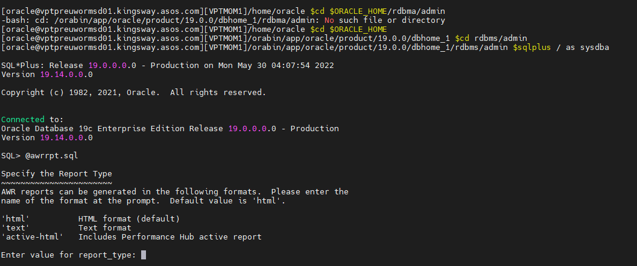
- Once the awrrpt.sql script is run, select the Report type. To select the default type HTML, just press enter without entering anything.
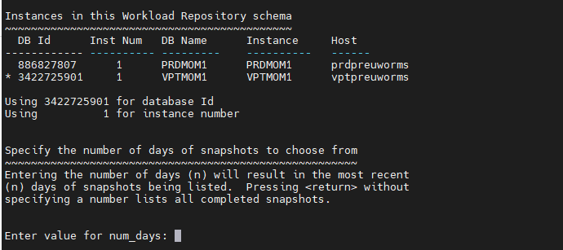
- Once the report type is selected, “Enter the Value for num_days” which will list down the most recent snapshots. Enter the number as per the recent Overnight job run or just hit enter which will result in all snapshots.
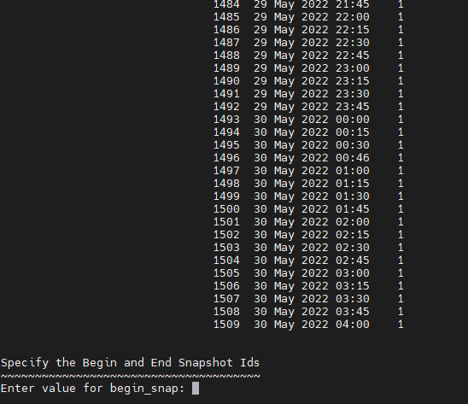
- Enter the Begin_snap value. Please make note of Overnight Job start time and accordingly give the Snap ID.
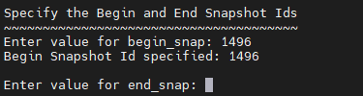
- Enter the Value for end_snap. Provide the end snapshot id which is 4 after the start_snap id.
Ex: If the start_snap is 1496 then provide the end_snap as 1500. This 4 snap IDs will have the results of 1 hour (as each snap is created for every 15 mins).
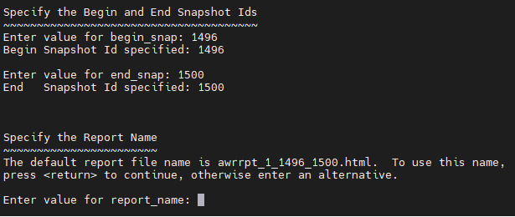
- Enter the Value for report_name or user can hit enter if the chose the default naming convention as (awrrt_1_<start_snap>_<end_snap>.html)
- Once clicked Enter in previous step, awrrpt.sql will run and generate the report as save it as per the given file name.
- Generate all the awrrpt for the overnight run duration for each hour interval.
- User can view the generated reports in below directory.
/orabin/app/oracle/product/19.0.0/dbhome_1/rdbms/admin
