ReSA RTLOG Data Preparation
RTLOG (Resa Transaction LOG) is a flat file which consists of transactional data which is performed at store/online in each timeframe (once a day / once in stipulated time).
These files are generated by POS (for physical store) / OMS (for online) application and are integrated to ReSA.
These RTLOG files are fed to ReSA job (saimptlogi) and get it consumed by ReSA application for auditing sales performed for that period.
RTLOG Files consists of Transaction details like, Sales, Returns, VOID, Post Void, etc.
Below are the steps to prepare RTLOG files:
- Historical (roughly for a period of 1 month) Production cut files to be requested from Elias.Souza@asos.com
- Unzip the folder and save all RTLOG_*.dat.done files in local machine.
NOTE 1: * in the file name is the datetimestamp of the files generated. Zip files are created for each day with ‘n’ number of transactions in multiple RTLOG files.
NOTE 2: Most/some of the RTLOG files names will be like RTLOG_<StoreNumber>_<datetimestamp>.dat.done.<datetimestamp>.gz
- Connect VPT RMS host through WINSCP following below steps.
  - Open WINSCP application.
  - Click on New Site
  - In File Protocol select SFTP
  - In ‘Host Name’ field enter RMS host ID (10.98.101.47)
  - Enter Port number as 22
  - Enter username and password
  - Click on Login Button.
  - Click on Continue button
  - In the next pop-up window click on YES button.
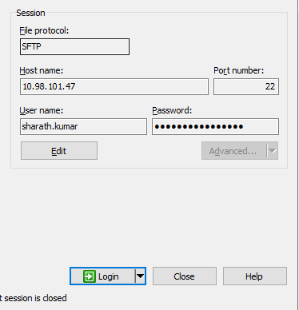

- Create 4 Directories in home directory for each of the virtual store where sales are performed
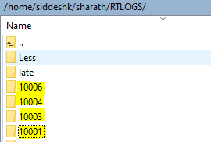
- In the left panel open the local machine path where RTLOG files are saved
- Now segregate the files according to the <StoreNumber> in the RTLOG files
- Move the RTLOG files from local machine to RMS newly created directory in each of the Store number directory respectively
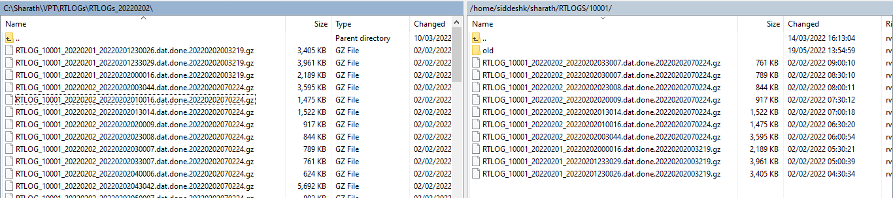

- Open Mobaxterm application and in top left corner Click on Session.
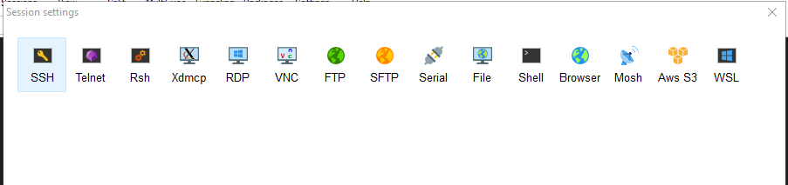

- In Session Settings, Click on SSH and in Basic SSH Settings, Enter Remote Host number (10.98.101.47) and click on Specify username checkbox

- Remove <default> username and enter your login username and click on OK button

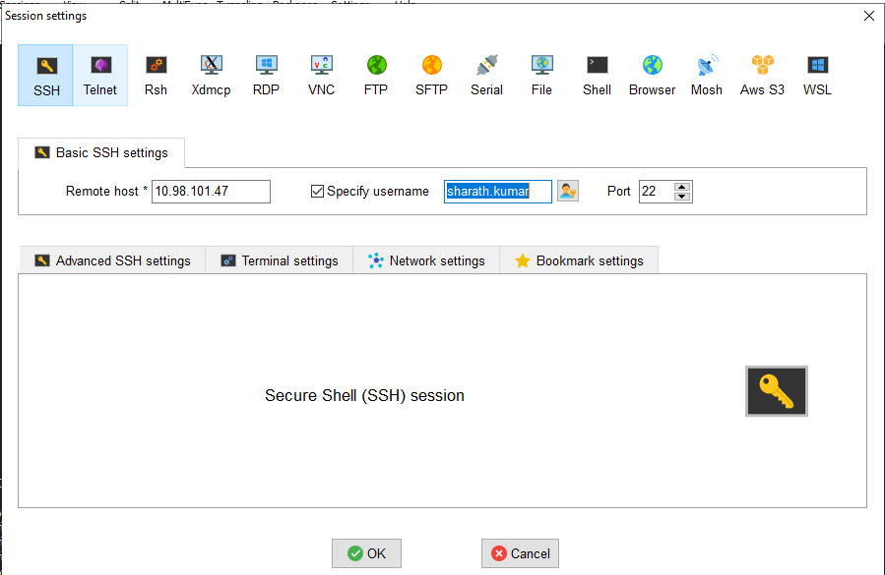

- In the session enter the password (entered password is not visible)
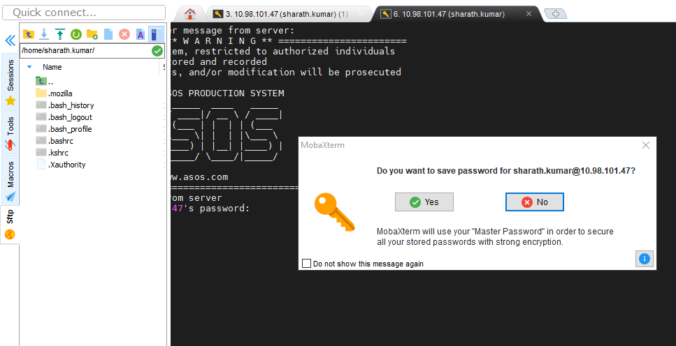

- Click on NO button.
- Once logged in, the screen looks like below.

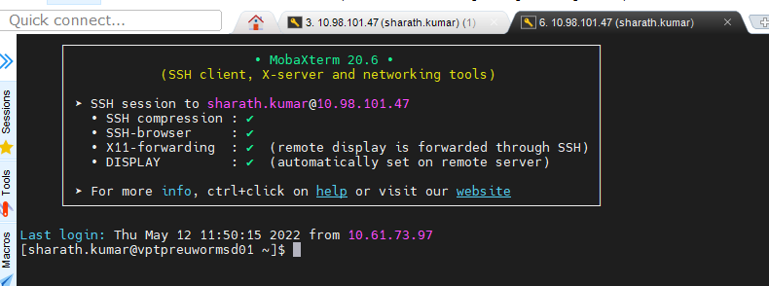

- Run the SUDO script to have the permission to run jobs
sudo su - oracle
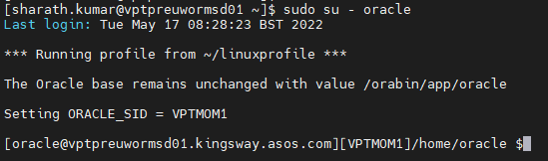
- Go to the path where RTLOG files were saved in step 7 with cd command

- List all the RTLOG files which are moved to the directory in step 7 with ls -lrt command
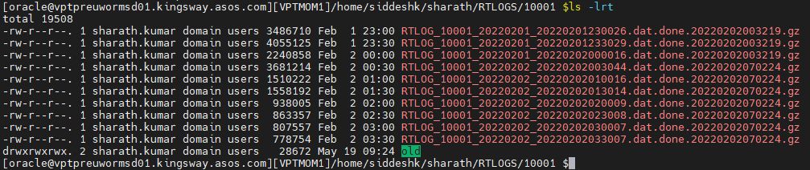
- Select all the files from the directory and paste it in Notepad ++ workpad
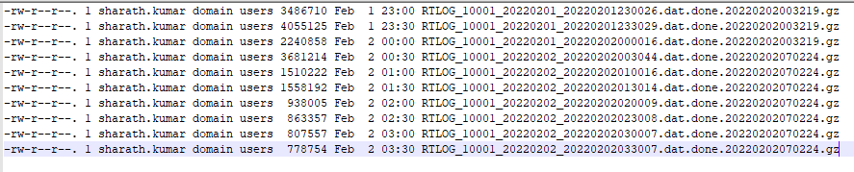
- Remove all the details except RTLOG_<StoreNumber>_<datetimestamp>.dat.done.<datetimestamp>.gz
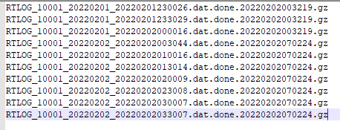

- Unzip the files again with below command in unix box.
gzip -d RTLOG_<StoreNumber>_<datetimestamp>.dat.done.<datetimestamp>.gz
ex: gzip -d RTLOG_10001_20220201_20220201230026.dat.done.20220202003219.gz
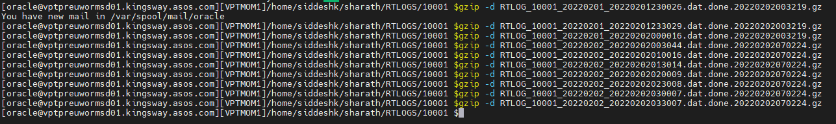

- Validate the unzip step is successful by listing the file names again in unix box with the command ls -lrt
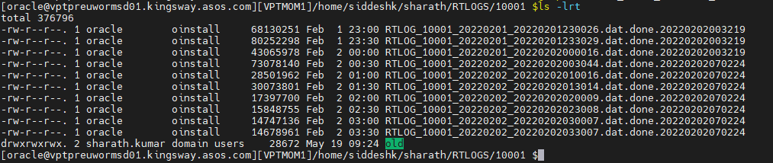

- Select all the files from the directory and paste it in Notepad ++ workpad
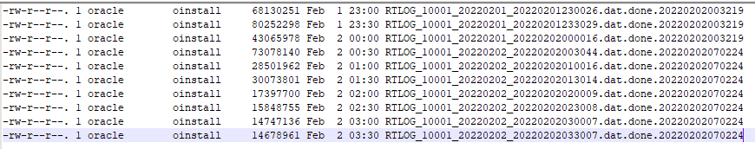
- Remove all the details except RTLOG_<storenumber>_*.dat (where * is datetimestamp of files)
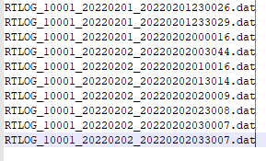
- Change file datestamp to vdate (from PERIOD table) in NOTEPAD++
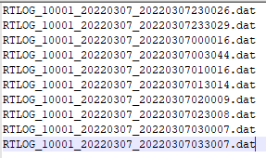
- Change the timestamp of the file (last 6 digits) to have the unique identifier number by having sequential number and directory number in which these files are to be copied.
RTLOG_<StoreNumber>_<datestamp>_<datestamp><directoryNumber><sequentialNumber>

EX: RTLOG_10001_20220307_20220307000001.dat
RTLOG_10001_20220307_20220307000002.dat
In the above example, 000 is the directory number and 001, 002 are the sequential numbers.
- Rename the RTLOG files in unix box directory with the name as changed in step 23.

mv <old file name> <new file name>
ex: mv RTLOG_10001_20220201_20220201230026.dat.done.20220202003219 RTLOG_10001_20220307_20220307000001.dat
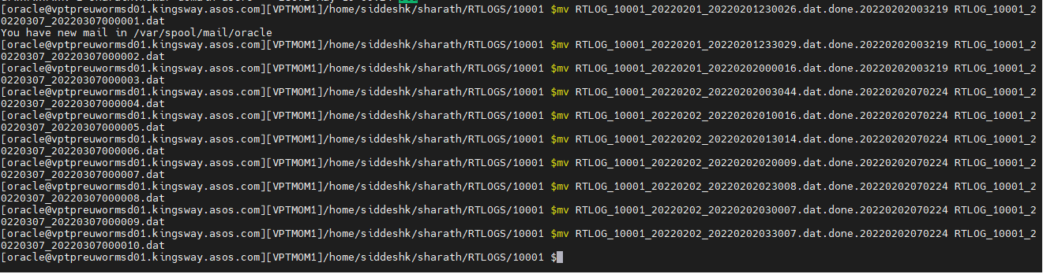

- Validate whether the files are renamed by using ls -lrt command in the same directory.

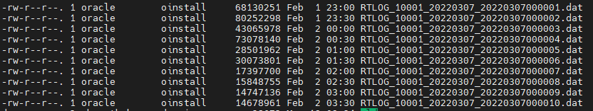

- Change all the dates within each of the files to vdate (from PERIOD table) by using below command.
sed -i ‘s/<old date>/<new date>/g’ RTLOG_*.dat
ex: sed -i 's/20220201/20220307/g' RTLOG_*.dat
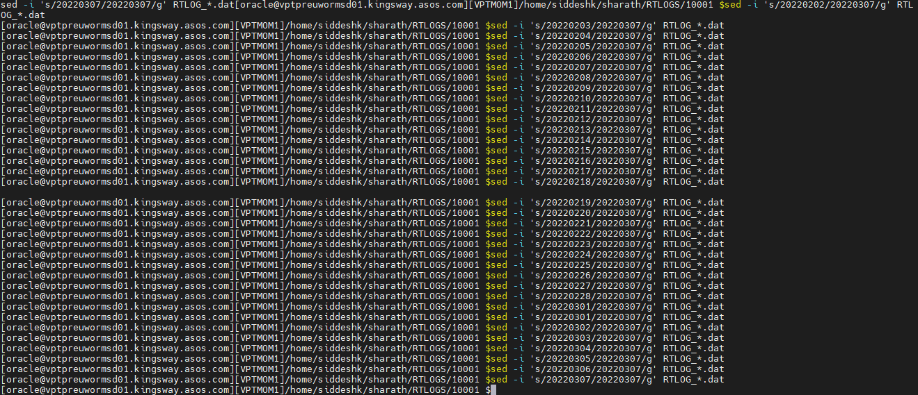

- Open some random files and validate that the dates are changed to vdate.
NOTE: under /ReSA_day folder, there are sub-folders from 0-23 hours. Remove old files from all 0-23 directories.
- In Winscp navigate to the path “/asos/oracle/vpt/data/inbound/Integration/sales/rtlog/pending/Archive/ReSA_day/” remove (delete) if any old files are there.

- Move the files from the directory where the RTLOG files were edited to the below directory.
“/asos/oracle/vpt/data/inbound/Integration/sales/rtlog/pending/Archive/ReSA_day/0 “Under the above /ReSA_day directory, there are 0-23 directories. Files under 1-23 are used for Intra-day jobs and files under 0 directory is used for Overnight Job.
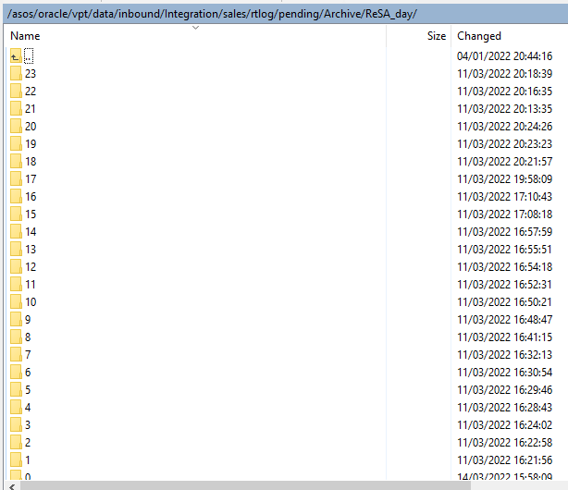
mv <current directory where RTLOG files are saved/*.*> < “/asos/oracle/vpt/data/inbound/Integration/sales/rtlog/pending/Archive/ReSA_day/*>
NOTE 1: /*.* will move all the files from the given directory
/* is the directory (like 0-23) in which files to be moved.
- View the transaction count in each of the file under RTLOG_<store_number>_* files can be viewed by using grep -o 'THEAD' RTLOG_<sotrenumber>_*.dat | wc -l.
Ex: grep -o 'THEAD' RTLOG_10004_*.dat | wc -l

- Validate the transaction count for the given hour (like 0-23) against a given store (like 10001, 10002, 10003, 10006) and try to match it with the expected transaction count for ReSA Peak sales volume as shown in below sheet.

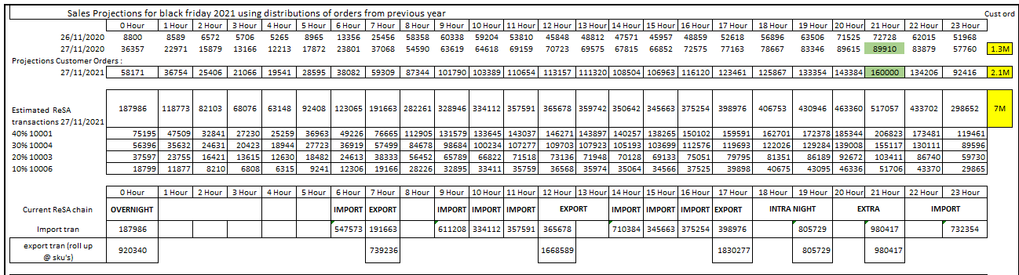
In the above table, Estimated ReSA transaction row shows the sum of transactions across all stores for a given hour.
Ex: For 0th hour total estimated transactions across all stores to be around 187k.
Further, for each of the store total estimated ReSA transaction count for the given hour is defined in the same table.
Ex: For 0th hour total estimated transactions for store 10001 is 75k, whereas for store 10004 is 56k, for store 10003 is 37k and for store 10006 is 18k
NOTE 1: There is no need to match the exact count of the transaction while moving files to respective hour directory. If it is anywhere closer to the given transaction that should be ok.
NOTE 2: IF the total transaction count against each of the store does not match anywhere close, please follow the steps 2-31 and pull more files to the given hour directory and validate the count again. If the count exceeds, then remove some files from the directory.

- Follow the steps from 2-31 for stores 10004, 10003 and 10006 for the hours 0-23.
- Below are the ReSA jobs which will be run during the day at different hours.

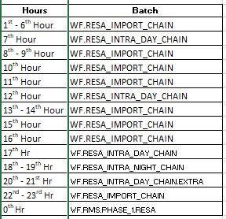
NOTE:
- While running respective hour job, move the files from respective hour directory from the path “/asos/oracle/vpt/data/inbound/Integration/sales/rtlog/pending/Archive/ReSA_day” to
“/asos/oracle/vpt/data/inbound/Integration/sales/rtlog/pending”
Follow below steps to achieve this step.
- Select all the files from the directory.
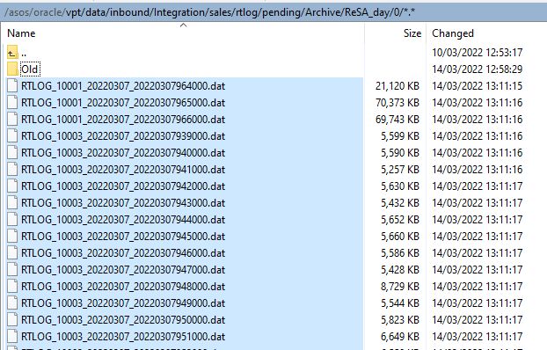
- Right click on the mouse and select Duplicate from the list
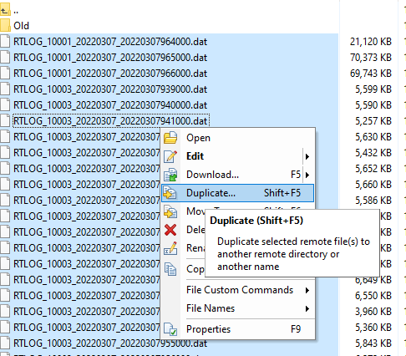

- In the Duplicate window, remove the existing Target Remote Path and enter the below path.
/asos/oracle/vpt/data/inbound/Integration/sales/rtlog/pending/*.*
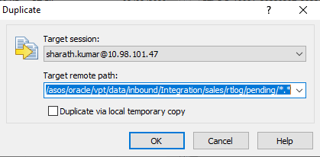

- Click on OK on the Confirm window.
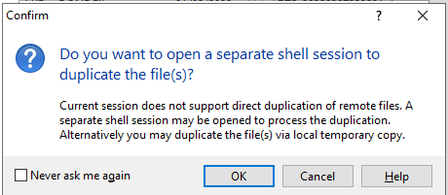

- Once the copying is done, validate whether the files are moved to “/asos/oracle/vpt/data/inbound/Integration/sales/rtlog/pending” directory.
