ORC
Wholesale portal

Functional Design Document

Author: Reetu Muneem
Creation Date: 19/11/2021
Last Updated: 09/05/2022
Document Ref: ASOS Wholesale Portal
Version: 1.2

Approvals:
Rajul Shah
Carol-Anne Adriaans
Eve Hankins


Document Control

Change Record
3
Date | Author | Version | Change Reference
19-11-2021 | Reetu Muneem | 1.0 | Initial Draft – This version does not include the new requirement shared on 12th Nov session with wholesale team. The requirements are captured in Open Issues’ section of this document.
20-12-2021 | Reetu Muneem | 1.1 | Incorporated review comments and new requirements discussed in FDD review session.
09-02-2022 | Reetu Muneem | 1.2 | 1. Incorporated review comments discussed on 11/01/2022 and updated excel extracts for dashboards.  2. Included Bulk Upload CR for Sales Order attributes –  Partner DC No.  Partner Store No.  Partner PO No.  Partner DC No.  3. Included requirement for Partner Dept. No.
Table 1 - Change Record

Reviewers
Name | Position
Kevin Clubb | Senior Business Analyst
Sue Leach | Business Analyst
Michael Mann | Principle Architect – Commercial Tech
Rajul Shah | Senior Trading Partner - Wholesale
Carol-Anne Adriaans | Senior Trading Partner - Wholesale
Simon Johnson | Trading Partner - Wholesale
Mollie Morris | Trading Partner - Wholesale
Lianne Edmondson | Trading Partner - Wholesale
Deborah Brown | Trading Partner - Wholesale
Eve Hankins | Senior Commercial Transformation Partner
Jennifer Hale | Commercial Transformation Partner
Rhian Saint | Principle Business Analyst
Table 2 - Reviewers

Contents
1 Document Control ii
1.1 Change Record ii
1.2 Reviewers ii
1.3 Contents iii
2 Introduction 1
2.1 Purpose 1
2.2 Scope 1
2.3 Definitions, Acronyms, and Abbreviations 1
2.4 References 2
3 Solution Overview 3
3.1 Overview 3
3.2 Key Functional Requirements 4
3.3 Design Assumptions 5
3.4 Integration Requirements 9
3.5 Data Requirements 10
3.6 Dependencies 11
4 Solution Functional Design – Wholesale Portal 12
4.1 User Interface Design 13
4.1.1 Landing Page 14
4.1.2 Taskbar 20
4.1.3 Pre-receipt units variance dashboard 23
4.1.4 Despatch window varaince dashboard 33
4.1.5 Post receipt units variance dashboard 39
4.1.6 Re-distribute po screen 44
4.1.7 Sales order to release dashboard 53
4.1.8 Unproductive stock dashboard 59
4.1.9 Edit/View Sales order screen 63
4.1.10 Manage sales order screen 70
4.1.11 Upload 76
4.2 Behaviour Design 80
4.2.1 System parameters 80
4.2.2 Batch Processes 81
5 Open and Closed Issues 82
5.1 Open/Closed Issues 82
6 Appendix 89
6.1 Excel extract from Dashboards/Screens 89

Introduction

The Requirments Specification captures the complete software requirements for the system, or a portion of the system. Following is a typical outline for a project using use case modeling. This artifact consists of a package containing use cases of the use case model and applicable Supplemental Specifications and other supporting information.

Purpose
The purpose of this document is to provide the functional design for the Wholesale Portal application.
Wholesale Portal is a new application that will be used by ASOS Wholesale Team in Release 1 along with existing WTSO system to maintain Sales Orders. In future releases Wholesale Portal might be evolved to be used by ASOS wholesale partners.
The application will have multiple dashboards and screens that will display the Sales Order information and would help the ASOS wholesale team to track the Sales order life cycle and distribute and release the Sales Order post receipt of associated Supplier Purchase Order. For Release 1 wholesale team will be able to edit limited number of fields on Sales Orders in the portal. Details of dashboards and screens are detailed further in the document in relevant sections.

Scope
The scope of this document is to detail the functional design of Wholesale Portal, containing the dashboards, screens and their design logic, search input fields, results and controls (menus, buttons and actions). This document will also detail the overview, design decisions and assumptions for Release 1.

Definitions, Acronyms, and Abbreviations

Acronym/Abbreviation | Position
ORMS | Oracle Retail Merchandising System
PO | Purchase Order
ASN | Advance Shipment Notification
CFA | Custom Flex Attributes
DC | Distribution Centre
WMS | Warehouse Management System
IDD | Integration Design Document
WTSO | Wholesale Trading Spreadsheet Optimisation
RSA | Retail System Administrator
RTSA | Retail Tech Support Applications
RTSC | Retail Tech Support Core
RIS | Retail Integration System
LOV | List of Values
DAS | Data Access Schema
Table 3 - Definitions, Acronyms, and Abbreviations

References
Document | Location (URL)
Placeholder- Any ASOS requirement document for wholesale | TBD
Placeholder- Any mapping document or data contract with WTSO | TBD
Table 4 - References

Solution Overview

Overview
With the acquisition of the Arcadia brands, ASOS have entered the wholesale business. The wholesale business is mostly supported through WTSO tool which they have inherited through this acquisition, in addition to several manual processes. The ASOS vision is introduce more efficiency and control to the wholesale business processes in order to grow and meet demand from both their existing wholesale business partners and to engage with new partners. As of now ASOS runs the wholesale business model only for Top brands, Miss Selfridge but they also want to introduce their own ASOS brands and other brands like As You, IP Brands, Collusion and HIIT to this model.
ASOS have envisaged a Wholesale Portal to systemise the current manual allocation and distribution method used to send stock to picks along with supporting information to Advanced., whilst leaning upon the functionality available in the base Oracle Retail solutions implemented through the TGR programme. The functionality available in the Wholesale Portal is anticipated to grow over time, but initially will align with the WTSO solutions. For Release 1 this portal would only be used by the ASOS Wholesale team, and not the Wholesale Partners. The Sales Order will continue to be raised/maintained in WTSO and will be integrated to this portal.
In ASOS existing wholesale business process, there is high degree of communication which happens manually outside of ASOS systems which are used to raise Supplier POs and Sales Orders via Commercial Team and Wholesale team respectively. For Release 1 some part of this communication can be reduced using different dashboards provided in the portal. However, some communication will continue manually and in future releases this portal will evolve to remove that dependency and track it systematically.

The main functionalities for Release 1 of Wholesale Portal are:
- Variance Dashboards - A set of dashboards will provide the visibility of any discrepancy between Supplier POs and associated Sales Orders in terms of units and despatch month.
- Distribution and Release Dashboards/screens- A set of dashboards and screens will provide the visibility of Sales Orders that are ready to be distributed and released after the receipt of associated Supplier PO.
- Unproductive Stock Dashboard – This dashboard will provide the visibility of un-productive wholesale stock available in a warehouse of ASOS for different brands. The ORMS concept of virtual warehouses will be used to track the wholesale inventory in a warehouse.
- Edit/View Sales Order screen – This screen will show individual Sales Order and wholesale team will be able to edit some fields on this screen. Details of what fields user can edit are described in relevant section of this document.
- Manage Sales Order screen – This screen will help the user to search for any Sales Order in all statuses and take specific actions. Details of what action user can take are described in relevant section of this document.
- Send Sales Order to ORMS so that its visibility can be provided to other systems.
- Providing necessary information for Pick to supply chain.
- Generate billing extract for finance.
- Download and Upload of Sales Orders list, for updating Sales Order attributes in bulk.

Wholesale team will be logging on to this portal via web (using secure communication, HTTPS protocol) with their corresponding single sign on user id / password.

Key Functional Requirements
The following requirements have been identified during the design phase to support Wholesale Business process in Release 1:
- Sales Orders
  - Ability to receive Sales Orders from WTSO that are linked to a Supplier PO (Direct/Split).
  - Ability to consume Sales Orders generated from WTSO to satisfy trade orders which are not linked to a supplier PO and are raised based on unproductive wholesale stock.
  - Ability to receive amendments on these Sales Orders from WTSO before their release from Wholesale Portal.
  - Ability to show any discrepancy between Supplier POs and associated Sales Orders in terms of units or despatch month.
  - Ability to show Sales Orders that needs to be re-distributed due to the supplier PO being under or over receipted.
  - Ability to distribute Supplier PO’s receipted units on associated Sales Orders.
  - Ability to release Sales Orders individually or in multiple.
  - Ability to edit certain fields on Sales Order, details of editable fields are provided in relevant section of the document.
  - Ability to view a Sales Order.
  - Ability to search for a Sales Order using different filtering criteria.
  - Ability to put individual or multiple Sales Order on hold.
  - Ability to apply partner level hold on Sales Orders.
  - Ability to send Sales Order and their amendments to ORMS.
  - Ability to extract data in excel from relevant dashboards. Details of extracts are provided in section 6.1.
  - Ability to download and upload Sales Order list to update following Sales Order attributes-
- Partner DC No.
- Partner Store No.
- Partner PO No.
- Partner Dept. No.

- Unproductive Wholesale Stock
  - Ability to provide visibility of unproductive wholesale stock. Any wholesale stock that is not linked with any Sales Order or manual transfer for a virtual warehouse linked with wholesale channel, will be accounted as unproductive wholesale stock.

- Invoices
  - Ability to integrate sales orders with ORMS to automate the billing process.

- Pick information
  - Ability to pass relevant information to ORMS to release the associated Sales Order’s allocations and send the Release and Pick information to WMS.

Design Assumptions
The following design assumptions have been considered for Release 1 while designing the solution described in this document:

- Wholesale Portal will be built using JET framework. Thus, the look and feel of this portal will be slightly different to existing ASOS micro apps.
- Application look and feel will be consistent for all users.
- Each user will have their own individual login details - login id and password.
- Wholesale Portal will have inbound integration with WTSO but there will be no outbound integration from portal to WTSO.
- There will be no default hierarchy setup for any user, they will be able to search for different Supplier POs or Sales Orders independent of hierarchy.
- ORMS multiple channel and virtual warehouse functionality will be used to differentiate between online and wholesale transactions.
- The foundation data to support the wholesale business process will be created and maintained in ORMS and will be replicated in Wholesale Portal to be used. However, following data elements will be specific to Wholesale Portal and will be maintained in portal through service requests for RTSA team. As there will be no front end to manage this data in this release –
- Default number of days per ASOS warehouse to be added on to Supplier PO delivery to calculate the despatch month. Current assumption is it will be set to 21 days for all warehouses.
- Partner level hold indicator setup for each partner. For Release 1 all partners will be set with hold indicator so that wholesale team can distribute and release each Sales order after reviewing it.
- Mandatory Partner PO No. indicator at partner level. This indicator will determine if the Partner PO No. Number is mandatory for the invoicing and release or not. User would not be able to release a Sales Order if this indictor is set to ’Y’ and the Sales Order does not have a Partner PO No.
- Threshold percentage for each Partner which will be used to calculate the variance at SKU level during Supplier PO’s receipt distribution.
- Mandatory DC/store level indicator at partner level. This indicator will determine if partner DC number or parent store number is mandatory for the Sales Order or not.
- Association of partner store numbers with partner DC and partner.

- Following Sales Order status will be visible to wholesale team on the portal-
- Worksheet – this status will not be applicable for Release 1, as WTSO will only send approved Sales Orders to portal.
- Approved – First time the Sales Order will be sent from WTSO to portal its status will show as Approved in portal. If any updates will be received on the sales order from WTSO then also its status will show as Approved in wholesale portal except for if it gets cancelled in WTSO or if it is put on hold or released or despatched or posted.
- Cancelled – In wholesale portal the status will show as cancelled if a cancellation is received from WTSO on the Sales Order.
- On Hold – If the Sales Order has either partner hold, or individual Sales Order hold applied then its status will show as ‘On Hold’ in wholesale portal.
- Released – If the Sales Order has been released from the wholesale portal, then its status will show as Released.
- Despatched – If the allocations linked with the Sales Order are despatched by the WMS. The wholesale portal will show this status as soon as one of the allocations linked with Sales Order is despatched by WMS system.
- Posted – Wholesale portal will show this status if the billing information for the Sales Order is extracted to the finance. This status will show up even if a part of Sales Order despatched information was posted to finance.
Out of these statuses following status will be referential status based on the journey of Sales Order and would not be send to any other system as part of Sales Order record.
- On Hold
- Released
- Despatched
- Posted
- The Sales Order type will have two valid values as described below. This differentiation of Sales Order type will only be visible on Wholesale Portal and will not passed to any other system.
- Pre-Order – Sales Order created based on a Supplier PO.
- Trade – Sales Order based on unproductive wholesale stock.
- As part of ASOS wholesale business process the Supplier POs will be raised as Direct or Split. But for split POs it will be a 100% allocation from first destination to final destination. In PO Micro app there will be no restrictions to apply this logic systematically it would be governed by ASOS business process. If the Supplier PO is raised incorrectly by commercial team, the associated Sales Order from WTSO will fail to integrate in the portal. Auto PO are not in scope for wholesale but there will no systematic restrictions applied on PO micro app to stop it and it will be handled as part of business process. If due to human error an auto wholesale supplier PO will be raised, then commercial team should cancel that Supplier PO.
- Supplier PO will continue to be raised and maintained in POMA and ASNs in ASOSNET.
- Order Row code will be used to identify the Supplier POs with relevant Sales Orders.
- Wholesale team will be combining Sales orders from different partners having same despatch month for an option under same Order Row Code.
- If commercial team has raised Supplier PO with wrong order row code, then the sales order associated with this order row code will fail in integration from WTSO to the portal. Wholesale team will receive the reason for failure in an error report and they can accordingly advise commercial team to correct the order row code on Supplier PO.
- Wholesale team would be able to send new Sales Order with same order row code as other existing Sales Order linked to a Supplier PO, provided there is no receipt on the Supplier PO and there are units available on Supplier PO to be linked with new Sales Orders. But any discrepancy between Supplier PO units and associated Sales Orders will show up in Pre-receipt Unit Variance Dashboard as usual. If receipt will exist on Supplier PO and WTSO will send any new Sales Order with same order row code as Supplier PO, that Sales Order will fail and will not exist on wholesale portal. The failure will be shared with wholesale team in an error report.
- The financial calendar used in WTSO and ORMS will be same.
- Individual Sales Order hold will always supersede the Partner level hold.
- WTSO will not be able to integrate the created by ids or last updated by ids, so the user id of batch process will be used to populate these fields in portal data base.
- WTSO will be able to differentiate a Supplier PO Sales Order versus Wholesale Stock Sales Order in the WTSO extract to Wholesale Portal.
- Cancellation reason codes for Sales Orders will be aligned between ORMS and WTSO. Existing business process will be leveraged to upload these reason codes in Merch management by RSAs.
- WTSO Sales Order file sent to Wholesale Portal will contain both ASOS design and other brand Sales Orders. In portal these Sales Orders will be consumed and treated in same way.
- WTSO will not send any updates on Sales Order once it is released. Any such updates will fail in inbound interface to Wholesale Portal from WTSO with relevant error to inform the wholesale team on the reason of failure.
- No systematic auto release of Sales Order will be triggered from Wholesale Portal. Wholesale team will be taking these steps manually from the dashboard and screens in this release.
- For dashboards any discrepancy between Supplier PO details and associated wholesale orders will continue to be highlighted in dashboards until it is resolved fully. In this release user will not be able to mark these discrepancies as confirmed etc so that they stop appearing on the dashboard.
- Wholesale Portal screens will open in view mode for cases where Sales Order is currently locked by any other user or has been released, despatched, posted or cancelled. Following information message will be shown to user in such cases-
‘Sales Order # is currently locked by another user and cannot be released’, or ‘Another user is editing this Sales Order. The Screen is now in View mode.’.
- All the dashboards will be refreshed using batch processes. These batches will run multiple times a day.
- ASOS FC will show the FC name instead of the ids in the portal.
- Any dashboard or screen in wholesale portal showing brand sizes will use the display order set up in merch management for these brand sizes under the size group, to appropriately show them in sequence. The same display order is used by commercial team in merch management while viewing brand sizes.
- Wholesale Portal will be available in English. All front-end labels are defined in a translation file. Additional languages can be additionally added by ASOS to the translation file.
- No validation will be done on Partner PO No. and Partner Dept No. values entered by the user in the Wholesale Portal either through Edit Sales Order screen or bulk upload functionality.
- The maximum Sales Order lines that a user can update in one upload will be 100. This would be configurable and wholesale team could decide to change this value in future. It will be an RTSA activity to update this config.
- Manage Sales Order screen will display maximum 500 records in result table.

- Design Decisions
- The following design decisions have been considered for Release 1 while designing the solution described in this document:

- Wholesale team will continue to create/maintain Sales Orders in WTSO. They will review the Supplier PO and Sales Orders comparisons in Wholesale Portal dashboards but to make any adjustments on Sales Orders they will be making the amendments in WTSO which will flow to Wholesale Portal as updates.
- Any errors encountered during the processing of Sales Order from WTSO to wholesale portal will be extracted and send to wholesale team by RTSC.
- WTSO will not receive any updates from wholesale portal.
- ASOS brand Sales Order will also be raised in WTSO in same way as other Brands. No separate data setup is expected for them in wholesale portal.
- Brands between WTSO and ORMS will be consistent.
- Each user will have their own individual login details - login id and password.
- No wholesale partner will be logging into wholesale portal.
- WTSO will send the Sales Order to Wholesale Portal only after it has been sized and option id is populated in WTSO. Option Id will be validated by inbound interface to Wholesale Portal from WTSO. If invalid option id will be sent, then that Sales Order will be rejected by the interface.
- WTSO will send the Sales Order files in csv format.
- WTSO will send the partner cancellation reason code with ‘P’ appended in the front.
- A new ‘Wholesale’ channel will be created in ORMS.
- The new wholesale virtual warehouses will be linked to this new ‘Wholesale’ channel, and it will serve the purpose of segregating un-productive wholesale stock and provide that visibility on portal’s Unproductive Stock Dashboard. These virtual warehouses will also be used to raise Supplier POs for wholesale stock.
- Sales Order Attributes bulk download and upload file will be in CSV format.

Integration Requirements
Below is a high-level view of the interfaces identified to support the Wholesale Portal.

Document | Location (URL)
Placeholder- WTSO to wholesale Portal inbound IDD | TBD
Placeholder- Wholesale Portal to ORMS IDD | TBD
Placeholder – IDD for pick instructions | TBD
Placeholder – IDD for allocation enrichment | TBD
Placeholder – IDD for invoicing | TBD
Table 5 - Integration Requirements

Data Requirements

This section defines data needed to support the Wholesale Portal.

ORMS/DAS
- Product Hierarchy and Buyrarchy Structures
- New wholesale channel
- Locations (Warehouse and Stores) – New virtual warehouses linked with new wholesale channel.
- Matrices setup for the new virtual warehouses.
- Suppliers
- Customer Groups, Customer and Customer Locations – This data set will hold the ASOS wholesale partners information.
- Item and item attributes
- Purchase Orders and relevant CFAs
- Shipments and relevant CFAs
- Allocations and relevant CFAs
- Transfers
- Wholesale billing sales
- Calendar
- Cancellation Reason codes setup matching with WTSO codes.
Note: For some of these data entities an initial migration or database upload will be required to set them in ORMS and in portal.

Wholesale Portal
- Sales Order header and detail
- Wholesale Partners Groups, Partners, Partner Locations and their attributes. Attribute’s data will hold following information for partners that will not be maintained in ORMS.
- Hold indicator
- Mandatory Partner PO indicator
- Mandatory DC/store indicator
- Mandatory Department indicator
- Thresholds

- System parameters – this data will hold following information for general functioning of the wholesale portal and will not be modified very frequently
- Setup of default number of days for each ASOS warehouse to calculate the despatch month.
- Purge days – When Sales Order information will be purged from wholesale portal.
- Sales Order Attributes Upload threshold – This configuration will determine how many Sales Order can be updated in one upload.

Dependencies
Wholesale Portal has dependency on following systems for Release 1
- DAS database is up and running.
- WTSO to provide Sales Order files to be uploaded in portal.
- ORMS system to be available to consume Sales Order and its related information from portal.
- RIS to be available to pass the Sales Order and associated allocations, release and pick list information to downstream systems.
- Automic Batch Schedular.

Solution Functional Design – Wholesale Portal
This section will provide a description of the solution design to support the functional requirements for Release 1 as stated previously in the document.

The following link contains the Wholesale Portal business processes identified by ASOS:
https://asos1.sharepoint.com/:u:/r/sites/WholesaleStrategic/Shared%20Documents/Business%20Process/Process%20Flow/Business%20Process%20-%20WS%20exceptions%20report%20v1.0.vsdx?d=w20ff0dad032c44ff9aa6d8071173711d&%3Bcsf=1&%3Bweb=1&%3Be=dWp0Jv&isSPOFile=1

The following link contains the Partner Group/Partner/Partner Location/DC Id and Store Id data setup discussed and agreed with wholesale team-
https://asos1.sharepoint.com/:x:/r/sites/WholesaleStrategic/_layouts/15/Doc.aspx?sourcedoc=%7B8D699A44-3253-40BE-83A8-5301954686F5%7D&%3Bfile=Customers+template+v3.1.xlsx&%3Baction=default&%3Bmobileredirect=true&%3Bcid=7643c6a2-0e0a-4c8d-a580-f388f2d9fe39&isSPOFile=1

User Interface Design

This section defines the dashboards, screens and their logic. When user will login to the portal, they will be taken to the landing page. From this page they will be able to access different dashboards. The action taken by user in respective dashboards will open different screens in portal. Some screens will be accessible through the task bar as well. Following figure depicts the overall dashboards and screens flow in the portal. Details of each Dashboard and Screen are provided further in sub sections.

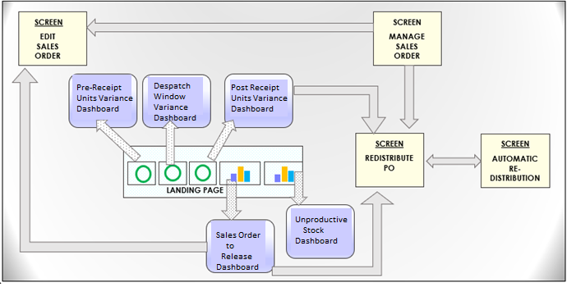
Figure 1 – Dashboard and Screen Navigation

Landing Page

Landing page will be the first thing user will see after logging into the Wholesale Portal. All the dashboards will appear as tiles on this landing page. Following figure represents the view of landing page.

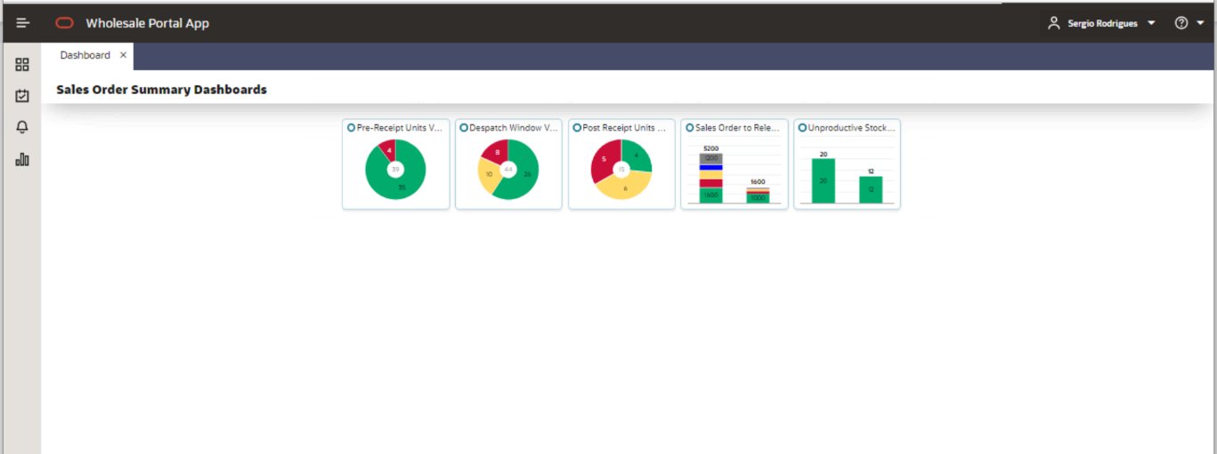
Figure 2 – Landing Page

Following dashboards will appear as pie charts
- Pre-Receipt Units Variance Dashboard
- Despatch Window Variance Dashboard
- Post Receipt Units Variance Dashboard

Following dashboards will appear as bar charts
- Sales Order to Release Dashboard
- Unproductive Stock Dashboard

When user will click on any of the dashboard tiles, an enlarged image of the dashboard will appear as shown below in the diagram where user will be able to see the following details
- Total count of entities shown in the centre.
- Definition of each colour and their respective counts (when user hover over the colour these values will be shown, please see figure 3 for reference). Please note that the colour user clicks on chart will open the respective dashboard with results matching the colour definition. If the whole pie chart has a single colour, then the count will only appear in the centre.
- Date and time when dashboards were last refreshed.

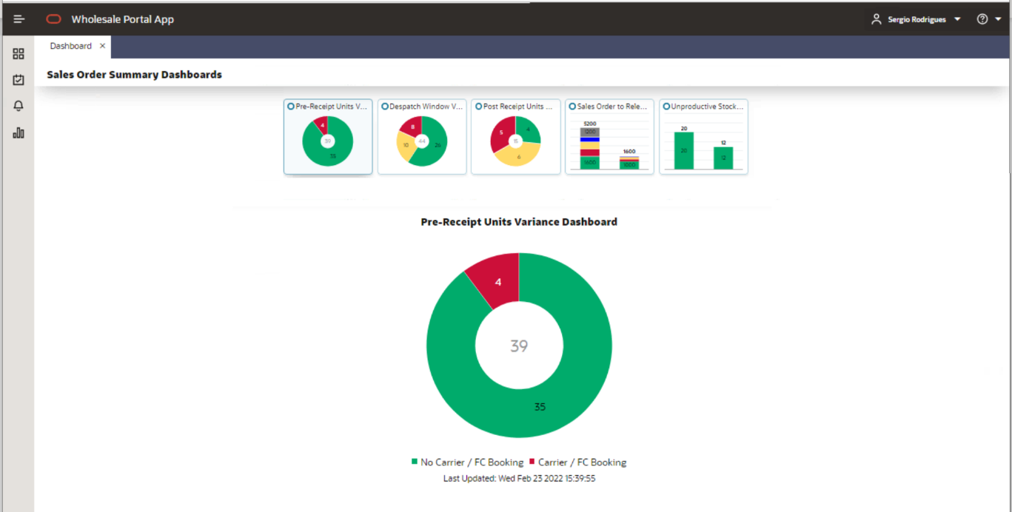
Figure 3 – Landing Page with enlarged dashboard (Pie chart example)

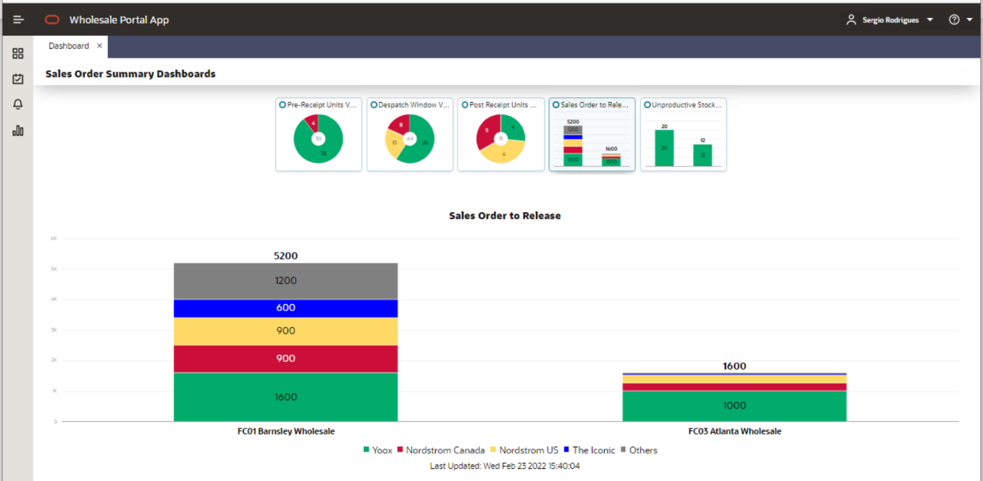
Figure 4 – Landing Page with enlarged dashboard (Bar chart example)

The colour definition for each dashboard is described below
- Pre-Receipt Units Variance dashboard
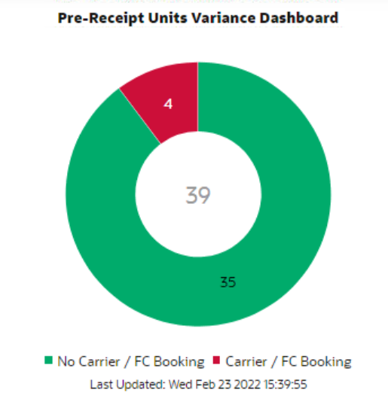
Figure 5 – Pre-Receipt Units Variance Dashboard

- Green – This will represent number of Sales Orders associated with Supplier POs, where Supplier PO’s ASN have got no carrier or FC booking date.
- Red – This will represent number of Sales Orders associated with Supplier POs, where Supplier PO’s ASN have got carrier or FC booking date.

- Despatch Window Variance Dashboard

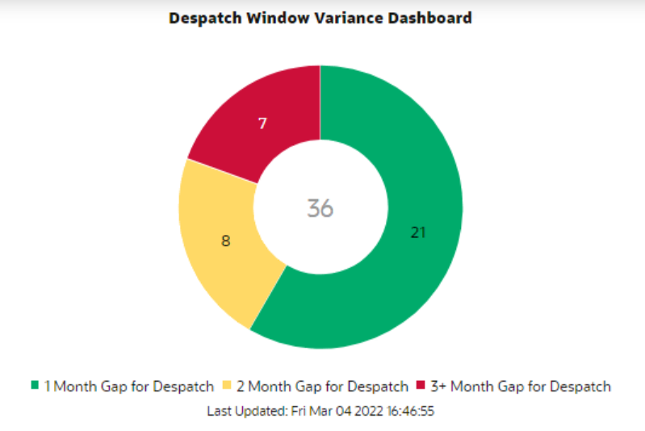
Figure 6 – Despatch Window Variance Dashboard

- Green – This will represent number of Sales Orders where there is one-month gap between the current despatch month and the calculated despatch month (based on latest view of Supplier PO’s/ASNs delivery month).
- Yellow – This will represent number of Sales Orders where there is two-month gap between the current despatch month and the calculated despatch month (based on latest view of Supplier PO’s/ latest ASNs delivery month).
- Red – This will represent number of Sales Orders where there is three-month or more, gap between the current despatch month and the calculated despatch month (based on latest view of Supplier PO’s/latest ASNs delivery month).

- Post Receipt Units Variance Dashboard
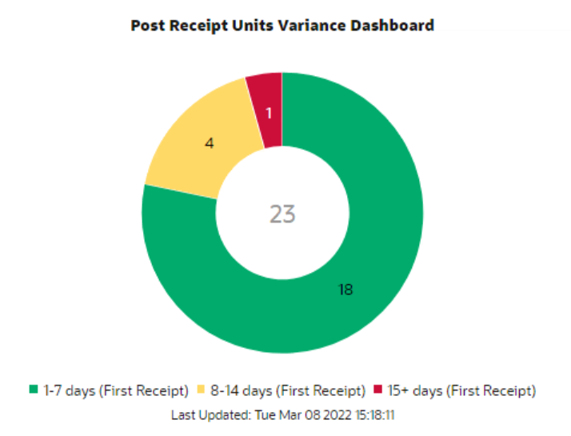
Figure 7 – Post Receipt Units Variance Dashboard

- Green – This will represent number of Sales Orders where first receipt on the associated Supplier PO has passed 1-7 days.
- Yellow – This will represent number of Sales Orders where first receipt on the associated Supplier PO has passed 8-14 days.
- Red – This will represent number of Sales Orders where first receipt on the associated Supplier PO has passed more than or equal to 15 days.

- Sales Order to Release Dashboard

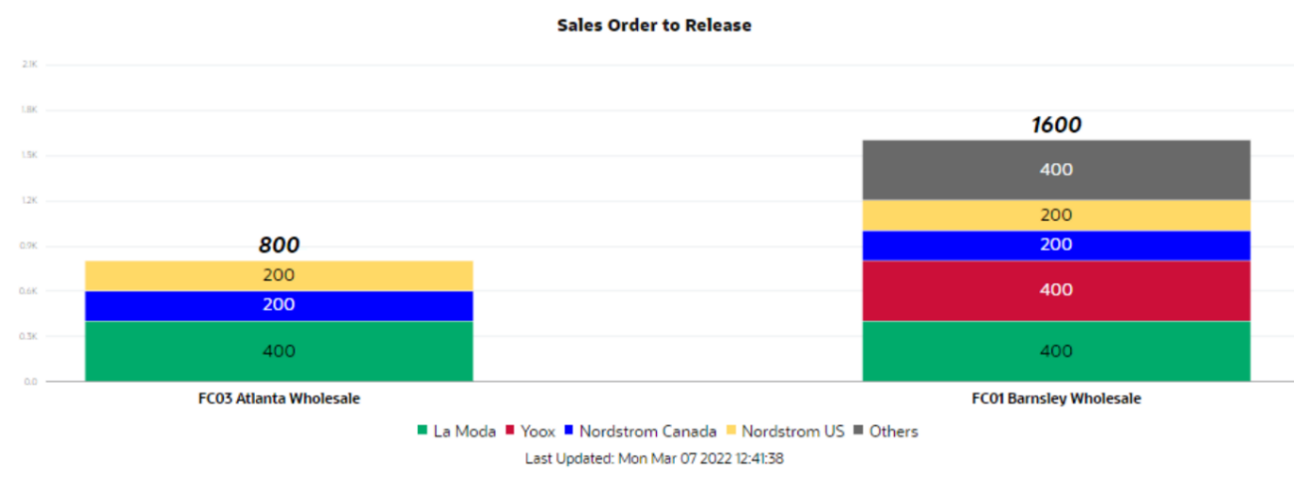
Figure 8 – Sales Order to Release Dashboard

This dashboard will have multiple colours in the bar depending on the number of units on Sales Orders that needs to be Released for each partner sourced from respective ASOS warehouse. Five partners with highest number of units on Sales Order that needs to be Released will be assigned five distinct colours while all other partners will be summed up together under ‘Others’ label and will be assigned a different colour. The colours are yet to be agreed with business, the above figure is just an example for look and feel.

- Unproductive Stock Dashboard

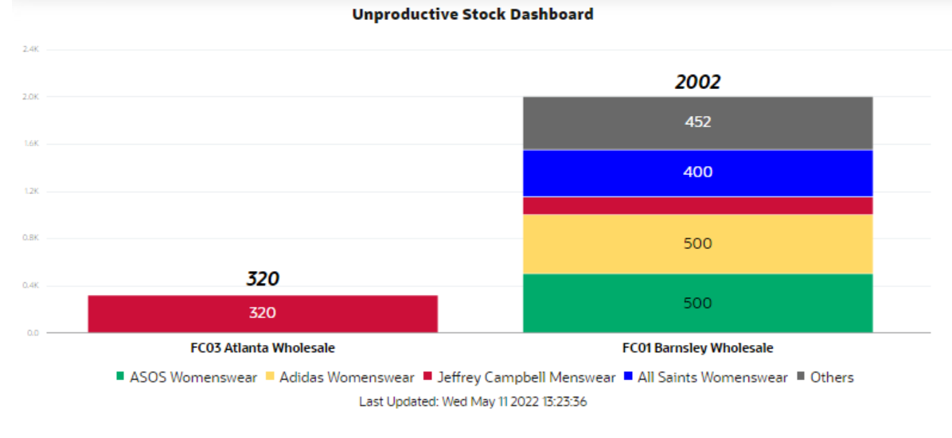
Figure 9 – Unproductive Stock Dashboard

This dashboard will have multiple colours in the bar depending on the un-productive wholesale stock for each brand/division combination in each ASOS wholesale warehouse. The details of what will account as unproductive stock is provided in the detailed section of this dashboard (Section 0). Five brands/division combination with highest units will be assigned five distinct colours while all other brands/division combinations will be summed up together under ‘Others’ label and will be assigned a different colour. The colours are yet to be agreed with business, the above figure is just an example for look and feel. The dashboard will be driven based on the wholesale units.

Taskbar

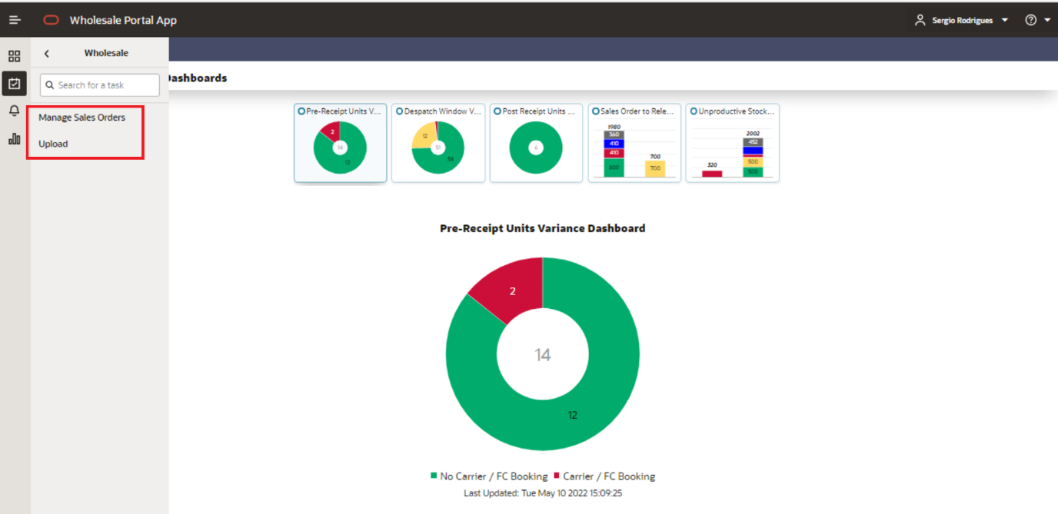
Figure 10 – Task Bar

User would be able to access ‘Manage Sales Order’ and ‘Upload’ screen from task bar as shown above.
Details of Manage Sales Order screen and Upload screen are described in Section 0 and Section- 0 respectively.

The sections below will detail the functionality of each dashboard and screen. Any data shown on the figures of dashboards or screens in this section should be treated as dummy data.
Each of the dashboard and relevant screens will have search filters provided to help the user to narrow down the specific data entity they want to look at. Most of these filters will be searchable fields in a pop-up (will have a magnifying glass next to them), or a drop-down field or a calendar field. Few examples are provided below

- If user will search for an Option ID, they could either directly type in or copy paste the option id in the field as shown in figure below. The user should know the exact Option Id in this case-
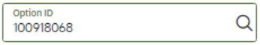
Figure 11 – Option ID Search field

If user does not know the Option ID, they can click on the magnifying glass icon which will open a pop-up as shown in below screen shot where user can search by both Option ID or the Option Description. Both the Option Id and Option Description field can be used to search a broad range.
For e.g., if user will enter 1000 in Option Id field it will search for all options that have 1000 in their Option id or id user search with Option Description as ‘Day Dress’ it will bring all the options which has ‘Day Dress’ in their descriptions.
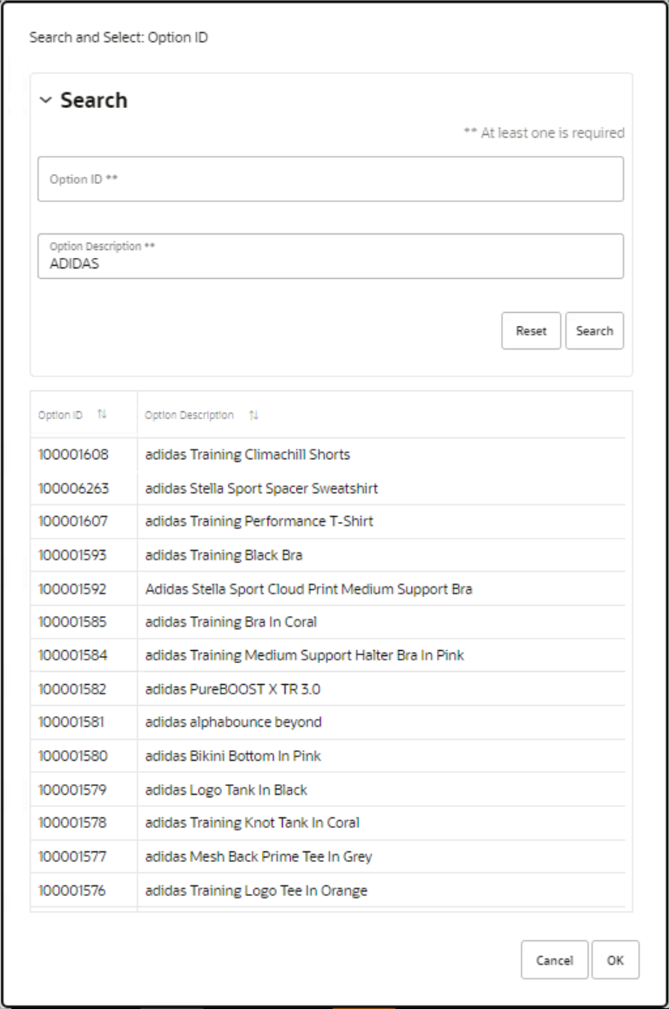
Figure 12 – Option Popup Screen

- If user will search for PO Number, they can key in the exact PO number or copy paste it as shown in below screenshot.
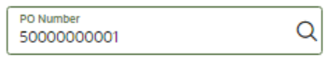
Figure 13 – Supplier Purchase Order ID Search field

If user does not know the exact PO Number, they can click on the magnifying glass icon which will open a pop-up as shown in below screen shot where user can search by partial PO number and the list of all POs which contains that partial PO Number.

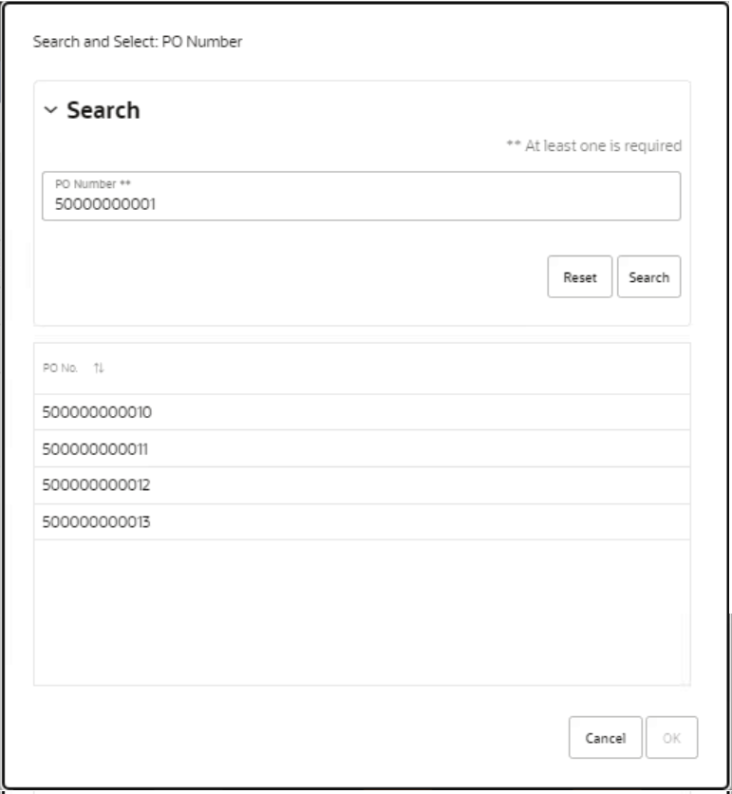
Figure 14 – Supplier Purchase Order Popup Screen

Pre-receipt units variance dashboard

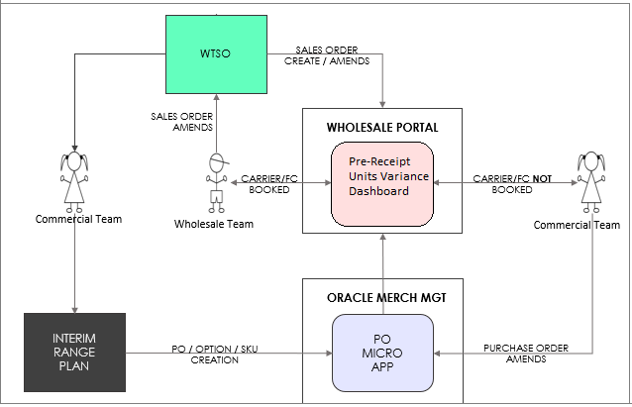
Figure 15 – Pre-Receipt Units Variance Dashboard

The above figure depicts the flow of Supplier PO and Sales Order between different systems. As part of existing wholesale business process Wholesale team will be capturing the Sales Orders from different partners in WTSO. They will then collate these different partner orders under one Order Row code for one option and one despatch month, being sourced from a specific ASOS warehouse. They will pass the relevant information to Commercial Team to raise the Supplier PO with relevant warehouse with requested number of units for that option using same order row code.
Ideally this business process should work fine but due to human error if Commercial team has raised the Supplier PO to a different number of units, then requested by Wholesale team, this discrepancy will show up in this dashboard. This discrepancy will be removed from dashboard once the Supplier PO and active Sales Orders are matching or the Supplier PO have receipts, or all the Sales Orders fulfilled by Supplier PO are cancelled. If for any reason Supplier PO is cancelled but the Sales Orders are not yet cancelled, then also user will see that discrepancy on this dashboard, unless all these Sales Orders are cancelled in WTSO, and those updates are sent to Wholesale Portal.
After reviewing the discrepancy Wholesale Team will take one of the below actions outside of Wholesale Portal. The decision could be influenced by the presence of Carrier or FC booking date on the ASNs of the supplier PO.
- Request the commercial team to correct the Supplier PO units so that it matches the request from wholesale team.
- Update the respective Sales Orders in WTSO to match units ordered on Supplier PO.

This Pre-Receipt Units Variance dashboard will have following sections-
  - Search
    - User would be able to further narrow down the result using any of the search filters provided in this section.
  - Header and Detail Tables
    - Header table will show the data at Supplier PO level that are in variance in units with their respective Sales Orders
    - Detail table will show the data at Sales Order level. The data in this table will change based on the Supplier PO line selected by the user in header table.
  - Contextual Pane
    - This section will show the SKU level distribution for the Sales Order user have selected in the detail table.

  - Close Button
    - This button will close the dashboard. The cross on top of the screen will also close the dashboard. This button will be available on all dashboard with same functionality of closure. Thus, details of this button are not repeated in each dashboard’s section in this document.

Search

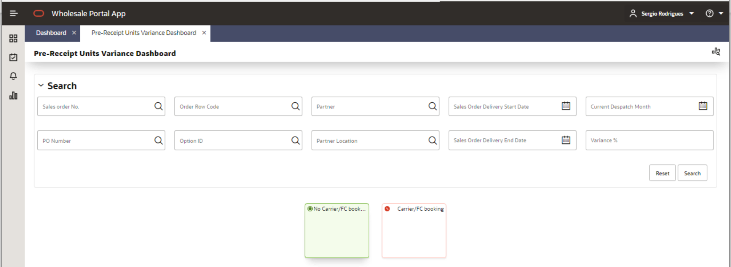
Figure 16 – Pre-Receipt Units Variance Dashboard (Search Section)

Filters: In the Search section user will be able to use any of the following filters to further narrow down the results shown in the dashboard-

- Sales Order No. – This will be the Sales Order No. generated / maintained in Wholesale Portal to track a unique Sales Order.
- PO Number – This will be Supplier PO No.
- Order Row Code
- Variance % – The dashboard will show over all variance (inclusive of all SKUs) of units between Supplier PO and associated Sales Orders. But to drill down to SKU level user can use this filter. If user will search using a positive variance say 10% it will bring result where at least one SKU has breached this exact variance % or higher. But if user search with negative variance says -10% then it will bring result with exact same variance or lower. If user search with 0 they will receive following error – ‘Only values greater or less than 0 are allowed.’
- Partner– Wholesale Partner
- Partner Location– Wholesale Partner location.
- Option id
- Current Despatch Month
- Sales Order Delivery Start Date
- Sales Order Delivery End Date

Usually in WTSO the Sales Order delivery’s start and end date will be start and ending of a month. But user will be able to search with any date. If both dates are used as search criteria, then it will be treated as fixed date range. If only start date will populated, then only those Sales Order will be searched that have that matching start date on Sales Order delivery window independent of end date. Similarly, for end date only those Sales Order will be searched that have matching end date on Sales Order delivery window.

Colour Tiles: Details of the colour tiles in Search section are mentioned below.

No Carrier/FC Booking - If user selects this tile the result tables will show Supplier POs where none of associated ASNs have either Carrier or FC booking date and the Supplier PO do not have any receipt.

Carrier/FC Booking - If user selects this tile the result tables will show Supplier POs where at least one of associated ASNs have either Carrier or FC booking date and the Supplier PO do not have any receipt.

Buttons: Details of the buttons in Search section are mentioned below. The same buttons are used in all dashboard’s search section, and they will perform the same functions as mentioned below. Thus, details of these buttons are not repeated in each dashboard’s section in this document.

Search - When user will select this button the selection filters used by user will refresh the result tables in dashboard.

Reset – When user will select this button the selection filters used by user will be cleared and user can do a fresh selection again without the hassle of removing already selected filters.

Header and Detail Tables
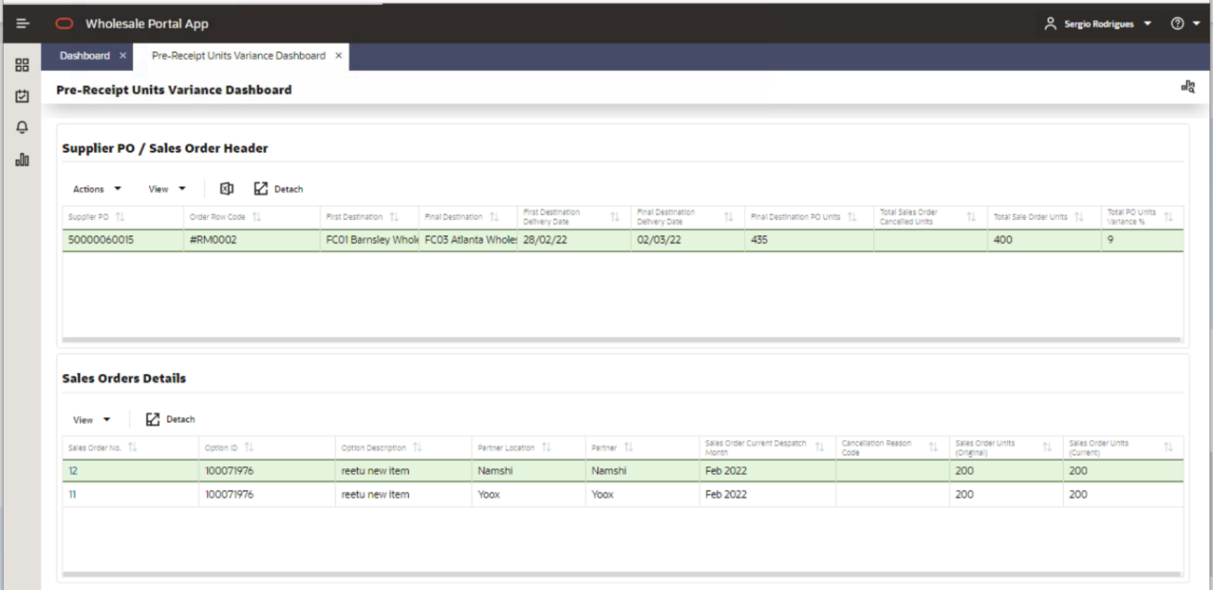
Figure 17– Pre-Receipt Units Variance Dashboard (Header & Detail Section)

Header Table – Supplier PO/Sales Order Header
Each Header table will have following actions in all dashboards and the functionality of these will remain consistent in all dashboards thus, their details will not be repeated in each dashboard section of this document.

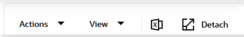
Figure 18– Pre-Receipt Units Variance Dashboard (Header Table)

- Action – In this Action drop down user will see the actions they can take on this table. For e.g., in this dashboard the only action user can take is to export the dashboard data in an excel file. So, the Actions drop down will show ‘Export to Excel’ as shown in below screenshot.

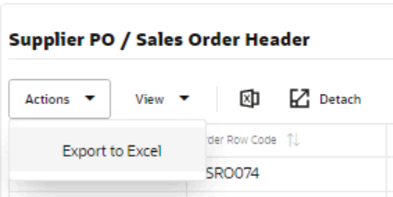
Figure 19– Pre-Receipt Units Variance Dashboard (Menu Action)

- View – When user will click on View drop down, they will be presented with selection choice as shown in below screenshot-

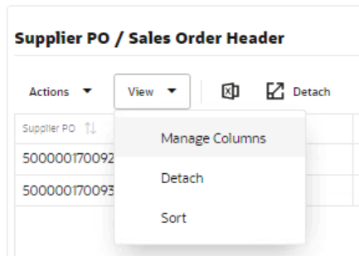
Figure 20 – Pre-Receipt Units Variance Dashboard (View Menu)

- Manage Columns - By default, all columns will be shown to the user in the table. But if they want to remove certain columns or want to re-arrange them, they can use this functionality. When user click on Manage Columns, they will see list of all columns available on the table as shown in below screenshot. They could move the columns they do not want to see on left side by clicking the cross on top of each column in right hand side table. In right hand side they could move the columns up and down to re-arrange them in desired sequence they want to see in the table If they want to bring back the default setting, they can click on ‘Reset to Defaults’. The setup user will select through Manage Columns functionality will be applicable only for that dashboard/screen page in that instance. Once user will close the dashboard page the setup will be lost, next time user will open the dashboard page the user selection will no longer be applicable.

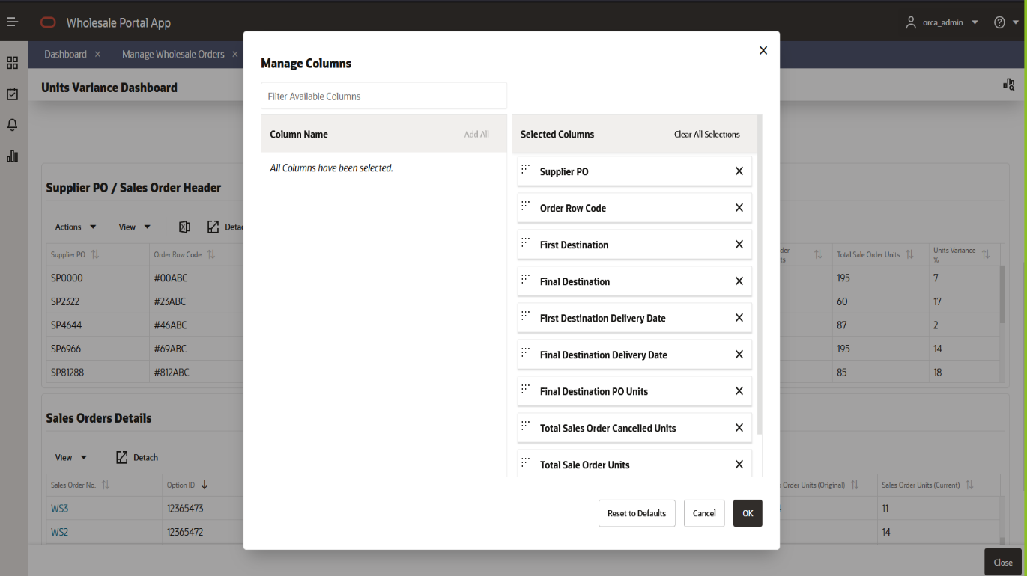
Figure 21– Pre-Receipt Units Variance Dashboard (Manage column Menu)

- Detach – This function will allow user to open the table in enlarged view as shown in below screenshot.

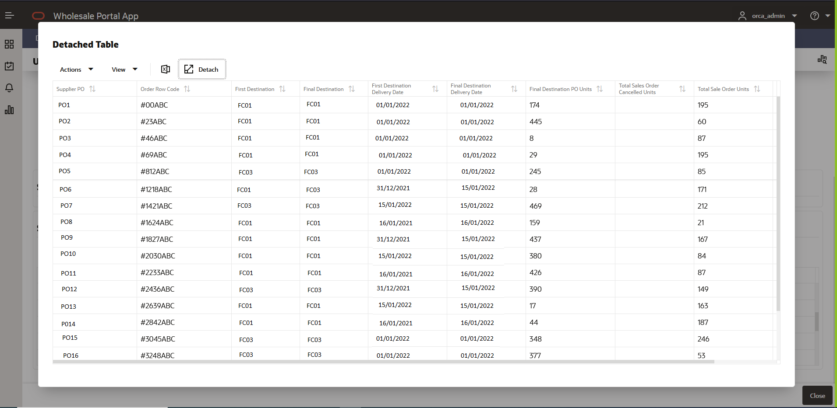
Figure 22 – Pre-Receipt Units Variance Dashboard (Detached table)

- Sort – The Sort functionality will allow user to decide on how they can sort the data in the table. Below screenshot display the sort pop-up where user can select columns and then decide how they want to sort them.

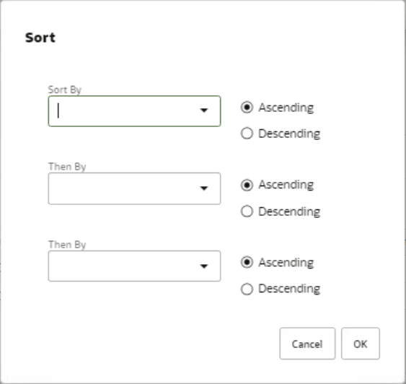
Figure 23– Pre-Receipt Units Variance Dashboard (Sort functionality)

- Export to excel – This function will export the data from the dashboard into an excel. The sample export file for each dashboard is attached in the Appendix section- Section 6 of this document.
The header table will display all the Supplier POs that are in variance of overall units compared to the units on associated Sales Orders.

Available fields in the Header Table are:
Fields | Description | Notes
Supplier PO | PO raised by the Commercial team to the supplier.
Order Row Code | A unique identifier associated with the Supplier PO and the corresponding Sales Orders. | Order row code in Wholesale Portal will be the key identifier to establish the relationship between Supplier POs and respective Sales Orders.
First Destination | An ASOS virtual warehouse | This field will show the ASOS warehouse where Supplier PO will be receipted.
Final Destination | An ASOS virtual warehouse | This field will show the ASOS warehouse from where Sales Orders will be sourced.  - If the supplier PO will be direct, then first and final warehouse will be same.  - If the supplier PO will be split, then first and final destination warehouse will be different. Once the Supplier PO will be receipted on First destination it will be send to final destination as allocations.
First Destination Delivery Date | Supplier PO delivery date | This date will show the delivery date of Supplier PO into ASOS warehouse.
Final Destination Delivery Date | Supplier PO delivery date or allocations delivery date into source ASOS warehouse. | This field will show the delivery date of Supplier PO/allocations for the source warehouse from where Sales Orders will be sourced.  - If the supplier PO will be direct, then first and final destination delivery date will be same.  - If the supplier PO will be split, then first and final destination delivery date will be different.
Final Destination PO Units | Sum of all SKUs on Supplier PO | These PO units will be a summed-up value of all SKUs present as commitment on Supplier PO.
Total Sales Order Cancelled Units | Sum of all SKUS from all Sales Orders that are cancelled and are linked with Supplier PO.
Total Sales Order Units | Sum of all SKUs from all Sales Orders that are linked with supplier PO and are not cancelled.
Total PO Units Variance | This field will display the variance between total units of SKUs between Supplier PO and Sales Orders. | The Calculation for variance % will be:  ((Final Destination PO Units - Total Sales Order Units)/ Total Sales Order Units) * 100  Depending on the above calculation variance value can be negative (if Supplier PO didn’t fulfil Sales Orders Units) or positive (if Supplier PO is raised with inflated units).  Variance will always be a whole number either rounded up or down depending on decimal calculation.
Table 6 - Pre-Receipt Units Variance Dashboard (Header Table)

Detail Table – Sales Order Details
The detail table will display all the Sales Orders that are linked with the Supplier PO user has selected in the Header table.

Available fields in the Detail Table are:
Fields | Description | Notes
Sales Order No. | Unique reference in Wholesale Portal assigned to each Sales Orders. | This reference will be generated in Wholesale Portal and would be sent over to ORMS.  This Sales Order No. will appear as link, and it will open Edit Sales Order screen described later in this document.
Option Id | The parent item on the Sales Order
Option Description | Description of the option
Partner Location | Wholesale Partner location
Partner | Wholesale Partner
Sales Order Current Despatch Month | The existing despatch month of the Sales Order.
Sales Order Units (Original) | Sum of all SKUs on the Sales Order when it was first sent from WTSO to Wholesale Portal. | This original unit’s column will never change in value in Wholesale Portal, as it will captured only for the first time when Sales Order was first sent to Wholesale Portal from WTSO.
Sales Order Units (Current) | Sum of all SKUs on the sales orders. | If the Sales Order units were never updated after it was first sent from WTSO then both Original and Current unit column will show the same value.
Table 7 - Pre-Receipt Units Variance Dashboard (Detail Table)

Contextual Pane
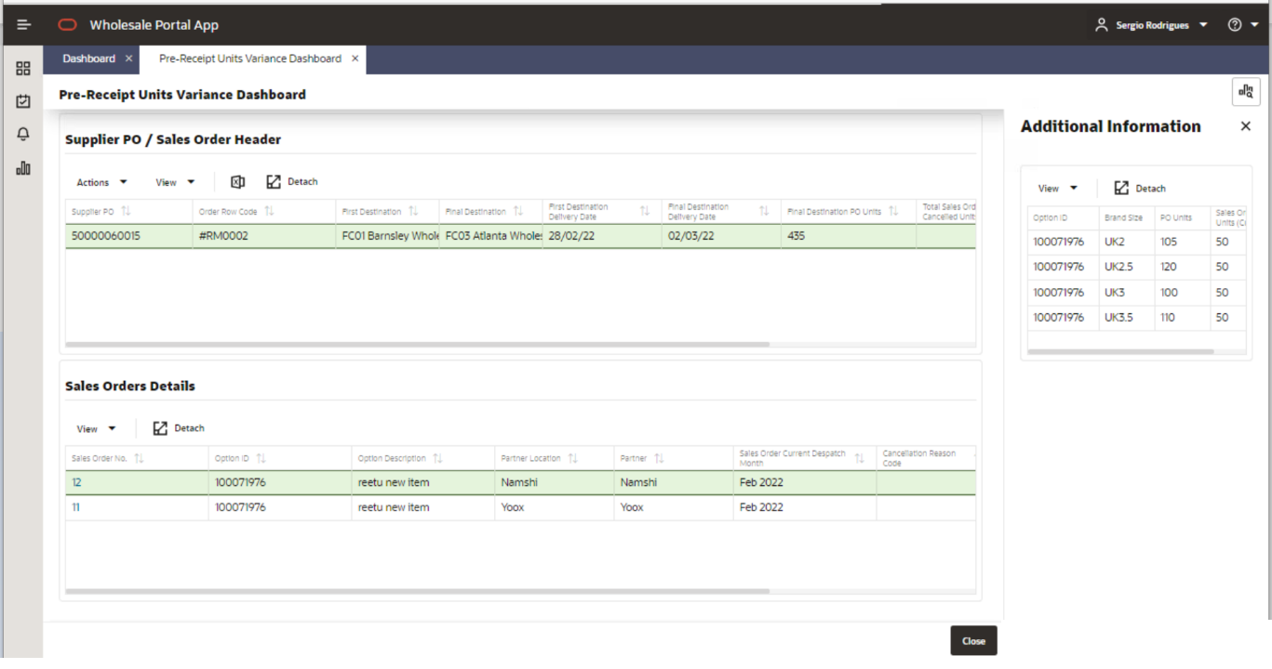
Figure 24 – Pre-Receipt Units Variance Dashboard (Contextual Pane)

The side bar will be hidden by default, it will only show when user will select a Sales Order line in detail table and click on below icon on right hand top corner of the dashboard. The brand size information in the side bar would be specific to the Sales Order selected by the user in detail table.
If the user selects another Sales Order the side bar will refresh and will show detail of the current selected sales Order. Please refer to Figure 4.4 for reference.

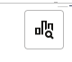
Figure 25 – Pre-Receipt Units Variance Dashboard (Additional Information button)

Available fields in the Side Bar Table are:
Fields | Description | Notes
Option Id | The parent item on the Sales Order
Brand Size | The brand size of the respective SKU on the Sales Order
PO Units | Total Supplier PO units of the brand size
Sales Order Units (Current) | Current Sales Order units of the brand size for the specific Sales Order selected by user.
Table 8 - Pre-Receipt Units Variance Dashboard (Side Bar Table)

Despatch window varaince dashboard

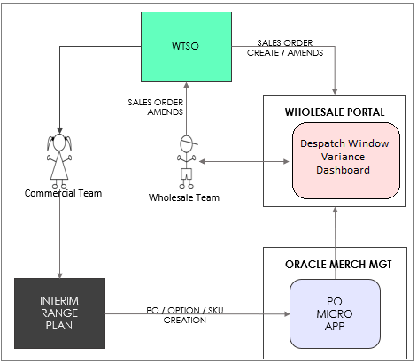
Figure 26 – Despatch Window Variance Dashboard

The above figure depicts the flow of Supplier PO and Sales Order between different systems. Once the commercial team has raised the Supplier PO, that supplier PO will have a specific delivery date into ASOS warehouse. But a supplier PO will have its own journey from being raised, to have ASNs (could have multiple ASNs raised at different point of time), multiple receipts on these ASNs. Thus, as the Supplier PO will progress in its life cycle its delivery date into ASOS FC from where Sales Order will be sourced can vary. This delivery date based on PO or the latest ASN delivery date or the latest receipt date plus default number of days configured in Wholesale Portal for each ASOS warehouse will calculate the despatch month for the associated Sales Orders. Now if this calculated despatch month does not match to the current despatch month of Sales Orders, then those Supplier POs and Sales Orders will show up on this dashboard.

After reviewing the discrepancy in despatch month Wholesale Team will update the calculated despatch month in WTSO and this update will then flow to Wholesale Portal. This discrepancy will be removed from dashboard once the calculated despatch month and the current despatch month of Sales Orders are same, or all the Sales Orders fulfilled by Supplier PO are cancelled or the Sales Order is released.
This Despatch Window Variance Dashboard will have following sections-
  - Search
    - User would be able to further narrow down the result using any of the search filters provided in this section.
  - Header and Detail Tables
    - Header table will show the data at Supplier PO level that are in variance in despatch month with their respective Sales Orders.
    - Detail table will show the data at Sales Order level. The data in this table will change based on the Supplier PO line selected by the user in header table.

Search
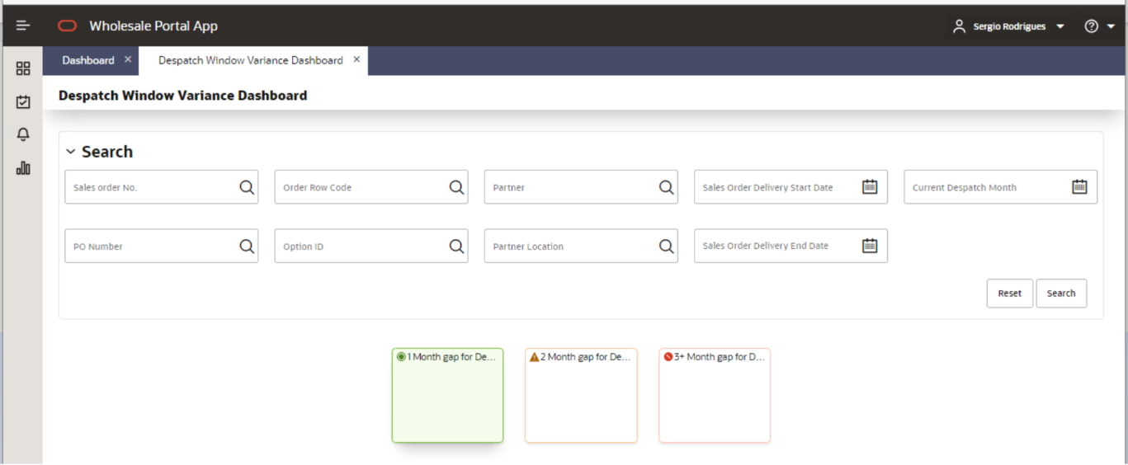
Figure 27 – Despatch Window Variance Dashboard (Search Section)

Filters: In the Search section user will be able to use any of the following filters to further narrow down the results shown in the dashboard-

- Sales Order No. – This will be the Sales Order No. generated / maintained in Wholesale Portal to track a unique Sales Order.
- PO Number – This will be Supplier PO No.
- Order Row Code
- Partner – Wholesale Partner
- Partner Location – Wholesale Partner location.
- Option id
- Current despatch month
- Sales Order Delivery Start Date
- Sales Order Delivery End Date

Colour Tiles: Details of the colour tiles in Search section are mentioned below.

1-month gap for despatch– If user selects this tile the result tables will show Sales Orders where there is one-month gap between the current despatch month and the calculated despatch month of Sales Order (based on latest view of Supplier PO’s/latest ASNs delivery month/latest ASN receipt).

2-month gap for despatch– If user selects this tile the result tables will show Sales Orders where there is two-month gap between the current despatch month and the calculated despatch month of Sales Order (based on latest view of Supplier PO’s/latest ASNs delivery month/latest ASN receipt).

3+-month gap for despatch– If user selects this tile the result tables will show Sales Orders where there is three-month gap or more between the current despatch month and the calculated despatch month of Sales Order (based on latest view of Supplier PO’s/latest ASNs delivery month/latest ASN receipt).

Header and Detail Tables
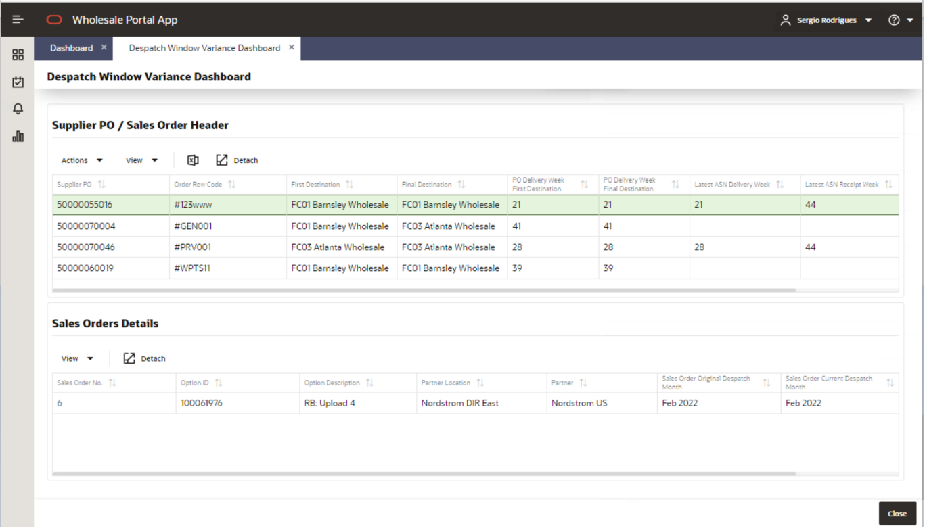
Figure 28 – Despatch Window Variance Dashboard (Header & Detail Section)

Header Table – Supplier PO/Sales Order Header
The header table will display all the Supplier POs that are in variance of calculated despatch month compared to the current despatch month on associated Sales Orders.

Available fields in the Header Table are:
Fields | Description | Notes
Supplier PO | PO raised by the Commercial team to the supplier.
Order Row Code | A unique identifier associated with the Supplier PO and the corresponding Sales Orders. | Order row code in Wholesale Portal will be the key identifier to establish the relationship between Supplier POs and respective Sales Orders.
First Destination | An ASOS virtual warehouse | This field will show the ASOS warehouse where Supplier PO will be receipted.
Final Destination | An ASOS virtual warehouse | This field will show the ASOS warehouse from where Sales Orders will be sourced.  - If the supplier PO will be direct, then first and final warehouse will be same.  - If the supplier PO will be split, then first and final destination warehouse will be different. Once the Supplier PO will be receipted on First destination it will be send to final destination as allocations.
PO Delivery Week First Destination | Supplier PO delivery week into ASOS warehouse. | This date will show the delivery week of Supplier PO into ASOS warehouse.
PO Delivery Week Final Destination | Supplier PO delivery week or allocations delivery week into source ASOS warehouse. | This field will show the delivery week of Supplier PO/allocations for the source warehouse from where Sales Orders will be sourced.  - If the supplier PO will be direct, then first and final destination delivery week will be same.  - If the supplier PO will be split, then first and final destination delivery week will be different.
Latest ASN Delivery week | Delivery week of the ASN raised for Supplier PO, into ASOS warehouse. | This delivery week will keep updating based on following logic-  - When first ASN for the supplier PO will be raised then it will show delivery week of that ASN.  - If multiple ASNs exists for Supplier PO, then field will show the ASN whose delivery week will be most distant in future.  - If the supplier PO is split, then in that case the transit transportation matrix from merch management will be used to calculate the delivery week for the source warehouse. This matrix holds the no. of days setup to ship between different ASOS warehouses.
Latest ASN Receipt week | Receipt week of the ASN raised for Supplier PO, into ASOS warehouse. | This Receipt week will keep updating based on following logic-  - Whichever ASN is receipted first its receipt week will show in this field.  - When multiple ASNs are receipted at different point of time for the Supplier PO then this field will show the receipt week of an ASN which was receipted most recently.
Final Destination despatch Month | This despatch month will show the latest view of a calculated despatch month based on the recent view of Supplier PO, or its ASNs or its receipts. | This field will be updated on following rules-  - When Supplier PO exists without ASNs it will show the despatch month based on delivery week of the PO in source warehouse plus default no. of days setup in wholesale portal to calculate the despatch month.  - When ASN exists on Supplier PO without receipts it will show the despatch month based on maximum delivery week of the ASN in source warehouse plus default no. of days setup in wholesale portal to calculate the despatch month.  - When receipt exists on Supplier PO’s ASNs it will show the despatch month based on maximum receipt week of the ASN in source warehouse plus default no. of days setup in wholesale portal to calculate the despatch month.  - For Split POs all above three points will be applicable. The extra calculation that will be added to calculate the dispatch month will be no. of days from transportation transit matrix (it defines the no. of days it takes to send stock from one ASOS warehouse to the other). These days will be added when split Supplier PO will have ASNs and receipt on first destination. When no ASN exists on Supplier PO or when the stock was already received on final destination then this setup will not be used in despatch month calculation.
Table 9 - Despatch Window Variance Dashboard (Header Table)

Detail Table – Sales Order Details
The detail table will display all the Sales Orders that are linked with the Supplier PO user has selected in the Header table.

Available fields in the Detail Table are:
Fields | Description | Notes
Sales Order No. | Unique reference in Wholesale Portal assigned to each Sales Orders. | This reference will be generated in Wholesale Portal and would be sent over to ORMS.  This Sales Order No. will appear as link, and it will open Edit Sales Order screen described later in this document.
Option Id | The parent item on the Sales Order
Option Description | Description of the option
Partner Location | Wholesale Partner location
Partner | Wholesale Partner
Sales Order Original despatch Month | despatch month captured in Wholesale Portal when the Sales Order was sent from WTSO first time.
Sales Order Current despatch Month | Latest despatch month that exists on Sales Order.
Final Destination despatch Month | This field will show the despatch month that user should update in WTSO on Sales Orders. | This calculated despatch month will be same as the Final Destination despatch Month in header table.
Table 10 - Despatch Window Variance Dashboard (Detail Table)

Post receipt units variance dashboard

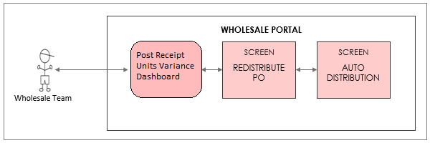
Figure 29 – Post Receipt Units Variance Dashboard

The above figure depicts the flow of actions user will take from Post Receipt Units Variance Dashboard. This dashboard will provide the visibility of all Supplier POs that are wholesale and are short/over receipted by each SKU. Fully receipted Supplier POs with exact match at SKU level with associated Sales Orders will not appear on this dashboard. They will Directly appear on ‘Sales Order to Release’ dashboard.
After reviewing details of the receipts on this dashboard Wholesale team will manually distribute the Supplier PO receipts through ‘Re-distribute PO‘ screen on associated Sales Orders in Wholesale Portal. This re-distribution screen on Wholesale Portal will have the capability to auto-redistribute based on PO receipts. Details of this screen are defined in section – 4.1.6.
Receipted Supplier PO and associated Sales Orders will stop appearing on this dashboard if all Sales Orders linked with Supplier PO are distributed or all Sales Orders are cancelled in which case the receipted units will become part of un-productive Wholesale Stock in the source warehouse. If some Sales Orders linked to Supplier PO are cancelled and rest all are distributed, then also it will stop appearing on this dashboard.
Split Supplier POs will not appear on this dashboard if, they are receipted only on first destination. Once they get receipted on final destination then only, they will appear on this dashboard.
This Post Receipt Units Variance Dashboard will have following sections
  - Search
    - User would be able to further narrow down the result using any of the search filters provided in this section.
  - Header and Detail Tables
    - Header table will show the data at Supplier PO that are receipted.
    - Detail table will show the data at Sales Order level. The data in this table will change based on the Supplier PO line selected by the user in header table.

Search
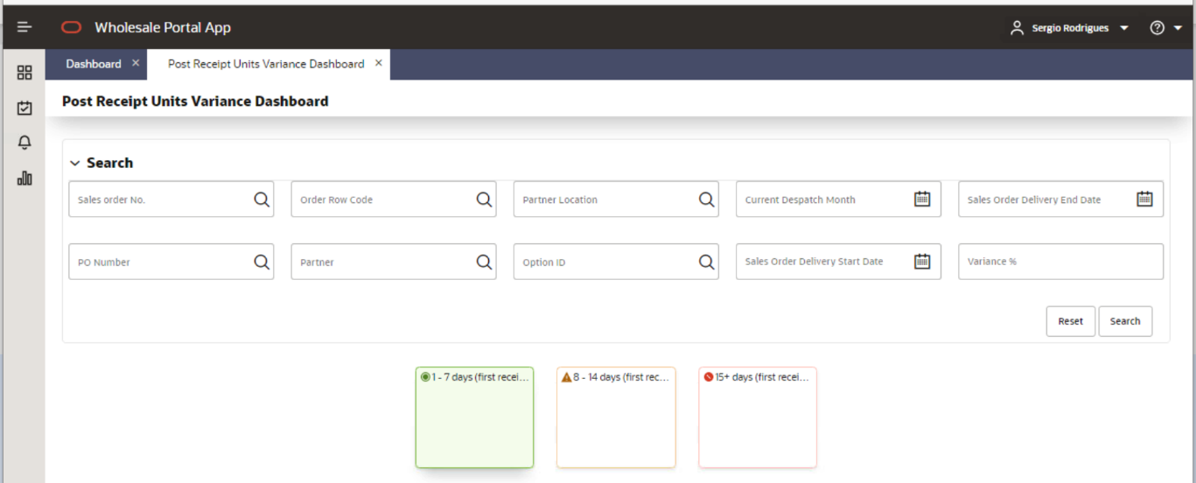
Figure 30 – Post Receipt Units Variance Dashboard (Search Section)

Filters: In the Search section user will be able to use any of the following filters to further narrow down the results shown in the dashboard-

- Sales Order No. – This will be the Sales Order No. generated / maintained in Wholesale Portal to track a unique Sales Order.
- PO Number – This will be Supplier PO No.
- Order Row Code
- Variance % – The dashboard will show over all variance (inclusive of all SKUs) of units between Supplier PO receipted units and associated Sales Orders units. But to drill down to SKU level user can use this filter. If user will search using a positive variance say 10% it will bring result where at least one SKU has breached this exact variance % or higher. But if user search with negative variance says -10% then it will bring result with exact same variance or lower. If user search with 0 they will receive following error – ‘Only values greater or less than 0 are allowed.’
- Partner – Wholesale Partner
- Partner Location – Wholesale Partner location.
- Option id
- Current despatch month
- Sales Order Delivery Start Date
- Sales Order Delivery End Date

Colour Tiles: Details of the colour tiles in Search section are mentioned below.

1-7 days (first receipt) – If user selects this tile the result tables will show Supplier POs and associated Sales Orders where first receipt on the associated Supplier PO has passed 1-7 days.

8-14 days (first receipt) – If user selects this tile the result tables will show Supplier POs and associated Sales Orders where first receipt on the associated Supplier PO has passed 8-14 days.

15+ days (first receipt) – If user selects this tile the result tables will show Supplier POs and associated Sales Orders where first receipt on the associated Supplier PO has passed 15+ days.

Header and Detail Tables
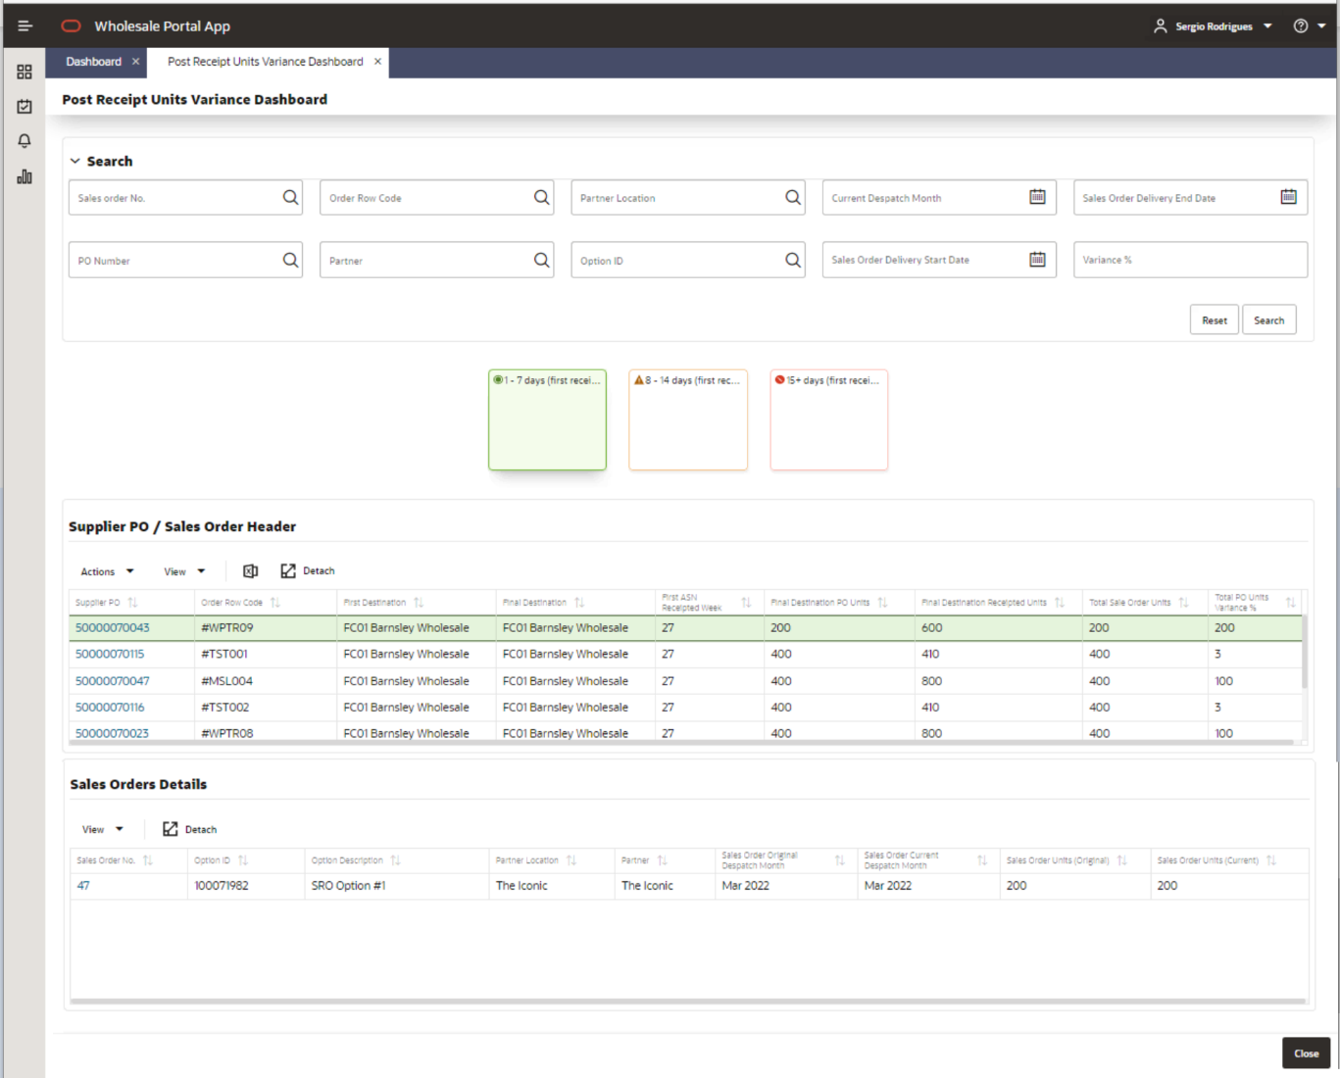
Figure 31 – Post Receipt Units Variance Dashboard (Header & Detail Section)

Header Table – Supplier PO/Sales Order Header
The header table will display all the Supplier POs that are in variance of calculated despatch month compared to the current despatch month on associated Sales Orders.

Available fields in the Header Table are:
Fields | Description | Notes
Supplier PO | PO raised by the Commercial team to the supplier. | This Supplier PO will appear as a link and if user clicks on this link, it will take them to ‘Re-distribute PO’ screen.
Order Row Code | A unique identifier associated with the Supplier PO and the corresponding Sales Orders. | Order row code in Wholesale Portal will be the key identifier to establish the relationship between Supplier POs and respective Sales Orders.
First Destination | An ASOS virtual warehouse | This field will show the ASOS warehouse where Supplier PO will be receipted.
Final Destination | An ASOS virtual warehouse | This field will show the ASOS warehouse from where Sales Orders will be sourced.  - If the supplier PO will be direct, then first and final warehouse will be same.  - If the supplier PO will be split, then first and final destination warehouse will be different. Once the Supplier PO will be receipted on First destination it will be send to final destination as allocations.
First ASN receipt week | First Receipt week of the ASN raised for Supplier PO, into ASOS warehouse. | This receipt week will not change it will always show the oldest receipt date on the ASNs of Supplier PO.
Final Destination PO Units | Sum of all SKUs on Supplier PO | These PO units will be a summed-up value of all SKUs present as commitment on Supplier PO.
Final Destination Receipted Units | Sum of all SKUs on Supplier PO that are receipted in the source warehouse.
Total Sales Order Units | Sum of all SKUs from all Sales Orders that are linked with supplier PO and are not cancelled.
Unit Variance % | This field will display the variance between total units of receipted SKUs on Supplier PO versus the total units od SKUs on associated Sales Orders that are not cancelled. | The Calculation for Unit Variance % will be:  ((Final Destination Receipted Units – Total Sales Order Units)/ Total Sales Order Units) *100  Depending on the above calculation variance value can be negative (if Supplier PO receipts didn’t fulfil Sales Orders Units) or positive (if Supplier PO is over receipted).  Variance will always be a whole number either rounded up or down depending on decimal calculation.
Table 11 - Post Receipt Units Variance Dashboard (Header Table)

Detail Table – Sales Order Details
The detail table will display all the Sales Orders that are linked with the Supplier PO user has selected in the Header table.

Available fields in the Detail Table are:
Fields | Description | Notes
Sales Order No. | Unique reference in Wholesale Portal assigned to each Sales Orders. | This reference will be generated in Wholesale Portal and would be sent over to ORMS.  This Sales Order No. will appear as link, and it will open Edit Sales Order screen described later in this document.
Option Id | The parent item on the Sales Order
Option Description | Description of the option
Partner Location | Wholesale Partner location
Partner | Wholesale Partner
Sales Order Original despatch Month | Despatch month captured in Wholesale Portal when the Sales Order was sent from WTSO first time.
Sales Order Current despatch Month | Latest despatch month that exists on Sales Order.
Sales Order Units (Original) | Sum of all SKUs on the Sales Order when it was first sent from WTSO to Wholesale Portal. | This original unit’s column will never change in value in Wholesale Portal, as it will captured only for the first time when Sales Order was first sent to Wholesale Portal from WTSO.
Sales Order Units (Current) | Sum of all SKUs on the sales orders. | If the Sales Order units were never updated after it was first sent from WTSO then both Original and Current unit column will show the same value.
Table 12 - Post Receipt Units Variance Dashboard (Detail Table)

Re-distribute po screen

This screen will open when user selects the Supplier PO link in the ‘Post Receipt Units Variance Dashboard’ as mentioned in section 4.1.5. As user will be distributing the receipted units of Supplier PO on multiple Sales Orders that are associated with it thus, this screen will open in edit mode. But if any of the Sales Orders linked with Supplier PO are being edited by any other user or have any locks then this screen will open in view mode and user could view the data but could not take any action on it. This screen will also be accessed from ‘Manage Sales Order’ screen, details of this screen are mentioned further in this document. User will only be able to re-distribute the PO units on the Sales Orders that are linked with the Supplier PO, any other sales orders cannot be added for re-distribution.
This screen will utilize the threshold set at partner level to determine if any of the SKU distribution has breached that threshold. The distribution for each SKUs will be highlighted to the user.
If user has already released some of the Sales Order that were linked with the Supplier PO, then on this screen those Sales Order will not appear anymore, and the PO receipt units will account for those Released Sales Orders and will only show the available PO receipt units that can be used to fulfil rest of the un-released associated Sales Orders.

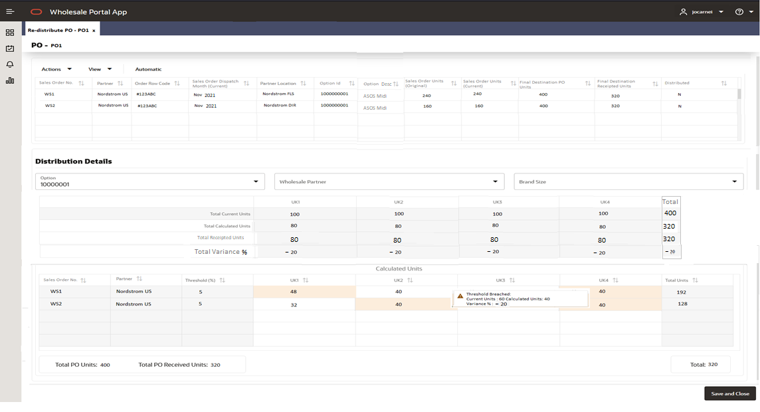
Figure 32 – Re-distribute PO screen

This Re-distribute PO screen will have following sections-
  - Header Section
    - The table in the header section will be non-editable and will show all the valid Sales Orders associated with Supplier PO.
    - ‘Automatic’ button – User will use this button to auto prorate the supplier PO receipted units across all Sales Orders through a pop-up screen.
    - The cross button on screen will close the screen but will warn the user that they could lose their changes with following warning message. If user will select ‘Cancel’ the screen will not close but if user will click ‘OK’ screen will close without saving their changes.
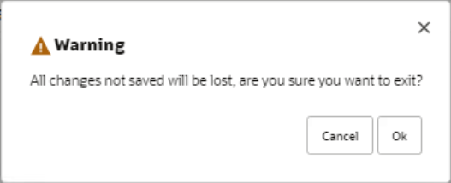
Figure 33 – Re-distribute PO screen closing warning

  - Detail Section will have following sub sections-
    - Filters
    - Non-editable Totals table
    - Editable distribution detail table- In this table user would be able to manually enter the units they want to assign to each Brand size in individual Sales Order.
    - Save and Close Button – When user clicks this button the screen will close, and the Sales Orders re-distributed by the user will be saved. The button will also validate if the distributed units on Sales Order has not become more then PO receipted units and will present user with below warning if this happens-Cannot distribute more than receipted Supplier PO units.
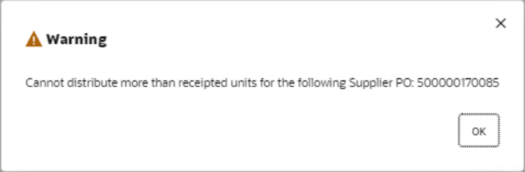
Figure 34 – Re-distribute PO screen over distribution warning

But if user has under distributed the PO receipts a pop-up will be shown to user with following message- ‘PO receipt is under distributed. Do you want to continue?’
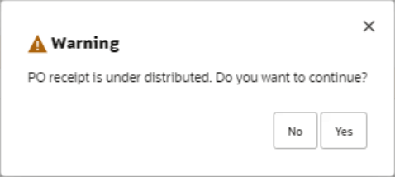
Figure 35 – Re-distribute PO screen under distribution warning

Pop-up will have ‘Yes’ and ‘No’ button. ‘Yes’, will accept the distribution and will close the screen. ‘No’ will take them back to existing distribution where they can change the re-distributed quantity again.

The functionality of this screen is described using following example-
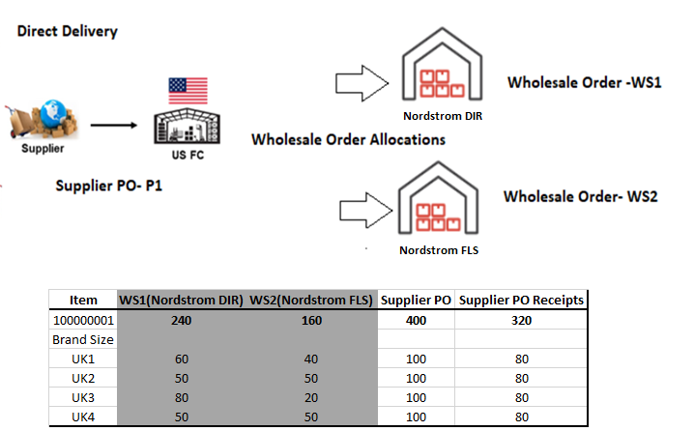
Figure 36 – Re-distribute PO screen example

In the above example a supplier PO was raised with 400 units in total, spread across 4 different brand sizes. These 400 units were fulfilling two Sales Orders -WS1 (with total units of 240) and WS2 (with total units of 160). The SKU distribution on each Sales Order is described in the example.
Now instead of receiving 400 units on Supplier PO in total 320 units were receipted; each brand size was receipted with 80 units. Thus, the overall variance between Supplier PO receipted units and Sales Order units is 20 % as calculated by below formula-
((Supplier PO receipts - Sum of sales Order units)/ Sum of sales Order units) *100
((320-400)/400) *100= -20%
Thus, once this Supplier PO will appear on Post Receipt Units Variance dashboard it will show this -20% variance.
User will click on the Supplier PO link, and it will open the ‘Re-distribute PO’ screen for that supplier PO. How user will re-distribute the PO is detailed in next section.

Header Section
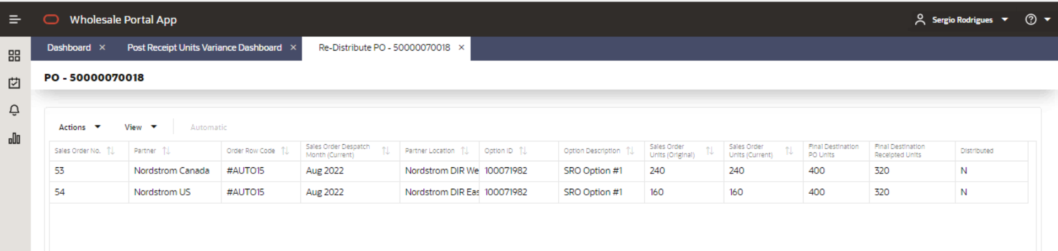
Figure 37 – Re-distribute PO screen (Header Section)

This table will be read only and will display all the Sales Order associated with Supplier PO.
Based on the example from Figure 7.2 this table is showing the units accordingly. Details of available fields in the Header Table are:
Fields | Description | Notes
Sales Order No. | Unique reference in Wholesale Portal assigned to each Sales Orders. | This field will show all valid Sales Orders associated with the Supplier PO which are not yet released
Sales Order Current despatch Month | Latest despatch month that exists on Sales Order.
Partner | Wholesale Partner
Order Row Code | A unique identifier associated with the Supplier PO and the corresponding Sales Orders. | Order row code in Wholesale Portal will be the key identifier to establish the relationship between Supplier POs and respective Sales Orders.
Sales Order despatch Month (Current) | Latest despatch month that exists on Sales Order.
Partner Location | Wholesale Partner location
Option Id | The parent item on the Sales Order
Option Description | Description of the option
Sales Order Units (Original) | Sum of all SKUs on the Sales Order when it was first sent from WTSO to Wholesale Portal. | This original unit’s column will never change in value in Wholesale Portal, as it will captured only for the first time when Sales Order was first sent to Wholesale Portal from WTSO.
Sales Order Units (Current) | Sum of all SKUs on the sales orders. | In the Sales Order was never updated after it was first sent from WTSO then both Original and Current unit column will show the same value. From the above example in Figure 7.3 this value will be 400.
Final Destination PO Units | Sum of all SKUs on Supplier PO | These PO units will be a summed-up value of all SKUs present as commitment on Supplier PO. From the above example in Figure 7.3 this value will be 400.
Final Destination Receipted Units | Sum of all SKUs on Supplier PO that are receipted in the source warehouse. | From the above example in Figure 7.3 this value will be 320. So, user would have to re-distribute these 320 units on both Sales orders. If user has already released some of the associated Sales Orders, then this receipted units will deduct the no. of units present on the released Sales Orders.
Distributed | This column will show if the Sales Order is distributed or not. | The valid values for this field are-  - Y- Sales Order is distributed  - N – Sales Order is not yet distributed  From the above example in Figure 7.3 this value will be N as user has not distributed the receipted units yet.
Table 13 - Re-distribute PO screen (Header Table)

Automatic Button
This automatic button will allow user to auto prorate the receipted Supplier PO units for each brand size in Supplier PO to respective Sales Order units based on the ratio of current units in each individual Sales Order. When user will click on Automatic button an ‘Automatic Re-distribution PO’ pop-up will open as shown in below figure.

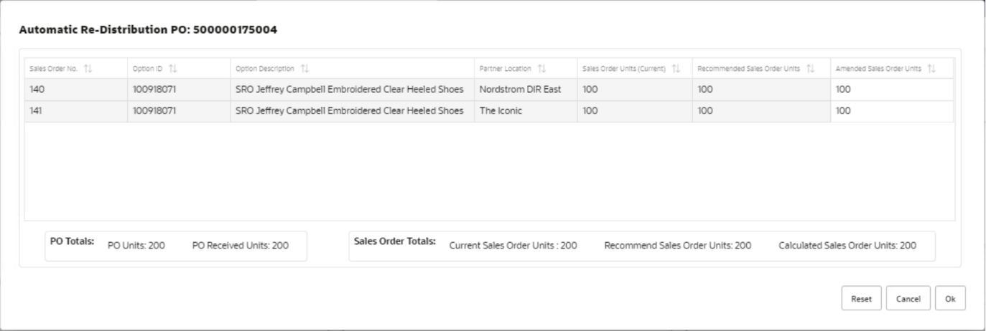
Figure 38 – Automatic Re-Distribution PO pop-up

Details of all fields shown in this table are described below:
Fields | Description | Notes
Sales Order No. | Unique reference in Wholesale Portal assigned to each Sales Orders. | This field will show all valid Sales Orders associated with the Supplier PO.
Option Id | The parent item on the Sales Order
Option Description | Description of the option
Partner Location | Wholesale Partner location
Sales Order Units (Current) | Sum of all SKUs on the sales orders. | From the above example in Figure 7.3 this value will be – 240 (For Sales Order WS1) and 160 (For Sales Order WS2).  At the bottom of this column, it will show a total of all Sales Order current Units for e.g., 400 in this example.
Recommended Sales Order Units | This field will show the total units of the option that system has calculated to be assigned to each Sales Order after applying the auto proration logic. | Auto proration logic for example shown in Figure 7.3 is described after this table in Figure 7.5.  This logic will calculate the recommended order units as – 192 (For Sales Order WS1) and 128 (For Sales Order WS2). At the bottom of this column, it will show a total of all Recommended Sales Order Units for e.g., 320 in this example. If user has already released some of the associated Sales Orders, then this receipted units will deduct the no. of units present on the released Sales Orders.
Amended Sales Order Units | This column will be editable for the user. | This column will show following values-  - When pop-up will open it will the values in this column will be defaulted from ‘Recommended Sales Order Units’. If user would be happy with the auto proration system has applied, then they can accept these values.  - If the user wishes to change the values system has recommended, then they can edit those values in this column. Any change made to the values in this column will not reflect on ‘Recommended Sales Order Units’ as the intention for recommended column is to always show the system generated values.  At the bottom of this column, it will show a total of all Calculated Sales Order Units for e.g., 320 in this example.
Total PO Units | Sum of all SKUs on Supplier PO | 400 in this example.
Total PO Received Units | Sum of all SKUs on Supplier PO that are receipted in the source warehouse. | 320 in this example. If user has already released some of the associated Sales Orders, then this receipted units will deduct the no. of units present on the released Sales Orders.
Reset button | This button will reset the values in ‘Calculated Sales Order Units’ to match with ‘Recommended Sales Order Units’. This button will aid the user in cases where user want to get rid of the changes they made manually on ‘Calculated Sales Order Units’ column and want to either accept the system generated values or want to re-distribute again manually using system generated value as basis.
Cancel Button | This button will close the ‘Automatic Re-distribution PO’ pop-up and will not save any re-distributed values in the pop-up. The user will return to Re-distribution PO screen.
OK Button | This button will close the ‘Automatic Re-distribution PO’ pop-up and will save any apply the re-distributed values to the Sales Orders. The user will return to Re-distribution PO screen. | OK button will validate if the sum of ‘Calculated Sales Order Units’ <= Total PO Receipted Units. If not, then user will be presented with below error, and they would have to re-adjust the values –  Cannot distribute more than receipted Supplier PO units.  But if user has under distributed the PO receipts a pop-up will be shown to user with following message –  'PO receipt is under distributed. Do you want to continue?'  Pop-up will have YES and NO button. Yes, will accept the distribution and will close the screen. No, will take them back to existing distribution where they can change the re-distributed quantity again.
Table 14 - Automatic Re-Distribution PO pop-up fields

Proration logic to calculate ‘Recommended Sales Order Units’ –
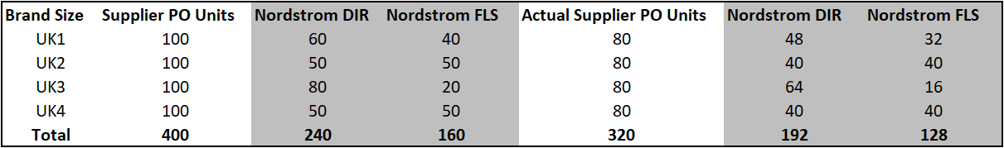
Figure 39 – Automatic PO Re-Distribution Proration

The size distribution from Sales Orders Units is applied to Actual Supplier PO receipted units. For e.g., for UK1 the current Units on Sales Order Nord DIR is 60 and on Sales Order Nord FLS it is 40 out of 100 units on Supplier PO. Thus, this same ratio will be applied on receipted units of UK1 i.e., 80 Units. Thus, 60% of 80 is updated for Nord DIR (48 units) and for Nord FLS 40% of 80 (32 units) is calculated. This logic is applied on each brand size on the supplier PO receipts to calculate the ‘Recommended Sales Order Units’ and is then summed up to show the value at option level in this Automatic Re-distribution pop-up.
Once user has done the distribution on pop-up, they will come back on main Re-distribution PO screen. The proration summed at option level is then shown at granular level for each brand size in Detail section tables of the screen. Functionality of this section are mentioned below.

Detail Section
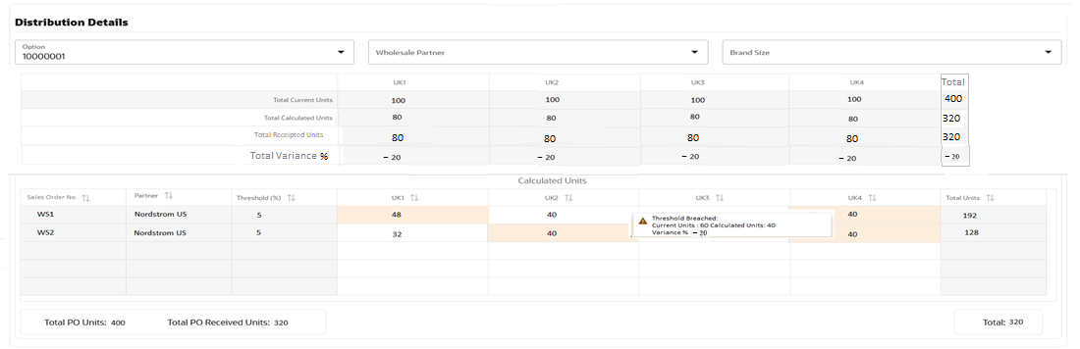
Figure 40 – Re-distribute PO screen (Detail Section)

This section will have following filters
- Option – This filter will be mandatory and will be pre-populated with Option Id on the Supplier PO for Release 1. (As of now Supplier PO for wholesale Sales Orders are raised with single options but if in future multiple options will exists on Supplier PO then user will be able to filter based on Option id and filter will change based on the option id line selected by user in top table.)
- Partner
- Brand Size

Table in Figure-7.7 will show the brand size level distribution done by the Automatic Re-distribution pop-up. Based on the calculation shown in Figure-7.5 each of the brand size column is populated will relevant calculated value for each brand size on individual Sales Orders. But each these values will be editable in this table, so user can either again update this calculated value for each brand size on a Sales order or if they didn’t use the automatic proration logic then they can manually distribute the quantity for each brand size in this table across different Sales Orders.
Each partner will have a threshold defined in Wholesale Portal; this threshold will define that how much tolerance of units % is acceptable for this partner. Any of the brand size value breaching that threshold will be highlighted in this table for the respective partner’s Sales order. When user will double click on that specific value, they will be able to see the ‘Current Unit’, ‘Calculated Units’ and Variance % between these two units. This will allow them to decide and re-distribute the units again.
In case of over-receipted Supplier POs user will be able to distribute the actual receipted units on associated Sales Orders or they can distribute the only units requested by partner on Sales Order, in which case the extra units will become part of un-productive wholesale stock.
If the number of brand sizes are high on supplier PO, then a horizontal scroll bar will appear for user to scroll and check all brand sizes.
If user has already released some of the associated Sales Orders, then this receipted units will deduct the no. of units present on the released Sales Orders.

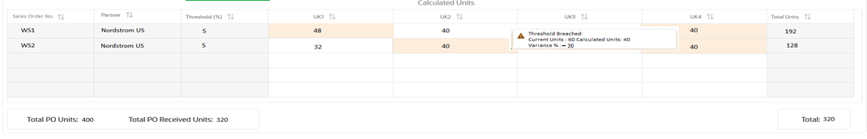
Figure 41 – Re-distribute PO screen (Detail Section-editable)

Table in Figure 7.8 will be present just above the editable table to show the Total Current units, Total Calculated Units and Total Receipted units on Supplier PO of each brand size across different Sales Orders. Any changes user will make in editable table shown in Figure 7.7 will automatically re-calculate values in this Total’s table. This table will also show the Total Variance % which will be calculated as follows-
((Total Calculated Units -Total Currents Units) / (Total current Units)) *100

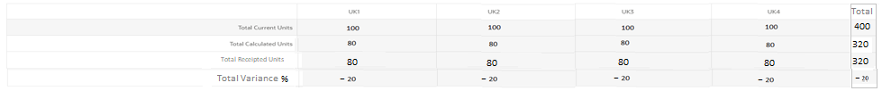
Figure 42 – Re-distribute PO screen (Detail Section-non-editable Total level table)

Sales order to release dashboard
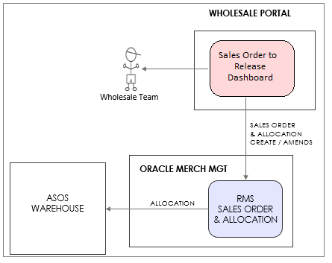
Figure 43 – Sales Order to Release Dashboard

The above figure depicts the flow of actions user will take from ‘Sales Order to Release’ dashboard and how it will trigger the release of Sales Orders to ASOS sourcing warehouse. This dashboard will provide the visibility of all Sales Orders that can be released. Over and under receipted Supplier POs will be first re-distributed and then only appear on this dashboard. But fully receipted Supplier PO will directly appear on this release dashboard and if user want to re-distribute them just before release, they will be able to open them in re-distribute PO screen from this dashboard. However, they would have to wait for the next dashboard batch run to reflect it on Release Sales Order dashboard with the latest view of re-distributed units. If the user has not waited for next batch run and has released the sales order just after re-distributing then the units sent on pick instructions to WMS will be the one user has re-distributed, even though the release dashboard will show the old units. If a user has released a sales order and before the next dashboard run if another user will try to release that sales order again then no pick instructions will be generated for the WMS twice, as the sales order was already released. The second user who will try to re-release the sales order will get an error that the sales order is already released. For Release 1 there is will no automatic release of Sales Orders. Wholesale team will manually release Sales Orders from this dashboard.
The Sales Order that are created based on unproductive wholesale stock will directly appear on this dashboard. User will not be able to re-distribute them on wholesale portal. Sales Orders will stop appearing on this dashboard if they are marked as Released, Cancelled, Despatched or Posted.

This Sales Order to Release Dashboard will have following sections
  - Search
    - User would be able to further narrow down the result using any of the search filters provided in this section.
  - Sales Order Detail table
    - This table will show the Sales Order that can be released.

Search
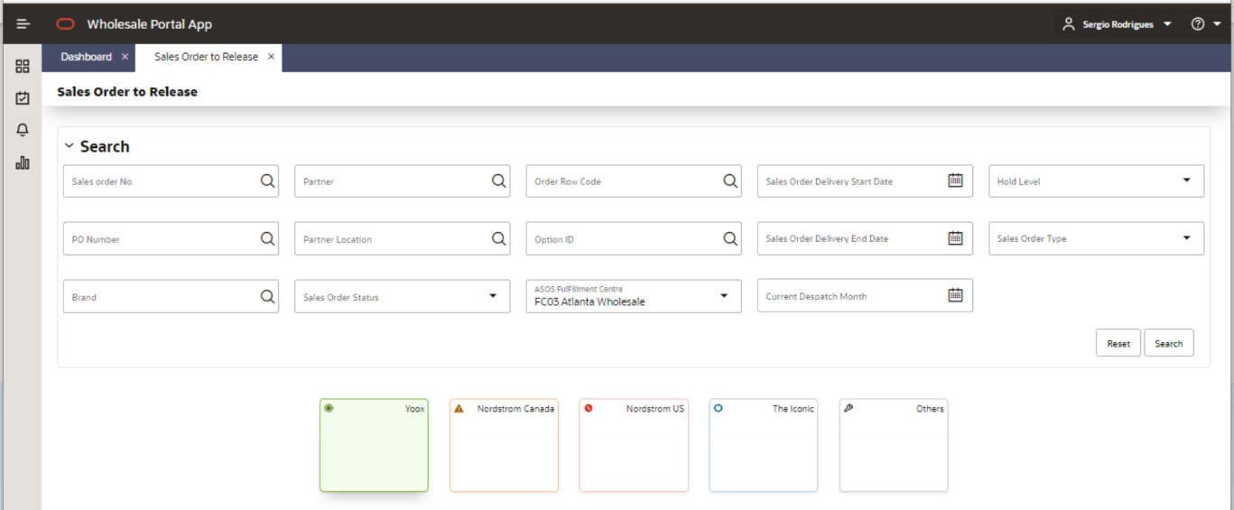
Figure 44 – Sales Order to Release Dashboard (Search Section)

Filters: In the Search section user will be able to use any of the following filters to further narrow down the results shown in the dashboard-

- Sales Order No. – This will be the Sales Order No. generated / maintained in Wholesale Portal to track a unique Sales Order.
- PO Number – This will be Supplier PO No.
- Order Row Code
- Brand – Even though this dashboard will be brand based but some of the brands will be clubbed under ‘Others’, so to drill down to specific brands this filter would be useful.
- Sales Order status
- Partner – Wholesale Partner
- Partner Location – Wholesale Partner location.
- Option id
- ASOS Fulfilment Centre (This field will be mandatory)
- Current despatch month
- Sales Order Delivery Start Date
- Sales Order Delivery End Date
- Hold Level – This filter will help wholesale team to differentiate between Sales Orders that are put on hold either because of Partner setup or if the Sales Order was individually set on hold. For Release 1 all Sales Order will have Partner Hold applied.
- Sales Order Type – This will be a drop down with two values – Pre-Order and Trade

Colour Tiles: Any colour tile user will select will show the Sales Orders for that partner. For ‘Others’ tile user would be able to drill down to individual partner under that section using partner filter. Figure 8.2 just show an example of tiles, the assumption is total no. of coloured tiles will be 5 which will be assigned to first top 4 partner which has highest no. of units on Sales Orders to be released for a specific ASOS warehouse. Rest all partners will be clubbed under ‘Others’ and will be assigned the 5th colour tile.

Detail Table
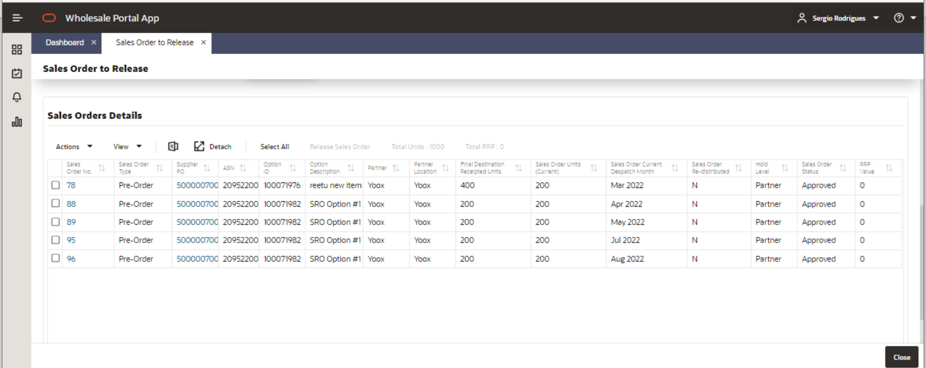
Figure 45 – Sales Order to Release Dashboard (Detail Section)

Detail Table – Sales Order Details
This table will display all Sales Orders that are ready to be released. User can select one or multiple Sales Orders to release. They can also use the ‘Select All’ to select all the Sales Order shown in dashboard. As this table will also show the ASN raised for the Supplier PO, there are chances that if multiple ASNs will exists then same information for the Sales Orders will be replicated in multiple lines with the exception of ASN no. being different in each line. If user will select the same Sales Order multiple lines to release, it will be released only once.

Available fields in Table are:
Fields | Description | Notes
Sales Order No. | Unique reference in Wholesale Portal assigned to each Sales Orders. | This field will appear as a link that will open the Edit Sales Order screen described in later section of the document.
Sales Order Type | Type of Sales Order if it is created based on Supplier PO or unproductive wholesale stock. | Each sales order will either be classed as ‘Pre-Order’ (linked with Supplier PO) or ‘Trade’ (linked with unproductive wholesale stock).
Supplier PO | PO raised by the Commercial team to the supplier. | This Supplier PO will appear as a link and if user clicks on this link, it will take them to ‘Re-distribute PO’ screen in edit mode so that user can review the distribution they did. But if they will change the re-distribution again before release, they will have to wait for the next dashboard batch run to reflect the re-distributed units on the ‘Sales Order to Release Dashboard’.
ASN | This field will show the ASN raised for the Supplier PO.
Option id | The parent item on the Sales Order
Option Description | Description of the option
Partner | Wholesale Partner
Partner Location | Wholesale Partner location
Final Destination Receipted Units | Sum of all SKUs on Supplier PO that are receipted in the source warehouse.
Sales Order Units (Current) | Sum of all SKUs on the sales order.
Sales Order Current despatch Month | Latest despatch month that exists on Sales Order.
Sales Order Re-Distributed | A flag to show if Sales Order was already re-distributed by Wholesale Team. | This value will be ‘Y’ or ‘N’. It will be ‘N’ for fully receipted POs as over and under receipted POs will first needs to be distributed before appearing on this dashboard.
Hold Level | Type of hold level applied on a Sales Order. | Even though the valid values for Hold level are mentioned below but Sales Order will always supersede the Partner level hold. If none of the hold are applied, then this value will be blank. The valid values will be:  - Partner  - Sales Order
Sales Order Status | Current Status of Sales Order | Valid values are (meaning of each status has been explained under Design Assumptions (Section-3.3)-  - Worksheet – this status will not be applicable for Release 1, as WTSO will only send approved Sales Orders to portal.  - Approved  - Cancelled  - On Hold  - Released  - Despatched  - Posted
RRP Value | RRP value will be UK zone full price of the option. | The value will be in GBP.
Total Units | This field in Header will sum all the Sales Order Units that user has searched on the dashboard.
Total RRP | This field in Header will sum all the RRP value that user has searched on the dashboard. | The value will be in GBP.
Table 15 - Sales Order to Release Dashboard (Detail Table)

Release Sales Order button – Once user has selected the Sales Order; they want to release they can click on this button to release them. This will send an update to the ORMS Allocation, so that RIS can send the pick instructions to supply chain.
When user clicks on Release Sales Order button, system will validate if the Sales Orders selected by the user do not have ‘Sales Order’ level hold. If any of the selected Sales Order will have this hold level, then following warning message will be displayed to user.
‘You are about to release On-Hold Sales Orders. Do you want to continue?'
This will be a Ok and Cancel selection. If user press ‘Ok’ further validations will be done for release. If user selects ‘Cancel’, no further checks are done, and no sales order will be released. User will stay on 'Sales Order to Release dashboard' and would have to correct their Sales Order selection.
If selected Sales Orders only have ‘Partner’ level hold then above warning will not be shown to the user and system will move to next set of checks.
Once the above checks are finished by the system, user will be prompted to select a Freight Method in a pop-up in a LOV (List of Values). The default value for the freight would be ‘Standard’ in the LOV but user would be able to select another value as – ‘Other’. The freight selected by the user would be applicable to all Sales Orders selected by the user for Release.

After above selection is done by the user, system will perform following validations before releasing the Sales Order.

- If the partner on Sales Order has mandatory Partner Order indicator set to ‘Y’, then user will not be allowed to release Sales Order without a Partner PO No.
- If the partner on Sales Order has mandatory DC/store indicator set to ‘Y’, then user will not be allowed to release Sales Order without a Partner DC No. and Partner Store No associated.
- If any of the Sales Order are being edited by any other user, then user will not be allowed to release the Sales Order.
- If the partner on Sales Order has mandatory Partner Dept. indicator set to ‘Y’, then user will not be allowed to release Sales Order without a Partner Dept No.
- If Sales Order is Approved, but already released and the dashboard has not refreshed yet or Sales Order is, Cancelled, Despatched, Posted user will not be allowed to release Sales Order.

If any of the Sales order will fail this validation, then user will be informed, and they would be able to add these attributes on Sales order by clicking the relevant Sales Order link in dashboard which will open the ‘Edit Sales Order’ screen (described in section 4.1.9).
Following errors will be shown to the user when above data conditions will fail-
Cannot Release following Sales Orders –
- Sales Order XXXX – Missing mandatory Partner PO.
- Sales Order XXXX – Missing mandatory Partner DC No. or Partner Store No.
- Sales Order XXXX – Is locked by another user and cannot be released.
- Sales Order XXXX – Missing mandatory Partner Dept. No.
- Sales Order XXXX – Is already released.

Unproductive stock dashboard

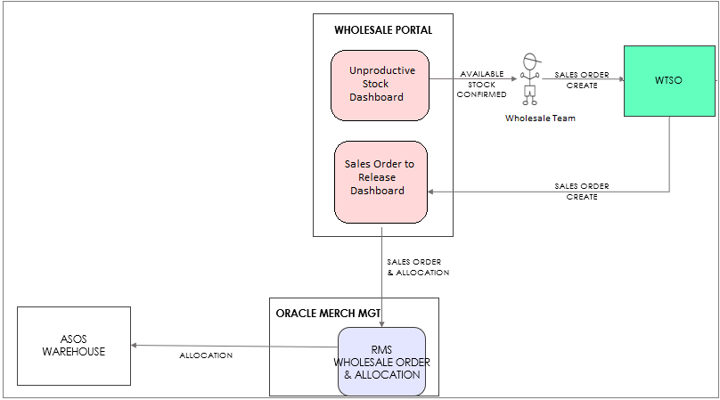
Figure 46 – Unproductive Stock Dashboard

The above figure depicts the flow of actions user will take after reviewing available un-productive wholesale stock for brands in a specific ASOS warehouse. Any stock on a wholesale channel linked virtual warehouse that have no associated Sales Order or manual transfer will be accounted as un-productive wholesale stock. User will review the unproductive wholesale stock on this dashboard and will create Sales Order in WTSO for that stock and these Sales Orders will flow to Wholesale Portal. If for any reason the stock was not available anymore the inbound interface to Wholesale Portal from WTSO will fail those Sales Orders. These Sales Orders will not have any Supplier PO linked to them and as they will already come as sized from WTSO so they will directly appear on ‘Sales Order to Release Dashboard’, waiting to be released. User will not be able to re-distribute them in Wholesale Portal.
This Unproductive Stock Dashboard will have following sections
  - Search
    - User would be able to further narrow down the result using any of the search filters provided in this section.
  - Detail table
    - This table will show the available stock by brand size.

Search
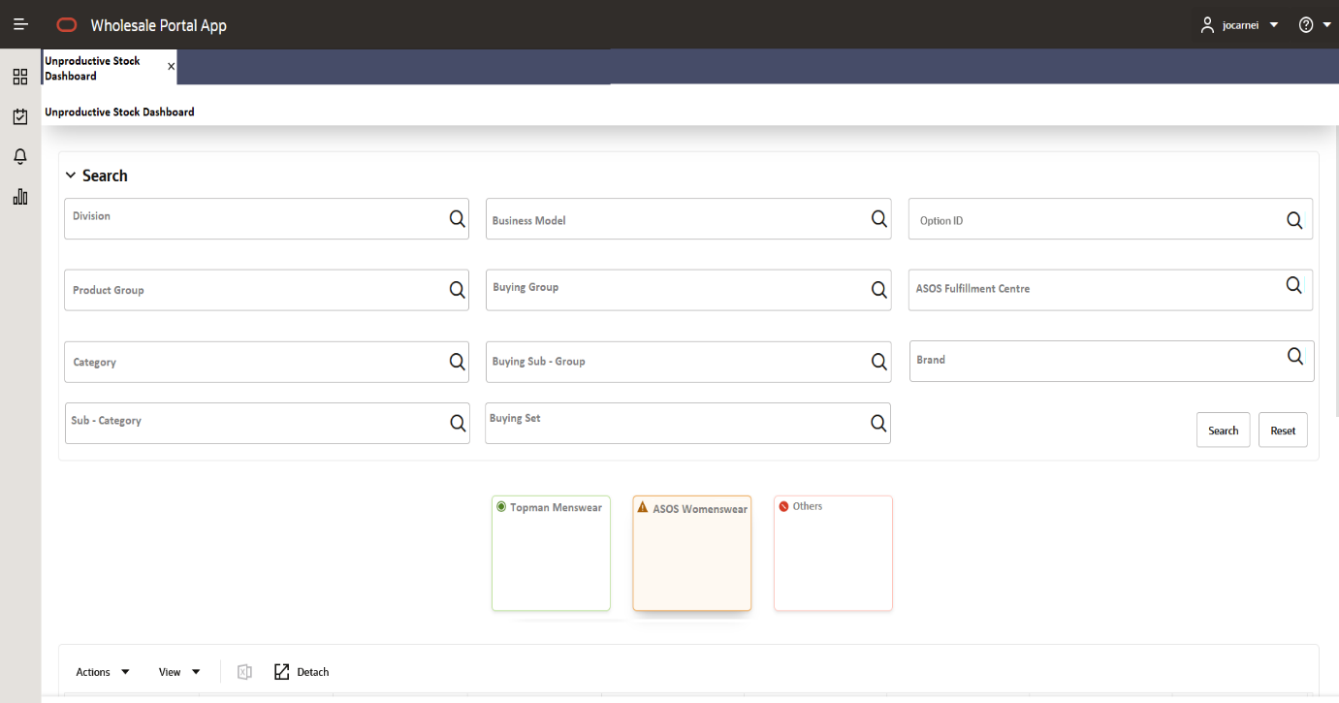
Figure 47 – Unproductive Stock Dashboard (Search Section)
Filters: In the Search section user will be able to use any of the following filters to further narrow down the results shown in the dashboard-

- Division – Part of merchandise hierarchy
- Product Group – Part of merchandise hierarchy
- Category – Part of merchandise hierarchy
- Sub-Category – Part of merchandise hierarchy
- Business Model – Part of buyrarchy
- Buying group – Part of buyrarchy
- Buying Sub-group – Part of buyrarchy
- Buying Set – Part of buyrarchy
- Option id
- ASOS Fulfilment Centre (This field will be mandatory)
- Brand

Colour Tiles: Any colour tile user will select will show the unproductive wholesale stock for that brand/division combination. For ‘Others’ tile user would be able to drill down to individual brands/division under that section using brand and division filter. Figure 9.2 just show an example of tiles, the assumption is total no. of coloured tiles will be 5 which will be assigned to first top 4 brands/division combinations which has highest no. of un-productive wholesale stock for a specific ASOS warehouse. Rest all brands/division combinations will be clubbed under ‘Others’ and will be assigned the 5th colour tile.

Detail Table
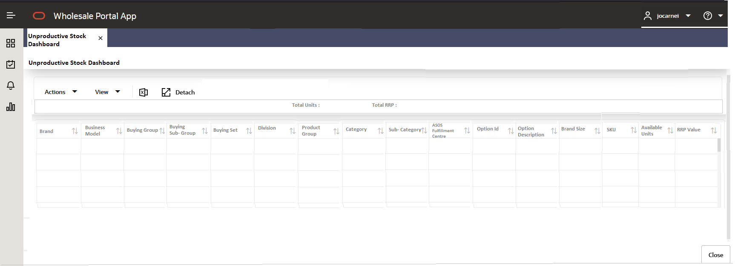
Figure 48 – Unproductive Stock Dashboard (Detail Section)

Detail Table
This table will display the un-productive wholesale stock at brand size level for different options in a brand or multiple brands for a specific ASOS warehouse.

Available fields in Table are:
Fields | Description | Notes
Brand | Brand Name
Business Model | This field will display the business model description.
Buying Group | This field will display the buying group description.
Buying Sub-Group | This field will display the buying sub-group description.
Buying Set | This field will display the buying set description.
Division | This field will display the division description.
Product Group | This field will display the product group description.
Category | This field will display the category description.
Sub-Category | This field will display the sub-category description.
Option id | The parent item on the Sales Order
Option Description | Description of the option
Brand Size | The brand size specified by ASOS business for the SKU
SKU | SKU id
ASOS Fulfilment Centre | This would be the virtual warehouse for the wholesale channel.
RRP Value | RRP value will be UK zone full price for the option. | The value will be in GBP.
Available Units | The value in this field will show the available un-productive wholesale stock in wholesale virtual warehouse. | The Available units will be calculated using the stock reflected only in MOM base tables on these locations as follows –  Available Stock = Stock_on_hand - (non_sellable_qty + tsf_reserved_qty + rtv_qty + customer_resv)  For approved PO linked to approved SO:  Available Un-productive Wholesale Stock = Available Stock –  if (PO rcv qty < SO qty) then PO rcv qty else PO rcv qty
Total Units | This field in Header will sum all the unproductive units shown on the dashboard.
Total RRP | This field in Header will sum all the RRP value that user has searched on the dashboard. | The value will be in GBP.
Table 16 - Unproductive Stock Dashboard (Detail Table)

Edit/View Sales order screen

This screen will allow user to view/edit an individual Sales Order. For Release 1 most of the amendments on a Sales Order will flow from WTSO but user will be able to edit/maintain certain attributes of Sales Order in the Wholesale Portal. In below screenshot they are highlighted in red. This screen will be accessible from the Sales Order link described in different dashboard sections. From dashboards this screen will open in Edit mode but if the Sales Order is already opened by another user in edit mode, then for the current user the screen will open in view mode. If the sales order was cancelled or released, then also it will open in view mode. This screen will be accessible from Manage Order screen (described in section 4.1.10) as well in view or edit mode. For a cancelled Sales Order this screen will open only in view mode.

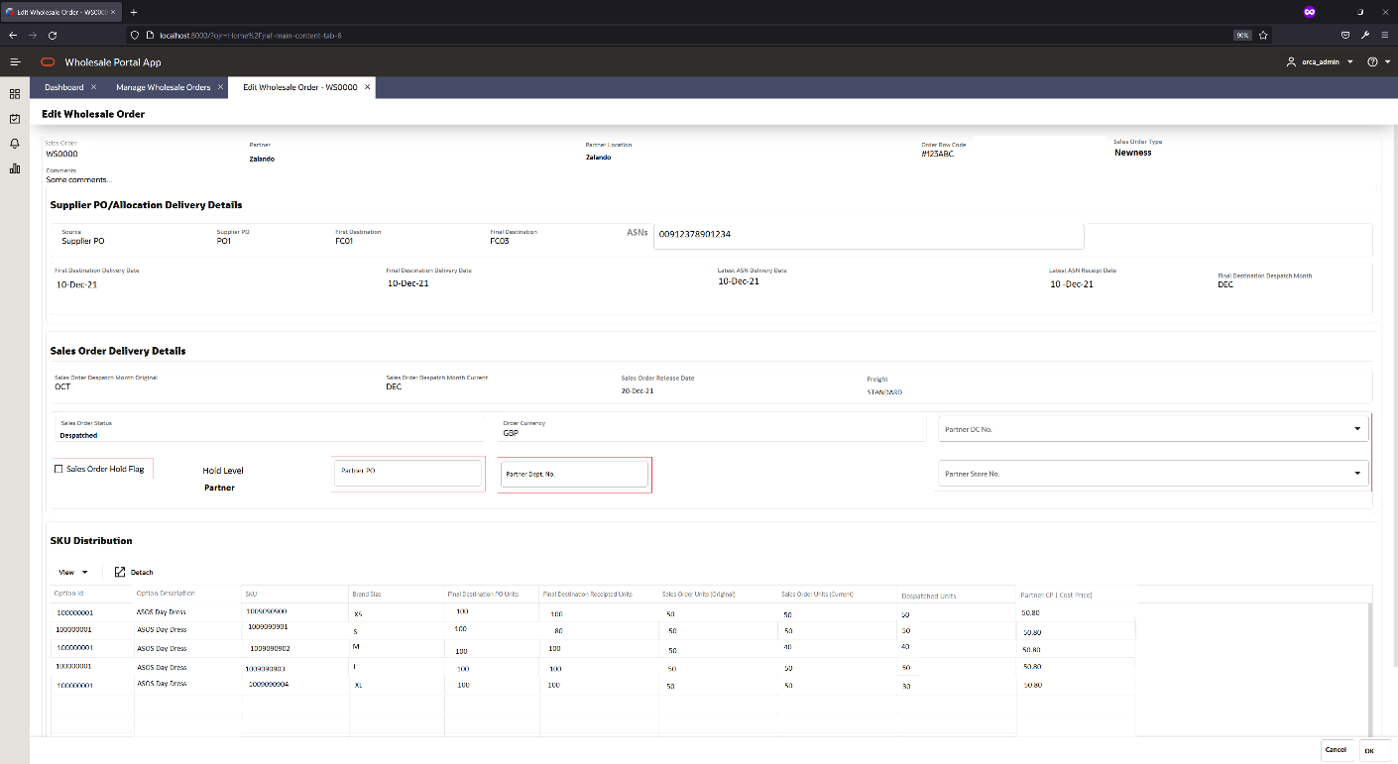
Figure 49 – Edit/View Sales Order screen

Details of available fields in this screen are mentioned in below table. The details also define which fields are editable and non-editable:
Fields | Description and Editable/Non-Editable | Notes
Sales Order No. | Unique reference in Wholesale Portal assigned to each Sales Orders.  Non-Editable
Sales Order Type | Type of Sales Order if it is created based on Supplier PO or unproductive wholesale stock.  Non-Editable | Each sales order will either be classed as ‘Pre-Order‘ (linked to Supplier PO) or ‘Trade’ (linked to unproductive wholesale stock).
Partner | Wholesale Partner  Non-Editable
Partner Location | Wholesale Partner location  Non-Editable
Order Row Code | A unique identifier associated with the Supplier PO and the corresponding Sales Orders.  Non-Editable | Order row code in Wholesale Portal will be the key identifier to establish the relationship between Supplier POs and respective Sales Orders.
Comments | Any comments interfaced from WTSO on Sales Orders.  Non-Editable
Source | This field will show what is the source of Sales Order.  Non-Editable | Valid values for Source will be-  - Supplier PO (for sales order linked with direct supplier PO).  - Supplier Allocation (for sales order linked with split supplier PO).  - Wholesale Stock (for Sales order that are source from un-productive wholesale stock).
Supplier PO | Supplier PO no.  Non-Editable | This field will be populated only when Source field is either – Supplier PO OR Supplier Allocation
First Destination | An ASOS virtual warehouse  Non-Editable | This field will show the ASOS warehouse where Supplier PO will be receipted.
Final Destination | An ASOS virtual warehouse  Non-Editable | This field will show the ASOS warehouse from where Sales Orders will be sourced.  - If the supplier PO will be direct, then first and final warehouse will be same.  - If the supplier PO will be split, then first and final destination warehouse will be different. Once the Supplier PO will be receipted on First destination it will be send to final destination as allocations.  - For Sales order with Source as -Wholesale Stock, will also show same first and final destination.
ASN | ASN No.  Non-Editable | This field will show the ASNs raised for the Supplier PO.
First Destination Delivery Date | Supplier PO delivery date on first destination.  Non-Editable | This field will be empty for sales order with Source as -Wholesale Stock.
Final Destination Delivery Date | Supplier PO delivery date on source destination.  Non-Editable | - This field will be empty for sales order with Source as -Wholesale Stock.  - For Sales Order with Source as – Supplier PO, first and final destination date will be same.  - For Sales Order with Source as – Supplier Allocation, first and final destination date will be same.
Latest ASN Delivery Date | Delivery week of the ASN raised for Supplier PO, into ASOS warehouse.  Non-Editable | - If multiple ASNs exists for Supplier PO, then field will show the ASN whose delivery date will be most distant in future.  - If the supplier PO is split, then in that case the transit transportation matrix from merch management will be used to calculate the delivery date for the source warehouse. This matrix holds the no. of days setup to ship between different ASOS warehouses.  - This field will be empty for sales order with Source as -Wholesale Stock.
Latest ASN Receipt Date | Receipt date of the ASN raised for Supplier PO, into ASOS warehouse.  Non-Editable | This field will be empty for sales order with Source as -Wholesale Stock.
Final Destination despatch Month | This despatch month will show the latest view of a calculated despatch month based on the recent view of Supplier PO ASNs or receipts.  Non-Editable | This field will be updated on following rules-  - When Supplier PO exists without ASNs it will show the despatch month based on delivery week of the PO in source warehouse plus default no. of days setup in wholesale portal to calculate the despatch month.  - When ASN exists on Supplier PO without receipts it will show the despatch month based on delivery week of the ASN in source warehouse plus default no. of days setup in wholesale portal to calculate the despatch month.  - When receipt exists on Supplier PO’s ASNs it will show the despatch month based on receipt week of the ASN in source warehouse plus default no. of days setup in wholesale portal to calculate the despatch month.  - For sales order with Source as -Wholesale Stock, this field will show the despatch month as sent from WTSO.
Sales Order despatch Month (Original) | despatch month captured in Wholesale Portal when the Sales Order was sent from WTSO first time.  Non-Editable
Sales Order despatch Month (Current) | The existing despatch month of the Sales Order.  Non-Editable
Release Date | Date when Sales Order was Released from the Wholesale Portal.  Non-Editable
Sales Order Status | The latest status of Sales Order  Non-Editable | Valid values are-  - Worksheet – this status will not be applicable for Release 1, as WTSO will only send approved Sales Orders to portal.  - Approved  - Cancelled  - On Hold  - Released  - Despatched  - Posted
Sales Order Currency | This currency will be received from WTSO and will be the partner currency maintained in WTSO.  Non-Editable
Freight | Freight method used for Sales Order.  Non-Editable | This field will show the freight method selected by the user while releasing the Sales Order. This field will be blank and will only be populated once the Sales Order has already been released.
Sales Order Hold Flag | Flag to specify individual Sales Order hold  Editable | User would be able to edit this flag. If this flag is selected that mean user has kept the specific Sales Order on hold.  User would be able to select this flag till sales order is released.
Hold Level | Type of hold level applied on the Sales Order.  Non-Editable | Even though the valid values for Hold level are mentioned below but ‘Sales Order’ will always supersede the ‘Partner’ level hold.  If the user has manually selected the above mentioned ‘Sales Order Hold Flag’ then this field will be set to ‘Sales Order’ automatically. But if the flag is not selected and Partner level hold is applied then this field will show the value as ‘Partner’. If none of the hold are applied this field will be blank. Valid values for this field would be –  - Partner  - Sales Order
Partner PO | Partner order no.  Editable | User would be able to populate a Partner PO No. in this field. This partner Po no. will be used in invoicing. No validation will be performed on the value of this partner po no. User would be responsible for entering the correct partner po no.
Partner Dept. No. | Partner department number.  Editable | User would be able to populate a Partner Department No. in this field. This field will be used in invoicing and pick list. No validation will be performed on the value of this partner dept. no. User would be responsible for entering the correct partner dept no.
Partner DC No. | DC id linked with the partner.  Editable | User would be able to select a partner DC no. for Sales Order from a drop down. This drop down will show only those DCs that are linked with partner location.
Partner Store No. | Store id linked with partner.  Editable | User would be able to select a partner store no. for Sales Order from a drop down. This drop down will show only those stores that are linked with DC selected by user in partner DC No. field. (This field will become editable only when Partner DC no. is populated by user).
Option Id | The parent item on the Sales Order  Non-Editable
Option Description | Description of the option  Non-Editable
SKU | SKU number  Non-Editable
Brand Size | Brand size specified by ASOS business for the SKU.  Non-Editable
Final Destination PO Units | Sum of all SKUs on Supplier PO  Non-Editable | These PO units will be a summed-up value of all SKUs present as commitment on Supplier PO.
Final Destination Receipted Units | Supplier PO receipted units in final destination warehouse.  Non-Editable
Sales Order Units (Original) | Units of the specific brand size on the Sales Order when it was first sent from WTSO to wholesale portal.  Non-Editable | This original unit’s column will never change in value in Wholesale Portal, as it will captured only for the first time when Sales Order was first sent to Wholesale Portal from WTSO.
Sales Order Units (Current) | Current units of the specific brand size on the Sales Order.  Non-Editable | If the Sales Order was never updated or re-distributed, then both Original and Current unit column will show the same value. From the above example in Figure 7.3 this value will be 400.
Despatched Units | Sum of all units for the brand size that are despatched by the warehouse.  Non-Editable | User would be able to see if the specific brand size was under or over picked in the warehouse for the Sales Order.
Partner CP (Cost Price) | This value will come from WTSO. This is the cost for the Wholesale Partner.  Non-Editable | This value will be sent by WTSO in partner currency.
Table 17 - Edit/View Sales Order screen (Fields Table)

Cancel Button
This button will close the screen and will not save any changes user made on the screen. Though before closing the screen, it will give below warning message to the user in case they do not want to close the screen and lose their change.

Figure 50 – Edit/View Sales Order screen closing warning

OK Button-
This button will close the screen and will save any changes user made on the screen.

Manage sales order screen

This screen will be accessed through the task bar as shown in Figure – 3.6. and will provide following functionality, details of each function are provided further in this section-
- Search screen - As most of the dashboards will show Sales Order based on certain conditions thus, this screen will allow user to search for any Sales Orders using different filters. As the result of a search may return hundreds of records, to guarantee the usability and performance of the screen the search records will be display using pagination. User will be able to jump to a specific page or click on next page to see next set of search records.

- Download Sales Order Attributes template – This screen will allow users to download Sales Order Attributes from search records using a template. With that same template users will be able to update it and do a bulk upload of different Sales Order attributes using ‘Upload’ screen described in Section- 4.1.11.
- User would be able to open Sales Order in Edit or View mode from this screen depending on data condition.
- User would be able to apply Hold Flag on Sales Orders from this screen.
- User would be able to open ‘Re-distribute PO’ screen in either edit or view mode depending on data condition.
- User would be able to export data shown in result table in an excel file through ‘Export to excel’ functionality.

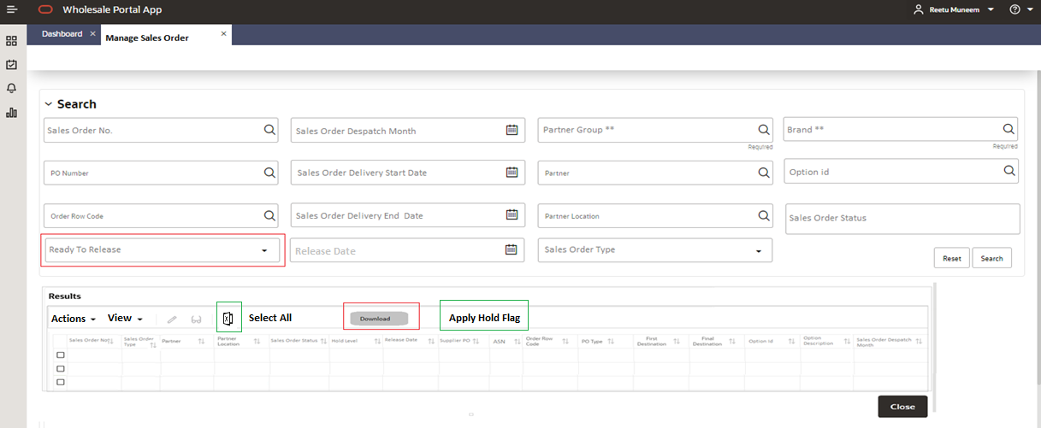
Figure 51 – Manage Sales Order Screen

This Manage Sales Order screen will have following sections-
  - Search
    - User would be able to search by filters provided in this section.
  - Result table
    - This table will show the Sales Order information user have searched.

Search
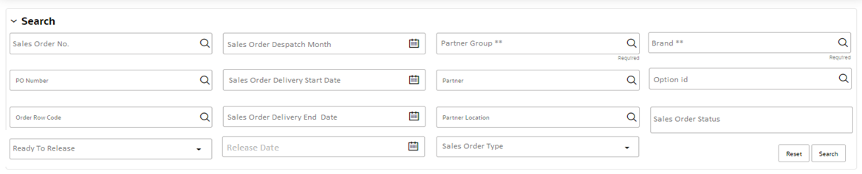
Figure 52 – Manage Sales Order Screen (Search Section)

Filters: In the Search section user will be able to use any of the following filters to search different Sales Orders-

- Sales Order No. – This will be the Sales Order No. generated / maintained in Wholesale Portal to track a unique Sales Order.
- PO Number – This will be Supplier PO No.
- Order Row Code
- Option Id
- Sales Order Delivery Start Date
- Sales Order Delivery End Date
- Partner group – Wholesale Partner parent (This field will be mandatory if “Brand” is not populated)
- Partner – Wholesale Partner
- Partner Location – Wholesale Partner location.
- Sales Order despatch month - Current despatch month on Sales orders
- Sales Order Status (This field will allow multi-selection)
- Release Date
- Brand (This field will be mandatory if “Partner Group” is not populated)
- Sales Order Type – This will be a drop down with two values – Pre-Order and Trade
- Ready To Release – This filter will be a drop down with two values, ‘Y’ and ‘N’.

In order to avoid situations where user will do a full-blown search on all Sales Orders in data base, the Partner Group or Brand filters will be mandatory. User would be able to search with any of these two fields and other non-mandatory filters.

Order Status field will allow users to select multiple Sales Order status. Following screenshot provide a view of how this field will look. User will click on the respective status they want to select, and it will keep adding it to the main filter. As shown in below screenshot user has selected both Approved and Released status.

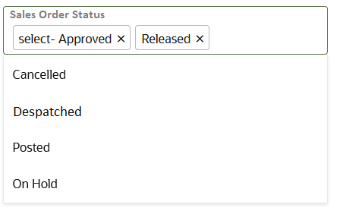
Figure 53 – Manage Sales Order Screen (Status selection)

Result Table
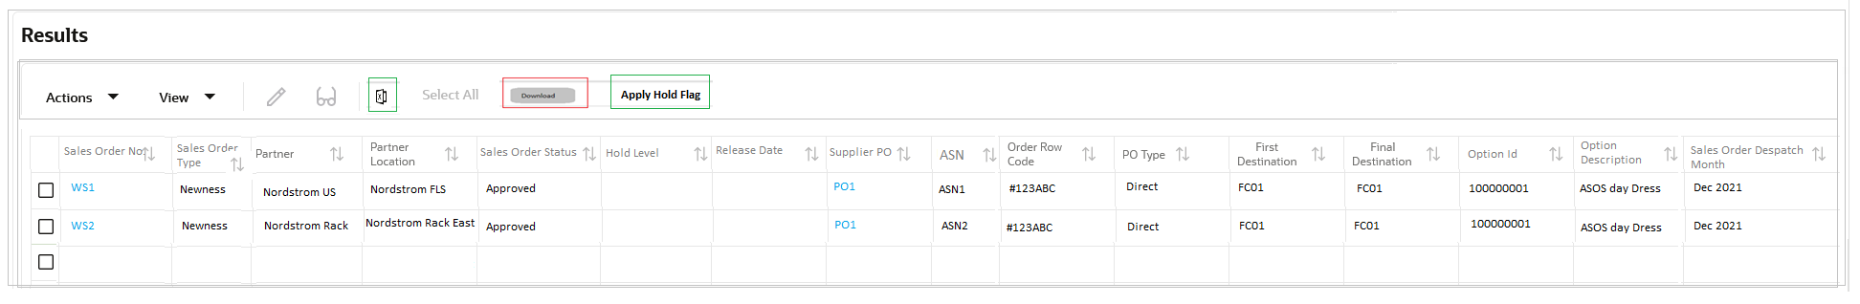
Figure 54 – Manage Sales Order Screen (Result Section)

Details of available fields in this table are mentioned below: As this table will also show the ASN raised for the Supplier PO, there are chances that if multiple ASNs will exists then same information for the Sales Orders will be replicated in multiple lines with the exception of ASN no. being different in each line.
Fields | Description | Notes
Sales Order No. | Unique reference in Wholesale Portal assigned to each Sales Orders. | This will appear as a link and will open in Edit Sales Order screen or in View Sales Order screen.  Sales Order will open in view mode under following conditions-  - If the Sales Order was already released (it has a release date populated).  - Sales Order is locked.  - Sales Order is Cancelled.  Other than these conditions Sales Order will open in edit mode.
Sales Order Type | Type of Sales Order if it is created based on Supplier PO or unproductive wholesale stock. | Each sales order will either be classed as ‘Pre-Order’ (linked to Supplier PO) or ‘Trade’ (linked to unproductive wholesale stock).
Partner | Wholesale Partner
Partner Location | Wholesale Partner location
Sales Order Status | Current status of Sales Order
Hold Level | Type of hold level applied on a Sales Order. | Even though the valid values for Hold level are mentioned below but Sales Order will always supersede the Partner level hold. If none of the hold are applied, then this value will be blank. The valid values will be:  - Partner  - Sales Order
Release date | Date when Sales Order was released from the Wholesale Portal. | If the Sales Order was already released from the wholesale portal, then this date will show the date when it was released.
Supplier PO | Supplier PO no. | This will appear as a link and will open in Re-distribute PO screen in edit mode if at least one of the Sales Order linked to the Supplier PO is not yet distributed, and the PO has been receipted on its final destination. Otherwise, it will open it view mode.
ASN | ASN No. | This field will show the ASN raised for the Supplier PO.
Order Row code | A unique identifier associated with the Supplier PO and the corresponding Sales Orders. | Order row code in Wholesale Portal will be the key identifier to establish the relationship between Supplier POs and respective Sales Orders.
PO Type | Supplier PO Type | As per ASOS business process following type of Supplier Po will be raised for wholesale –  - Direct  - Split
First Destination | An ASOS virtual warehouse | This field will show the ASOS warehouse where Supplier PO will be receipted.
Final Destination | An ASOS virtual warehouse | This field will show the ASOS warehouse from where Sales Orders will be sourced.  - If the supplier PO will be direct, then first and final warehouse will be same.  - If the supplier PO will be split, then first and final destination warehouse will be different. Once the Supplier PO will be receipted on First destination it will be send to final destination as allocations.  - For Sales order that are raised based on available un-productive wholesale stock will show same first and final destination.
Option id | The parent item on the Sales Order
Option Description | Description of the option
Sales Order despatch Month | Current despatch month on Sales Order
Table 18 - Manage Sales Order Screen (Fields Table)

Apply Hold Flag – (Highlighted in green in Figure-11.1 and 11.3)
User can select one or multiple Sales Orders or all Sales Orders in result table through ‘Select All’ flag to apply Hold flag on selected Sales Order. This function will put each of these individual Sales Orders on hold which is different to partner hold. If multiple ASNs exists on a Supplier PO, then Sales Orders associated with Supplier PO will show up multiple times on the screen. Though hold flag would be applied to all Sales Order lines user has selected. Thus, if user has selected multiple lines for same Sales Order the flag would only be applied once. For Release 1 all partners will be set with Hold flag indictor thus, this ‘Apply Hold Flag’ button will apply the hold at Sales Order level which will always supersede the partner hold. If user will click this button following validations will be performed by the system before applying hold flag
- Can only apply the flag if sales Order has not been released or is not cancelled.
User will be presented with error for respective Sales Order that fails in above validation.

This flag will be enabled only if ‘Ready To Release’ filter (highlighted in red in Figure-11.1) is not selected by the user in filter section of the screen. User would have to select one of the mandatory fields ‘Brand’ or ‘Partner group’ to run the search. They could also narrow down the result using other non-mandatory filters.
Edit and View Icon
- The pencil icon will open the selected Sales Order in Edit Sales Order screen. But it will open the screen in view mode if the sales order is already being edited by any other user or has been Released (release date is populated) or cancelled. User would be able to open a single Sales Order in Edit Sales Order screen. The icon will be disabled if user has selected more than one Sales Order.
- The glasses icon will open the selected Sales Order in View Sales Order screen. User would be able to open a single Sales Order in View Sales Order screen. The icon will be disabled if user has selected more than one Sales Order.

Download – (Highlighted in red in Figure-11.1 and 11.3)
- This button will be enabled only if the ‘Ready To Release’ filter (highlighted in red in Figure-11.1) in filter section is selected by the user as ‘Y’ or ‘N’.
- If the ‘Ready to Release’ filter will be selected as ‘Y’ then user would be able to download the Sales Orders that are ready to be Released at that point of time. This search will utilize the dataset from ‘Sales Order To Release’ dashboard. User would have to select one of the mandatory fields ‘Brand’ or ‘Partner group’ along with ‘Ready to Release’ filter. They could also narrow down the result using other non-mandatory filters. These Sales Orders will exclude any Cancelled, Released, Despatched or Posted Sales Orders.
- If the ‘Ready to Release’ filter will be selected as ‘N’ along with mandatory and other non-mandatory filters then, it will download Sales Orders which are not ready to be released. These Sales Orders will exclude any Cancelled, Released, Despatched or Posted Sales Orders.
- The result table on Manage Sales Order screen could show multiple lines for same Sales Order (due to multiple ASNs on its Supplier PO). But when user will export the excel through the download button, it will export the Sales Order only once in the file.
- The download template is attached below. The records in the template will be ordered by – Brand Name, Partner Location, Product Group and Option Id. The template will download the current values of following fields as the Sales Order attributes, if no value is present, it will appear as blank.
- Partner DC No.
- Partner Store No.
- Partner PO
- Partner Dept. No.

Template:
In the template, Product Group and Partner Location columns will show the Product Group ID and Partner Location Id as the same template is used to upload updates to the fields referred in point 5 above.

Upload

This screen will be accessed through the task bar as shown in Figure-3.6. When user will click on the ‘Upload’ on the task bar it will open below screen.

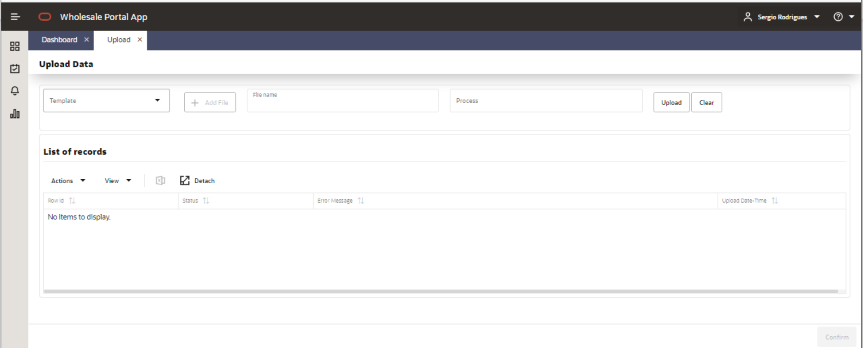
Figure 55 – Upload Screen

In Release 1 Wholesale Portal will just have one Upload, so by default the Upload Type drop down will be pre-populated as ‘Sales Order Attributes’.
User will click on ‘+ Add File’ button in order to select the file to be uploaded. The full name of the file will be displayed on the right side of the ‘+ Add File’ button and will not be editable. The ‘Process’ field will get pre-populated with the file name without its extension but users will have the flexibility to amend it and give their own description for the process.
The upload template has the exact same structure as the download template from “manage Sales Order Screen” so it can be used for the upload once updated. Though the template has several fields, but the upload will be driven by ‘Sales Order No.’ column. Based on this column Partner DC No., Partner Store No., Partner PO and Partner Dept. No. will be updated on respective Sales Order. The upload process will not run any data validations on following fields:
- Brand Name
- Partner Location
- Product Group
- Order Row Code
- Option Id
- Option Desc.

User is expected to only update - Partner DC No., Partner Store No., Partner PO No. and Partner Dept. No. on the template. If they change values in any of the above-mentioned fields in bullet points, upload process will ignore those updates.
After selecting the file and providing the process name when user will click on ‘Upload’ button, the upload process will run following validations and if it fails it will display the corresponding error message.

Scenario | Error message
Uploaded file is not in csv format or separator is not “,” | Uploaded file format or extension is invalid.
If the upload file is completely empty. | Uploaded file format or extension in invalid.
If any of the template columns are missing or any extra column is added. | Uploaded file format or extension in invalid.
If upload file is empty and only header row is present. | Uploaded file does not contain data to upload.
If Sales Order No. is blank | Mandatory fields are not populated
If Sales Order No. does not exist in Wholesale Portal. | Invalid Sales Order No.
If Sales Order No. is entered multiple times. | Duplicate rows for Sales Order No.
If Sales Order is cancelled. | Sales Order No is cancelled.
If Sales Order is already released. | Sales Order No. is released.
Partner DC No. and/or Partner Store No. are missing or not valid ones for the Partner Location on the Sales Order. | Invalid Partner DC or Partner Store No.
If Partner PO or Partner Dept. No. is populated for a Partner who does not have this attribute setup as mandatory. | Partner PO or Partner Dept No. is not mandatory for the partner on Sales Order.
If Partner DC No. and/or Partner Store No. is populated for a Partner who does not have this attribute setup as mandatory. | Partner DC No. or Partner Store No. is not mandatory for the partner on Sales Order.
If Sales Order is locked. | Sales Order No. is locked.
The maximum number of lines which can be uploaded is 100 for one upload file. If user tries to upload more than 100 lines. (This will exclude the header line). | Maximum number of records (100) per upload is exceeded. Please review number of records.
Table 19 - Upload Screen (Fields Table)

Note: The upload process will scan all rows and show the respective first error encountered on each Sales Order line. If a row passes validations, it will show as ‘Ready to upload’ while for other rows corresponding error will be shown. User will not be able to upload the file until all errors are resolved or user has removed the errored rows from the file. User would be able to Upload the file again after clicking on ‘Clear’ button, as it will clear out the already selected file, process name and all errors displayed.

Below screenshot shows a scenario where few lines are in error, and few are ready for upload.
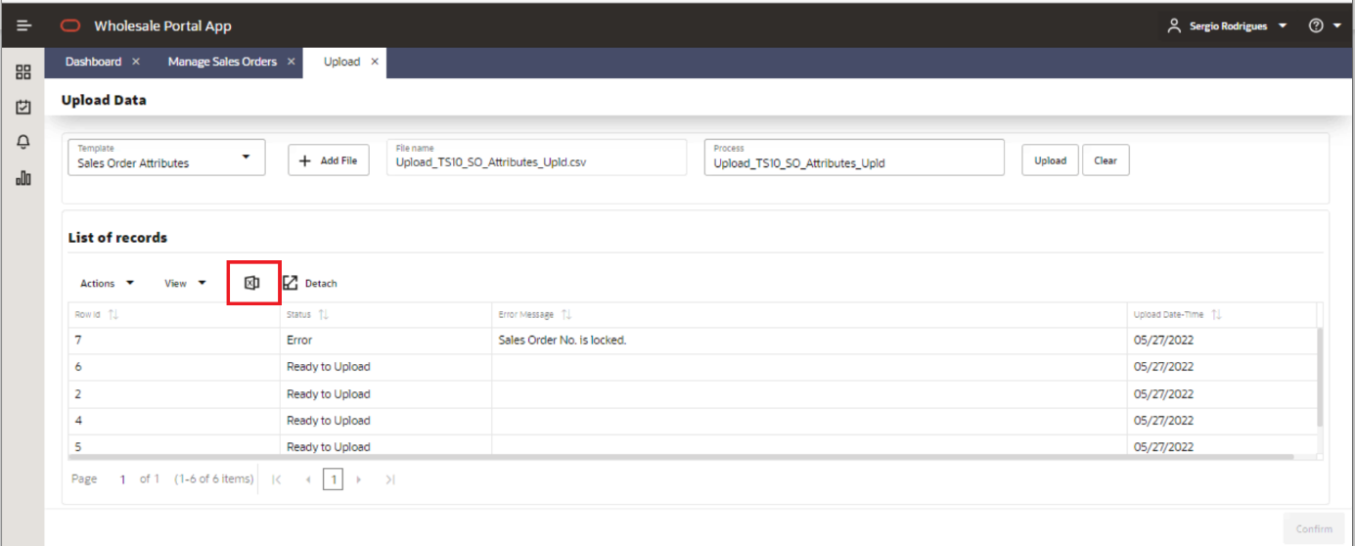
Figure 56 – Upload (Error report)
User would be able to extract this error table using the export to excel function highlighted in red in above screenshot. User would also be able to sort the columns in this table. The ‘Confirm’ button will only be enabled once all rows are set as ‘Ready to upload’.

Once user will click the ‘Confirm’ button following message will be shown to the user. The message will show a unique upload id, user should make a note of it. So that they can then check the notification using this upload id. This upload id would be useful if user would have uploaded multiple files successfully within lesser time gap.
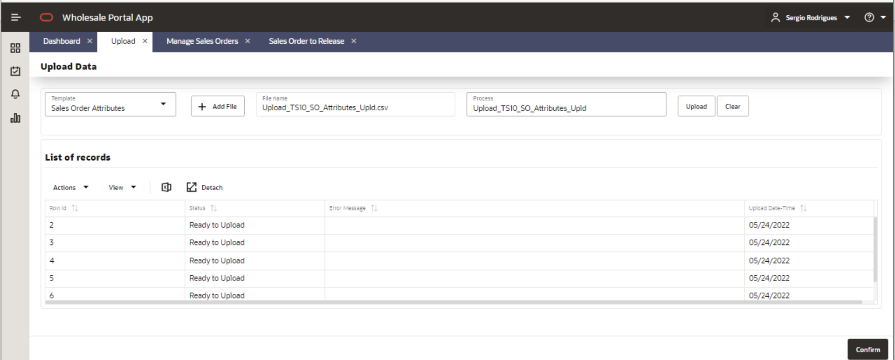
Figure 57 – Upload (Validations Successful)
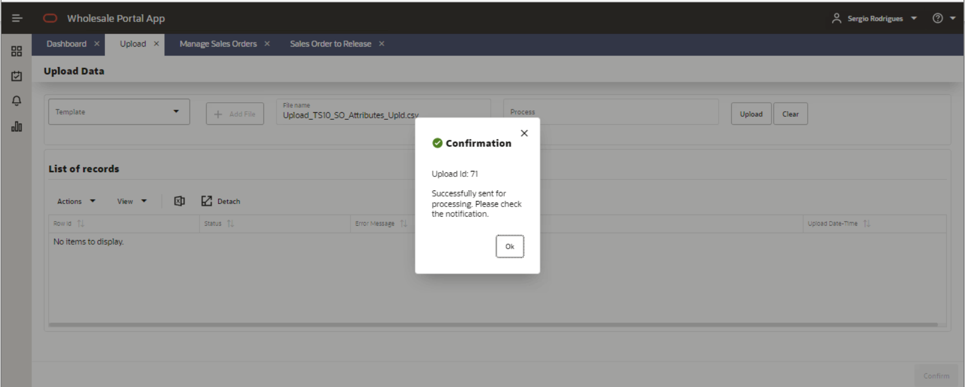
Figure 58 – Upload (Sent for Processing)

Once the updates on the Sales Orders are completed a notification will appear on the left-hand side bell icon, as shown in below screenshot. This will indicate that Partner PO, Partner DC No., Partner Store No., Partner Dept. No. are updated successfully on respective Sales Orders.
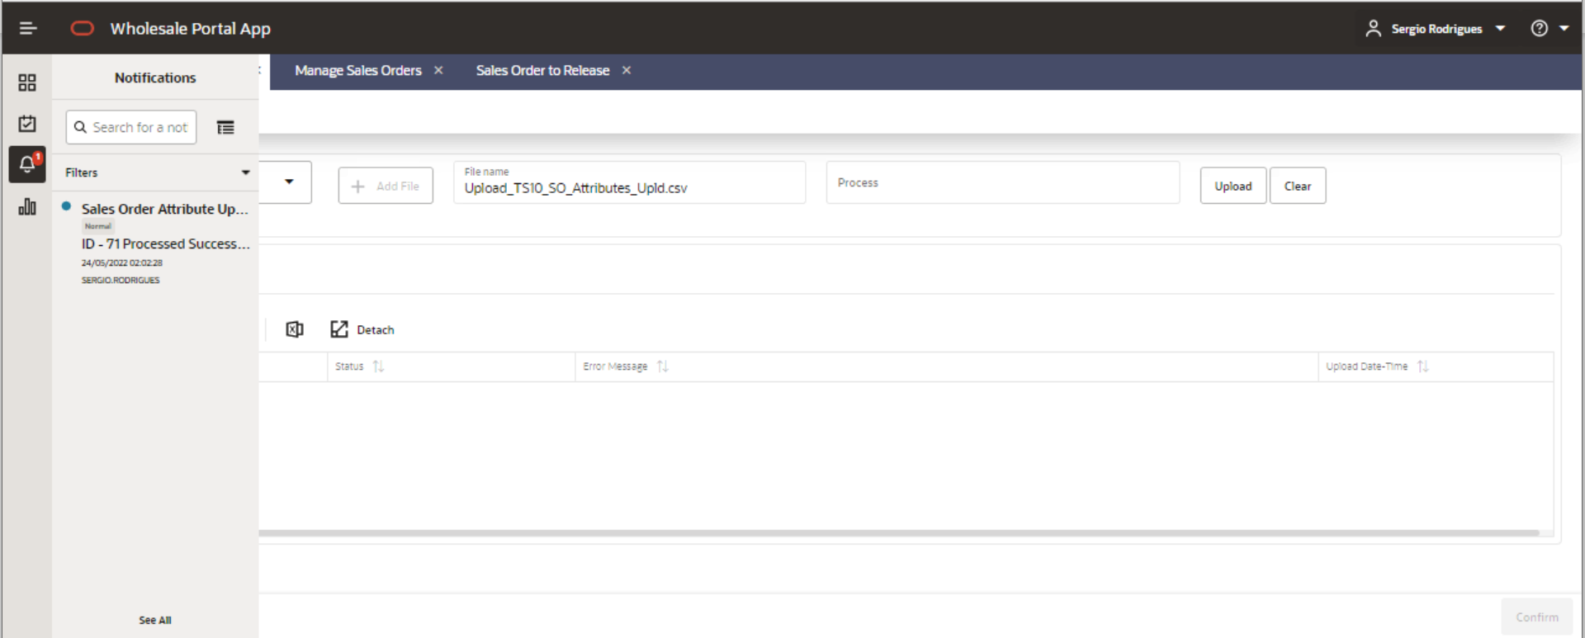
Figure 59 – Upload Notification

Upload Template:

Behaviour Design

System parameters
Below the list of all the system parameters defined for Wholesale Portal.

Functional Area | Parameter Name | Parameter Description | Accepted Values
VIRTUAL_WH | WH_DEFAULT_DAYS  (This parameter will be set for each ASOS virtual warehouse associated with wholesale channel.) | The default no. of days for each ASOS warehouse where Sales order is processed before being despatched to partners. | 21 days
WP_PURGE_CONFIG | SALES_ORD_PRG_DAYS | No. of days before Sales Orders are purged from wholesale Portal. | 730 days (2 years)
INBOUND_SALES_ORDER | INBOUND_PRG_DAYS | This value will determine after how many days data will be purged from any tables maintained for inbound interface like error tables etc. | TBD
WHOLESALE_CHANNEL | WS_CHANNEL_ID | This will be the same id no. of wholesale channel as set in RMS. | TBD
FREIGHT | FREIGT_TYPE | This will track the freight used on the Sales Order | Two values agreed with Wholesale Team are –  - Other  - Standard
Table 20 - System Parameters Table

Batch Processes

New/Custom Modules

Name | New  Mod | Description
wp_purge.ksh | New | This new batch will purge Sales order records after 2 years and any data maintained
wp_refresh_results.ksh | New | This dashboard batch will refresh all the dashboards of the portal.
wp_clear_stock.ksh | New | This batch will clear out the stock at end of each day on each of the partner locations, that will be maintained as virtual store in ORMS. When the allocations for the partner locations will be despatched by warehouse, that despatch will automatically auto-receive the stock on these partner locations. Thus, this batch is needed to clear out the stock at end of the day.
Table 21 – Batch Processes Table

Open and Closed Issues
The open issues /decisions /assumptions taken for Wholesale Business Solution by ASOS, and all associated systems are captured in following issue log-
https://asos1.sharepoint.com/:x:/r/sites/WholesaleStrategic/_layouts/15/doc2.aspx?sourcedoc=%7B111e79cb-0956-4bdc-8980-04ad92840396%7D&action=edit&activeCell=%27ACTIONS%26ISSUES%27%21E30&wdinitialsession=f00eb78d-ec2b-4c39-8655-ff8e95a16463&wdrldsc=10&wdrldc=1&wdrldr=AccessTokenExpiredWarning%2CRefreshingExpiredAccessT&isSPOFile=1

Add open issues that you identify while writing or reviewing this document to the open issues section. As you resolve issues, move them to the closed issues section and keep the issue ID the same. Include an explanation of the resolution.
When this work product is complete, any open issues should be transferred to the project- or process-level Issue Log (Manage focus area) and managed using a project level Issue Form (Manage focus area). In addition, the open items should remain in the open issues section of this work product, but flagged in the resolution column as being transferred.

Open/Closed Issues
Issues impacting the Wholesale Portal and its design assumptions are also captured in below section of this document.
ID | Issue | Resolution | Responsibility | Target Date | Status
1 | Wholesale Team is yet to decide on mandatory search filters for Manage Order screen. | A new filter ‘Brand’ has been requested to include in this screen. In FDD review session it was agreed to make Brand and Partner Group no. as mandatory fields. These details have been updated in FDD. | Wholesale Team | 10/12/2021 | Closed
2 | Setup of Sheffield in ORMS |  | ASOS |  | Open
3 | Wholesale Team has asked to display Option description in ‘Sales Order to Release Dashboard’ but Oracle suggestion is to include it in all dashboards and screens if it seems fit to wholesale team. | Option description has been added to all relevant tables in Wholesale Portal dashboard and screens. | Oracle | 10/12/2021 | Closed
4 | Wholesale Team to confirm if for any partners they would be populating the Partner PO No. even after the Sales Order is released. As of now the assumption is user will not be able to amend the Sales order once it has been released. | As per the ASOS business meeting between Jag and senior wholesale team members, the partners should provide the Partner PO no. upfront. Thus, Wholesale Portal will not allow editing Partner PO once Sales Order is already released and will always check that Partner PO exists before the release of Sales Order if the Partner level indicator for mandatory Partner PO is set to ‘Y’. | Wholesale Team | 16/12/2021 | Closed
5 | Need a further discussion with Wholesale Team to align on how they want to show the hold level in portal when partner level hold is already applied, and user also selects the hold flag on individual sales order level. | Hold level has been included in FDD on following screens  1. Sales Order Release dashboard.  2. Edit Sales Order screen.  3. Manage Sales Order screen. | Wholesale Team/Oracle | 10/12/2021 | Closed
6 | Oracle suggestion is to include some filter to differentiate Sales Order linked with PO versus Wholesale stock linked. Wholesale Team can review if it makes sense and would be relevant for which screens. | Sales Order type has been added on following screens in FDD –  1. Manage Sales Order screen (in filter and detail table).  2. Sales Order to Release Dashboard (in filter and detail table).  3. Edit Sales Order screen. | Oracle | 10/12/2021 | Closed
7 | Excel export for Post Receipt Units Variance dashboard is yet to be discussed with Wholesale Team. | Included in FDD. | Oracle | 10/12/2021 | Closed
8 | Oracle to explore the possibility of partial refresh of release dashboard. If it’s not possible to achieve then error messages will be used to inform the user if they are re-releasing a sales order which has already been released. | User will receive an error if they try to release an already released Sales Order. | Oracle | 09/02/2022 | Closed
9 | Time out mechanism for the wholesale portal and the release of respective data base locks acquired due to time out is yet to be finalized by oracle. |  | Oracle |  | Open
10 | As of now the purge days defined by wholesale team for Sales order are 730 days nearly 2 years. But it has to be further discussed with Commercial and Finance team, if they are happy with this configuration or if finance want longer duration to follow up on any invoicing related query on Sale Order. |  | Kevin/Finance |  | Open
11 | The pick instructions information for WMS team is still being agreed with RIS, Oracle and Supply Chain. |  | ASOS |  | Open
12 | Generating Billing Extract for finance. This billing information is yet to be shared by finance team. |  | Finance |  | Open
13 | For Release 1 wholesale team will not have any flexibility to mark data as seen so that it does not show again in dashboards. | In FDD review session it was agreed to have this requirement as a fast follower after Release1. | Oracle | 10/12/2021 | Closed
14 | New requirement to –  Add Release Date in Manage Sales Order Search filters and in Edit/View Sales Order screen. | Added Release Date on following screens in FDD –  1. Manage Sales Order screen (filter and detail table).  2. View/Edit Sales Order screen. | Oracle | 10/12/2021 | Closed
15 | New requirement to –  Allow user to select a freight method while releasing the sales orders. | Freight selection has been added to FDD for following screens –  1. Sales Order to Release dashboard.  2. Edit/View Sales Order screen. | Oracle | 10/12/2021 | Closed
16 | New requirement to –  Bulk upload of Partner no. and DC no. on Sales orders- Current assumption is it will not be part of Release 1. | Details of the bulk upload of Sales Order attributes has been added to the FDD. | ASOS/Oracle | 09/02/2022 | Closed
17 | New requirement to –  Show cancelled units and a different status for warehouse-initiated cancellation on Sales Order allocations where they do not have enough quantity to despatch | As discussed in FDD review session as an interim solution for release 1 Despatched Units are added as an additional field in Edit Sales Order screen. | Oracle | 10/12/2021 | Closed
18 | New requirement to –  Show Sales order id/ref in following dashboards/screens-  a. Manage Sales Order Screen (need to confirm with Kevin if it’s at both filter and result level?)  b. Pre- receipt Units Variance dashboard (need to confirm with Kevin if it’s at both filter and result level?)  c. Sales Order to Release Dashboard (need to confirm with Kevin if it’s at both filter and result level?)  d. Edit/View Sales Order screen | As discussed in FDD review session, this requirement is not needed anymore. Thus, no changes are done in FDD for this requirement. | Wholesale Team | 10/12/2021 | Closed
19 | New requirement to –  ASN visibility (mostly used to communicate ASN no. to WMS system, post release of wholesale orders)- Current assumption is it will not be part of Release 1. | ASN details have been included in FDD for following screens –  1. Manage Sales Order Screen.  2. Sales Order to Release Dashboard.  3. Edit/View Sales Order screen. | Oracle | 10/12/2021 | Closed
20 | If all ASOS warehouses will be set up with multiple virtual FCs for online and wholesale, is still an open question. What would be the name and Ids of these virtual warehouses are yet to agreed and setup. |  | ASOS/Supply Chain/Oracle |  | Open
21 | The dependencies section in the FDD will be updated later once there is more clarity for the requirement of inbound interfaces from Supply chain to RIS to Merch management related to stock movement between virtual warehouses. |  | ASOS/Supply Chain/RIS/Oracle |  | Open
22 | New requirement to share SKU information with the partners. Several options like BI reporting or getting a download from WTSO or EDI interface to partners or csv from Wholesale Portal, are being discussed for this new requirement. |  | ASOS |  | Open
23 | New Requirement to publish Collection Date on pick information to RIS. Option for allowing user to enter this date on wholesale portal or to hold configuration of default no. of days at partner level to calculate Collection date based on Release Date is under discussion. |  | ASOS / Oracle |  | Open
24 | Grouping of allocations requirement from Supply chain is still being discussed. The inclination as of now is to explore this possibility on WMS side itself as they have all necessary information for them to group including the Sales order no. which is a unique identified for them to group allocations belonging to a specific Sales Order raised for a specific wholesale partner. |  | ASOS / Supply Chain |  | Open
25 | New requirement to allow cancelling a Sales Order post its release. This will not be a systematic solution for Release 1 and would be handled through manual process. The business process to handle it manually is yet to be documented. |  | ASOS |  | Open
26 | The new requirement from ASOS to allow changing wholesale tag on PO and also start using tag on ASNs and allowing changing them at ASN level will have a design impact on wholesale portal. But unless ASOS and all associated systems clears out the requirement and design for this tag change its difficult to gauge the level of impact on design. | As per the ASOS business meeting between Jag and senior wholesale team members, this requirement to allow changing wholesale tag will be added to backlog as a future requirement. | ASOS/RIS/Supply Chain/Oracle/Finance | 16/12/2021 | Closed
Table 22 – Open/Close Issues Table

Appendix

Add open issues that you identify while writing or reviewing this document to the open issues section. As you resolve issues, move them to the closed issues section and keep the issue ID the same. Include an explanation of the resolution.
When this work product is complete, any open issues should be transferred to the project- or process-level Issue Log (Manage focus area) and managed using a project level Issue Form (Manage focus area). In addition, the open items should remain in the open issues section of this work product, but flagged in the resolution column as being transferred.

Excel extract from Dashboards/Screens

- Pre-Receipt Units Variance dashboard export sample-

- Despatch Window Variance Dashboard export sample-

- Post Receipt Units Variance Dashboard export sample-

- Sales Order to Release Dashboard export sample-

- Unproductive Stock Dashboard export sample –

- Manage Sales Order Screen export sample

- Upload Screen export sample –

