We have completed the wholesale batch testing with peak volume and sharing the results.
Summary of the result:
1. Peak volume of 5000 records processed in 22 minutes.
2. After peak volume inserted with import batch the refresh batch jobs took nearly 15 minutes to complete.

Batch runtimes:
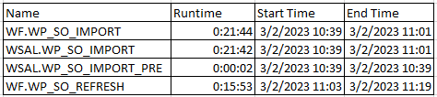

File created with 5000 records and processed:
