ANDROID CALCULATOR APPLICATION

Background
The Android Calculator is a powerful and user-friendly mobile application developed using the Python programming language. The app offers a wide range of mathematical functions and provides a convenient tool for performing calculations on Android devices. By leveraging the flexibility and versatility of Python, this calculator app aims to deliver a seamless and intuitive user experience.
The Android Calculator app incorporates a sleek and modern user interface, ensuring easy navigation and efficient input of mathematical expressions. Users can perform basic arithmetic operations such as addition, subtraction, multiplication, and division, as well as advanced functions like square root, exponentiation, and trigonometric calculations. The app supports integer and decimal inputs, offering precision and accuracy in calculations.
Furthermore, the Android Calculator allows users to customize their experience by selecting different themes, font sizes, and color schemes to suit their preferences. The app also includes a history feature, enabling users to review and reuse previous calculations, and a memory function for storing intermediate results.
The implementation of the Android Calculator app utilizes the Python programming language's extensive mathematical libraries, providing robust and reliable calculations. The app leverages the Android platform's capabilities through the use of frameworks like Kivy or BeeWare, which facilitate the development of cross-platform applications.
The Android Calculator built using Python is a feature-rich and user-centric application that offers a comprehensive set of mathematical functions, a customizable interface, and a seamless user experience. With its intuitive design and reliable calculations, this calculator app is a valuable tool for Android users in various fields, including education, finance, and everyday calculations.
We can create amazing python calculator application for both android & iOS devices by using kivy module.
It’s created using the input field, buttons, and logic defined in functions for calculation purposes. For example, if you want to add two numbers, there must be logic for addition, similarly for subtraction, multiplication, and so on, we have created functions whose task is to perform these operations.
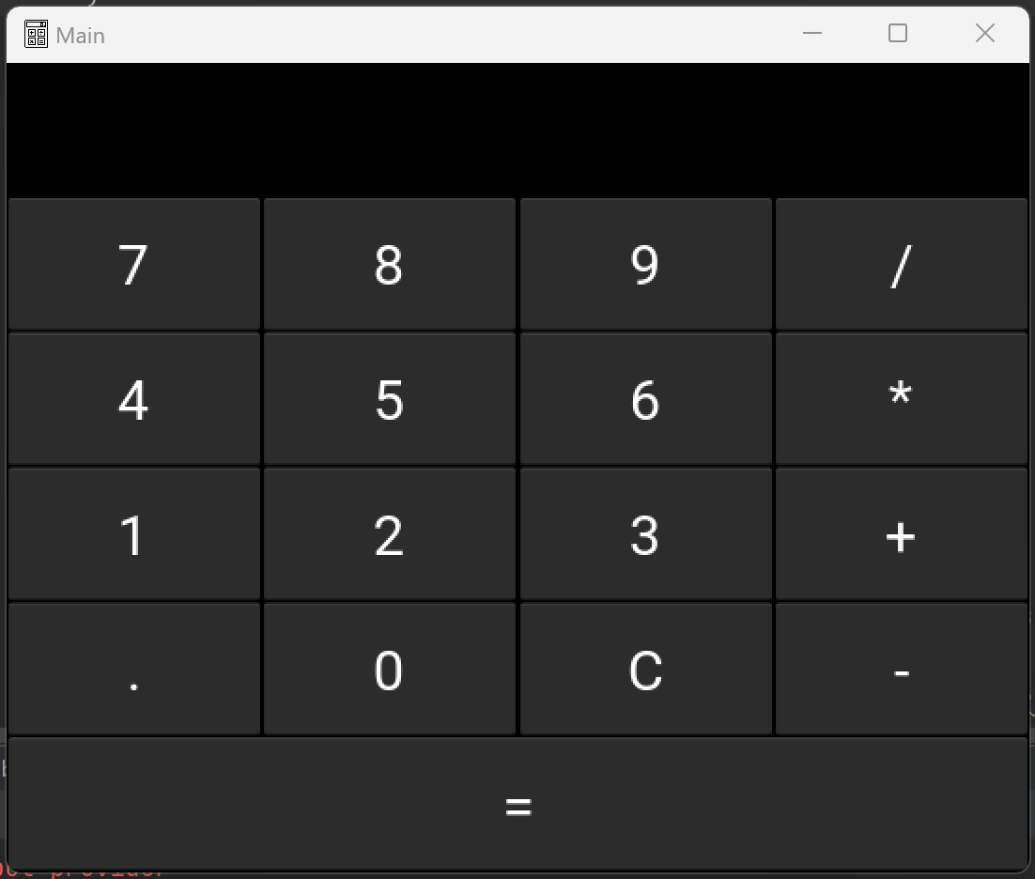

We have an Input Field where the user input will be shown along with the calculation's ultimate result.
The buttons are numbered 0, 1, 2, 3, 4, 5, 6, 7, 8, 9, +, -, *, /, =, and C. (clear button).

How Android Calculator is Working?

The Android Calculator app built using Python operates through a combination of user input, mathematical calculations, and a graphical user interface (GUI). Here's a high-level overview of how the app works:

User Interface: The app presents a graphical user interface on the Android device, allowing users to input mathematical expressions and view the results. The interface typically includes buttons for numbers, operators, and functions, as well as text fields to display the input and output.

Input Processing: When a user interacts with the app by pressing buttons or entering values, the input is processed to determine the desired operation. This involves parsing the input string and identifying the numbers, operators, and functions involved.

Mathematical Calculations: Once the input is processed, the app utilizes Python's mathematical libraries to perform the necessary calculations. Python provides built-in functions and modules for arithmetic operations, trigonometric calculations, exponentiation, square root, and more. These functions are called upon based on the user's input and mathematical requirements.

Error Handling: The app incorporates error handling mechanisms to detect and handle invalid inputs or mathematical operations. For example, it can detect division by zero, invalid syntax, or unsupported operations and display appropriate error messages to the user.

Displaying Results: The calculated result is then displayed in the output field of the app's user interface. The result may be formatted based on the desired precision (decimal places) or scientific notation, depending on the user's preferences.

Cross-Platform Development: The Android Calculator app may be developed using frameworks like Kivy or BeeWare, which enable cross-platform compatibility. This means the app can potentially be deployed on other platforms, such as iOS or desktop operating systems, with minimal modifications.

Overall, the Android Calculator app built using Python combines user input, mathematical calculations, error handling, and a user-friendly interface to provide a comprehensive and efficient calculator experience on Android devices.

Advantages

The Android Calculator app built using Python offers versatility, a user-friendly interface, customization options, robust error handling, cross-platform compatibility, extensive mathematical libraries, and benefits from the open-source Python ecosystem. These advantages combine to provide a powerful and user-centric calculator experience on Android devices.

Project Life Cycle
The waterfall model is a classical model used in the system development life cycle to create a system with a linear and sequential approach. It is termed a waterfall because the model develops systematically from one phase to another in a downward fashion. The waterfall approach does not define the process to go back to the previous phase to handle changes in requirements. The waterfall approach is the earliest approach that was used for software development.
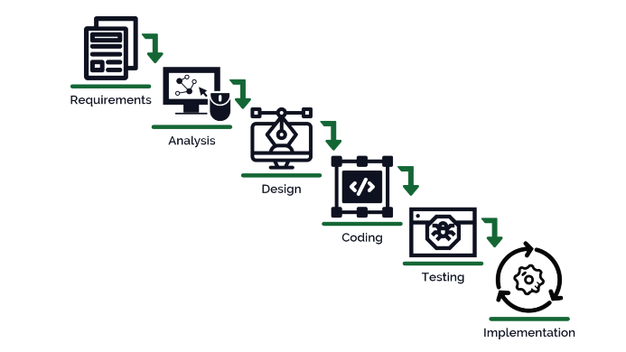

- System Requirements

- Hardware Requirement

- Laptop or PC
- Windows 7 or higher
- I3 processor system or higher
- 8 GB RAM or higher
- 100 GB ROM or higher

- Android Phone (6.0 and above)

- Software Requirement

- Laptop or PC
- Android Studio IDE or Pycharm IDE
- Kivy Framework
Interface

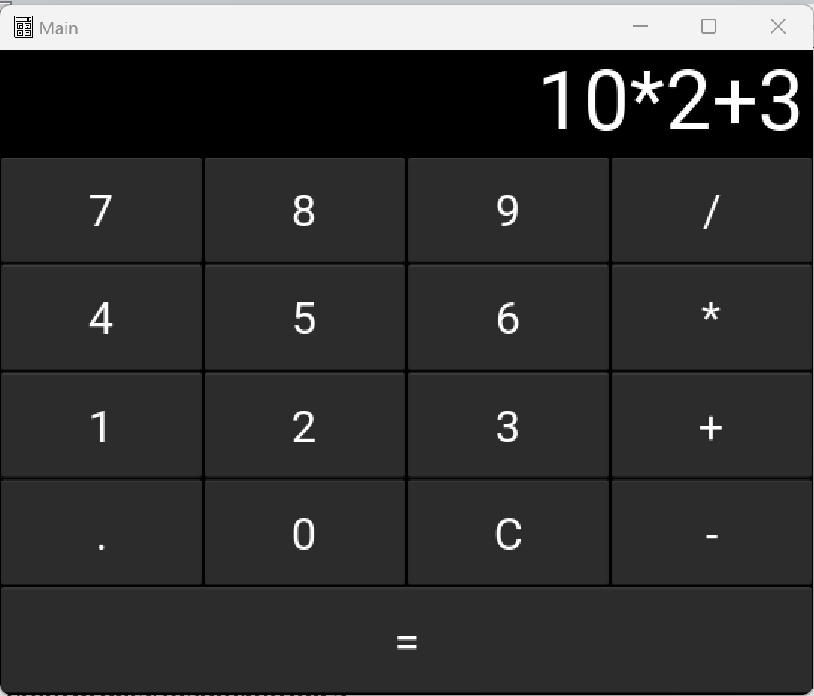
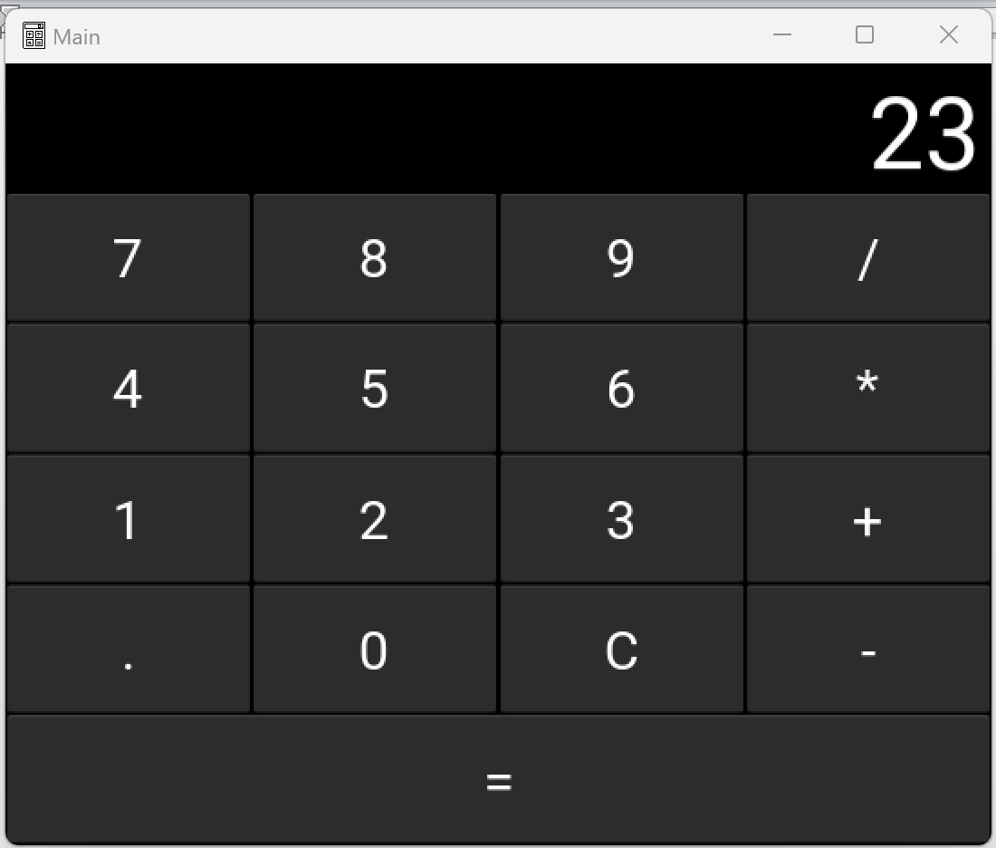

Code
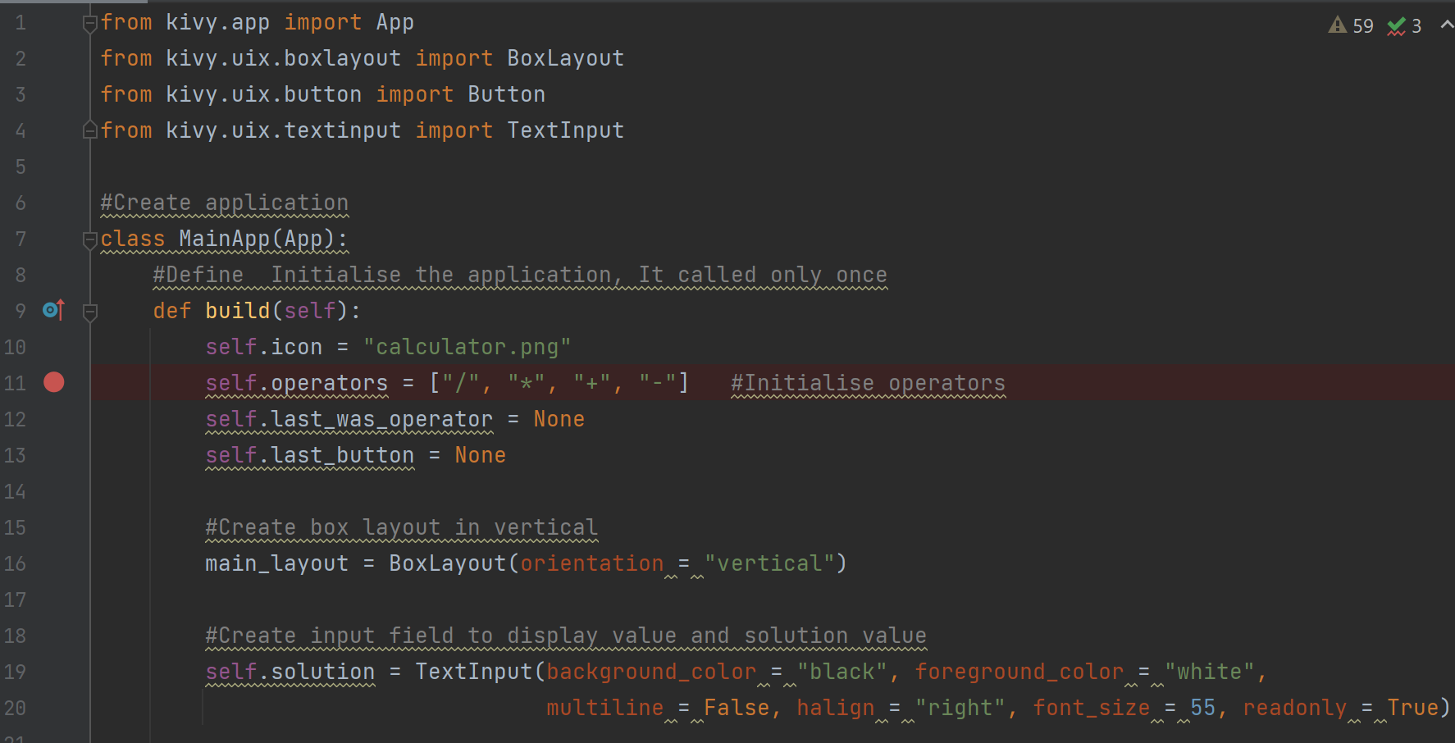
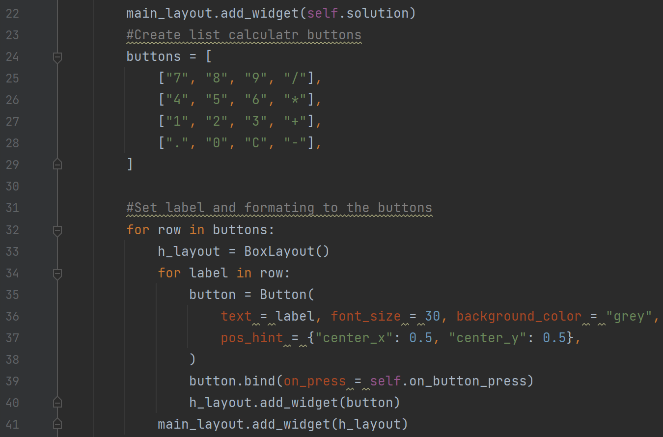
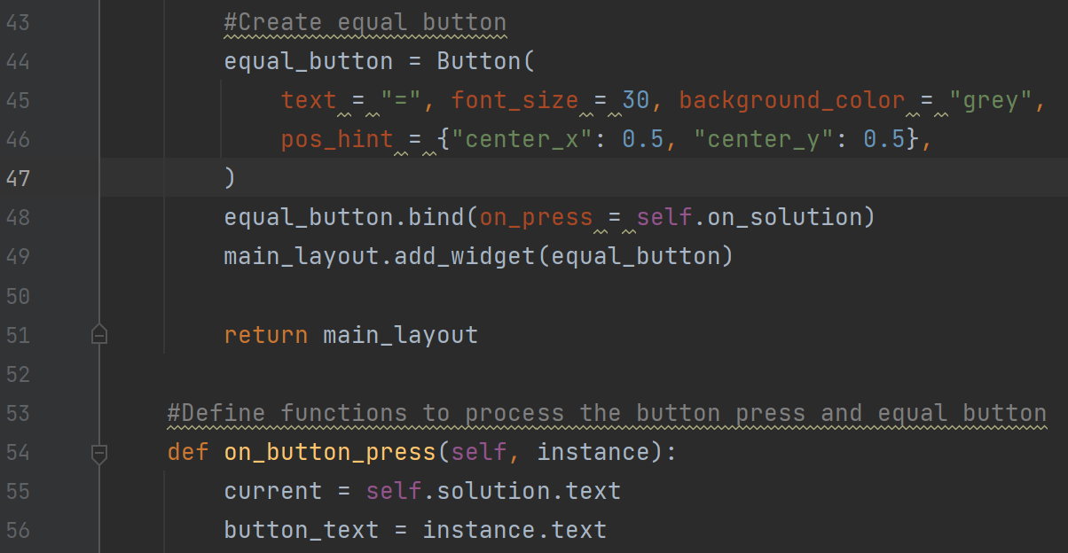
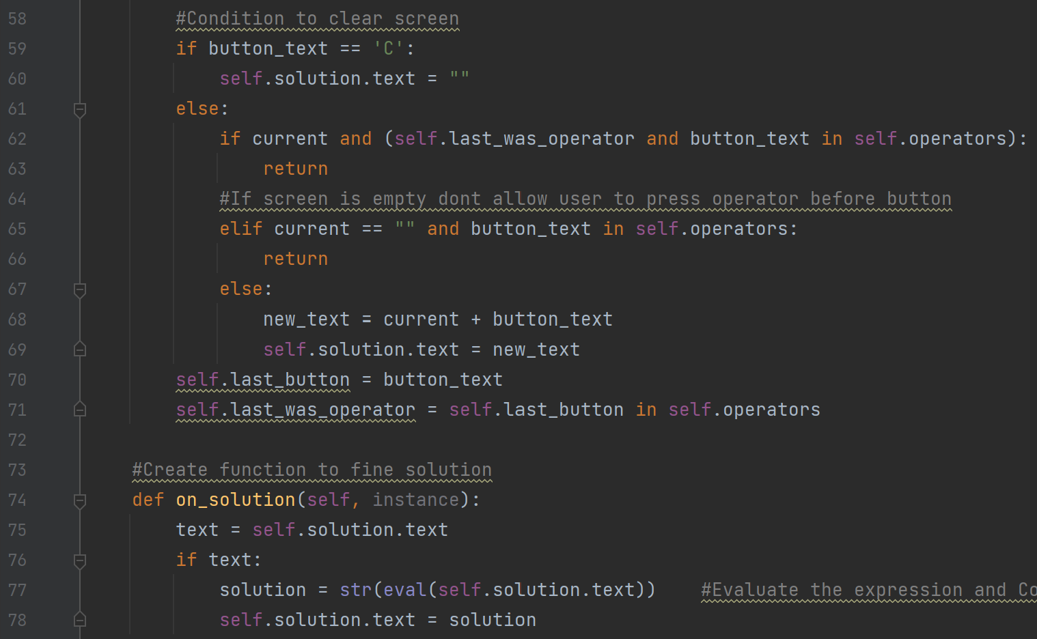
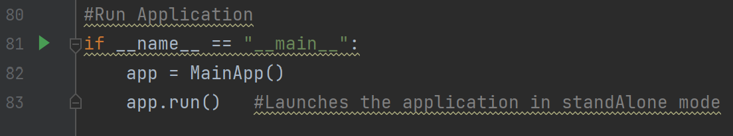

Limitations/Disadvantages

Additional Features: The app may not include additional features such as a history function that records previous calculations, allowing users to review and reuse them. It cannot also include a memory function to store and recall intermediate results for complex calculations.

Customization: The app does not offers customization options such as themes, font sizes, and color schemes, also not allowing users to personalize their experience and tailor the app's appearance to their preferences.

Reference

- en.wikipedia.org
- http://ieeexplore.ieee.org/document/6396090/
- https://www.creatrixcampus.com/blog/top-10-advantages-automated-student-attendance-system
- https://www.slideshare.net/AkGoverdhan/rfid-attendance-system-48338237

