
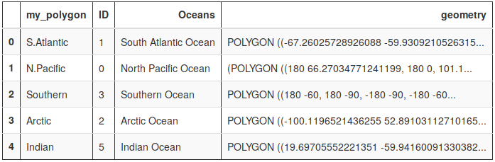
GeoPandas
Out:

Info Sheet

Python Geospatial Data Frame : http://geopandas.org/

Overview
GeoPandas is a project to add support for geographic data to pandas objects. It currently implements GeoSeries and GeoDataFrame types which are subclasses of pandas.Series and pandas.DataFrame respectively. GeoPandas objects can act on shapely geometry objects and perform geometric operations.

As you are aware, a pandas DataFrame is a collection of columns, additionally the rows are indexed. GeoPandas extend the core elements of pandas to include geospatial attributes and support geospatial data types for columns. One such, very important attribute, is the coordinate reference system (CRS). CRS each of a particular projections (http://geopandas.org/projections.html), which is a mathematical definition of how the coordinates map to a spheroid or planar system.
The geometry (Shapely) types supported by GeoPandas includes:
- Points / Multi-Points
- Lines / Multi-Lines
- Polygons / Multi-Polygons

Related libraries
Pandas : https://pandas.pydata.org/
Shapely : https://github.com/Toblerity/Shapely
Fiona : https://github.com/Toblerity/Fiona
import fiona;
fiona.supported_drivers
{'ARCGEN': 'r',
'AeronavFAA': 'r',
'BNA': 'raw',
'DGN': 'raw',
'DXF': 'raw',
'ESRI Shapefile': 'raw',
'GPSTrackMaker': 'raw',
'GPX': 'raw',
'GeoJSON': 'rw',
'Idrisi': 'r',
'MapInfo File': 'raw',
'OpenFileGDB': 'r',
'PCIDSK': 'r',
'SEGY': 'r',
'SUA': 'r'}
Checking Supported Geospatial Formats
In:
Out:

Code Samples
Loading a Geospatial Data File

import geopandas as gpd
oceans =
gpd.read_file("oceans.shp")
oceans.head()
In:

import pandas as pd
import geopandas as gpd
from shapely.geometry import Point

df=pd.read_csv('datafile_with_LatLon.csv')

# Generate a List of shapely.geometry.Point
# from the (lon, lat) pair for each row
geom_list = [Point(xy) for xy in
zip(df['lon'], df['lat'])]

# Create a GeoPanda DF with original data
gdf =
gpd.GeoDataFrame(df,geometry=geom_list)
Convert regular file data to GeoPandas
In:

Recipes:

Other References and Links:

Spatial Joins
https://github.com/geopandas/geopandas/blob/master/examples/spatial_joins.ipynb

Basic Rendering
http://geopandas.org/mapping.html

Well-known Text
https://en.wikipedia.org/wiki/Well-known_text

