Connecting to PostgreSQL

# Quick Start Details

**Hostname**: dbase.dsa.missouri.edu

**Database Name**: dsa_student

**Credentials**: MU SSO credentials

Connect Example from server: **jupyterhub.dsa.missouri.edu**

|  |
| --- |
| $ psql -h dbase.dsa.missouri.edu dsa_student  Password:  psql (9.5.8)  Type "help" for help.  cs_student=# |

**PostgreSQL Database Cluster:**

The PostgreSQL database cluster includes a database named “dsa_student”.

In that database, students each have a “schema” which is a namespace for them to create objects.

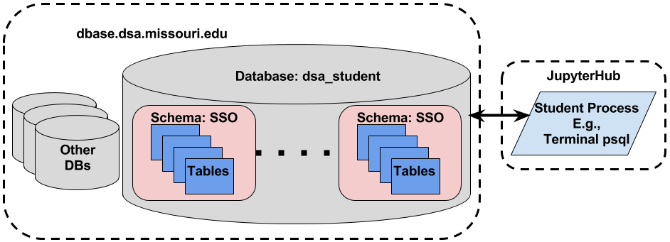

Students will interact with the database using command line client (psql) or scripts and programming code. Currently, the dbase server is only accessible from **jupyterhub.dsa.missouri.edu**.

### Basic PostgreSQL Commands

0. Command help:

\?

1. Setting Search Path (substitute your SSO for the characters SSO):

set search_path to SSO, public;

2. See your tables

\dt

3. Describe a table: e.g., my_table

\d my table

4. List tables in a particular schema, e.g., public or your SSO

\dt public.*

\dt SSO.*

5. Access database resources with fully qualified name, e.g. public.test_table

|  |
| --- |
| dsa_student=> select * from public.test_table;  id | t  ----+------------  1 | Hello DBMS  (1 row) |