Aslam Pathan

[Pathan.ashu109@gmail.com](mailto:Pathan.ashu109@gmail.com)

Assignment day 4

Question 1:

* Find out mail servers of the following domain:

Ibm.com :- 1) mx0b-001b2d01.pphosted.com

2) mx0a-001b2d01.pphosted.com

Wipro.com:- 1) wipro-com.mail.protection.outlook.com

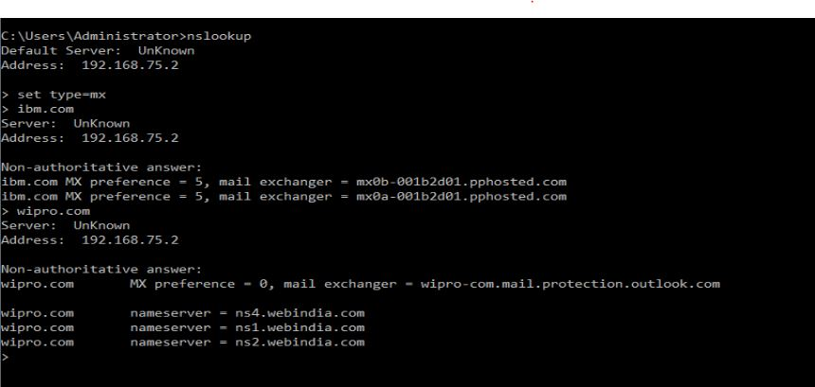

Question 2:

* Find the locations, where these email servers are hosted.

Ibm.com:- 1) mx0b-001b2d01.pphosted.com

Ip address= 148.163.156.1

Which show address of USA

2) mx0a-001b2d01.pphosted.com

Ip address= 148.163.158.5

Which show address of USA

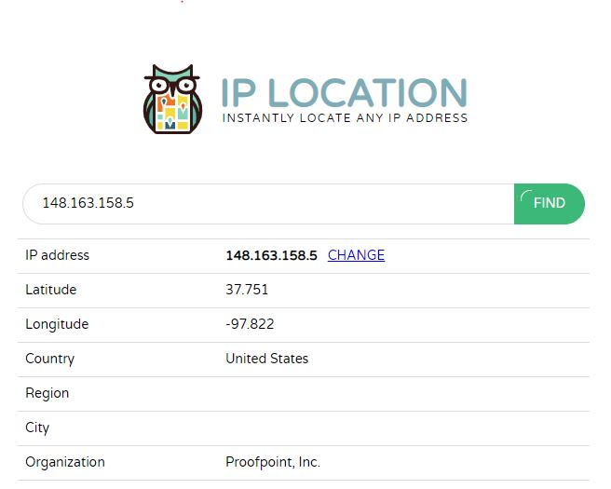

Wipro.com:- 1)wipro-com.mail.protection.outlook

Ip address= 104.47.124.36

Which show address of USA

Question 3:-

* Scan and find out port numbers open 203.163.246.23

There are no open ports in 203.163.246.23

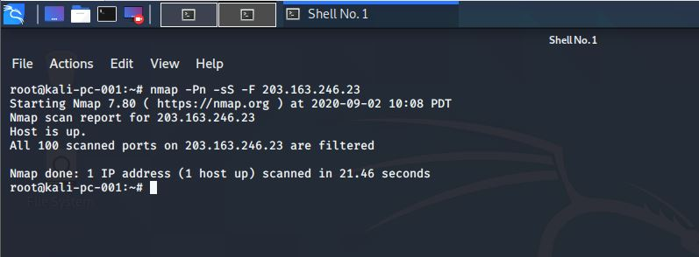

Question 4:-

* Install nessus in a VM and scan your laptop/desktop for CVE.

