Design Document

# UML

# GameController class structure

# Player class structure

# Card class structure

# A screenshot of a cell phone Description automatically generatedBoardPiece class structure

# Renting

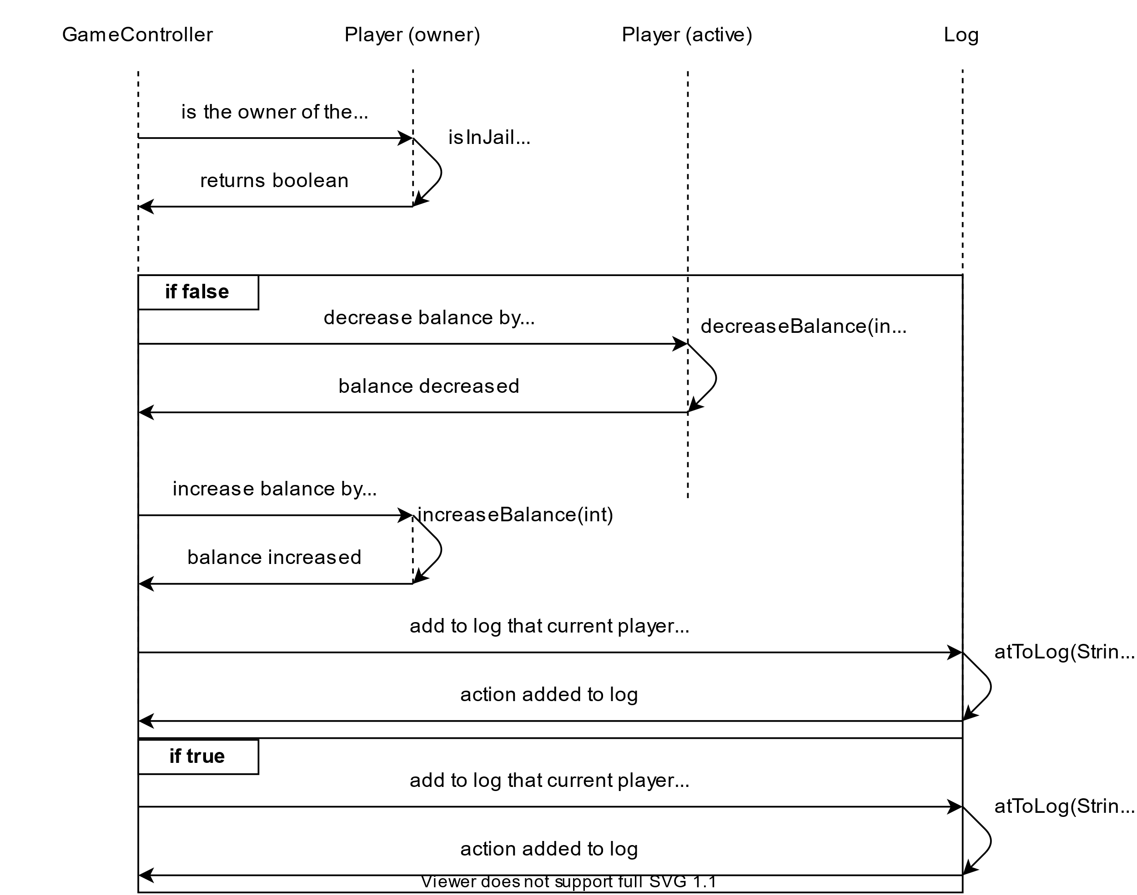

# Moving

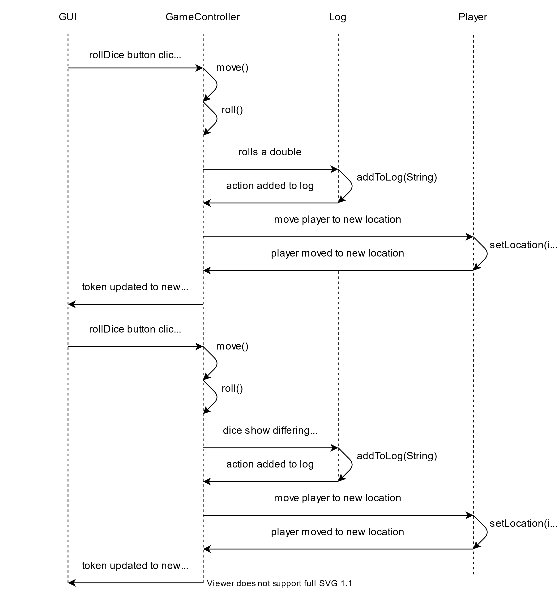

# Pay tax

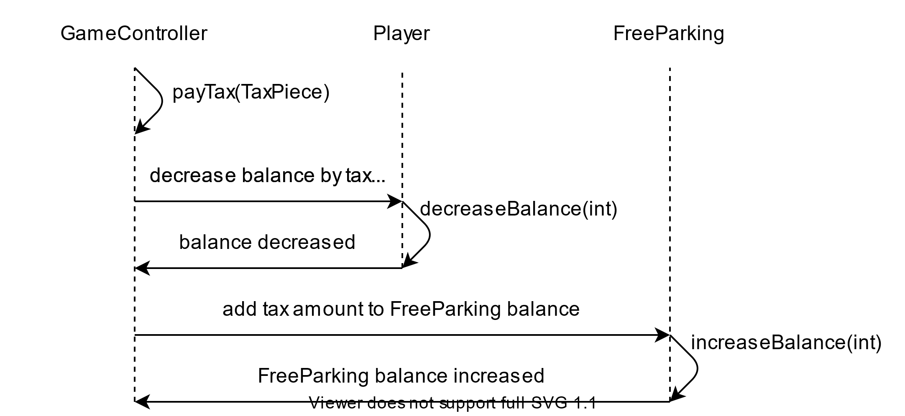

# Mortgage property

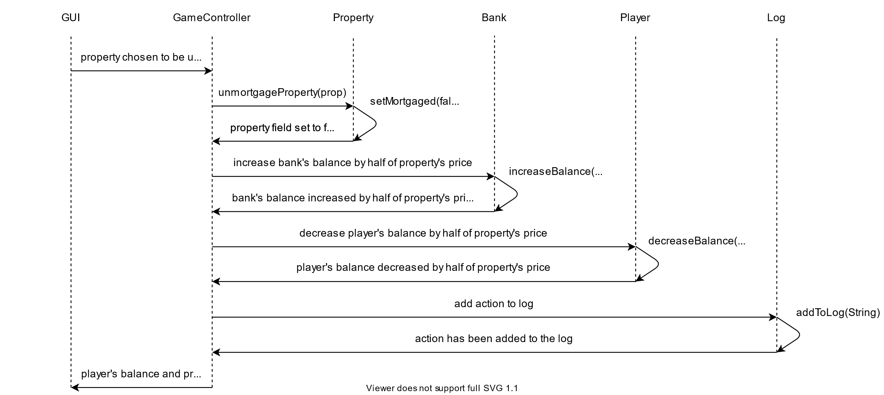

# Trading

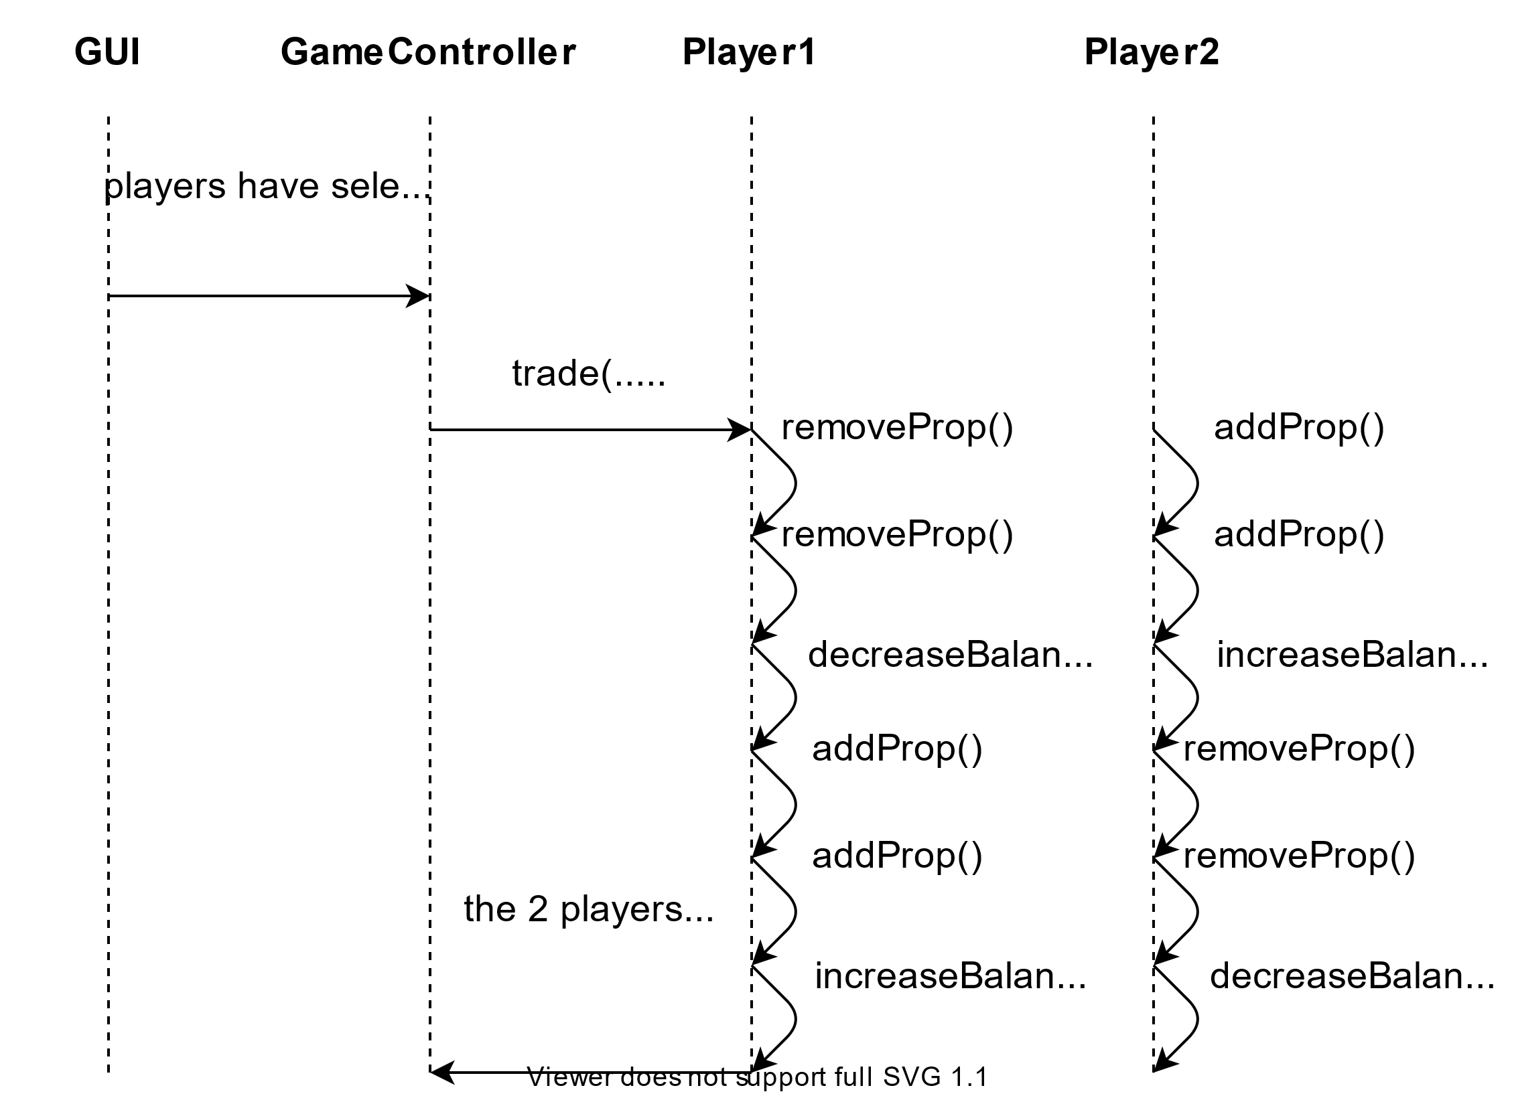

# Ending turn

