Project Plan

# Initial Plan

From the first sprint, we knew this was going to be a large project to work on. From our first meeting, we made an initial plan on what tasks and features we would be working on. This plan goes as such:

Sprint 1

The objectives of this sprint were quite easy but involved time and first-hand knowledge. First, we needed to plan out how to start to build the project as I am here writing about. Next, we would work on using technologies as Git to upload and store our code. Lastly, we would then start work on the project itself; we were to create the starting objects of the game such as players and properties.

Sprint 2

From this sprint, we would look back to what we accomplished from last week such as discussing the highlights and lowlights of last sprint. We would then create a plan on what tasks to solve for the current sprint. With that being said, we were to develop a simple textual-based game of Property Tycoon. The only features we planned to incorporate was renting; No houses, no jail, no mortgaging, no Opportunity Knocks / Pot Luck cards, etc. Along side this, a basic Graphical User Interface (GUI) were to be developed to include simple buttons and text boxes.

Sprint 3

In this sprint, we planned upon building upon the previously-developed textual game to include Opportunity Knocks / Pot Luck cards and incorporate many players into the game. From a frontend perspective, we were to develop the GUI to incorporate the features and methods created in last sprint. What we did not think at the time was how the GUI was going to interact with the backend.

Sprint 4

This week’s tasks were to add onto last sprint, but to incorporate houses and hotels onto properties. Once houses and hotels were built into the game, we would then focus on building auctioning and mortgaging mechanics for properties. The GUI would then be updated to the capacity of last week’s sprint tasks.

Sprint 5

The fifth sprint would mainly focus on developing the GUI up to speed from last week, but to also develop title screens, menus and loading bars. There was a comment to also build a splash screen to bring the players into the main menu screen.

Sprint 6

We had originally planned to finish the project in this sprint. In this sprint, we would focus on the features that were left to incorporate: Autonomous agents and the abridge version of the game. We were optimistic that no setbacks were going to affect us. We were wrong.

# **Actual Plan**

Sprint 1

We did not stray much from what was proposed in our initial plan. We learnt how to pull, fetch and push to GitHub through Git. We also got the Maven to synchronise dependencies of our project.

Sprint 2

We stayed on target by developing the textual-based game and creating a basic GUI.

Sprint 3

The start of the week was looking to plan. We got 2 days in until we noticed that we needed to redesign the board and the board pieces. We did not expect to do some redesign this early.

Sprint 4

We did not take into consideration having to completely redesign the project from scratch. At the time, we did not think that we would finish in the proposed 2 weeks left.

Sprint 5

At this point, we would have been solely working on the GUI. Instead, we had to make use of our team last week redesigning and keeping up to track in this sprint. We focused on getting new features into the game.

Sprint 6

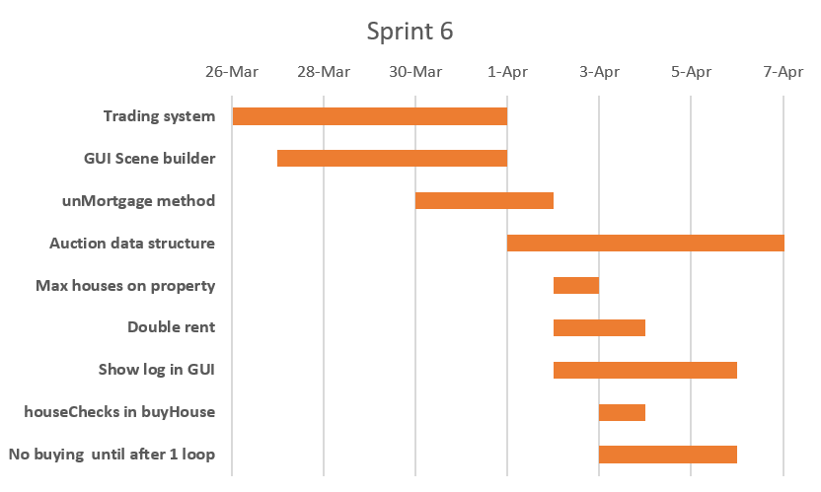This was supposed to be the last sprint in the project, but there were unexpected issues that we had to take care of and deal with thoroughly to ensure they do not appear again. We worked on a trading system, houses and mortgaging as well as debugging.

Sprint 7

Due to the initial plan not having more than six sprints, we looked through the user requirements the client has given us and started to tick off the ones we have already done. With the rest, we chose some features such as auction validation and selling mortgaged properties, etc.

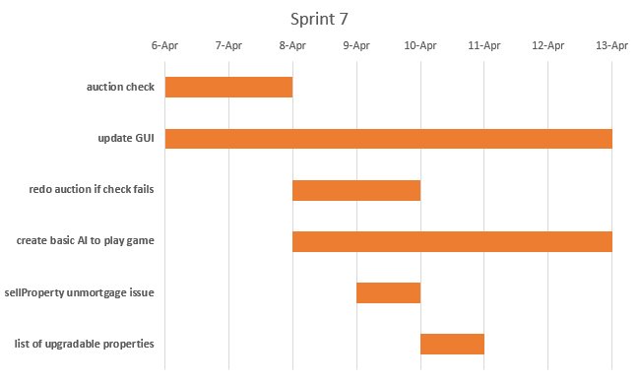

Sprint 8

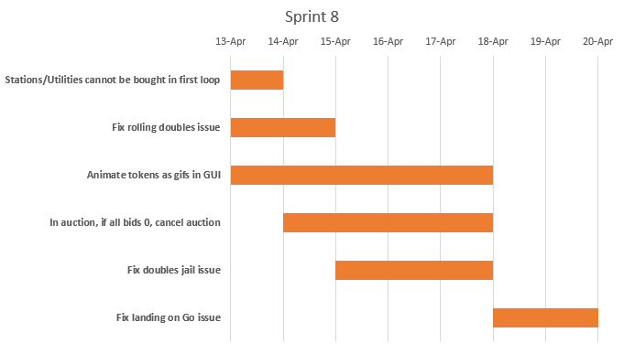This sprint evolved around edge cases and ensuring the small print in the user requirements was noted as a task card and taken care of before being forgotten.

Sprint 9

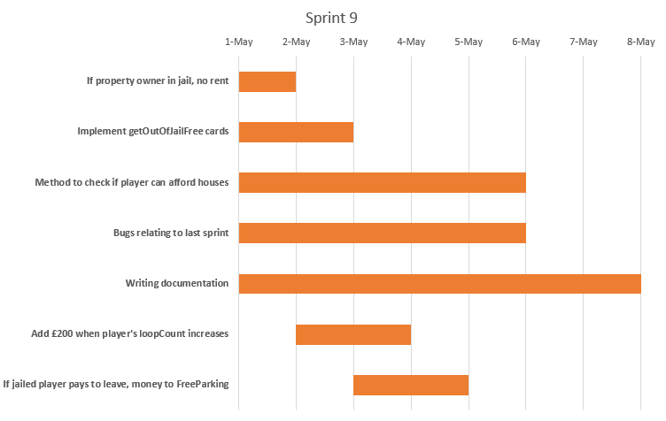In this sprint, we focused on debugging existent issues known in the previous sprint as well as new issues we had found whilst performing unit testing in the backend and system-wide testing in the frontend

Sprint 10

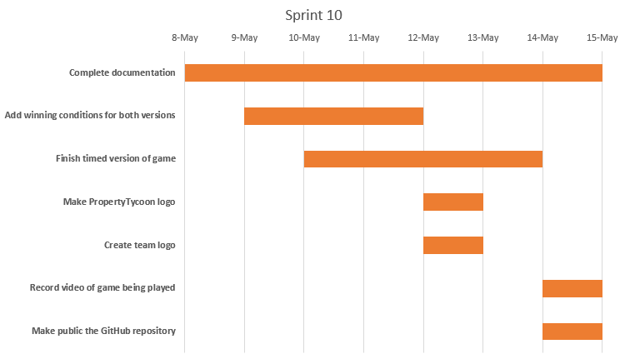The last sprint comprises of finishing off the documentation of the project and focus on the little things that count.