Group Report

Property Tycoon was the first software group project we have been tasked with. With this in mind, we were cautious at first as we knew some basic knowledge of the agile development cycle. Once we attended the first lectures and seminars highlighting the process of incremental software development and documentation, we quickly learnt these new methods of focusing a sprint on user stories and task cards.

We found out quite quickly the importance of design within the first 3 sprints. At the start of the project, we had conceptualised the initial game objects and how they were to interact with each-other. By the time we had started the user interface, we had noticed a problem on how we had made every object interact, but there was no centralised object controlling everything. When sprint 3 was finished, we were focused and determined to redesign the entire project even if it took 2-3 days to plan everything out. Everyone in the team gave their initial thoughts to some ideas. To the ideas with met with criticism, we thoroughly discussed the propositions at hand and considered their future consequences. By this time, one side had dismissed their argument due to a lack of prior knowledge.

One important aspect we, as a group, found useful was to split the team into 2 groups: 2 people designing frontend and 2 people working backend. The way we split the team into groups was by discussing every team member’s strengths in either frontend or backend. At the time, it was more of a split between having previous work in user interfaces and not having previous work in user interfaces.

An issue we found sometimes was miscommunication. There were times the backend team developing a method for the frontend, but at the end of the sprint, the method was not needed. The same can be said the other way round. The frontend team were designing a feature and when finished with the feature, the frontend would need a method right away to test whether the design worked or not. These issues were solved by clearly communicating what team member’s role were in the sprint. If a team member finished with their tasks ahead of schedule, they would either perform some system-wide testing in the frontend or debug the backend.

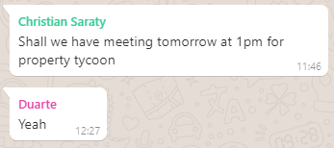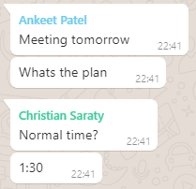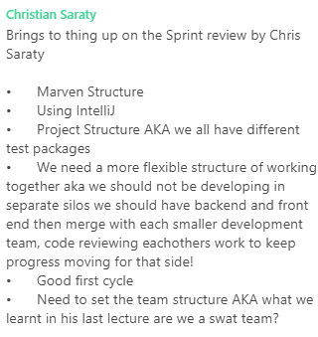Meetings were held weekly on Mondays when all team members were available. The length of these meetings ranged from 1 hour to 3 hours. Meetings were decided on Sunday with a place and time suggested. Due to unforeseen circumstances, the meetings had to be held online via WhatsApp in the middle of March as a team member was out of the country.

Overall, there was good sense of dedication and commitment to the project and to every sprint. The project went well as we worked well as a team. We coped with the sudden change of environments and we managed to complete a finished product. As a standard, all the work was complete as required and all team members were in agreement that the workload was fairly distributed. In all, we feel this task has built our skills as software developers greatly as well as working together in a group setting.