ENGINEERING MONOGRAPH / WM-01
WITNESS
Executable Evidence for Failure-Oriented Engineering Claims
A receipt-gated reproducibility architecture across systems, ML infrastructure, autonomy, quantitative simulation, search, imaging, navigation, and numerical methods
AARYAN PATEL
Independent Technical Monograph | August 2026 | Version 1.0
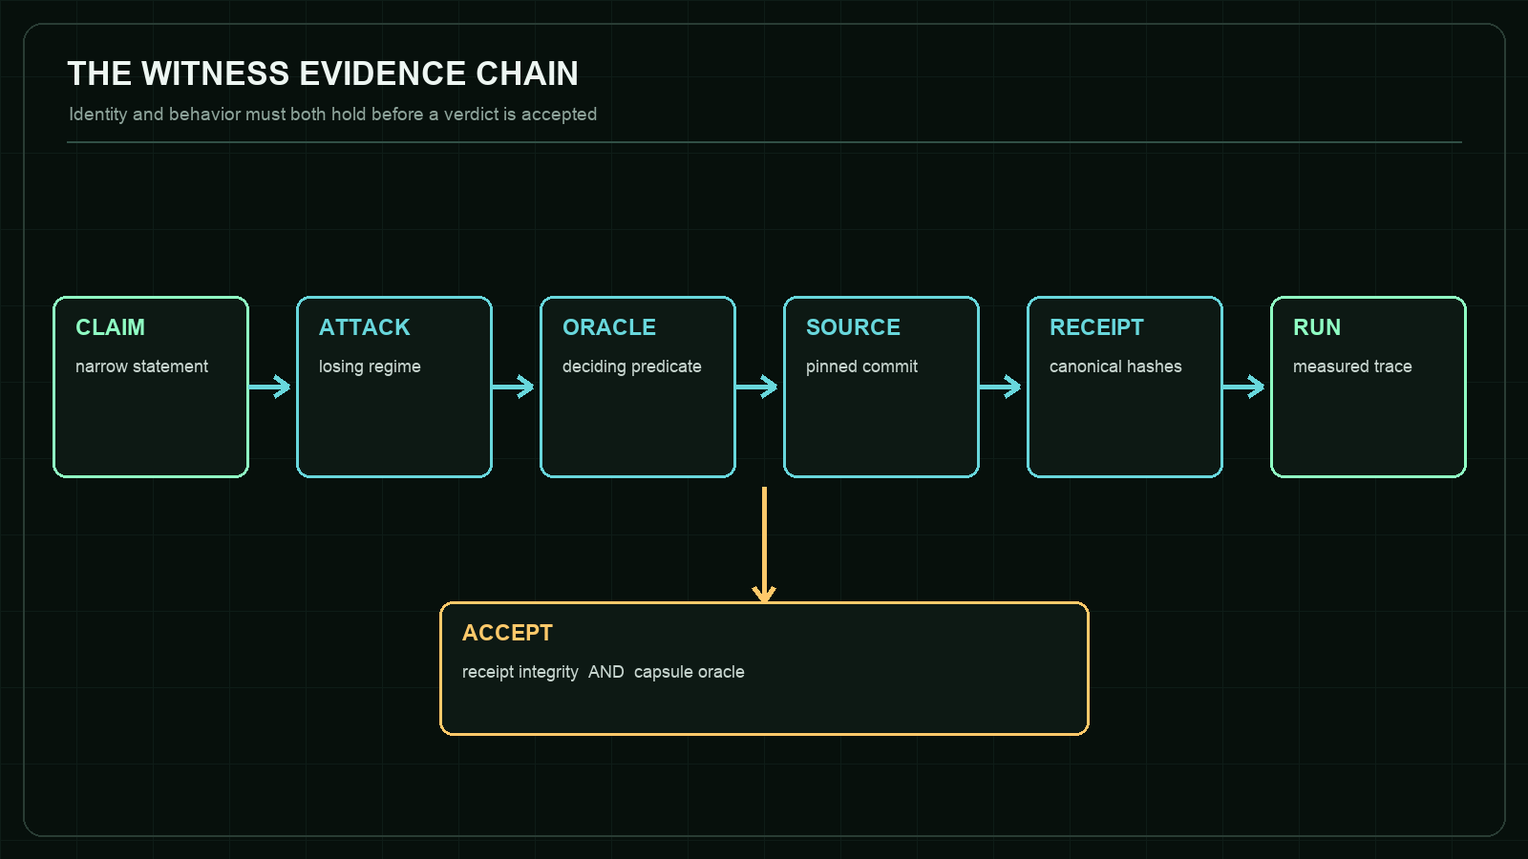
Figure 1. WITNESS accepts a claim only when identity and behavior agree.
Not a university dissertation or peer-reviewed publication.

Abstract
WITNESS is a browser-native reproducibility chamber for engineering claims. Instead of presenting screenshots or aggregate claims, it verifies a canonical failure receipt, binds that receipt to an immutable source revision, executes a bounded adversarial scenario, evaluates an explicit oracle, and emits a local run receipt whose attestation boundary is stated rather than implied.
This monograph develops the evidence model behind WITNESS and analyzes eight executable capsules spanning distributed systems, compiler validation, multi-target tracking, market microstructure, approximate nearest-neighbor search, synthetic-aperture radar autofocus, visual-inertial navigation, and algorithmic differentiation. The contribution is not a new theorem shared by all eight domains. It is an engineering method for keeping claims, losing regimes, measurements, source identity, and limitations coupled closely enough that a reader can rerun and challenge them.
All numerical observations reported here were reproduced in the browser against the pinned WITNESS build described in the artifact manifest. They are targeted counterexamples, not substitutes for full benchmark suites or independent external replication.

Artifact Status and Claim Boundary
This is an independent technical monograph, not a university dissertation, peer-reviewed publication, or claim that an academic degree has been awarded. The level of treatment is deliberately research-oriented: formal predicates, adversarial methodology, exact source revisions, negative results, and reproducibility artifacts are included so the work can be evaluated on evidence rather than labels.
The canonical COUNTEREXAMPLE release is provenance-attested. A WITNESS browser run is deterministic and hash-bound but explicitly local-unattested. No ACM badge or independent reproduction status is claimed. Section 15 maps the current artifacts to evaluation criteria without awarding them to itself.
READING RULE A passing capsule means the pinned oracle correctly classified its intended regime. It does not mean the underlying method is universally correct.

Contents
- Abstract
- Artifact Status and Claim Boundary
- 1. Research Problem and Contribution
- 2. Evidence Model
- 3. Threat Model
- 4. Architecture and Runtime Isolation
- 5. Experimental Method
- 6. Distributed Systems: Raft + MVCC
- 7. ML Compiler: TensorForge
- 8. Autonomy: Track Fusion
- 9. Market Microstructure: Limit Order Book Market Making
- 10. Vector Search: ANNLite HNSW
- 11. SAR Imaging: Phase Gradient Autofocus
- 12. Visual-Inertial Navigation: MSCKF VIO
- 13. Numerical Differentiation: AAD Greeks
- 14. Cross-Capsule Synthesis
- 15. Artifact Evaluation Readiness
- 16. Limitations
- 17. Future Work
- 18. Conclusion
- Appendix A. Reproduction Protocol
- Appendix B. Capsule Identity Register
- References

Artifact coordinates
Live chamber | asp53826.github.io/witness
Source | github.com/asp53826/witness
Publication | PDF, Word, and GitHub Markdown editions

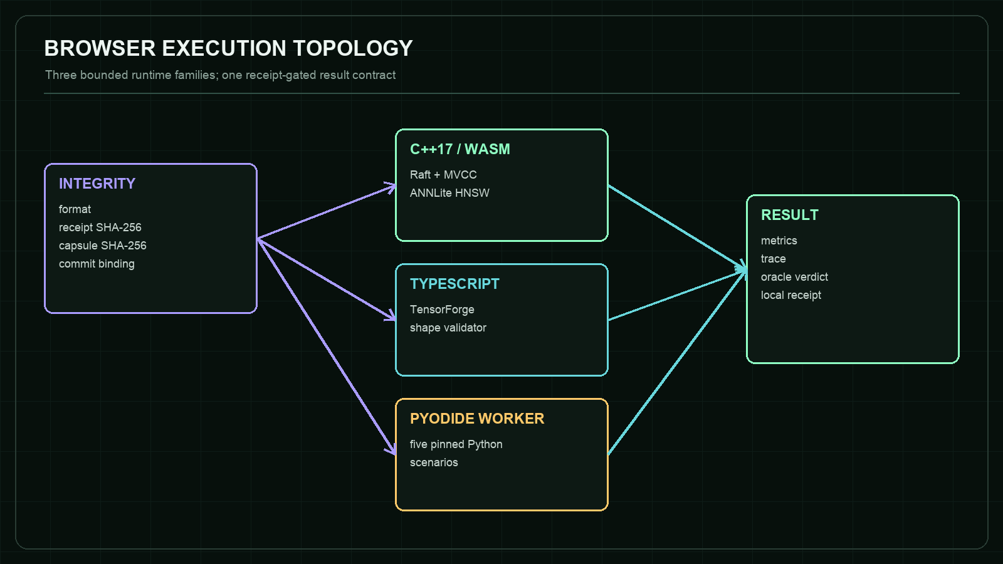
Figure 2. Runtime isolation and the shared structured result contract.
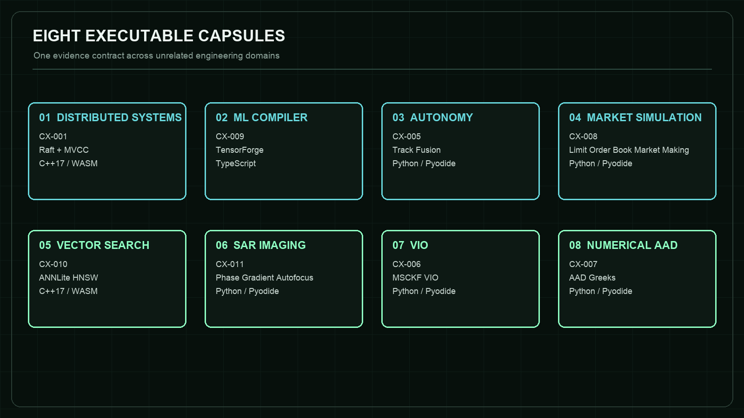
Figure 3. Eight domains share one evidence protocol.

1. Research Problem and Contribution
Engineering portfolios often collapse several distinct propositions into one visual claim: that code exists, that it ran, that a reported number came from that code, that the number supports the stated conclusion, and that the conclusion remains valid outside the demonstrated regime. WITNESS separates those propositions and exposes the joins between them.
The working research question is: how can a public engineering artifact make a narrow claim executable, falsifiable, source-bound, and limitation-aware without requiring a reviewer to reconstruct the author's entire environment? The design response is a small verification protocol whose output is useful even when the expected result is a failure.
The first contribution is a receipt-gated execution model. Every capsule names a claim, adversarial condition, oracle, source commit, and canonical receipt digest. Runtime execution is blocked if format, receipt hash, embedded capsule hash, or commit binding fails.
The second contribution is negative-result centricity. A capsule is not a product demo with an error state added later. It begins from a losing regime: minority acceptance without commitment, low-budget recall loss, clutter promotion, entropy/resolution disagreement, missing parallax, or a derivative that is exactly computed and still wrong.
The third contribution is a browser-local review surface. C++ engines compile to WebAssembly; Python engines execute in a module Worker through Pyodide; TypeScript validation runs directly. This reduces installation friction while preserving the distinction between a focused browser scenario and the repository's larger native benchmark suite.

2. Evidence Model
Let C be a narrow claim, A an adversarial scenario, O an oracle, S an immutable source revision, R a canonical receipt, and E an observed execution trace. WITNESS accepts a run only if both receipt integrity and behavioral evidence hold.
The integrity predicate is defined as:
I(R,S) = format(R) AND H(canonical(R without receiptSha256)) = R.receiptSha256 AND H(canonical(R.capsule)) = R.integrity.capsuleSha256 AND R.subject.commit = R.capsule.commit = S
The behavioral predicate is capsule-specific:
B(E,O) = O(E) = true
The chamber verdict is therefore V = I(R,S) AND B(E,O). This decomposition matters: a correct behavioral trace from the wrong revision is not accepted, and a perfectly hashed receipt cannot rescue a failing oracle.
The local run receipt records the selected capsule, subject commit, runtime, canonical receipt digest, integrity result, oracle result, timestamp, and a trace digest. It deliberately records signatureStatus=local-unattested. The receipt is evidence of what the visitor's browser observed, not an externally signed release artifact.

3. Threat Model
WITNESS is designed against evidence failures that are common in public technical demonstrations: screenshots that cannot be replayed, moving main branches, results detached from commands, stale binaries, silently changed oracles, favorable metrics that hide a losing dimension, and deterministic claims built on unrecorded random state.
The chamber does not defend against a malicious hosting origin, a compromised browser, fabricated upstream repositories, or a coordinated author who falsifies every layer consistently. It also does not transform self-reproduction into independent replication. Those limits are explicit because a threat model that claims everything protects nothing.
The invert-verdict control is a small tamper experiment. It leaves engine output unchanged while negating the expected oracle comparison. The resulting failed trace demonstrates that WITNESS is not merely painting a success state after execution.

4. Architecture and Runtime Isolation
The page has three trust-relevant layers. The integrity inspector fetches and verifies the canonical receipt. The execution adapter loads one of three bounded runtime families. The presentation layer renders measured metrics and trace lines from the returned structured result.
C++ capsules use modularized Emscripten output and pre-fetched WebAssembly bytes. TensorForge uses the pinned validator directly in TypeScript. Five Python capsules run in one module Worker. The Worker mounts only enumerated pinned source files and selects only hard-coded scenarios; visitors cannot submit arbitrary Python.
Worker isolation is a responsiveness boundary, not a security sandbox claim. It prevents scientific Python computations from blocking the main UI and keeps the DOM outside the worker global context. The hosting origin still controls both sides of the message channel.

5. Experimental Method
Each capsule is constructed as a minimal discriminating experiment. One variable or regime is attacked, the random state is fixed where relevant, and the oracle observes the state necessary to distinguish the intended invariant from an unrelated failure.
Results in this document are browser observations from the pinned scenarios, not copied headline numbers from repository READMEs. Where the browser intentionally uses a smaller dataset than a native benchmark, that difference is named in the capsule boundary.
The method favors exact paired comparisons and identities over broad but weak scores: commit index beside local append, dispatch count beside a shape exception, exact brute-force neighbors beside approximate search, entropy beside impulse-response width, dead reckoning beside VIO in a no-parallax regime, and analytic/bumped/smoothed deltas beside pathwise AAD.

6. Distributed Systems: Raft + MVCC
CX-001 / C++17 TO WEBASSEMBLY A command appended by a minority leader cannot become committed or visible without majority acknowledgement.

Field | Pinned evidence
Repository | asp53826/raft-mvcc
Pinned commit | a5dd0986756b26ff5f375b73d03d618d9b2aded0
Receipt SHA-256 | 57c9cc96b82129672391606b85b45a8b3cdd9f32588a3df22bb841fd78890313
Adversarial scenario | Elect node 1, isolate it from four peers, and submit transaction 7 to the stale leader.
Oracle | The isolated log grows locally, but commit index and every MVCC state digest remain unchanged.
Browser observation | Local log 1 to 2; commit index 1 to 1; four messages dropped; visible value: none.

Mechanism and interpretation
The distinction between acceptance and commitment is the center of this capsule. A client-facing append can look successful even though the replicated state machine has not crossed the majority boundary. WITNESS therefore observes the private log, commit index, follower logs, and state visibility separately instead of collapsing them into one success flag.
The failure injection is intentionally minimal: one bidirectional partition and one proposal. That narrow trace makes the oracle inspectable. The result is evidence for the majority-before-commit invariant at the pinned revision, not evidence that every Raft implementation or every storage layer is correct.
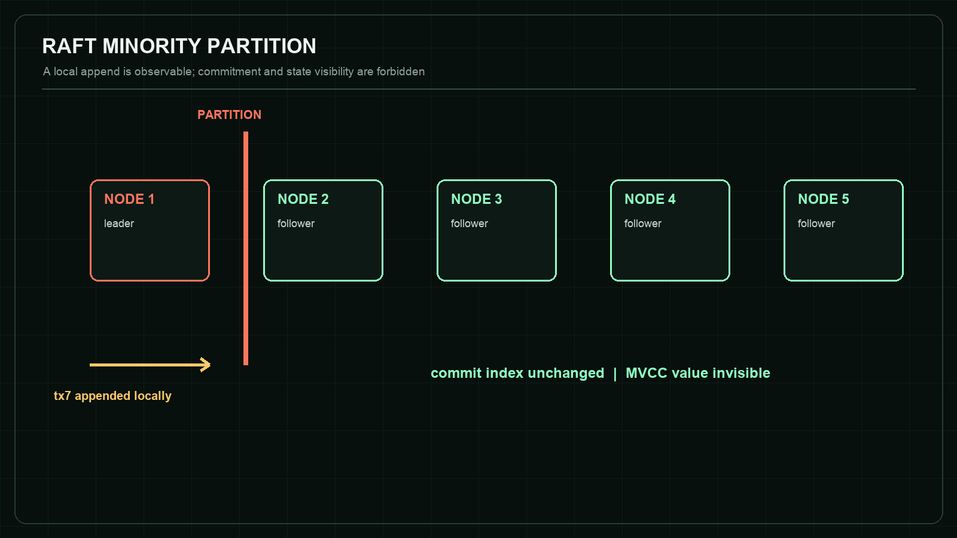
Figure 4. CX-001 - Raft + MVCC counterexample structure.

Claim boundary
The deterministic transport models exact partitions. It does not reproduce TCP backoff, kernel scheduling, disk faults, or fsync latency.

Reproduction target
https://asp53826.github.io/witness/?capsule=systems

7. ML Compiler: TensorForge
CX-009 / TYPESCRIPT Matrix multiplication must reject unequal contracting dimensions before optimization or GPU dispatch.

Field | Pinned evidence
Repository | asp53826/tensorforge-webgpu
Pinned commit | 70a5c855ef35e01a29ba351eb2645670060b9f0b
Receipt SHA-256 | 37576d77588845f3023d2debcb397f53eacfb91cdca94250f1013c1f778eefa6
Adversarial scenario | Mutate W1 from [128,256] to [127,256] while retaining the upstream [8,128] activation.
Oracle | The validator emits the exact shape error and the GPU dispatch counter remains zero.
Browser observation | Input [8,128]; W1 [128,256] to [127,256]; GPU dispatches 0; rejection exact.

Mechanism and interpretation
Compiler correctness begins before optimization. If malformed tensor programs reach fusion or code generation, later passes can transform the symptom and make the root cause harder to identify. The capsule makes validation a front-door invariant and records that no GPU work was launched.
The oracle is stronger than checking for any exception. It binds the expected mismatch to the contracting dimension and separately observes dispatch count. This prevents an unrelated runtime failure from being misreported as successful shape verification.
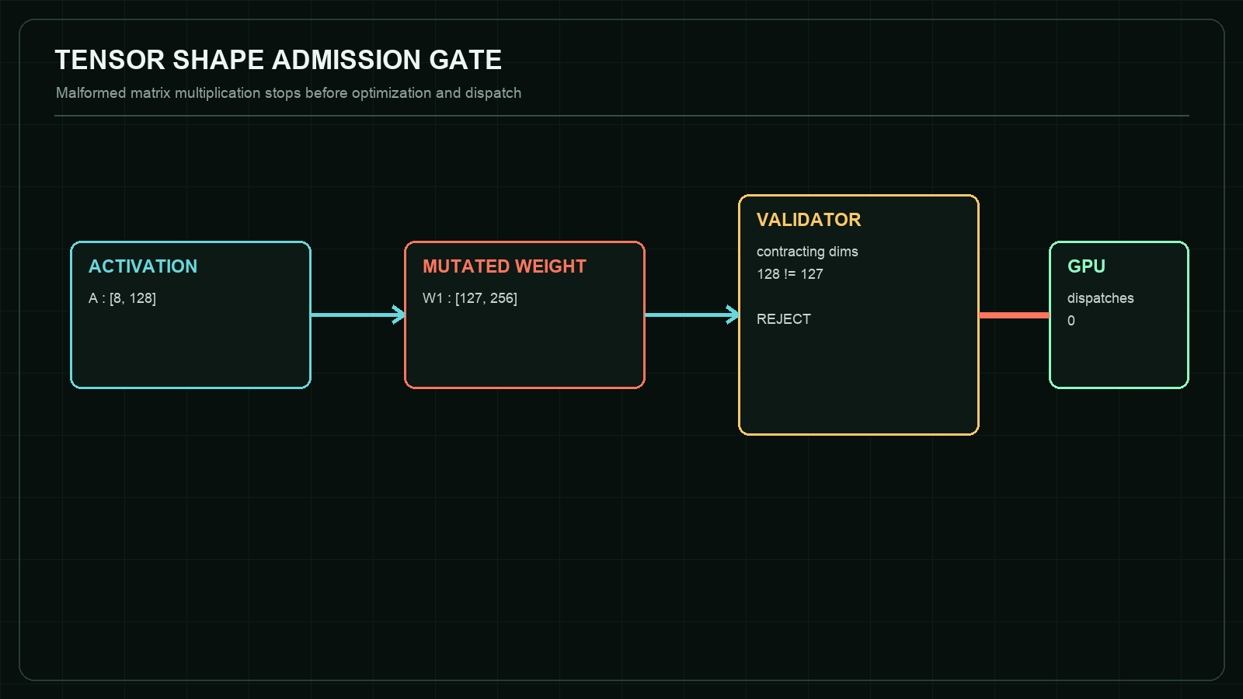
Figure 5. CX-009 - TensorForge counterexample structure.

Claim boundary
This is a static rank-and-dimension guard. It does not establish numerical stability, WebGPU driver correctness, or performance portability.

Reproduction target
https://asp53826.github.io/witness/?capsule=ml

8. Autonomy: Track Fusion
CX-005 / PYTHON, NUMPY, AND SCIPY IN A PYODIDE WORKER Target-free Poisson clutter must not be promoted into persistent confirmed tracks.

Field | Pinned evidence
Repository | asp53826/track-fusion
Pinned commit | 9a1092b8da88f5904ca190a393d77bd2bcd111b8
Receipt SHA-256 | 762231d01fdd53b48b8b958f22cc06b03476b5f3997246a6aa84168eaf29038d
Adversarial scenario | Replay 40 seeded scans with zero targets and an expected six uniform false alarms per scan.
Oracle | Wald sequential log-likelihood promotion produces no more than four confirmations.
Browser observation | 40 scans; 264 clutter returns; 0 confirmed tracks; acceptance boundary <= 4.

Mechanism and interpretation
A large validation gate can collect enough clutter to resemble persistence unless confirmation evidence accounts for both target likelihood and false-alarm density. The capsule attacks this failure directly by removing real targets from the scene.
Zero confirmations is not presented as a universal false-track rate. It is one seeded observation under a published target-free model. The receipt preserves the seed, scan count, clutter density, and acceptance threshold so the evidence can be replayed without being generalized beyond its regime.
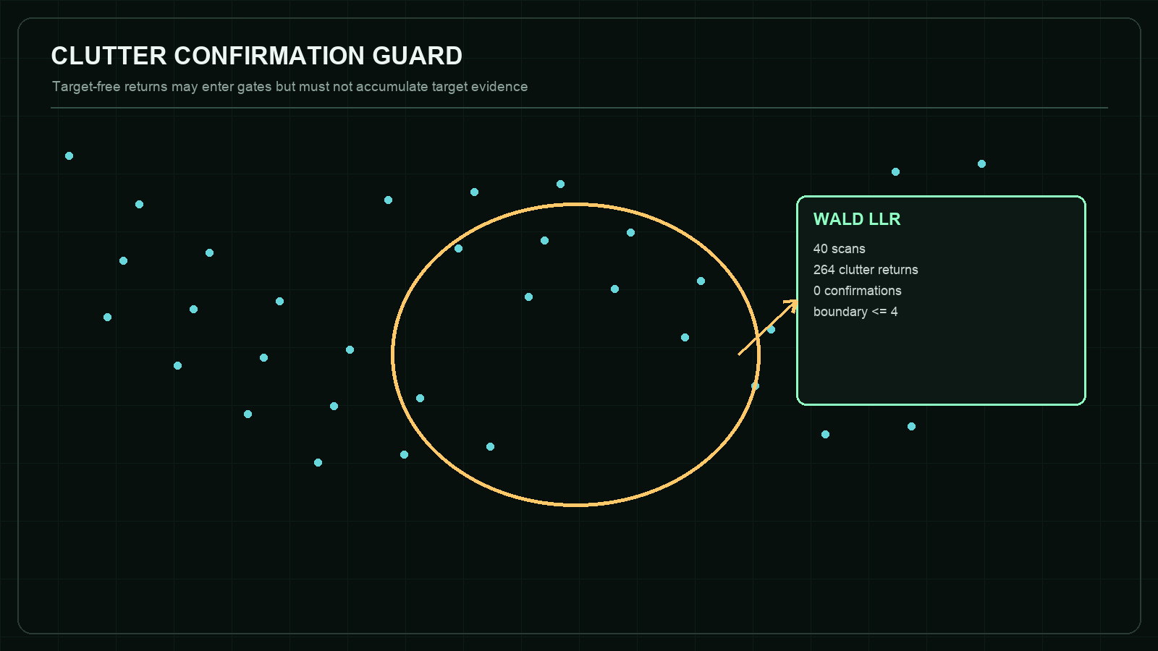
Figure 6. CX-005 - Track Fusion counterexample structure.

Claim boundary
The scenario uses simulated planar measurements and a declared clutter model, not calibrated production radar or EO sensor data.

Reproduction target
https://asp53826.github.io/witness/?capsule=autonomy

9. Market Microstructure: Limit Order Book Market Making
CX-008 / PYTHON IN A PYODIDE WORKER A profitability report must keep carried inventory risk and exact P&L decomposition beside total profit.

Field | Pinned evidence
Repository | asp53826/lob-market-making
Pinned commit | 82c75a1fd7824dd96bdb92432b58b3557cb7d577
Receipt SHA-256 | fa02f77611c71febb1d064c94e534db375104fd8998a39e5aee6d78d0d6e0cba
Adversarial scenario | Run paired 4,000-step simulations at seed 3 with naive and inventory-skew quoting.
Oracle | Inventory skew lowers inventory dispersion and both cash/inventory P&L ledgers reconcile exactly.
Browser observation | Inventory sigma 33.88 to 11.36; 66.5% reduction; two of two P&L ledgers exact.

Mechanism and interpretation
Profit alone is an incomplete state variable. Two strategies can end with similar totals while carrying very different exposure during the run. WITNESS keeps the dispersion of inventory and the accounting identity visible so a favorable total cannot hide a fragile path.
The comparison uses common configuration and seed to reduce irrelevant sampling differences. It still remains a targeted simulator result. No conclusion is drawn about expected live returns, optimal parameter calibration, or market impact.
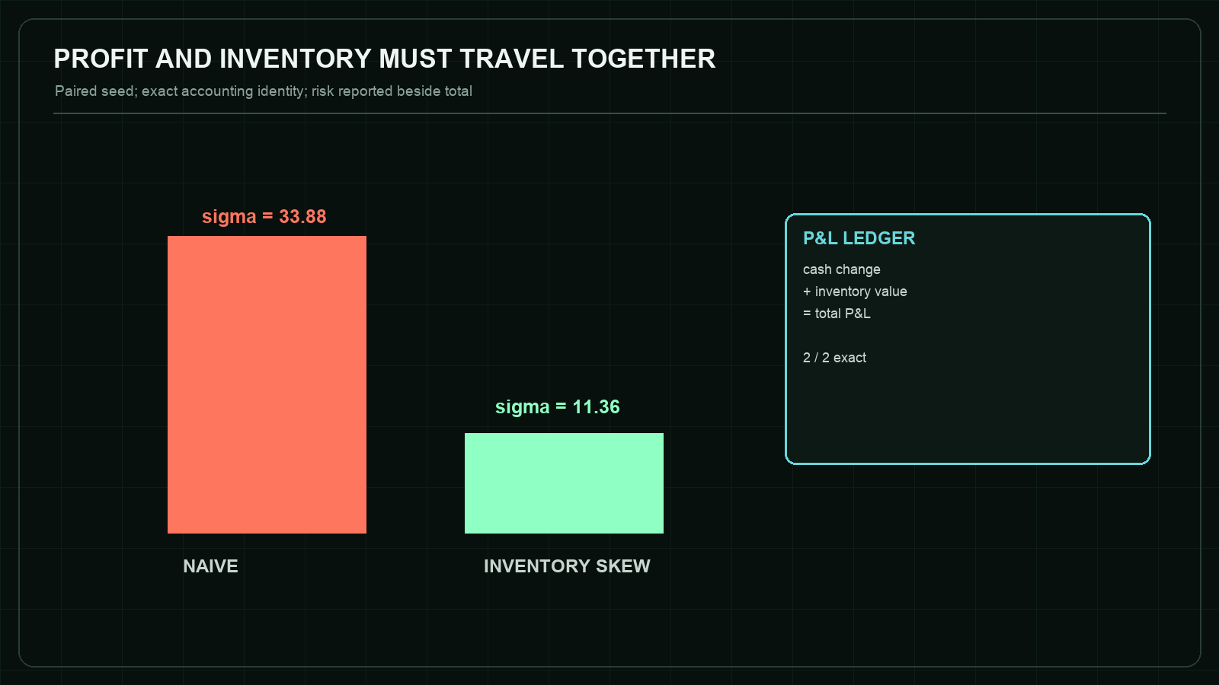
Figure 7. CX-008 - Limit Order Book Market Making counterexample structure.

Claim boundary
This is a synthetic paired test, not a live trading result, execution recommendation, or claim about transaction costs in a real venue.

Reproduction target
https://asp53826.github.io/witness/?capsule=quant

10. Vector Search: ANNLite HNSW
CX-010 / C++17 TO WEBASSEMBLY Approximate-search speed must be reported with exact-ground-truth recall across the search-work frontier.

Field | Pinned evidence
Repository | asp53826/annlite
Pinned commit | dc922c8c1816df48d75f2a16e51cd25819aab070
Receipt SHA-256 | cffc4aa733f3c13b314b666c99304a9fea583558322ed829e6aa83a7f118bf4a
Adversarial scenario | Hold one deterministic 1,800-vector graph and 80 queries fixed while sweeping efSearch from 10 to 100.
Oracle | Recall and distance computations must be monotone, and the high-budget endpoint must recover the low-budget misses.
Browser observation | Recall 95.375% to 100.000%; mean distance computations 132.97 to 207.91; frontier monotone.

Mechanism and interpretation
HNSW exposes a controllable accuracy-cost trade. Reporting only latency creates an incentive to choose a search breadth that looks fast while silently omitting neighbors. The browser capsule computes exact top-10 neighbors first, then measures the approximate result against that oracle.
The observed endpoint reaches full recall on this targeted dataset. That statement is deliberately local: different distributions, graph parameters, dimensions, and insertion orders can change the frontier. The contribution is the executable disclosure pattern, not a claim that efSearch=100 is universally sufficient.
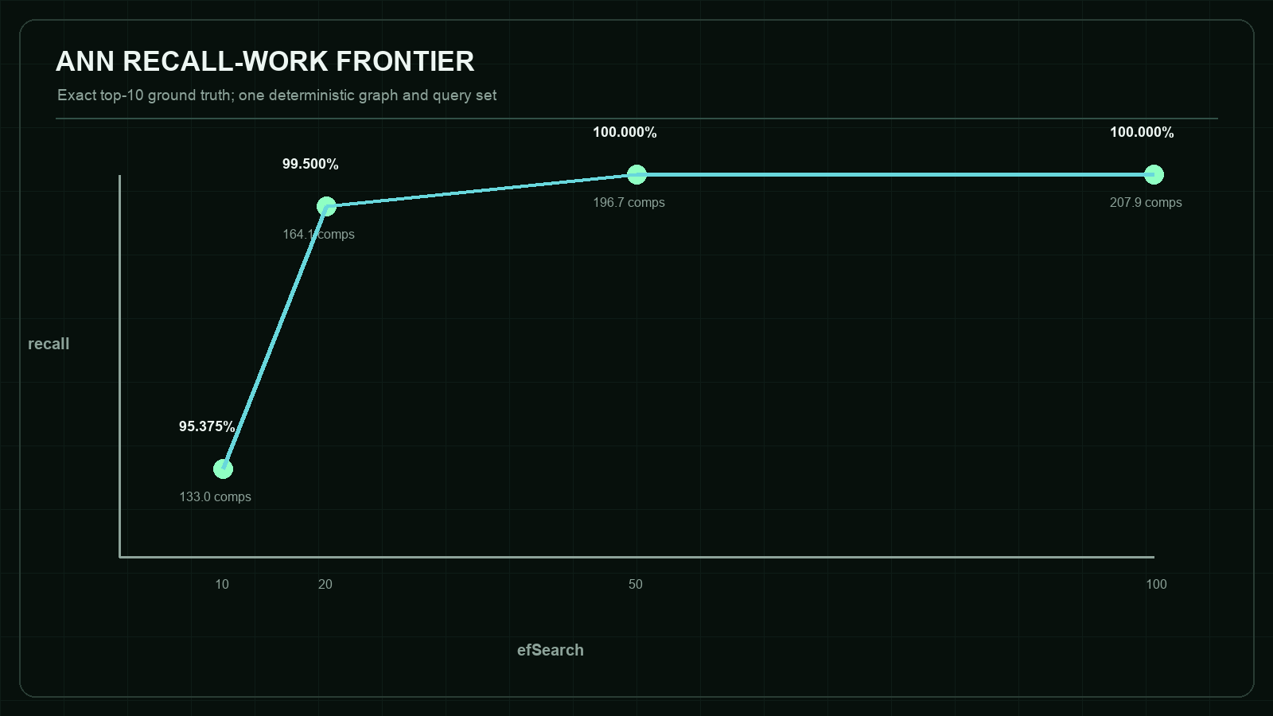
Figure 8. CX-010 - ANNLite HNSW counterexample structure.

Claim boundary
This browser-scale graph is not the repository's published SIFT1M throughput benchmark and does not claim production latency.

Reproduction target
https://asp53826.github.io/witness/?capsule=search

11. SAR Imaging: Phase Gradient Autofocus
CX-011 / PYTHON AND NUMPY IN A PYODIDE WORKER Autofocus acceptance must report both image entropy and impulse-response width.

Field | Pinned evidence
Repository | asp53826/sar-focus
Pinned commit | 83041573ebcfa935640f91cb091e1dbaad4f9aaa
Receipt SHA-256 | 0025d98e9f631c2f487bf3214364a9af6b5987817449e11671fda46404dd9b9e
Adversarial scenario | Inject a seeded random phase error at 5 rad RMS, backproject a four-target scene, and run eight PGA iterations.
Oracle | Detect the counterexample in which entropy decreases while azimuth IRW widens.
Browser observation | Entropy 10.103 to 9.917; azimuth IRW 0.3096 m to 0.3461 m; recovery 0.89x.

Mechanism and interpretation
Autofocus can optimize one scalar while damaging a property that the scalar does not encode. Here the entropy score improves, yet the measured main-lobe width becomes worse. A single-number acceptance test would approve the wrong output.
The capsule treats disagreement as the expected finding. Passing means the system correctly detects the losing regime; it does not mean PGA failed in general. The repository also contains regimes where the same method recovers a known phase error near the diffraction limit.
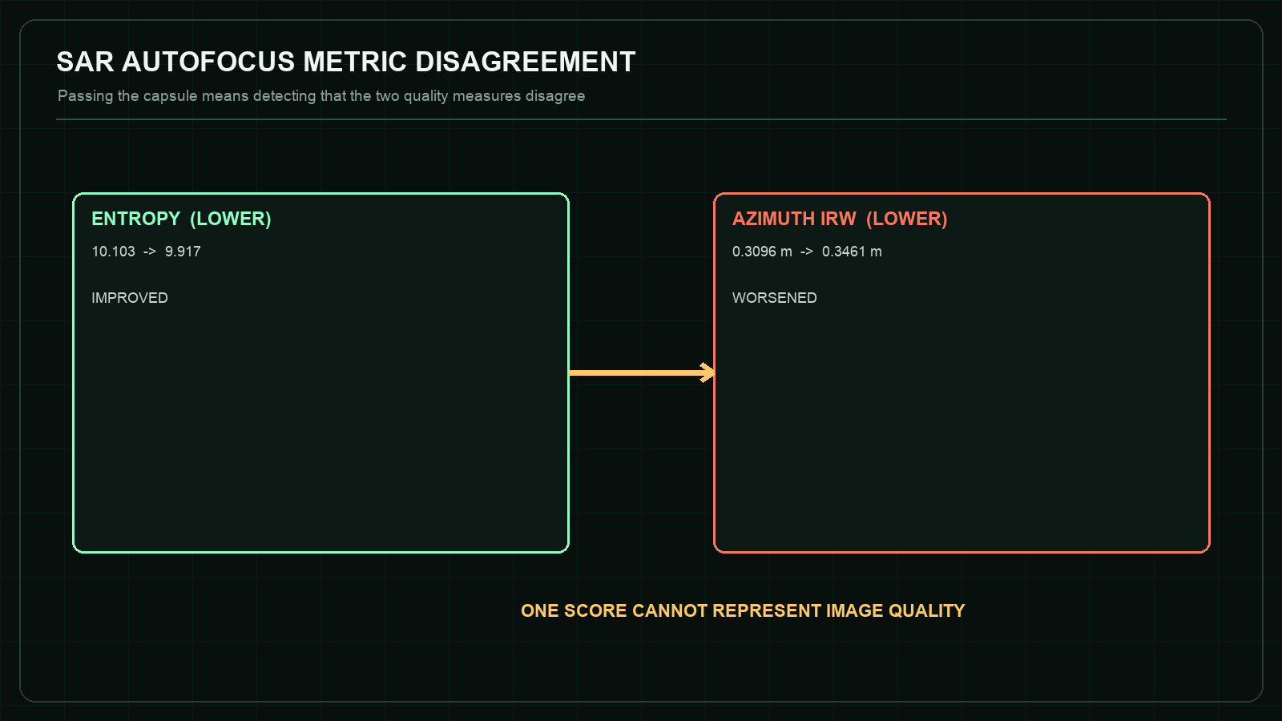
Figure 9. CX-011 - Phase Gradient Autofocus counterexample structure.

Claim boundary
The input is a simulated stripmap point-target scene, not flight data or a claim of operational image quality.

Reproduction target
https://asp53826.github.io/witness/?capsule=imaging

12. Visual-Inertial Navigation: MSCKF VIO
CX-006 / PYTHON AND NUMPY IN A PYODIDE WORKER A stationary camera must reject depth updates that contain no translational parallax.

Field | Pinned evidence
Repository | asp53826/vio-nav
Pinned commit | f38714f391ffb0dc3ae06b418aae51f929000e1e
Receipt SHA-256 | be84bcd3f1737f84f292a0169384b6701f537613a847621b19bf55d887a9f37e
Adversarial scenario | Hold the camera in an eight-second synthetic hover with 250 seeded landmarks.
Oracle | Reject non-triangulable feature tracks and produce no position correction beyond dead reckoning.
Browser observation | 6,956 parallax rejections; dead-reckoning ATE 0.01687 m; VIO ATE 0.01687 m.

Mechanism and interpretation
Multiple image observations do not automatically create geometric information. With rotation but no translational baseline, bearing rays do not supply the parallax required for stable depth triangulation. Updating anyway would manufacture structure from an unobservable direction.
The equal ATE values are therefore a feature of this test: the camera provides no valid translational correction. The stronger claim is that the filter recognizes the missing information and refuses to invent it.
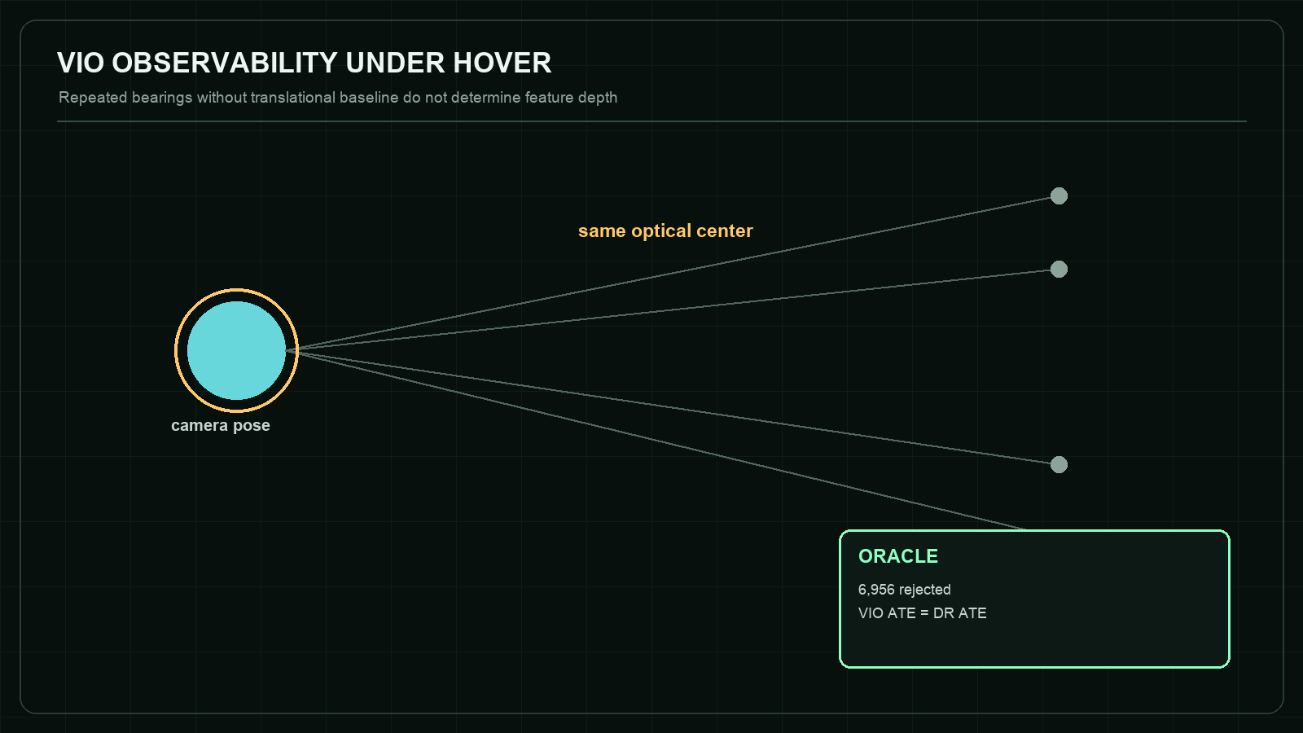
Figure 10. CX-006 - MSCKF VIO counterexample structure.

Claim boundary
The result demonstrates one observability guard in simulation; it is not evidence of field navigation accuracy or full estimator consistency.

Reproduction target
https://asp53826.github.io/witness/?capsule=navigation

13. Numerical Differentiation: AAD Greeks
CX-007 / PYTHON AND NUMPY IN A PYODIDE WORKER A discontinuous payoff cannot rely on pathwise automatic differentiation without an independent oracle.

Field | Pinned evidence
Repository | asp53826/aad-greeks
Pinned commit | c26ef7aa18f473b7cfd85642a62aef3a17b94c58
Receipt SHA-256 | d2d00e9583dfd3f7e7674985b8955cda352818e4a068299749e95cb97e75e4a3
Adversarial scenario | Differentiate a 200,000-path digital payoff at the strike using identical seeded normal draws.
Oracle | Compare sharp pathwise AAD with analytic delta, common-random-number central difference, and smoothed AAD.
Browser observation | Pathwise AAD 0.000000; analytic 0.019333; central difference 0.019220; smoothed AAD 0.019479.

Mechanism and interpretation
The program derivative is exact for almost every simulated path: the derivative of the step payoff is zero away from the strike. The estimator is nevertheless wrong for the derivative of the expectation because differentiation and expectation cannot be interchanged naively at the discontinuity.
The important behavior is silent confidence. No NaN or exception announces the failure. WITNESS therefore makes three independent estimates visible and accepts the capsule only when the false zero and both recovery methods appear together.
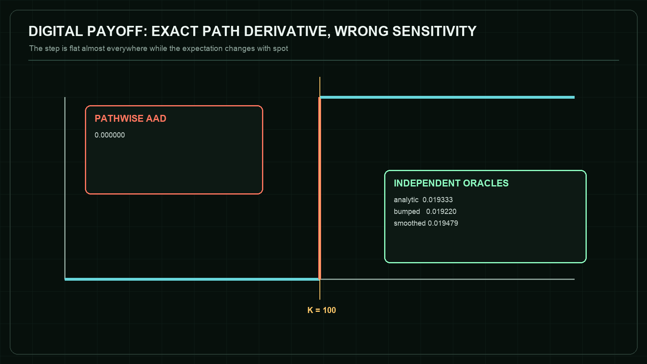
Figure 11. CX-007 - AAD Greeks counterexample structure.

Claim boundary
This is a numerical counterexample for one digital payoff, not financial advice or validation of a production pricing library.

Reproduction target
https://asp53826.github.io/witness/?capsule=numerical

14. Cross-Capsule Synthesis
Across the eight domains, the same structural failure appears repeatedly: an available measurement is mistaken for the property that actually matters. Local append is mistaken for commitment. Low latency is mistaken for adequate recall. Lower entropy is mistaken for better resolution. A formally propagated derivative is mistaken for the derivative of an expectation. WITNESS counters these substitutions by making the missing companion variable part of the oracle.
The capsules also show three distinct oracle classes. State invariants inspect forbidden transitions, as in Raft and TensorForge. Comparative oracles hold an environment fixed and compare paired methods, as in market making and AAD. Observability or disagreement oracles detect when the information required for a conclusion is absent or contradictory, as in VIO and SAR.
No single runtime establishes credibility. The strongest signal is agreement across layers: human-readable claim, adversarial test, machine-checkable oracle, pinned source, canonical hash, deterministic execution, and an explicit boundary. Removing any one layer creates a predictable ambiguity.

15. Artifact Evaluation Readiness
ACM artifact guidance distinguishes availability, functional evaluation, reusability, and independently reproduced results. WITNESS can prepare evidence for such review, but it cannot award itself a badge.
Availability: the repositories, source revisions, receipts, and browser chamber are public. Functionality: the CI suite validates eight receipt bindings, unit tests, WebAssembly smoke scenarios, and the production build. Reusability: source manifests, pinned links, runtime boundaries, and one-command checks lower the cost of inspection. Independent reproduction: not yet established; that status requires another person or team to obtain the results.
A credible next step is a blinded external replay packet: a fresh evaluator receives the release bundle and commands, records environment and deviations, reruns a predeclared subset, and publishes an independent report whether the results match or fail.

16. Limitations
The browser scenarios are deliberately bounded and should not be confused with full system evaluation. WebAssembly changes the execution environment for the C++ engines. Pyodide uses browser-distributed scientific Python. Timing measurements are excluded because browser, device, thermal, and scheduling conditions are not controlled.
Receipt hashing establishes identity and detects accidental or adversarial mutation relative to the expected digest. It does not prove that the original statement was true, that the source is free of bugs, or that the author did not choose a favorable scenario.
Several domains depend on simulated data. Simulation is valuable because it exposes ground truth and enables deterministic attacks; it is insufficient for claims about deployment realism. Each capsule therefore limits its conclusion to the modeled regime.
The monograph is authored by the same project owner and should be read as technical documentation, not peer review. Its value is that claims and methods are inspectable enough for others to disagree precisely.

17. Future Work
Add environment capture to local run receipts: browser engine, WebAssembly feature set, Pyodide build, package versions, device class, and runtime checksum, while avoiding collection of personal identifiers.
Introduce pre-registered scenario suites so a reviewer can run multiple seeds or parameter cells without granting arbitrary-code execution. Aggregate results should retain every cell and never replace the underlying traces.
Publish signed release artifacts for the WITNESS production bundle and its source manifest. GitHub artifact attestations can bind build provenance, but the UI must still distinguish build provenance from independent result reproduction.
Pursue one genuine external artifact review. The most valuable outcome is not a success badge; it is a public report that identifies which capsule could not be reproduced and why.

18. Conclusion
WITNESS treats a claim as an executable object with an attack surface, not a sentence decorated by a benchmark. Its eight capsules demonstrate that sophisticated engineering work becomes more credible when the losing regime is easier to find, the oracle is narrower, the source revision is immutable, and the boundary is impossible to miss.
The result is neither a proof of universal correctness nor a replacement for peer review. It is a practical research artifact: one that lets a reader move from assertion to counterexample, from counterexample to code, and from code to a measured verdict without leaving the evidence chain implicit.

Appendix A. Reproduction Protocol
- Open a capsule-specific deep link.
- Verify that format, receipt digest, embedded capsule digest, and commit binding show VERIFIED.
- Execute the capsule without inverting the expected verdict.
- Record measured metrics and trace lines.
- Download the local run receipt and confirm signatureStatus is local-unattested.
- Repeat with INVERT EXPECTED VERDICT and confirm that identical engine output yields a failing comparison.
- For native benchmark claims, leave the browser and run the repository command at the pinned source revision.

Appendix B. Capsule Identity Register
Case | Repository | Commit | Receipt SHA-256
CX-001 | asp53826/raft-mvcc | a5dd0986756b | 57c9cc96b8212967...
CX-009 | asp53826/tensorforge-webgpu | 70a5c855ef35 | 37576d77588845f3...
CX-005 | asp53826/track-fusion | 9a1092b8da88 | 762231d01fdd53b4...
CX-008 | asp53826/lob-market-making | 82c75a1fd782 | fa02f77611c71feb...
CX-010 | asp53826/annlite | dc922c8c1816 | cffc4aa733f3c13b...
CX-011 | asp53826/sar-focus | 83041573ebcf | 0025d98e9f631c2f...
CX-006 | asp53826/vio-nav | f38714f391ff | be84bcd3f1737f84...
CX-007 | asp53826/aad-greeks | c26ef7aa18f4 | d2d00e9583dfd3f7...

References
1. Association for Computing Machinery. Artifact Review and Badging. https://www.acm.org/publications/policies/artifact-review-and-badging-current
2. Ongaro, D., and Ousterhout, J. In Search of an Understandable Consensus Algorithm (Extended Version). 2014. https://web.stanford.edu/~ouster/cgi-bin/papers/raft-extended.pdf
3. Herlihy, M. P., and Wing, J. M. Linearizability: A Correctness Condition for Concurrent Objects. ACM TOPLAS 12(3), 1990. https://doi.org/10.1145/78969.78972
4. Malkov, Y. A., and Yashunin, D. A. Efficient and Robust Approximate Nearest Neighbor Search Using Hierarchical Navigable Small World Graphs. IEEE TPAMI 42(4), 2020. https://arxiv.org/abs/1603.09320
5. Mourikis, A. I., and Roumeliotis, S. I. A Multi-State Constraint Kalman Filter for Vision-aided Inertial Navigation. ICRA, 2007. https://www-users.cse.umn.edu/~stergios/papers/ICRA07-MSCKF.pdf
6. Wahl, D. E., Eichel, P. H., Ghiglia, D. C., and Jakowatz, C. V. Phase Gradient Autofocus - A Robust Tool for High Resolution SAR Phase Correction. IEEE TAES 30(3), 1994. https://doi.org/10.1109/7.303752
7. Fortmann, T. E., Bar-Shalom, Y., and Scheffe, M. Sonar Tracking of Multiple Targets Using Joint Probabilistic Data Association. IEEE Journal of Oceanic Engineering 8(3), 1983. https://doi.org/10.1109/JOE.1983.1145560
8. Avellaneda, M., and Stoikov, S. High-frequency Trading in a Limit Order Book. Quantitative Finance 8(3), 2008. https://doi.org/10.1080/14697680701381228
9. Giles, M. B. Fifteen Years of Adjoint Algorithmic Differentiation in Finance. 2024. https://www2.maths.ox.ac.uk/~gilesm/files/AAD_Review.pdf
10. LLVM Project. MLIR Shape Inference. https://mlir.llvm.org/docs/ShapeInference/
11. Emscripten Project. WebAssembly and Modularized Output Documentation. https://emscripten.org/docs/compiling/WebAssembly.html
12. Pyodide Project. Using Pyodide in a Web Worker, version 314.0.2. https://pyodide.org/en/stable/usage/webworker.html
13. GitHub. Using Artifact Attestations to Establish Provenance for Builds. https://docs.github.com/en/actions/how-tos/secure-your-work/use-artifact-attestations/use-artifact-attestations
14. Patel, A. WITNESS source repository, pinned capsule definitions, tests, and source manifest. https://github.com/asp53826/witness
15. Patel, A. COUNTEREXAMPLE v1.0.0 release and canonical failure receipts. https://github.com/asp53826/counterexample/releases/tag/v1.0.0

WITNESS
CLAIM / ATTACK / ORACLE / SOURCE / RECEIPT / RUN
Executable evidence is strongest when the losing regime is easy to inspect and the claim boundary is impossible to miss.
RUN THE EIGHT CAPSULES
INSPECT THE SOURCE
Independent technical monograph / Version 1.0 / August 2026
No degree, peer-review status, or independent reproduction is claimed.

