Project Charter

**Bit-Wallet**

(Responsive crypto wallet app)

Version 1.0, date

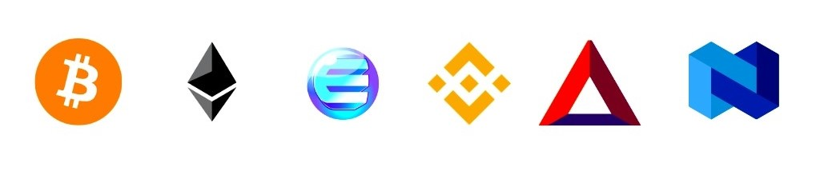

# Contents

General Information 2.

Version Updates 3.

Purpose of the project Charter 4.

Problem Definition 4.

Initial Approach 4.

Assumptions & Constraints 5.

Project Flexibility 6.

Charter Statement 6.

Key Contacts 7.

Sponsor’s Authorization 7.

Appendix A: Glossary, terms, & Acronyms 8.

# General Information

|  |  |
| --- | --- |
| Project Name | Bit-Wallet. |
| Project Sponsor | Entri Full Stack development. |
| Project Stakeholders | Balasubramanya & Vidhya latha. |
| Document Prepared by | Aspak |
| Document Date | 14/01/2023 |

# Approver’s

|  |  |  |
| --- | --- | --- |
| Name | Details | Date |
| H.S Balasubramanya | Educator | 12/01/2023 |
| Entri Full Stack Development | Learning Platform for Jobs skills | 13/01/2023 |
| Mr.John | Customer | 13/01/2023 |
| Web Designer | Aspak | 14/01/2023 |
| Vidhya Latha | Team Leader | 10/01/2023 |

# Version Updates

|  |  |  |
| --- | --- | --- |
| Version Number | Date | Update Details |
| 1.0 | 18/01/2023 | Current Version |
|  |  |  |
|  |  |  |
|  |  |  |
|  |  |  |
|  |  |  |
|  |  |  |
|  |  |  |
|  |  |  |
|  |  |  |
|  |  |  |
|  |  |  |
|  |  |  |

# Purpose of the project Charter

The Project Charter serves several purpose.

* Clearly states the problem that needs to be solved :

Some time difficult to-do Crypto trading’s & transactions. so you will make it easy for use, Because :

* An increasing number of companies worldwide are using Crypto and other digital assets for a host of investment, operational, and transactional purposes.
* Crypto Currency can enable transactions more easily is by using the internet of money, breaking through barriers, differing from the competition, and improving the speed of payment processing.
* Crypto could enable access to new capital and liquidity pools through traditional investments that have been tokenized, as well as to new asset classes.
* Initial approach to problem solving :
* Build Responsive web page for easy-to-use Mobiles & Laptops. We Design a crypto coin values Graphs, Create some Crypto price values, Create a wallet for banking facilities & Protect Your Money and Avoid Investment Scams.
* High-level expectations :
* Crypto investors are highly interested in the existing Cryptocurrency as well as the newly emerging ones to invest in their Digital wallet also known as blockchain wallets.

# Assumptions and Constraints :

The known assumptions and constraints that will affect this project are listed below:

* Assumption :
* The project should be completed and given within the given time .
* All Stakeholders will be available & willing to provide necessary input & feedback .
* The Technology required for the project is available and completable with existing system .
* The project team will have the necessary skills & expertise to complete the project .
* The project will not encounter any unexpected delays or complications .
* Constraints :

Budget:

* To give you a rough idea, the estimated cost to develop a crypto wallet app can be between $25,00 and $45,00.

Time:

* Average payback period: 1 week for a custom Crypto currency Web-app Design.

Resources:

* The availability of necessary resources such as tools, equipment, & materials may be limited & can impact the project’s progress .
* Risk :

Budget:

* The project may encounter unexpected coast, which can impact the project’s Budget & Time .

Schedule Risks:

* The project may encounter unexpected delays, which can impact the project’s progress .

# Project Flexibility :

* Project Goals. What is planned to achieve upon project completion? The project goals will identify the extent of project work and overall duration, so the project boundaries will be defined considering the high-level expectations of the project.
* Key Project Phases. There are five phases defined by the project phasing process. These phases are Measure, Plan, Produce, Introduce, and Manage. The Measure phase and the Manage phase will be the limits of project work in terms of the implementation process.
* The project's primary goal will be to express the brand’s position and personality while enhancing visitor interactions and engagement. & The project completes till given timing will be increase for 1 week .
* When the project time takes that time project cost will be increase .

# Charter Statement :

The project was designed in such a way that future modifications can be done easily. The following conclusions can be deduced from the development of the project.

Note :

The Charter statement is more strategic in natural than a project Objectives Statement (POS), which specifically addresses project scope, schedule & resource goals .

# Key Contacts :

The following individuals will be participating in the initial project definition effort.

|  |  |  |  |
| --- | --- | --- | --- |
| **Name** | **Project Role** | **Organization** | **Contact Info** |
| H.S Balasubramanya | Project Sponsor | Entri App | Balasubramanya@entri.me |
| Entri Team | Stakeholder/Subject Matter Expert (SME) | Entri App | contact@entri.me |
| H.S Balasubramanya | Stakeholder/SME | Entri App | Balasubramanya@entri.me |
| Full stack team | Project Management Oversight | Entri full stack | https://www.entri.me |
| Vidhya Latha | Project Manager | Entri full stack | vidhyalatha@entri.me |

# Sponsor’s Authorizations :

Project Sponsor Project Manager

H.S Balasubramanya Vidhya Latha

Sign : Sign :

Date : Date :

Project Designer Customer

Aspak Mr.John

Sign : Sign :

Date : Date :

# Appendix A : Glossary, Terms & Acronyms :

|  |  |
| --- | --- |
| **API** | **Application Programming Interface .** |
| Entri | https://www.entri.me |
| ASIC | Application-Specific Integrated Circuit. |
| HASH | A hash is the result of a piece of data being put through a special algorithm. |
| KYC | Know Your Customer . |
| DAA | Daily Active Addresses . |
| DLT | Distributed Ledger Technology . |

