**Urban Impact on Juvenile Salmonid Health**

Andrew Spanjer

PI: Dave Beauchamp

# Background

The Puget Sound region is experiencing rapid human population growth in the city of Seattle and the surrounding area with a projected 1.2 million additional residents by 2040 (Washington State OFM 2012). This increasing population and urbanization leads to stress in freshwater systems from a variety of anthropogenic influences including: structural changes to habitat, temperature effects from increased runoff and reduced canopy cover, flow changes, and an increased presence of toxicants both from point and non-point sources (Konrad and Booth 2005). Physical and chemical changes affect the biota within these urban streams at varying scales ranging from the individual to population; creating complex interactions that present challenges for correctly characterizing and monitoring the impact on species utilizing these freshwater habitats. Assessing the urban impact from water quality changes is particularly difficult owing in part to the sheer number of different chemicals present in the environment (Hamilton et al. 2004), differential timing of their entry into waterways (Lee et al. 2002), and technological limitations in quantification (Ellis 2006).

Water quality in Pacific Northwest streams is routinely monitored by federal, state, county, and municipal agencies using continuous measures of water chemistry such as pH, conductivity, dissolved oxygen, nutrient levels, and discrete measures of toxic pollutants. Monitoring biological measures of ecosystem health is carried out using measures of species assemblages, such as the Index of Biotic Integrity (IBI) (Karr 1991). Currently, ecosystem health is determined from the comparisons of these species assemblage to a reference condition. IBIs for fish and benthic invertebrates are widely used in the Pacific Northwest (Whittier et al. 2007, Mebane 2003, Morley and Karr 2002, Harris and Silveira 1999). Correlations drawn between IBI metrics and water quality measures are used as a metric to assess potential impacts from anthropogenic pollution. While these IBIs have been successful at identifying general patterns of ecosystem impact from toxic chemicals (Dickson et al. 1992), they aren’t capable of mechanistically linking specific components of water quality (physical or chemical) to biological harm and health impacts to the individual are left unquantified (Landis et al. 2011). With the advent of modern molecular tools, it’s possible to move towards assessing an individual’s biological response to contaminants present in their environment (Hook et al. 2014), thus mechanistically linking chemical stress to individual health. Little consensus currently exists on a method to screen for biological response to toxicants in a holistic sense that can indicate direct biological exposure from all potential chemicals in a system. With the increasing need to monitor our freshwater streams due to urbanization (Hughes et al. 2014), tools that can directly measure exposure in individuals would benefit the understanding and identification of stress in these urban streams for the investigation of impacts to a specific family or species of animal.

In the Pacific Northwest salmon have and continue to be the focus of intense study and interest, owing to both their cultural and commercial significance. Billions of dollars have and continues to go toward salmon recovery, conservation efforts, and research (Lackey, 2013). Conservation and restoration efforts in the region seek to improve habitat and reproductive success of salmon. In 2014 King County alone began 23 new projects to improve small stream habitat for salmon (King County 2014). Despite these large scale efforts, few direct tools are routinely utilized for monitoring the health of juvenile salmonids with regards to toxicant exposure. More generally, the tools that do exist for measuring toxicant effect in natural populations are finding limited use in the field (Hook et al. 2014). Salmon, therefore, are the focus of this proposal. They serve the dual purpose of designing a stress and molecular monitoring tool for a commonly found family of fish in our region’s urban streams that is also applicable to monitoring the success of specific restoration projects.

Coho (*Oncorhynchus kisutch*) and cutthroat (*Oncorhynchus clarkii*) salmon are intended as the target species. Coho inhabit small to medium sized Puget Sound lowland streams (the focus of the USGS study) where they spend roughly a year rearing before they out-migrate, and at least regionally, rarely stay longer (Sandercock 1991). Cutthroat also rear in these streams and will spend most of their life moving in and out of these small systems. These life history traits result in fish that will integrate the effects of toxicants over similar periods of time, thus allowing for better comparison of toxicant exposure between sites and for measuring integrative effects of contaminants throughout the first year of growth. Finally, the juvenile life stage is of great interest because it is often the most sensitive period of an organism to toxicant stress (Hutchinson et al. 1998) and previous work has shown that juvenile coho are sensitive to toxicants (McIntyre et al. 2012 and Barbee et al. 2008).

This proposal seeks to provide a comprehensive monitoring assessment of salmonid health due to this strong emphasis on conserving and protecting salmonids in the Pacific Northwest and the increasing threats from population growth in the region. The focus is on small urban perennial streams that serve as important rearing and spawning habitat for fish and are often the most heavily impacted by urban growth. This fish health assessment attempts to be comprehensive by measuring the direct impact of contaminants to salmonids using modern molecular tools, observable impacts from disease, and fully characterizing growth conditions in each stream. In addition to informing the current study, once developed, these tools can be used by local, state, and federal agencies in continued regional monitoring.

# Objectives

During the spring of 2015 the US geological Survey National Water Quality Assessment program characterized stream quality in the Pacific Northwest (VanMetre et al. 2015). The program’s goals were to assess both water and habitat quality in small urban streams and evaluate anthropogenic impacts. In addition to standard measures of chemical concentration and physical habitat assessment, the program aimed to better assess anthropogenic impact on biota living within these streams. The tools proposed here attempt to integrate these measures of habitat quality with their direct impact on fish rearing in these streams by measuring the health of salmonids.

One of the primary goals of the 2015 USGS NAQWA study was to complete a fish health assessment to determine if urbanization and anthropogenic pollution are impacting salmonid species. The main questions of this research are:

* + To determine if increasing urbanization and anthropogenic pollution are causing impacts to salmon health?
  + Can we account for (distinguish between) anthropogenic and natural (near-term) influences on juvenile salmonid growth?
  + Can we mechanistically link toxicant exposure and impacts to stage specific growth?

To answer these questions, I propose three tiers of assessment to quantitatively determine the health of salmonids in these urban streams (Fig. 1): 1) the use of a field based quantitative necropsy screening; 2) assessment of near-term growth conditions at each stream using a bioenergetics framework; 3) next generation sequencing techniques to directly assess exposure to contaminants by quantification of differential expression of key detoxification genes.

Figure 1. Conceptual diagram of research monitoring approach.

# Research Approach

The proposed approach is broken into three sections to address each level of assessment and the overall study design. These three sections represent the three chapters planned for the proposed Master’s thesis. Each provides a summarized version of the methods used and planned analysis.

## 1) Site Selection, Field Sampling, and Visual Fish Health Assessment

During the summer of 2015 fish were collected for this study from 15 perennial streams located around the Puget Sound (table 1, supplemental material). These streams spanned a range of urban impact and were chosen based on the level of urban land use within each watershed as a percentage of total land area. In June each site was simultaneously sampled for fish and surveyed for ecological condition by the USGS following NAWQA protocols (Rowe et al. 2013). Data available for each stream includes: 6-12 months of stream temperature data, discrete and continuous water chemistry data (metals, pesticides, pharmaceuticals, and organic contaminants), fish density surveys, benthic and drift invertebrate sampling, and physical stream characteristics (canopy cover, gradient, and bed composition). Six of the original fifteen streams were sampled again in August and September for growth assessment over the summer.

Fish sampling during June and September consisted of collecting coho and cutthroat salmonids using double-pass backpack electroshocking along a 150-meter length of stream. 15 fish of each species were euthanized for field necropsy, tissue sampling, size measurements, and diet analysis. Juvenile fish were kept alive in an aerated tank of native stream water until individual processing could take place. Fish were euthanized one at a time and immediately weighed, measured, and quickly dissected for preservation of liver tissue for later genetic analysis. Once the liver was removed, each fish was examined underneath a dissection microscope both externally and internally using the methods described by Goede and Barton (1990), (see table 2, supplemental material for detailed scoring criteria). During this examination each major organ (skin, eyes, kidney, etc.) was rated for any observable abnormalities, including hemorrhaging, presence of parasites, size, color, and tumor growths. Using this method each organ gets scored according to specific guidelines on a 30-point scale. Determination of both individual and population health condition will use the aggregate of this score alongside the other health metrics.

## 2) Characterization of Stream Growth Conditions and Energetics Assessment

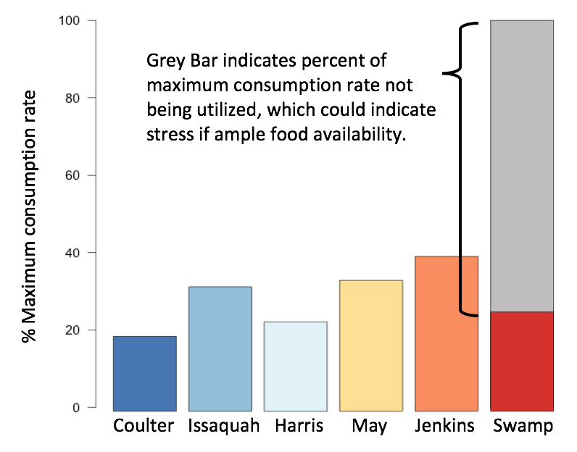Bioenergetics modeling can accurately predict changes in growth and consumption of organisms to explore the interactions between an individual’s environmental experience and utilization of available resources. It uses an energy balance equation to describe the basic physiological processes that an individual needs to survive (Chipps and Wahl 2008, Hartman and Kitchell 2008, Ney 1993). Measures of growth result in predictions of consumption with equations used to model respiration, metabolism and waste. The most common application of this model uses measured temperature, diet, and growth in the field to estimate consumption rates. The field derived model output can be compared to empirically derived maximum consumption rates for a species to determine environmental conditions facing the organism (e.g. at what percent of their maximum consumption they are able to feed) (Beauchamp 2009, Hanson et al. 1997). The model has been corroborated for a number of species, but is particularly well suited for exploring growth and consumption of salmonids (Chipps & Wahl 2008). Parameterization of the model exists for many Pacific Northwest salmonids including coho and cutthroat (Hanson et al. 1997). Rice (1990) called for increased use of the bioenergetics model for stress response in fish and suggested using energetics to pinpoint the most significant source of stress on individual growth, to investigate stress at a mechanistic level, and to run simulations of different levels of a stressed condition. Beyer et al. (19991,2) and Nault et al. (2012) proposed the use of energetics models to predict the effects of toxicant exposure to fish.

Figure . Modeled average consumption rates for 6 fish sites during summer of 2015.

In order to determine near-term influences on juvenile salmonid growth water temperature, prey abundance, and prey quality will be characterized in each stream. Water temperature was measured directly by using temperature sensors and prey quality is being determined by identifying prey items in collected drift samples. Prey abundance can be investigated by using energetics modeling by determining and comparing between streams the model predicted consumption rates. Furthermore, the comparison of drift biomass to modeled consumption rates will determine if fish are experiencing stress. This would be indicated by low modeled consumption rates in areas with high prey abundance (large relative biomass), and would suggest other influences on growth besides temperature or prey availability such as disease or toxicant exposure (Fig 2). A miss-match between low predicted consumption, yet ample prey availability, would indicate a different stress is acting on the individual. When combined with the genetic assays, this will allow for the linking of potential harm from toxicants and effects to juvenile fish growth.

Inputs needed for the bioenergetics model include prey composition, weight of the fish, temperature and age data on individual fish. A brief description of methods to produce model inputs is followed by plans for data analysis.

### Bioenergetic Input Metrics

#### Drift Sampling

Invertebrate drift sampling was conducted at all sites. Sampling occurred during the middle of the day, which has been shown to be less variable between sites (Wall et al. 2015). Drift was collected three times during the growing season: during initial fish sampling, half way through the summer season, and during the final fish collection in September. The sampling pattern followed that of the overall study design, with all 15 sites sampled in June, and only the 6 long-term sites in mid- and late-summer. Sampling was conducted in each stream with a 250 um mesh net constructed into a 3-pannel design. Each net had a 1x1 foot opening. Nets were placed in the thalweg of the river. The nets were placed so that the opening was at least 1 inch above the water, to collect floating terrestrial insects, and 1 inch off the bottom, to prevent benthic invertebrates from crawling into the net. Water velocity was measured in front of each of the three panels at a point roughly centered in front of the net using a Marsh-McBernny velocity meter both at initial deployment and when the nets were pulled. Deployment time varied, averaging around 3 hours during the June deployments and 1 hour during both August and September. Once nets were pulled, collected drift was washed down to the cod-end of each net, and placed into separate jars and preserved in 95% ethanol.

Drift samples were processed in the lab. Each sample was separated into two size fractions, 500-1000 um and >1000 um, to simplify processing. Invertebrates were separated from debris using dissection microscopes and sorted down to the order level. Both counts and blotted wet weights were obtained for each order. This was further condensed into 3 major energetic categories based on work of McCarthy et al (2009) to use as inputs for the Wisconsin bioenergetics model.

#### Diet Processing

Remaining fish tissue after liver and otolith removal were kept on ice in the field and later kept frozen at -4°C. In order to identify diet contents, fish were removed from the freezer and allowed to partially thaw. Stomachs were removed under a dissection scope, carefully cut open, and contents removed. Stomach contents were sorted based on digested and and undigested material. Undigested invertebrates were identified at the order level and blotted-wet weights obtained. All digested material was weighed in aggregate. Diet samples composition will be compared to drift samples in each stream to determine if there was evidence of fish selectively feeding.

#### Water Temperature

Water temperature was measured using Hobo instream loggers. Loggers were placed prior to the USGS sampling event during site visits in the fall/winter of 2014/2015. Temperature was logged on an hourly timescale. Averages for each day of deployment were calculated and will be used as input for the Wisconsin bioenergetics model.

#### Fish Energetic Content

To determine the average energetic content of fish from each site, 5 whole body extra fish from each site will be pooled, thawed and ground using a blender to fully homogenize all tissue. An initial wet weight will be obtained from this fish slurry and then dried in a drying oven to determine percent moisture. Dried tissue will be processed in triplicate in the bomb calorimeter to determine caloric content of fish from each site. Sites will be processed separately to determine if a difference exists between them. The resulting calorie content will be used as input for the energetics model.

#### Otolith Analysis and Fish Age Structure

Extracted otoliths were cleaned with 100% ethanol to remove any organic tissue, and then kept dry until analysis. Otolith structure analysis was completed by the USGS Western Fisheries otolith lab. One otolith from each fish (right or left), was first mounted in an epoxy resin and then sanded and polished to prepare for imaging. Polished otoliths were imaged using Image-Pro and analyzed to give an age at emergence. Additionally, the width between counted increment lines was measured. Regression models were run taking observed final weights and average increment width for all individual samples. This regression allowed for an estimate of growth per mm. Using this average, the growth rate for each individual was back-calculated, giving a rate of growth for each individual over the time since emergence. Emergence dates and growth rates will be used to analyze growth between streams with the Wisconsin energetics model.

### Bioenergetics modeling and data analysis

Modeling will be conducted using the Rstudio and the recently completed Wisconsin bioenergetics script. The model will be parameterized with a combination of empirically derived constants for adult coho and juvenile rainbow trout (Tyler and Bolduc 2008; Willey 2004). The model will be iteratively run per individual at each site based on an initial weight at emergence of .2g and their final measured wet weight. Comparisons between sites will use a standard parametric ANOVA followed by a Dunn’s post hoc test to determine statistically relevant differences in consumption rates. To determine stress condition in fish, sites will be identified that have low consumption rates as compared to reference streams. This will be further compared to both biomass of invertebrate prey items and and fish densities calculated from electroshocking of the streams to account for other impacts on fish growth.

## 3) Water Quality and Toxicogentic Biomarkers

In order to use a method that can be both broad in its scope and specific in its diagnosis, differential gene expression using transcriptomics will be used as a biomarker screening for potential toxicant exposure (Qian Xi et al. 2014). Current transcriptome sequencing technologies allow the exploration of a multitude of genetic pathways from a single sample. Many of these pathways are highly sensitive and unique to chemical classes (e.g. metals, pesticides, hydrocarbons, etc.). When gene expression data is paired with water chemistry characterization, specific chemicals that are directly affecting fish at a sub-lethal level can be directly linked, resulting in an early indicator of chemical exposure (Roberts et al. 2005).

The assessment of coho and cutthroat for gene expression will use livers collected during the USGS regional assessment. Livers were preserved in RNAlater solution and stored at -20º C resulting in minimal RNA degradation (Olsvik et al. 2007). The methods are broken down into four steps: high coverage transcriptome sequencing (RNAseq) for 6 individuals from 4 sites spanning the gradient of urban land use, differential expression analysis of sequenced individuals, targeted gene expression analysis for remaining samples using Nanostring Sequencing, and data analysis of targeted genes with water chemistry. Methods described are adapted from Blazer et al. 2015 and Qian Xi et al. 2014 with additional insight unique to the study provided by University of Washington Geneticist Dr. Steven Roberts (personal communication).

### RNAseq and Nanostring Sequencing

RNAseq is a technology that allows for reading millions of lines of genetic code from a single sample generating a large dataset detailing gene expression for each individual sequenced. For this analysis RNA was isolated with RNAzol®RT using the manufacture methods (Molecular Research Center Inc. 2015). RNA was transferred to the genetic core facility at the University of Washington, who handled library construction and sequencing using the Illumina NextSeq 500 system at a 150-bp paired-end read length. After sequencing, a de novo assembly and annotation of the transcriptome was conducted using Trinity and Blast respectively. Currently individual samples are being mapped back to the assembled transcriptome, quantified, and a gene ontology analysis conducted. From this analysis 50-100 differentially expressed genes between sites will be carried forward for Nanostring sequencing on the remaining samples. Selection of target genes is being conducted by comparing a list of previously identified stress related genes (Wiseman et al. 2007) (see table 3 in supplemental material for a detailed list) with those identified as differentially express as compared to samples from a reference stream.

Nanostring technology allows for the quantification of up to 800 unique genes of interest based on barcoding technology (Blazer et al. 2015). Barcodes are uniquely designed for each gene of interest and then attached to RNA samples through a reaction process. These unique codesets are proprietarily developed by Nanostring Inc. Once a codeset is developed, the reagents are supplied by the company and a genetic core facility can run each sample. To keep costs and analysis within reason the 50-100 genes showing the highest differentiation in expression identified from RNAseq will be moved forward for analysis. RNA will be isolated from the remaining liver samples prior to transfer to the Fred Hutch Cancer Research Center for Nanostring sequencing using this unique codeset.

To check both the Nanostring and RNAseq analysis, RNA material from each submitted sample will be run using qPCR to check the expression of 2-6 specific genes. Although the enumeration of gene expression naturally varies within subsamples of individual tissue samples and methods are not directly comparable, the same pattern of expression should be identifiable between sites (i.e. Up- or down- regulated) at roughly the same magnitude. This check will help to assure that sequencing coverage in RNAseq was sufficient and that differential expression in the Nanostring analysis is accurate.

### Water Quality

Water quality samples were analyzed at all 15 fish health sites in the weeks leading up to fish collections. Surface water samples were taken to measure for common use pesticides, nutrients, pharmaceuticals and waste water indicators. Sediments were sampled for organochlorines, PAHs, PCBs, and hydrocarbons. At the six fish health sites sampled throughout the summer of 2015, passive water quality samplers were used to quantify pesticides and metals. The results from this assessment of anthropogenic chemical pollution will be made available by the US Geological Survey for use in data analysis alongside the toxicogenetic biomarker assessment. The methods for the collection and processing of water quality samples are outside the scope of this proposal, but can be found in the *National field manual for the collection of water-quality data* (US Geological Survey, variously dated).

### Data Analysis

Expression for individual genes included in the Nanostring assay will be averaged across individual fish collected at each stream and normalized to chosen reference genes included in the Nanostring analysis. The use of reference genes that should be universally expressed at similar rates across individuals allows for correcting gene expression based on the amount of starting tissue (Urbatzka et al. 2013). Comparisons between sites will use a non-parametric Kruskal-Wallis ANOVA followed by a Dunn’s post hoc test to determine statistically relevant differential expression for genes of interest. Natural variation in expression between individuals from the same site is expected and gene expression normalization techniques to account for differences in size and age will be explored but is currently not well represented in the literature.

The biological function of genes with significantly different expression between sites will be compared to chemistry data from the USGS regional study to determine what chemicals are potentially driving gene response. This analysis will use non-parametric multivariate techniques to determine relationships between observed gene expression and the concentration of chemicals observed.

## Summary

Utilizing these tiers of assessment, I’ll be able to answer the three research questions. First by determining if there are impacts to juvenile salmonid growth in urban streams, determining what limiting factor is causing this impact to growth whether temperature, food quality, food quantity, or stress; and finally determine what chemicals present are causing a biological response in fish in the system. In places where a stress condition is observed, I should be able to determine which chemicals in the system are responsible or if disease is present and causing negative impact on growth.

## Timeline

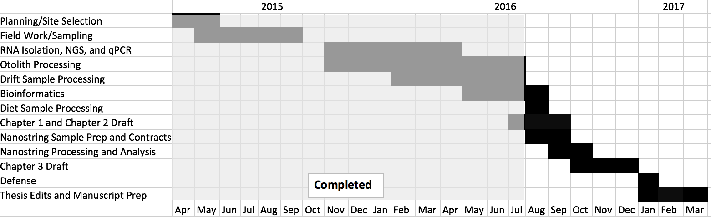

# Intellectual Merit

Targeted chemical studies often fail to account for the synergistic, antagonistic, and additive effects of mixtures inherent to natural systems (Spurgeon et al. 2010). The use of techniques that screen for effects from a large number of chemicals, while at the same time narrowing down potential candidates of effect, are preferred. These techniques at varying scales of physiology are supported in the Adverse Outcomes Pathway conceptual framework proposed by Ankley et al. (2009). Currently, limited work exists using these techniques in a comprehensive assessment of fish health and chemicals identified in discrete sampling are rarely linked to biological effect or harm. This study will provide one of the first comprehensive assessments of Juvenile Salmonid health in Pacific Northwest urban streams using modern molecular approaches, and will provide a foundation on which future work can be based. Additionally, while the Wisconsin bioenergetics model was suggested as a tool for stress identification (Rice 1990) few studies have used this approach in a field application. This work will test if energetics modeling is sensitive enough to detect stress in systems where chemical contamination is present and chemical exposure is occurring.

Next-generation transcriptomic sequencing of coho will require de novo assembly of their transcriptome because their genome has not been fully sequenced. Currently only one known study has explored the transcriptome of coho salmon (Kim et al. 2015). The resulting assembled transcriptome will aid in future research of liver tissue gene expression in these species providing a map-able database of annotated gene transcripts. The availability of a transcriptome will make further studies into toxicant biomarkers cheaper and more cost effective and provides the backbone for further gene expression studies outside the scope of toxicology.

# Broader impacts

This project leverages cooperative work between multiple government entities and the University of Washington while taking advantage of funding that allows for a full characterization of water and habitat quality in the streams being studied. Specific entities involved include: University of Washington USGS Co-Op, the USGS Washington Water Science Center, Western Fisheries, a graduate student, an undergraduate technician and capstone students. The research provides learning opportunities for the main graduate student involved and has the potential to provide a number of undergraduate research opportunities through the University of Washington’s undergraduate capstone program

The successful characterization of fish health in these systems would create a usable method for future stream monitoring work, creating a tremendous amount of value-added information to monitoring programs currently funded both regionally and nationally with little additional cost. Successful completion of a fish health screening method has support from the Puget Sound Partnership, local tribes, and municipal governments and would provide an assessment tool for these organizations with important implications for conservation and environmental management. This health screening could be used by these agencies to assess conservation efforts that seek to improve water quality and remove contaminants from our urban waterways.

## Budget

The oversight and primary workforce has and continues to be a masters student at the University of Washington with 9 quarters of funding for salary and tuition (27 months). The next generation sequencing was carried out by the UW genetics core facility. Due to the technical learning curve of these techniques money is best spent using contract services with the exception of RNA extraction, cDNA conversion, Nanodrop quantification, electrophoresis, and qPCR confirmation. These are well established laboratory methods using standard reagents and with the corresponding equipment available at the University. To aid in the completion of the drift and diet sample processing two and a half months of laboratory technician assistance is included in the budget. Additional costs are for laboratory supplies, conference registration and travel. Funds are fully received and currently being used.

|  |  |  |  |
| --- | --- | --- | --- |
| **Title: Development and Application of a Juvenile Salmonid Health Index** | | |  |
| Category/Description School of Fisheries and Aquatic Sciences | | | Totals |
| **SALARIES** |  |  |  |
| Post Doctoral Research Associate |  |  |  |
| Research Technologist |  |  |  |
| Research Assistant- MS (2.25 year GRA salary) | 27 | months | 53,262.02 |
| Hourly research technician | 2.5 | months | 6,300.00 |
|  |  | *Salary Subtotal* | 59,562.02 |
| **BENEFITS** |  |  |  |
| Faculty @ 22.7% |  |  |  |
| Classified Staff @ 33.8% |  |  |  |
| Professional Staff @ 27.7% |  |  |  |
| Graduate Student @ 20.6% |  |  | 10,971.98 |
| Hourly research technician @ 17.0% |  |  | 1,071.00 |
|  |  | *Benefit Subtotal* | 12,042.98 |
| **TOTAL SALARIES AND BENEFITS** |  |  | **71,605.00** |
| **LAB-** NGS and Nanostring processing |  |  | 18,000.00 |
| **SERVICES** |  |  |  |
| Long Distance, copies and other associated project services. | | | 2,000.00 |
| **TRAVEL** |  |  |  |
| Lodging, per diem, airfare and other associated travel costs. | | | 5,000.00 |
| **SUPPLIES & MATERIALS** |  |  |  |
| Associated field and lab supplies. |  |  | 2,000.00 |
| **GRADUATE STUDENT OPERATING FEES** |  |  | 41,778.00 |
| **TOTAL DIRECT COSTS** |  |  | 140,383.00 |
| **FACILITIES & ADMINISTRATIVE FEES @ 15%** | |  |  |
| (Per WACWRU Cooperative Agreement No. 1434-HQ-97-RU-01583) | | | 21,057.45 |
| **TOTAL PROJECT COSTS** |  |  | 161,440.45 |
|  |  |  |  |

## Sources

Ankley, G., R. Bennett, R. Erickson, D. Hoff, M. Hornung, R. Johnson, D. Mount, J. Nichols, C. Russom, P. Schmieder, J. Serrrano, J. Tietge, and D. Villeneuve. 2010. Adverse outcome pathways: A conceptual framework to support ecotoxicology research and risk assessment. Environmental Toxicology and Chemistry 29(3):730-741.

Barbee, G., J. Barich, B. Duncan, J. Bickham, C. Matson, C. Hintze, R. Autenrieth, G. Zhou, T. McDonald, L. Cizmas, D. Norton, and K. Donnelly. 2008. In situ biomonitoring of PAH-contaminated sediments using juvenile coho salmon (Oncorhynchus kisutch). Ecotoxicology and Environmental Safety 71(2):454-464.

Beauchamp, D. 2009. Bioenergetic ontogeny: linking climate and mass-specific feeding to life-cycle growth and survival of salmon. American Fisheries Society Symposium. 70:1–19.

Beyers, D.W., J.A. Rice, and W.H. Clement. 19991. Evaluating biological significance of chemical exposure to fish using a bioenergetics-based stressor-response model. Canadian Journal of Fisheries and Aquatic Sciences. 56:823–829.

Beyers, D.W., JA Rice, W.H. Clements, and C.J. Henry. 19992. Estimating physiological cost of chemical exposure: integrating energetics and stress to quantify toxic effects in fish. Canadian Journal of Fisheries and Aquatic Sciences. 56:814–822.

Blazer, V.S., P.M. Mazik, L.R. Iwanowicz, R. Braham, C. Hahn, H.L. Walsh, and A. Sperry. 2014. Monitoring of wild fish health at selected sites in the Great Lakes Basin—methods and preliminary results. U.S. Geological Survey Open-File Report 2014-1027.

Chipps, S.R. and D.H. Wahl. 2008. Bioenergetics Modeling in the 21st Century: Reviewing New Insights and Revisiting Old Constraints. Transactions of the American Fisheries Society. 137:298–313

Dickson, K. L., W.T. Waller, J.H. Kennedy, and L.P. Ammann. 1992. Assessing the relationship between ambient toxicity and instream biological response. Environmental Toxicology and Chemistry 11(9):1307-1322.

Ellis, J. B. 2006. Pharmaceutical and personal care products (PPCPs) in urban receiving waters. Environmental Pollution. 144(1): 184-189.

Goede, R.W. and B.A. Barton. 1990. Organismic indices and an autopsy-based assessment as indicators of health and condition of fish. American Fisheries Society Symposium. 8:93-108.

Hamilton, P.A., T.L. Miller, and D.N. Myers. 2004. Water quality in the Nation's streams and aquifers - Overview of selected findings, 1991-2001. U.S. Geological Survey Circular 1265.

Hanson, P.C., T.B. Johnson, D.E. Schindler, and J.F. Kitchell. 1997. Fish Bioenergetics 3.0 for Windows. Center for Limnology, University of Wisconsin-Madison and the University of Wisconsin Sea Grant Institute. WISCU-T-97–001.

Harris, J., and R. Silveira. 1999. Large-scale assessments of river health using an Index of Biotic Integrity with low-diversity fish communities. Freshwater Biology 41(2):235-252.

Hartman K.K. and J.F. Kitchell. 2008. Bioenergetics Modeling: Progress since the 1992 Symposium. Transactions of the American Fisheries Society. 137:216–223.

Hook, S., E. Gallagher, and G. Batley. 2014. The role of biomarkers in the assessment of aquatic ecosystem health. Integr Environ Assess Manag 10(3):327-341.

Hughes, R.M., S. Dunham, K.G. Maas-Hebner, J.A. Yeakley, C. Schreck, M. Harte, N. Molina, C.C. Shock, V.W. Kaczynski, and J. Schaeffer. 2014. A review of urban water body challenges and approaches: rehabilitation and remediation. Fisheries. 39(1):18-29.

Hutchinson, T., J. Solbe, and P. Kloepper-Sams. 1998. Analysis of the ecetoc aquatic toxicity (EAT) database III — Comparative toxicity of chemical substances to different life stages of aquatic organisms. Chemosphere 36(1):129-142.

Karr, J. R. 1991. Biological integrity: a long-neglected aspect of water resource management. Ecological applications 1(1):66-84.

Kim, J. H., J.S. Leong, B.F. Koop, and R.H. Devlin. 2015. Multi-tissue transcriptome profiles for coho salmon (Oncorhynchus kisutch), a species undergoing rediploidization following whole-genome duplication. Marine genomics. In Press.

King County. 2014. Small habitat restoration program. Annual Report. Seattle, WA.

Konrad, C. P. and D.B. Booth. 2005. Hydrologic changes in urban streams and their ecological significance. American Fisheries Society Symposium 47:157-177.

Lackey, R. T. 2013. Saving wild salmon: a 165 year policy conundrum. In Dubach Workshop: Science and Scientists in the Contemporary Policy Process.

Landis, W. G., R Sofield, M.H. Yu. 2003. Introduction to environmental toxicology: impacts of chemicals upon ecological systems. CRC Press, Florida.

Lee, J. H., K.W. Bang, L.H. Ketchum, J.S. Choe, and M.J. Yu. 2002. First flush analysis of urban storm runoff. Science of the Total Environment 293(1): 163-175.

McCarthy, S. G., J.J. Duda, J.M. Emlen, G.R. Hodgson, and D.A. Beauchamp. 2009. Linking habitat quality with trophic performance of steelhead along forest gradients in the South Fork Trinity River watershed, California. Transactions of the American Fisheries Society 138(3): 506-521.

McIntyre, J., D. Baldwin, D. Beauchamp, and N. Scholz. 2012. Low-level copper exposures increase visibility and vulnerability of juvenile coho salmon to cutthroat trout predators. Ecological Applications 22(5):1460-1471.

Mebane, C., T. Maret, and R. Hughes. 2003. An Index of Biological Integrity (IBI) for Pacific Northwest Rivers. Transactions of the American Fisheries Society 132(2):239-261.

Molecular Research Center, Inc. 2015. RNAzol®RT Brochure. Cincinnati, OH

Morley, S.A. and J.R. Karr. 2002. Assessing and restoring the health of urban streams in the Puget Sound basin. Conservation Biology 16(6):1498-1509.

Nault, R., S. Al-Hameedi, and T.W. Moon. 2012. Effects of polychlorinated biphenyls on whole animal energy mobilization and hepatic cellular respiration in rainbow trout, Oncorhynchus mykiss. Chemosphere, 87(9):1057–1062.

Ney, JJ. 1993. Bioenergetics Modeling Today: Growing Pains on the Cutting Edge. Transactions of the American Fisheries Society. 122(1):736–748.

Olsvik, P. A., K.K. Lie, and E.M. Hevrøy. 2007. Do anesthetics and sampling strategies affect transcription analysis of fish tissues?. BMC molecular biology 8(1):48.

Qian, X., Y. Ba, Q. Zhuang, and G. Zhong. 2014. RNA-Seq Technology and Its Application in Fish Transcriptomics. OMICS: A Journal of Integrative Biology 18(2):98-110.

Rice, J.A. 1990. Bioenergetics modeling approaches to evaluation of stress in fishes. American Fisheries Society Symposium. 8:80–92.

Roberts, A.P., JT Oris, G.A. Burton, and W.H. Clements. 2005. Gene expression in caged fish as a first‐tier indicator of contaminant exposure in streams. Environmental toxicology and chemistry, 24(12): 3092-3098.

Rowe, G.L., Jr., K. Belitz, C.R. Demas, H.I. Essaid, R.J. Gilliom, P.A. Hamilton, A.B. Hoos, C.J. Lee, M.D. Munn, and D.W. Wolock. 2013. Design of cycle 3 of the National Water-Quality Assessment Program, 2013–23: Part 2: Science plan for improved water-quality information and management. U.S. Geological Survey Open-File Report 2013–1160.

Sandercock, F.K. 1991. Life history of Coho Salmon (Oncorhynchus kisutch). Pages 397-445 in Groot, C., and L. Margolis editors. Pacific salmon life histories. UBC Press, Vancouver.

Spurgeon, D., O. Jones, J. Dorne, C. Svendsen, S. Swain, and S. Stürzenbaum. 2010. Systems toxicology approaches for understanding the joint effects of environmental chemical mixtures. Science of The Total Environment 408(18):3725-3734.

Tyler, J. A. and M.B. Bolduc. 2008. Individual variation in bioenergetic rates of young-of-year rainbow trout. Transactions of the American Fisheries Society 137(1): 314-323.

Urbatzka, R., S. Galante-Oliveira, E. Rocha, L.F.C. Castro, and I. Cunha. 2013. Normalization strategies for gene expression studies by real-time PCR in a marine fish species, Scophthalmus maximus. Marine genomics 10:17-25.

U.S. Geological Survey. variously dated. National field manual for the collection of water-quality data: U.S. Geological Survey Techniques of Water-Resources Investigations, book 9 chaps: A1-A10.

VanMetre, P.C., J.L. Morace, and R. Sheibley. 2015. The Pacific northwest stream quality assessment. U.S. Geological Survey Fact Sheet 2015–3020, 2 p.

Wall, C. E., N. Bouwes, J.M. Wheaton, W.C. Saunders, and S.N. Bennett. 2015. Net rate of energy intake predicts reach-level steelhead (Oncorhynchus mykiss) densities in diverse basins from a large monitoring program. Canadian Journal of Fisheries and Aquatic Sciences 73(999): 1-11.

Washington State Office of Financial Management (OFM). 2014. County growth management population projections by age and sex: 2010-2040. Forecasting Division. Olympia, Washington.

Whittier, T., R. Hughes, J. Stoddard, G. Lomnicky, D. Peck, and A. Herlihy. 2007. A structured approach for developing indices of biotic integrity: three examples from streams and rivers in the Western USA. Transactions of the American Fisheries Society 136(3):718-735.

Willey, W. S. 2004. Energetic response of juvenile coho salmon (Oncorhynchus kisutch) to varying water temperature regimes in northern California streams (Doctoral dissertation, Humboldt State University).

Wiseman, S. 2007. Gene expression pattern in the liver during recovery from an acute stressor in rainbow trout. Comparative Biochemistry and Physiology Part D Genomics Proteomics 234-44.

## Supplemental Material

Table 1. Sampling site information and sampling dates.

|  |  |  |  |  |  |
| --- | --- | --- | --- | --- | --- |
| Site Name | USGS site # | Sampling Location | Drainage Area KM2 | % Urban1 | Sample Date(s) |
| Rock Creek near Landsburg, WA | 12117695 | N 47.40300  W 121.89900 | 12.89 | 3.2 | 6/19/2015 |
| Coulter Creek near Allyn, WA | 12073895 | N 47.40861  W 122.81583 | 33.55 | 4.0 | 6/23/2015  8/15/2015  9/29/2015 |
| E. Fork Dairy Creek near Meacham Corner, OR | 14205400 | N 45.68233  W 123.06955 | 87.63 | 2.4 | 6/30/2015 |
| Issaquah Creek near Hobart, WA | 12120600 | N 47.45732  W 122.00512 | 49.20 | 16.0 | 6/15/2015  8/16/2015  9/24/2015 |
| Harris Creek | NA | N 47.69391  W 121.90026 | 23.36 | 18.4 | 6/22/2015  8/15/2015  9/24/2025 |
| Church Creek near Stanwood, WA | NA | N 48.24787  W 122.31454 | 31.38 | 25.1 | 6/19/2015 |
| May Creek near Renton, WA | 12119495 | N 47.52100  W 122.19700 | 35.24 | 52.2 | 7/15/2015  8/16/2015  9/23/2015 |
| Kelley Creek near Portland, OR | 14211499 | N 45.47679  W 122.49842 | 12.69 | 39.6 | 7/1/2015 |
| Jenkins Creek near Auburn, WA | NA | N 47.33986  W 122.12967 | 46.95 | 65.9 | 6/16/2015  8/16/2015  9/21/2015 |
| Woodland Creek near Lacey, WA | 12080800 | N 47.06361  W 122.80722 | 62.90 | 63.6 | 6/24/2015 |
| Mercer Creek near Bellevue, WA | 12120000 | N 47.60288  W 122.18096 | 32.81 | 85.5 | 6/18/2015 |
| Thornton Creek near Seattle, WA | 12128000 | N 47.69565  W 122.27624 | 31.02 | 95.9 | 6/20/2015 |
| Longfellow Creek near West Seattle, WA |  | N 47.56000  W 122.36700 | ? | ? | 6/21/2015 |
| Burnt Bridge Creek near Vancouver, WA | 14211902 | N 45.66123  W 122.66899 | 70.09 | 95.3 | 7/2/2105 |
| Swamp Creek near near, Kenmore, WA | NA | N 47.79221  W 122.25631 | 59.58 | 88.2 | 7/9/2015  8/15/2015  9/17/2015 |

Table 2. Qualitative Necropsy Assessment. Adapted from: Goede and Batron 1990; Adams et al 1993; Schmitt et al 1999

|  |  |  |
| --- | --- | --- |
| **Organ** | **Rating** | **Quantitative Score** |
| **Quantitative Assessment** | | |
| **Fins** | 0-No active erosion  1-Light active erosion  2-Moderate active erosion with some hemorrhaging  3-Severe active erosion with hemorrhaging | 0  10  20  30 |
| **Skin** | 0-Normal; no aberrations  1-Mild skin aberrations  2-Moderate skin aberrations  3-Severe skin aberrations | 0  10  20  30 |
| **Eyes** | N-No aberrations: good “clear” eye  B-Generally, an opaque eye (one or both)  E-Swollen, protruding eye (one or both)  H-Hemorrhaging or bleeding in the eye (one or both)  M-Missing one or both eyes  OT-Other; any manifestation not fitting the above | 0  30  30  30  30  30 |
| **Pseudobranchs** | N-Normal; flat, containing no aberrations  S-Swollen, convex in aspect  L-Lithic, mineral deposits, white, somewhat amorphous spots  S&L-Swollen and Lithic  I-Inflamed; redness, hemorrhage, or other  OT-Other; any condition not covered above | 0  30  30  30  30  30 |
| **Gills** | N-Normal; no apparent aberrations  F-Frayed; erosion of tips of gill lamellae resulting in “ragged” gills  C-Clubbed; swelling of the tips of the gill lamellae  M-Marginate; gills with light, discolored margin along tips of the lamellae  P-Pale; very light in color  OT-Other; any observation not fitting above | 0  30  30  30  30  30 |
| **Parasites** | 0-No observed parasites  1-Few observed parasites  2-Moderate parasite infestation  3-Numerous parasites | 0  10  20  30 |
| **Spleen** | B-Normal; black, very dark red, or red  G-Normal; granular, rough appearance of spleen  D-Nodular; containing fistulas or nodules of varying sizes  E-Enlarged; noticeably enlarged  OT-Other; gross aberrations not fitting above categories | 0  0  30  30  30 |
| **Hindgut** | 0-Normal; no inflammation or reddening  1-Slight inflammation or reddening  2-Moderate inflammation or reddening  3-Severe inflammation or reddening | 0  10  20  30 |
| **Kidney** | N-Normal; firm dark red color, lying relatively flat along the length of the vertebral column  S-Swollen; enlarged or swollen wholly or in apart  M-Mottled; gray discoloration  G-Granular; granular appearance and texture  U-Urolithiasis or nephrocalcinosis; white or cream-colored mineral material  OT-Other; any aberrations not fitting previous categories | 0  30  30  30  30  30 |
| **Liver** | A-Normal; solid red or light red color  C-“Fatty” liver; “coffee with cream” color  D-Nodules in the liver; cysts or nodules  E-Focal discoloration; distinct localized color changes  F-General discoloration; color change in whole liver  OT- Other; deviation in liver not fitting other categories | 0  30  30  30  30  30 |
| **Qualitative Assessment** | | |
| **Visceral fat deposits** | 0-No fat deposits present  1-0-50% coverage of pyloric caeca with fat, or with no caeca coverage but with trailing fat bodies in the viscera  2-Pyloric caeca approximately 50% covered with fat  3-More than 50% of caeca covered with fat  4- Caeca completely fat-covered |  |
| **Bile** | 0-Bile straw-yellow and gall bladder partially full or empty  1-Bile yellow and bladder fully distended with bile  2-Bile light to grass-green and bladder full  3-Bladder full and bile dark green to blue-green |  |
| **Sex** | M-Male  F-Female  I-Indeterminate |  |
| **Gut Contents** | F-full  E-empty |  |

*Table 3. Rainbow Trout Stress Gene List used to query identified genes in RNAseq analysis; taken directly from Wiseman et al. 2007.*

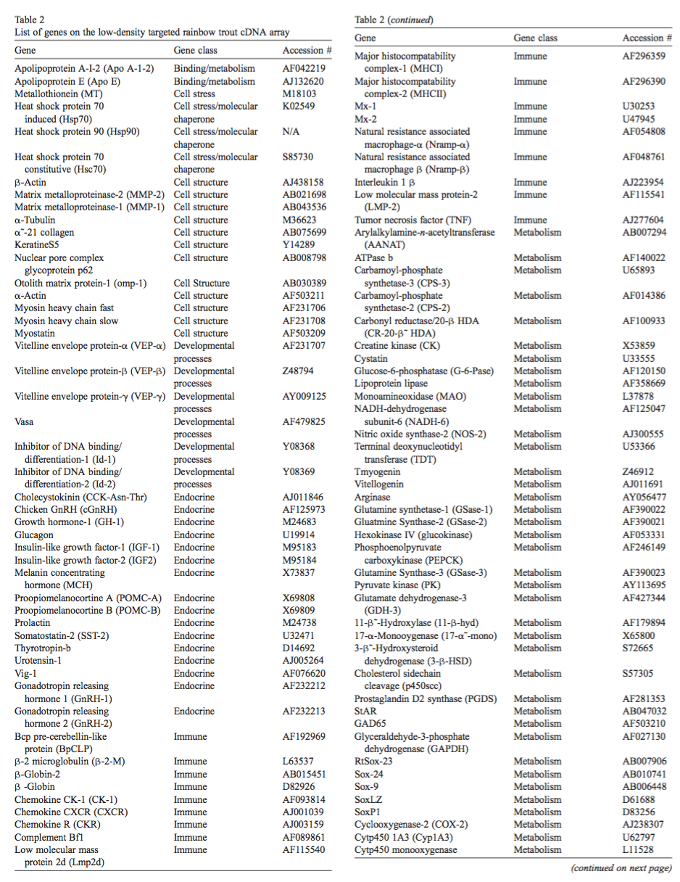

Table 2, cont. directly from Wiseman et al 2007.

