1. 查询"01"课程比"02"课程成绩高的学生的信息及课程分数

(select * from student where s_id in (select s_id from score s1 where s1.c_id like'01' and s1.s_score>(select s_score from

score s2 where s2.c_id like '02' and s1.s_id = s2.s_id)));

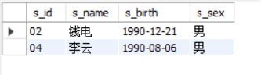

select * from score where s_id in (select s_id from score s1 where s1.c_id like'01' and s1.s_score>(select s_score from

score s2 where s2.c_id like '02' and s1.s_id = s2.s_id));

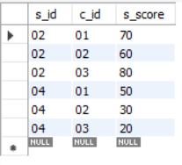

2、查询"01"课程比"02"课程成绩低的学生的信息及课程分数

(select * from student where s_id in (select s_id from score s1 where s1.c_id like'01' and s1.s_score<(select s_score from

score s2 where s2.c_id like '02' and s1.s_id = s2.s_id)));

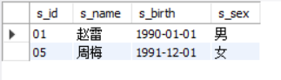

select * from score where s_id in (select s_id from score s1 where s1.c_id like'01' and s1.s_score<(select s_score from

score s2 where s2.c_id like '02' and s1.s_id = s2.s_id));

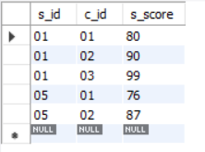

3、查询平均成绩大于等于60分的同学的学生编号和学生姓名和平均成绩

select avg_60.*,student.s_name from (select s_id,avg(s_score) from score group by s_id having avg(s_score)>60) avg_60,student where student.s_id =avg_60.s_id

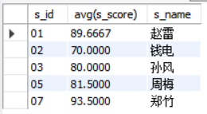

选择特定表的特定元素时，一定要select student.* 限定在某一个表不然会select错误

1. 查询平均成绩小于60分的同学的学生编号和学生姓名和平均成绩 (包括有成绩的和无成绩的)

Select （元素1,2,3） from table left outer join table on(条件)

select term.* from

(select student.s_id,student.s_name,avg1

from student left join

(select avg_60.*,student.s_name from (select s_id ,avg(s_score) avg1 from score group by s_id ) avg_60 ,student where avg_60.s_id = student.s_id) avg2

on avg2.s_id =student.s_id) term where avg1 <60 OR term.s_id like '08'

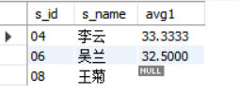

1. 查询所有同学的学生编号、学生姓名、选课总数、所有课程的总成绩

select ss1.*,ss2.cnt from

(select student.s_id,student.s_name,avg1

from student left join

(select avg_60.*,student.s_name from (select s_id ,sum(s_score) avg1 from score group by s_id ) avg_60 ,student where avg_60.s_id = student.s_id) avg2

on avg2.s_id =student.s_id) ss1 ,

(select student.s_id,cnt from student left join (select s_id, count(c_id) cnt from score group by s_id ) s1 on s1.s_id = student.s_id) ss2

where ss1.s_id =ss2.s_id

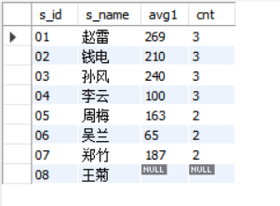

6、查询"李"姓老师的数量

select count(t_name) li from teacher where t_name like '李%'

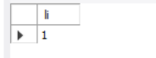

7.查询学过"张三"老师授课的同学的信息

select student.* from student,

(select score.s_id from score, (select course.c_id from course where course.t_id = '01' ) s1 where score.c_id = s1.c_id ) s2

where student.s_id =s2.s_id

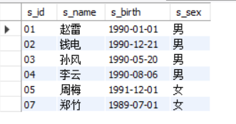

1. 查询没学过"张三"老师授课的同学的信息

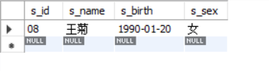

1. 查询学过编号为"01"并且也学过编号为"02"的课程的同学的信息

select student.* from student,

(select score.s_id from score, (select course.c_id from course where course.t_id = '01' ) s1 where score.c_id = s1.c_id ) s2,

(select score.s_id from score, (select course.c_id from course where course.t_id = '02' ) s3 where score.c_id = s3.c_id ) s4

where student.s_id =s2.s_id and s2.s_id =s4.s_id

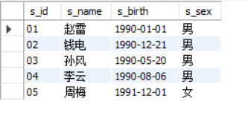

Not in 后面只能接表

1. 查询学过编号为"01"但是没有学过编号为"02"的课程的同学的信息

Group by 是聚集操作只能同时对多个数操作

select student.* from student where student.s_id in

(select score.s_id from score where score.c_id ='01'

)

and student.s_id not in (select score.s_id from score where score.c_id ='02')

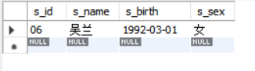

11、查询没有学全所有课程的同学的信息

select distinct student.* from student,

(select s_id from score group by score.s_id having count(s_score) !=3) s1

where student.s_id =s1.s_id or student.s_id in

(select distinct student.s_id from student,score where student.s_id not in

(select score.s_id from score ))

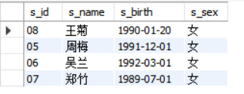

12、查询至少有一门课与学号为"01"的同学所学相同的同学的信息

select student.* from student where student.s_id in

(select distinct s1.s_id from

(select score.s_id,score.c_id from score where s_id !='01') s1

where s1.c_id = '01' or s1.c_id ='02' or s1.c_id ='03' )

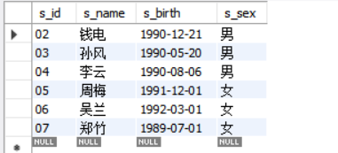

13、查询和"01"号的同学学习的课程完全相同的其他同学的信息

select student.* from student,

(select s1.s_id from

(select score.s_id,count(score.s_score) cnt1 from score group by score.s_id ) s1

where s1.cnt1=3) s2

where s2.s_id = student.s_id

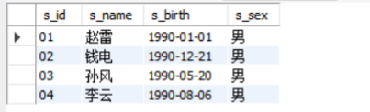

14、查询没学过"张三"老师讲授的任一门课程的学生姓名

select student.s_name from student where student.s_id not in

(select score.s_id from score where score.c_id ='02')

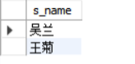

15、查询两门及其以上不及格课程的同学的学号，姓名及其平均成绩

select student.s_id,student.s_name,s2.avg1

from student,

(select s1.s_id,avg(s1.s_score) avg1 from

(select score.* from score where score.s_score <60) s1

group by s1.s_id having count(s1.s_id) >= 2) s2

where student.s_id = s2.s_id

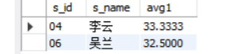

16、检索"01"课程分数小于60，按分数降序排列的学生信息

select student.*,s3.s_score from student,

(select s2.* from

(select s1.s_id,s1.s_score from

(select score.* from score where score.c_id ='01') s1

where s1.s_score <60) s2 order by s2.s_score desc) s3

where s3.s_id = student.s_id

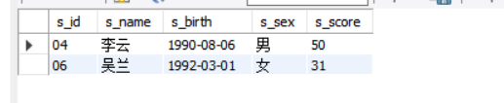

17、按平均成绩从高到低显示所有学生的所有课程的成绩以及平均成绩

select * from

(select student.s_name,s1.* from student,

(select score.*,avg(s_score) avg1 from score

group by s_id ) s1

where s1.s_id = student.s_id) s2

order by avg1 desc

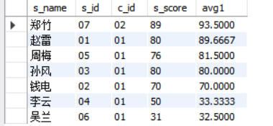

18.查询各科成绩最高分、最低分和平均分：

以如下形式显示：

课程ID，课程name，最高分，最低分，平均分，及格率，中等率，优良率，优秀率

--及格为>=60，中等为：70-80，优良为：80-90，优秀为：>=90

select s1.c_id,course.c_name,s1.* from course,

(select c_id,

max(score.s_score) '最高分',

min(score.s_score) '最低分',

avg(score.s_score) '平均分',

sum(case when s_score>=60 then 1 else 0 end)/count(s_id) as '及格率',

sum(case when s_score>=70 and s_score<=80 then 1 else 0 end)/count(s_id) as '中等率',

sum(case when s_score>=80 and s_score<=90 then 1 else 0 end)/count(s_id) as '优良率',

sum(case when s_score>=90 then 1 else 0 end)/count(s_id) as '优秀率'

from score

group by c_id) s1

where s1.c_id=course.c_id

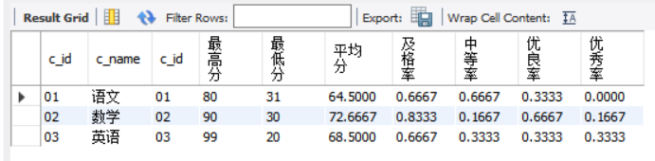

19、按各科成绩进行排序，并显示排名(实现不完全)

select s_id,c_id,s_score,row_number()

over(partition by c_id order by s_score desc) rk from score

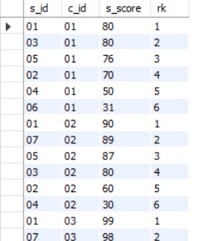

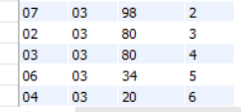

20、查询学生的总成绩并进行排名

select s1.s_id,s1.sum1,row_number()

over () rk

from (select s_id,sum(s_score) sum1 from score group by s_id) s1

order by s1.sum1 desc

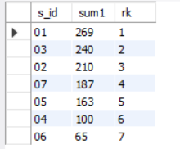

21、查询不同老师所教不同课程平均分从高到低显示

select teacher.t_name,s2.avg1,row_number()

over(order by avg1 desc) rk

from teacher,

(select course.t_id,s1.avg1 from course,

(select score.c_id,avg(s_score) avg1 from

score group by c_id) s1

where course.c_id =s1.c_id) s2

where s2.t_id=teacher.t_id

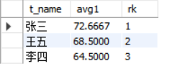

-- 22、查询所有课程的成绩第2名到第3名的学生信息及该课程成绩

select student.*,s2.c_id,s2.s_score,s2.rk from student,

(select s1.* from

(select score.* ,row_number()

over(partition by c_id order by s_score desc) rk

from score ) s1

where rk =3 or rk=2) s2

where student.s_id = s2.s_id

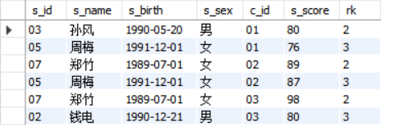

-- 23、统计各科成绩各分数段人数：

课程编号,课程名称,[100-85],[85-70],[70-60],[0-60]及所占百分比

select course.c_name,s1.* from course,

(select c_id ,

sum(case when s_score>=0 and s_score<60 then 1 else 0 end)/count(s_id) as '[0-60]',

sum(case when s_score>=60 and s_score<70 then 1 else 0 end )/count(s_id) as '[70-60]',

sum(case when s_score>=70 and s_score<85 then 1 else 0 end )/count(s_id) as '[85-70]',

sum(case when s_score>=85 and s_score<=100 then 1 else 0 end )/count(s_id) as'[100-85]'

from score

group by c_id) s1

where course.c_id =s1.c_id

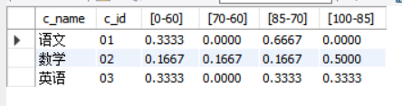

24、查询学生平均成绩及其名次

select s1.*,row_number()

over(order by s1.avg1 desc) rk from

(select s_id,avg(s_score) avg1 from score

group by s_id) s1

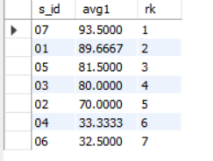

25、查询各科成绩前三名的记录

1.选出b表比a表成绩大的所有组

2.选出比当前id成绩大的 小于三个的

select s1.c_id,s1.s_score,s1.rk from

(select *,row_number()

over(partition by c_id order by s_score desc) rk

from score) s1

where rk = 1 or rk =2 or rk = 3

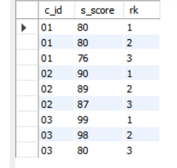

26、查询每门课程被选修的学生数

select score.c_id ,count(s_id)

from score

group by c_id

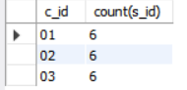

27、查询出只有两门课程的全部学生的学号和姓名

select student.s_id,student.s_name from student,

(select * from score

group by s_id having count(c_id) =2) s1

where s1.s_id =student.s_id

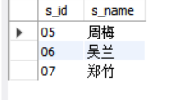

28、查询男生、女生人数

select

sum(case when s_sex = '男' then 1 else 0 end) boy,

sum(case when s_sex = '女' then 1 else 0 end) girl

from student



29、查询名字中含有"风"字的学生信息

select student.* from student

where student.s_name like '%风%'

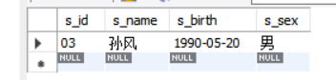

-- 30、查询同名同性学生名单，并统计同名人数

select s_name,count(s_name) from

(select first.s_name from student first ,student second where first.s_name = second.s_name

and first.s_sex = second.s_sex and first.s_id<> second.s_id) s1



-- 31、查询1990年出生的学生名单

select s_name,s_birth

from student

where year(s_birth) =1990

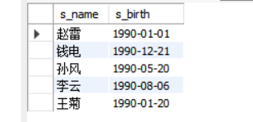

- 32、查询每门课程的平均成绩，结果按平均成绩降序排列，平均成绩相同时，按课程编号升序排列

select c_id ,avg(s_score) avg1 from score

group by c_id order by avg1 desc,c_id

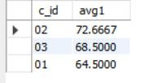

33、查询平均成绩大于等于85的所有学生的学号、姓名和平均成绩

select student.s_id,student.s_name,avg(score.s_score) avg1

from student,score

group by score.s_id having avg1>=85

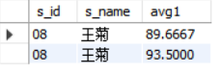

34、查询课程名称为"数学"，且分数低于60的学生姓名和分数

select student.s_name,s2.s_score from student,

(select s_id,s_score from score,

(select c_id from course

where c_name like '数学') s1

where s1.c_id = score.c_id) s2

where s2.s_score<60 and student.s_id = s2.s_id

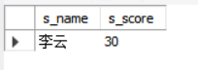

35、查询所有学生的课程及分数情况

select s1.s_name,course.c_name,s1.s_id,s1.c_id,s1.s_score from course,

(select student.s_name,score.*

from student,score

where student.s_id = score.s_id) s1

where s1.c_id = course.c_id

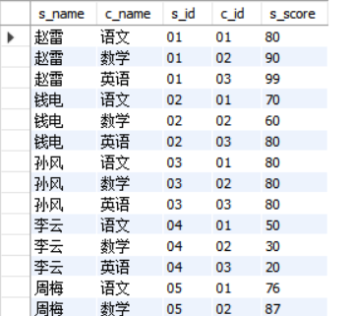

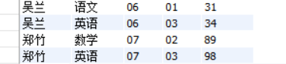

36、查询任何一门课程成绩在70分以上的姓名、课程名称和分数；

select student.s_name ,s1.* from student,

(select s_id,c_id from score

group by s_id having min(s_score)>70) s1

where student.s_id =s1.s_id

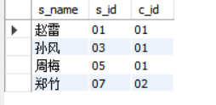

37、查询不及格的课程

select student.s_name, s2.* from student,

(select course.c_name ,s1.* from course,

(select s_id,score.c_id,s_score from score

where score.s_score <60) s1

where course.c_id = s1.c_id) s2

where student.s_id = s2.s_id

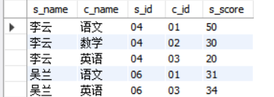

38、查询课程编号为01且课程成绩在80分以上的学生的学号和姓名；

select student.s_id,student.s_name,s1.s_score from student,

(select s_id,s_score from score

where c_id ='01' and s_score >=80) s1

where s1.s_id =student.s_id

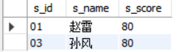

39、求每门课程的学生人数

select c_id,count(s_id) from score

group by c_id

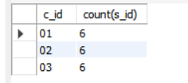

40、查询选修"张三"老师所授课程的学生中，成绩最高的学生信息及其成绩

select student.*,s2.c_id,s2.m1 from student,

(select s_id,c_id,max(s_score) m1 from

(select s_id,c_id,s_score from score where score.c_id =

(select course.c_id from teacher,course

where teacher.t_id =course.t_id and teacher.t_name like '张三') ) s1) s2

where s2.s_id = student.s_id



41、查询不同课程成绩相同的学生的学生编号、课程编号、学生成绩

(select s1.s_id,s1.c_id c_id1,score.c_id c_id2,s1.s_score from score,

(select s_id,s_score,c_id from score

where c_id = '01') s1

where s1.s_score = score.s_score and s1.c_id <> score.c_id and s1.s_id = score.s_id)

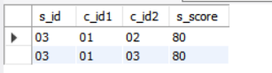

42、查询每门功成绩最好的前两名

select s_name,s1.s_id ,s1.c_id,s1.rk from student,

(select s_id,c_id,s_score,row_number()

over(partition by c_id order by s_score desc) rk

from score) s1

where (s1.rk = 1 or s1.rk =2) and s1.s_id = student.s_id

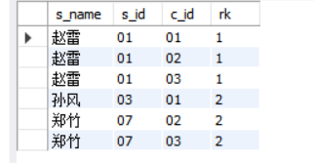

43、统计每门课程的学生选修人数（超过5人的课程才统计）。

要求输出课程号和选修人数，查询结果按人数降序排列，若人数相同，按课程号升序排列

select c_id,count(s_id) cnt from score

group by c_id

order by cnt desc,c_id

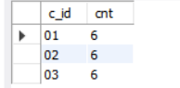

44、检索至少选修两门课程的学生学号

(select s_id,count(s_id) from score

group by s_id

having count(s_id) >=2)

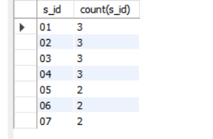

45、查询选修了全部课程的学生信息

select student.* from student,

(select s_id from score

group by s_id

having count(s_id) = 3) s1

where s1.s_id = student.s_id

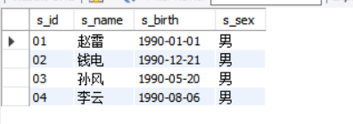

6、查询各学生的年龄

select s_name,year(now())-year(s_birth) age from student

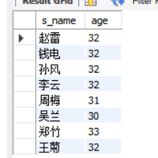

47、查询本周过生日的学生

select s_name from student where

week(s_birth) = week(sysdate())

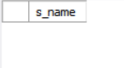

48、查询下周过生日的学生

select s_name from student

where week(s_birth) = week(sysdate())+1



-- 49、查询本月过生日的学生

select s_name from student

where month(s_birth) = month(sysdate())

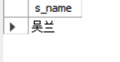

-- 50、查询下月过生日的学生

select s_name from student

where month(s_birth) = month(sysdate())+1



1.

Mysql

查看所有用户

SELECT

user

FROM

mysql.user;

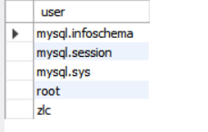

show grants for 'zlc'@'localhost' 可以查看用户权限

