Comparative Inventory Analysis of Remaining Tank Waste at the Savannah River Site and the Hanford Site
A cross-site evaluation of radiological and chemical inventories assembled from closure-basis (SRS) and Best-Basis-Inventory (Hanford) public data

October 2026

Executive Summary
The two largest inventories of legacy high-level radioactive tank waste in the United States sit at the Savannah River Site (SRS) in South Carolina and the Hanford Site in Washington. This paper compares what remains in the tanks as of the most recent public inventories: 33.2 million gallons and 191 megacuries across 51 SRS tanks (as of September 30, 2025), and 53.0 million gallons and 122.5 megacuries across 177 Hanford tanks (Best-Basis Inventory snapshots per tank, mostly effective between 2022 and 2026, decayed predominantly to January 1, 2022). SRS holds 63 percent of Hanford's volume but 156 percent of its reported activity, a 2.5-fold difference in activity density driven by salt waste chemistry: SRS supernate retains cesium-137 in solution at high concentration, while Hanford's inventory is older and its activity is more evenly split between strontium-90 in sludge and cesium-137 in saltcake and supernatant.
The two inventories are not equivalent bases. Hanford publishes a per-tank Best-Basis Inventory (BBI) with current radionuclide and chemical estimates by waste phase; SRS does not publish a per-tank current inventory, and the public per-tank data are closure residuals: conservative performance-assessment bases decayed to 2032, which represent what regulators expect to remain after bulk waste removal and cleaning. To compare the sites on a like-for-like current basis, we supplement SRS closure data with farm-level current phase totals and measured sludge-batch and salt-batch qualification data from Savannah River National Laboratory (SRNL). This mixed basis is inherent to any cross-site comparison and is quantified throughout.
The chemical contrast is the second major finding. Total non-water chemical inventory at Hanford is roughly 150,200 metric tons, dominated by sodium nitrate and nitrite and about 46,400 t of sodium. The SRS closure-residual chemical matrix (27 analytes across 51 tanks, residual-solids basis) totals about 299 t and is dominated by iron (94 t), aluminum (57 t), manganese (18 t), and 19 t of mercury. SRS chemistry reflects reprocessing with mercury-catalyzed digestion and a nitrate/nitrite working fluid; Hanford chemistry reflects bismuth-phosphate and REDOX/plutonium-uranium-extraction (PUREX) process chemistries with large sodium additions for alkaline stabilization. The SRS salt system carries about 19 t of mercury that is absent from Hanford's BBI; conversely Hanford carries about 566 t of chromium in its inventory, ten times SRS's residual-solids value, a legacy of sodium dichromate coolant additions to some single-shell tanks.
We compiled both inventories into a single SQLite database (56,700 rows across nine tables) with per-tank, per-nuclide, and per-chemical resolution, public-source provenance on every row, and released the parsed data, parse scripts, and both an interactive Streamlit dashboard and a static HTML dashboard. The database supports direct statistical comparison of the two sites and is positioned for machine-learning work on tank-waste characterization. Any quantitative risk or mission modeling that mixes the two sites must respect the closure-versus-current basis difference and the different decay dates, or results will be wrong by factors, not percentages.
1. Introduction
1.1 Two sites, two inventory problems
Defense reprocessing waste from five decades of weapons-material production is stored in large underground tanks at SRS and Hanford. The SRS F- and H-Area Tank Farms hold 51 carbon-steel tanks in four generations of design (Types I through IV), ranging from 750,000 to 1.3 million gallons, total capacity 58.6 million gallons, 8 of them operationally closed. Hanford's tank farms group 177 tanks across six farm complexes (A through U), single-shell tanks (SSTs, 149) and double-shell tanks (DSTs, 28), with capacities between 55,000 and 1.3 million gallons. Both sites must empty the tanks, convert the waste to glass or grouted waste forms, and close the farms to regulatory standards set by state agreements and, for closure, Section 3116 of the Ronald W. Reagan National Defense Authorization Act for Fiscal Year 2005.
The scale of the two problems differs by mission design, not by physics alone. SRS separates sludge (which holds most actinides and strontium) for vitrification at the Defense Waste Processing Facility (DWPF) and decontaminates salt supernate by cesium/strontium/actinide removal at the Salt Waste Processing Facility (SWPF), grouting the decontaminated effluent at Saltstone. Hanford's approach likewise splits the tank waste: high-level solids go to the Hig-Level Waste Facility (HLW) in the Waste Treatment Plant (WTP), and low-activity liquids are vitrified in the LAW (low-activity waste) facility. Much of the dissolved Cs-137 inventory in Hanford I planned to be removed through ion exchange in the Tank-side Cesium Removal (TSCR) system, or future planned AMPS units (Advanced Modular Pre-treatment System). The sites differ in how much waste remains to be processed and how much of the curie inventory each phase carries, which is exactly the kind of question a unified dataset can answer.
1.2 The Best-Basis Inventory and the SRS gap
Hanford's BBI is the site's official per-tank inventory: a point-in-time estimate of each tank's radionuclides and chemicals by waste phase, assembled by PNNL from process-knowledge models and sample data, published in the Tank Waste Information Navigator System (TWINS) and summarized in the Waste Information Data System (WIDS, HNF-EP-0182). The BBI is the working inventory for mission planning, safety basis, and regulatory reporting, and is available through the PNNL PHOENIX API for programmatic access. It carries 50 radionuclides and 140 chemicals per tank, by phase, with unit "Ci" and "kg" and data-quality qualifiers, and an effective date per tank snapshot.
SRS has no public equivalent. Savannah River tracks current tank-by-tank composition internally in the Waste Characterization System (WCS), which is not published per-tank. What SRS publishes at per-tank granularity is closure residual inventories: the performance-assessment (PA) and special-analysis (SA) tables that assign each tank a conservative residual source term, decayed to a 2032 closure horizon, after waste removal and chemical cleaning. These tables are the basis for the Section 3116 determinations and NRC consultations, and they are the only per-tank multi-analyte SRS inventories in the public record. Current SRS composition is available only at farm level (phase volumes and curies in the Liquid Waste System Plan, LWSP) and in SRNL qualification reports for processing batches (sludge batches and salt batches). The comparison in this paper therefore rests on three distinct data types: Hanford BBI per-tank current inventories, SRS per-tank closure residuals, and SRS batch qualification measurements. Section 3 describes how each was assembled and normalized.
1.3 Why a unified dataset
Tank-waste data science has matured at Hanford because the BBI exists in machine-readable form and because the site publishes unified retrieval plans and mission models against it. SRS data exists but is scattered across PA/SA tables and SRNL reports in PDF form. Assembling the SRS data into a schema mirroring the BBI (tank × phase × analyte, long format) does two things. It makes the SRS per-tank data usable for the same class of analysis, and it exposes precisely where the sites' public data models differ, which is itself a finding about the state of public tank-waste information. The companion database released with this paper (srs_tank_waste.db) normalizes 4,817 SRS radionuclide records, 1,987 SRS chemical records, 607 measured sample rows, and 46,600 Hanford BBI rows under one schema with per-row provenance.
The rest of the paper is organized as follows. Section 2 presents the comparative results: total volumes and activities, phase splits, per-farm and per-tank distributions, radionuclide and chemical composition, and measured current-waste data for SRS batches. Section 3 details the data sources and the assembly methodology, including the parsing pipeline and the normalization decisions. Section 4 discusses the basis-difference problem and its implications for cross-site work. Section 5 draws conclusions. All values in this paper are computed from the companion database unless otherwise noted.
2. Results
2.1 Site-level totals
Table 1 summarizes the two sites' remaining inventories on their own published bases. SRS reports 33.2 Mgal and 191 MCi as of September 30, 2025, from the WCS Curie and Volume Inventory Report transmitted with Liquid Waste System Plan Revision 24. Hanford's BBI, summed over the latest per-tank snapshots (effective dates between 2015 and 2026, dominated by 2022 through 2026), gives 53.0 Mgal of physical waste (excluding drained-void and retained-gas volume buckets) and 122.5 MCi decayed predominantly to January 1, 2022. On these numbers SRS holds 63 percent of Hanford's volume but 156 percent of its activity: an activity density of 5.8 MCi/Mgal versus 2.3 at Hanford.
Metric | SRS | Hanford | SRS/Hanford
Reporting basis | WCS farm totals (LWSP Rev 24) | BBI per-tank snapshots | n/a
As-of / effective dates | 2025-09-30 | 2015-10 to 2026-05 (per tank) | n/a
Decay basis | n/a (measured) | 2022-01-01 (139 tanks); 2015-07-01 (38) | n/a
Tanks with inventory | 43 active (51 total; 8 closed) | 177 | n/a
Volume, Mgal | 33.2 | 53.0 | 0.63
Activity, MCi | 191 | 122.5 | 1.56
Activity density, MCi/Mgal | 5.8 | 2.3 | 2.5
Nuclides reported | 54 (assigned closure) | 50 + aggregates | n/a
Chemicals reported | 27 (residual solids) | 140 (all phases) | n/a

Table 1. Site-level remaining inventories on each site's own published basis.
The activity-density ratio is not an artifact of the SRS closure basis. The 191 MCi figure is a measured, current farm-level total, and the closure-residual dataset (5.80 MCi total across 51 tanks) is more than an order of magnitude below it precisely because closure residuals assume waste removal succeeds. The density contrast therefore compares current SRS waste against current Hanford waste on their respective published bases. Its cause is chemical: SRS evaporated its supernate to saltcake under a chemistry that kept cesium mobile in concentrated nitrate-nitrite brine, so salt waste at SRS holds 45 percent of site activity in 91 percent of site volume. Hanford's older waste generated saltcake with the bulk of strontium-90 and a substantial fraction of cesium in sludge and solids, as shown in the phase split below.
2.2 Phase splits
Figure 1 shows the two sites' volume and activity by phase. SRS phase data come from the same WCS report: sludge 2.8 Mgal holding 106 MCi, supernate 16.4 Mgal holding 75 MCi, and saltcake 10.0 Mgal holding 10 MCi. Hanford's BBI volumes by phase (physical waste only) are supernatant 22.3 Mgal, saltcake solids plus interstitial liquid 21.3 Mgal, and sludge solids plus interstitial liquid 10.4 Mgal; the activity split is sludge 67.6 MCi, supernatant 30.2 MCi, and saltcake 24.7 MCi. SRS sludge is 8 percent of site volume but 55 percent of site activity; Hanford sludge is 20 percent of volume and 55 percent of activity. The two sites agree that sludge is the curie-dominant phase per gallon, but SRS carries nearly half its activity in mobile liquid phases (supernate plus saltcake interstitial), while Hanford keeps only a quarter of activity in its liquid phases.
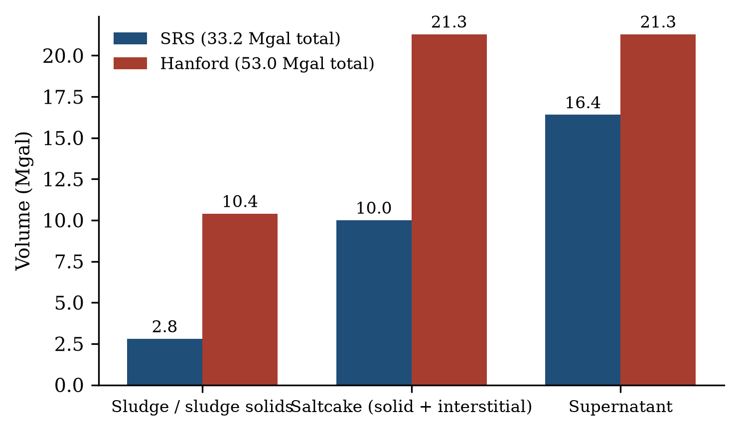
Figure 1. Remaining waste volume by phase at each site, on each site's own published basis. SRS values are WCS farm totals as of 2025-09-30; Hanford values are the sum of latest per-tank BBI volumes, excluding drained-void and retained-gas buckets.
A second-order difference is within-phase consistency. Hanford's DSTs hold mostly supernatant (27.5 Mgal across 28 tanks), and SSTs hold mostly saltcake and sludge (25.5 Mgal across 149 tanks), with activity split 69.3 MCi DST / 53.2 MCi SST. SRS has no DST/SST distinction in the same sense: all 51 tanks are single-wall but every tank sits inside a secondary containment arrangement (panned annulus for older types, double containment for Type III/IV). Hanford's 29 tanks under 50 kL of waste are effectively empty, awaiting closure or use as spare capacity; SRS's closed tanks hold assigned residuals only.
2.3 Radionuclide composition
Figure 2 compares the 12 highest-activity nuclides at each site on a log scale, and Table 2 gives the corresponding values. Because the sites report a different analyte set (SRS closure residuals list 54 nuclides; Hanford's BBI lists 50 nuclides plus aggregates like TotalAlpha), the comparison uses site totals per nuclide rather than per-tank values. Two families dominate both sites: strontium-90/yttrium-90 and cesium-137/barium-137m, each counted as a parent-plus-short-lived-daughter pair in secular equilibrium. Together the two pairs account for 97 percent of SRS current activity (Sr-90+Y-90 49 percent, Cs-137+Ba-137m 48 percent per the LWSP phase data) and 95 percent of Hanford BBI activity (Sr+Y 53 percent, Cs+Ba 42 percent).
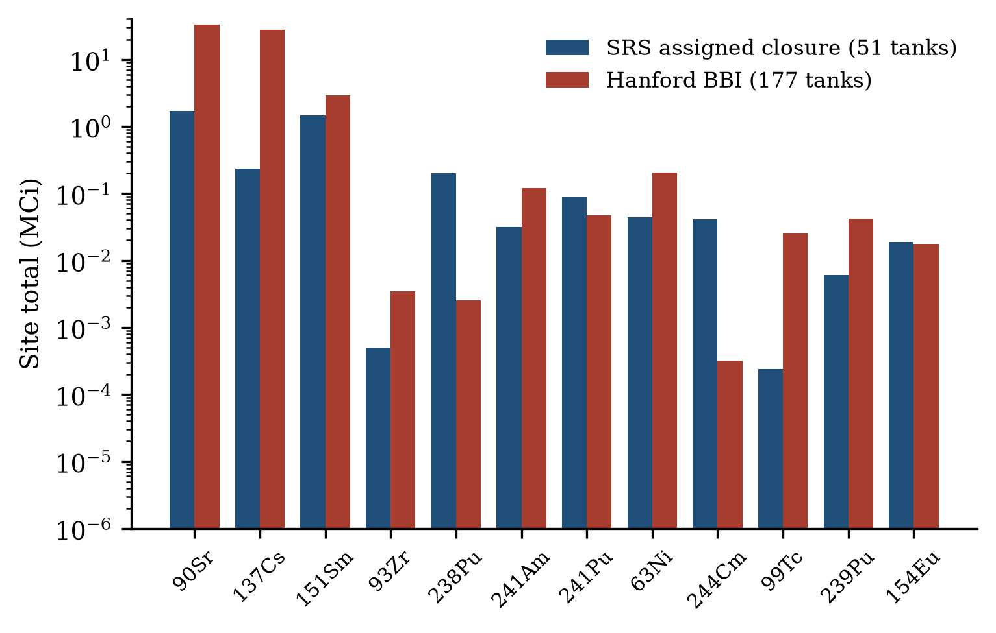
Figure 2. Site-total activity for the top 12 nuclides at each site, log scale. SRS values are assigned-closure sums across 51 tanks (residual basis, decayed to 2032); Hanford values are BBI sums across 177 tanks (current basis, decayed predominantly to 2022-01-01). Nuclides are labeled with the Hanford BBI naming convention (mass number first).
The mid-list is where the sites diverge. Samarium-151, a fission product with modest radiological hazard but a 90-year half-life, is third at SRS (1.46 MCi closure basis) and also third at Hanford (2.94 MCi), but its ratio to Sr-90 differs by a factor of 9.5 between the sites (Sm-151/Sr-90 of 0.85 at SRS versus 0.09 at Hanford), a signature of the sites' different decay ages and closure horizons. Zirconium-93 is reported by both inventories, at 497 Ci in SRS closure residuals and 3.5 kCi at Hanford, a ratio that reflects the residual-versus-current basis far more than generation. Plutonium-238 differs by two orders of magnitude: 0.20 MCi in SRS closure residuals versus 2.6 kCi in Hanford's BBI, consistent with SRS's dedicated Pu-238 production campaign for radioisotope heat sources, which has no Hanford analogue. Curium-244, americium-241, and plutonium-241 appear at both sites with SRS-to-Hanford ratios between 0.5 and 2. Technetium-99, the key long-lived mobile contaminant for both sites' performance assessments, is 25 kCi in Hanford's BBI and 239 Ci in SRS's closure-residual basis, a difference dominated by the residual-versus-current basis gap rather than by generation: SRS processes most Tc-99 into the Saltstone system.
Nuclide | SRS (Ci) | Hanford (Ci) | Note
Sr-90 (+Y-90) | 1.72E+06 (x2 = 3.44E+06) | 3.28E+07 (x2 = 6.55E+07) | secular-equilibrium pair, both sites
Cs-137 (+Ba-137m) | 2.36E+05 (x2 = 4.59E+05) | 2.76E+07 (x2 = 5.36E+07) | secular-equilibrium pair, both sites
Sm-151 | 1.46E+06 | 2.94E+06 | SRS/Sr ratio 9.5x Hanford's
Zr-93 | 4.97E+02 | 3.49E+03 | long-lived fission product
Pu-238 | 2.02E+05 | 2.56E+03 | SRS Pu-238 production mission
Pu-241 | 8.75E+04 | 4.68E+04
Ni-63 | 4.40E+04 | 2.07E+05
Cm-244 | 4.09E+04 | 3.19E+02
Am-241 | 3.19E+04 | 1.20E+05
Pu-239 | 6.00E+03 | 4.19E+04
Eu-154 | 1.87E+04 | 1.76E+04
Tc-99 | 2.39E+02 | 2.51E+04 | mobile; SRS value is residual basis

Table 2. Site-total activity for the twelve highest-inventory nuclides (Ci). SRS values are assigned-closure sums across 51 tanks, decayed to 2032; Hanford values are BBI sums across 177 tanks on latest per-tank snapshots.
Nuclide-by-phase behavior is central to mission modeling and differs sharply. At Hanford, 91 percent of Sr-90 is in sludge phases while 54 percent of Cs-137 is in supernatant; at SRS the corresponding split is carried in the farm totals: most actinides and Sr-90 concentrate in sludge (106 MCi in 2.8 Mgal) while supernate carries 75 MCi dominated by Cs-137. The practical consequence for retrieval and treatment flowsheets is opposite: Hanford's big DSTs are cesium-rich liquids awaiting ion-exchange treatment, while SRS's big volumes are already staged for SWPF processing.
2.4 Farm-level and per-tank distribution
Figure 3 plots every tank at both sites by activity and capacity or volume. The Hanford distribution is heavy-tailed: the eight hottest tanks (241-AZ-101 at 14.7 MCi, 241-AZ-102 at 6.8 MCi, 241-AP-102 at 6.7 MCi, 241-AN-106 at 5.0 MCi, 241-AY-101 at 4.9 MCi, 241-A-106 at 3.0 MCi, 241-A-105 at 2.9 MCi, and 241-AN-104 at 2.9 MCi) hold 38 percent of site activity (46.97 of 122.53 MCi) in 4.5 percent of its tanks. All eight are A-farm or AX/AP/AZ DSTs or older A-farm SSTs, a concentration that directly motivates Hanford's sequencing priorities. SRS's per-tank assigned-closure distribution is flat by comparison: 51 tanks between 119 Ci (Tank 20, a closed Type IV) and 424 kCi (Tank 6), median 141 kCi. The SRS flatness is partly an artifact of the max-of-group assignment method (Section 3.4), which deliberately removes inter-tank variation for conservative PA purposes; for the three tanks with measured residuals the assigned values reproduce the actuals to within rounding (Tanks 18 and 19: 25.1 and 8.2 kCi on both bases).
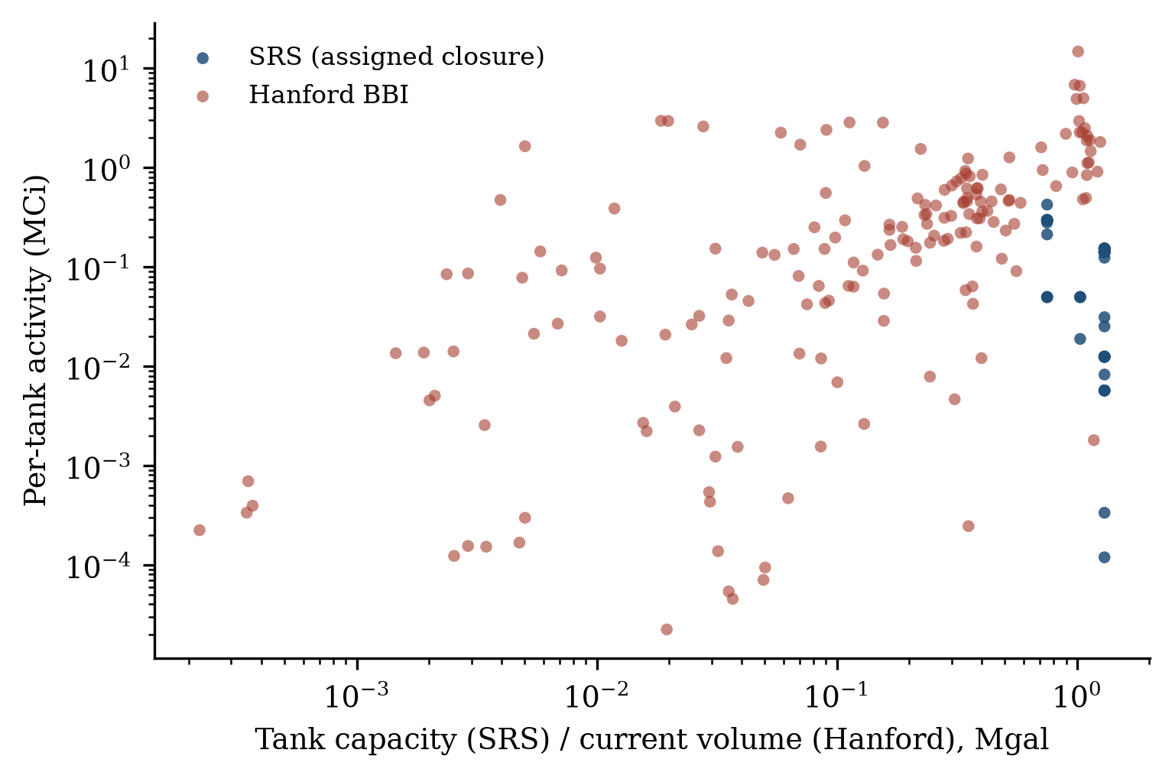
Figure 3. Every tank at both sites. Hanford points are current BBI activity against current waste volume; SRS points are assigned-closure activity against tank capacity, since SRS current per-tank volumes are not published. The axes are log-log.
Farm-level totals at Hanford are similarly concentrated: AZ farm alone (2 tanks) holds 21.6 MCi, 18 percent of the site total in 1.1 percent of its tanks; SX (15 tanks) 20.2 MCi, AN (7) 19.0, AP (8) 13.0, A (6) 9.2, AW (6) 7.9, S (12) 5.5, AY (2) 5.3, BY (12) 4.6, TX (18) 4.5, U (16) 3.8, SY (3) 2.6, AX (4) 2.0, and the B, BX, C, T, and TY farms together under 5 MCi. SRS's two farms are similar to each other on the closure basis: FTF 2.70 MCi across 22 tanks, HTF 3.11 MCi across 29 tanks, from the SA-reported totals. Farm closure sequencing at SRS (FTF first, then HTF) therefore does not follow a curie gradient but a tank-type and infrastructure logic.
2.5 Chemical composition
Figure 4 and Table 3 compare the chemical inventories. The bases differ more than for radionuclides: SRS chemical values are kg of element or anion on residual solids, while Hanford's are kg per tank across all phases including supernatant salts. The Hanford totals are therefore larger in part because they include dissolved salts. With that caveat, the contrast is stark: Hanford's non-water chemical inventory is 150,200 t, and 72 percent of it is Na, NO3, and NO2 combined (46,420 t Na, 50,066 t NO3, 11,904 t NO2), from the sodium hydroxide and nitrite additions that stabilized waste in alkaline brine. SRS's assigned residual-solids inventory is 299 t, dominated by process metals: 94 t Fe, 57 t Al, 18 t Mn, 13 t Ni, plus 19.3 t of mercury and 10.9 t of uranium.
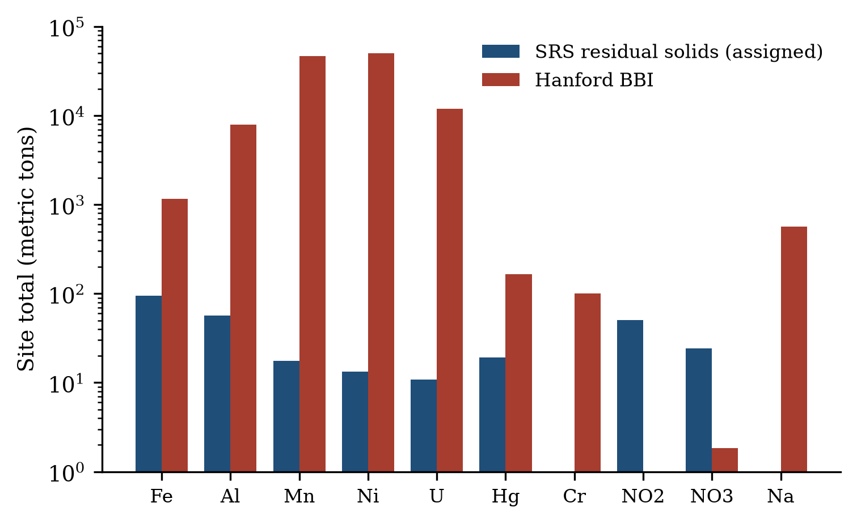
Figure 4. Site-total chemical inventories for ten comparison elements, log scale. SRS values are assigned-closure residual solids; Hanford values are BBI totals across all phases. The bases differ (Section 3.4): Hanford includes supernatant salts, SRS is residual solids after bulk removal.
Three elements carry site-specific processing signatures. Mercury (19.3 t in SRS residuals) entered SRS waste from the mercury-catalyzed deborated-zeolite. the historical use of mercury as a catalyst in the HM process dissolver; SRS mercury management (amalgamation, steam stripping in the M Area, and later collection) kept most of it out of the tank farms, and DWPF now controls it in the melter offgas. Hanford's BBI reports 1.8 t of mercury site-wide, from the same bismuth-phosphate process chemistry that also loaded B-farm. Chromium tells the opposite story: Hanford holds 566 t, largely from sodium dichromate coolant added to radiatively-cooled single-shell tanks (Yakima-area river-water-cooled tanks did not receive it), which today complicates LAW vitrification and SST corrosion-legacy decisions; SRS's residual chromium is 0.75 t. Aluminum is the largest glass-former burden shared by both sites: 7,938 t at Hanford (from REDOX and PUREX cladding-dissolution chemistry) versus 57 t in SRS residuals, though SRS aluminum is better known through DWPF's ongoing sludge-batch control of Al2O3 loading (Section 2.6).
Analyte | SRS (t) | Hanford (t) | Signature
Fe | 94.2 | 1,163 | sludge solids / cladding
Al | 56.8 | 7,938 | REDOX-PUREX cladding dissolution
Na | not reported (residual basis) | 46,420 | alkaline brine matrix
NO3 | 24.3 | 50,066 | nitrate brine
NO2 | 50.5 | 11,904 | nitrite corrosion inhibitor
Mn | 17.6 | 166
Ni | 13.3 | 100
U | 10.9 | 701 | reprocessing throughput
Hg | 19.3 | 1.8 | SRS Hg-catalyzed digestion
Cr | 0.8 | 566 | Hanford dichromate coolant
Total non-water | 299 | 150,200

Table 3. Chemical inventories for comparison analytes (metric tons). SRS values are assigned-closure residual solids; Hanford values are BBI totals across all phases including dissolved salts; the bases differ and the table is a composition-signature comparison, not a like-for-like mass balance.
2.6 Measured current waste: SRS batch data
The SRNL qualification reports give the only public per-analyte view of what is actually in SRS tanks today, at process-stream rather than tank level. Sludge Batch 11 (in Tank 51, a Type III/IIIA tank) was characterized in 2024 at 16,600 micrograms per gram Fe and 15,500 ug/g Al on a slurry basis (Table 4), with supernate at 110 g/L Na, 1.54 M free hydroxide, 89.9 g/L nitrate, and 25.8 g/L nitrite: the same nitrate-nitrite-hydroxide brine matrix that dominates Hanford's DSTs, at comparable concentration. Sludge Batch 10 radionuclides measured in Tank 40 in 2023 give the sludge-phase specific activity: 5,870 uCi/g dried solids Sr-90 (plus Y-90 in equilibrium), 403 uCi/g Cs-137, 101 uCi/g Pu-238, and 65.7 uCi/g Sm-151, with total sludge activity density near 3.7 Ci per gallon of slurry for Sr-90 alone.
Salt Batch 14, drawn from Tank 21H in 2025 for SWPF processing, measured 1.15e5 pCi/mL Tc-99, 5,380 pCi/mL Pu-241, 3,780 pCi/mL tritium, and full WAC-limit ratios: Tc-99 at 54 percent of its SWPF waste-acceptance-criteria limit, Pu-241 at 0.6 percent, and tritium at 0.7 percent of limit. These qualification measurements anchor the SRS current-waste picture that the closure tables cannot: they show a salt system deeply decontaminated in actinides (actinide concentrations four to five orders below the Cs-137 that drives SWPF decontamination), a Tc-99 stream sized for Saltstone, and a sludge system dominated by process metals at glass-former-relevant concentrations.
Measurement | Value | Unit | Source
SB11 slurry Fe | 16,600 | ug/g slurry | SRNL-STI-2024-00492
SB11 slurry Al | 15,500 | ug/g slurry | SRNL-STI-2024-00492
SB11 slurry U | 6,010 | ug/g slurry | SRNL-STI-2024-00492
SB11 slurry Hg | 4,710 | ug/g slurry | SRNL-STI-2024-00492
SB11 slurry Si | 1,190 | ug/g slurry | SRNL-STI-2024-00492
SB11 supernate Na | 110,000 | mg/L | SRNL-STI-2024-00492
SB11 supernate free OH | 1.54 | M | SRNL-STI-2024-00492
SB11 supernate NO3 | 89,900 | mg/L | SRNL-STI-2024-00492
SB11 supernate NO2 | 25,800 | mg/L | SRNL-STI-2024-00492
SB10 dried solids Sr-90 (+Y-90) | 5,870 | uCi/g dried solids | SRNL-STI-2024-00240
SB10 dried solids Cs-137 | 403 | uCi/g dried solids | SRNL-STI-2024-00240
SB10 dried solids Pu-238 | 101 | uCi/g dried solids | SRNL-STI-2024-00240
SB10 dried solids Sm-151 | 65.7 | uCi/g dried solids | SRNL-STI-2024-00240
Salt Batch 14 Tc-99 (Tank 21H) | 1.15E+05 | pCi/mL (54% of WAC) | SRNL-STI-2025-00012
Salt Batch 14 I-129 | 103 | pCi/mL (103% of WAC) | SRNL-STI-2025-00012
Salt Batch 14 Pu-241 | 5,380 | pCi/mL (0.6% of WAC) | SRNL-STI-2025-00012

Table 4. Measured SRS current-waste composition from SRNL qualification reports: Sludge Batch 11 (Tank 51, 2024) and Sludge Batch 10 radionuclides (Tank 40, 2023).
2.7 Historical trend
SRS farm-total inventories have declined from 263 MCi (32.5 Mgal) at end of 2016 to 248 MCi (35.0 Mgal) at end of 2018 to 191 MCi (33.2 Mgal) at end of September 2025, a 27 percent activity reduction in nine years while volume held roughly flat (Figure 5). The decline tracks salt-waste processing ramp: supernate activity fell from 120 to 75 MCi between 2018 and 2025 and saltcake from 12 to 10 MCi, while sludge activity fell modestly from 116 to 106 MCi as DWPF consumes sludge batches. Hanford's BBI snapshots are per-tank effective dates rather than a site-wide series, so no comparable trend series can be drawn from the BBI alone; retrieval to date has been limited to a small number of tanks and the site's remaining inventory is effectively static relative to SRS's.
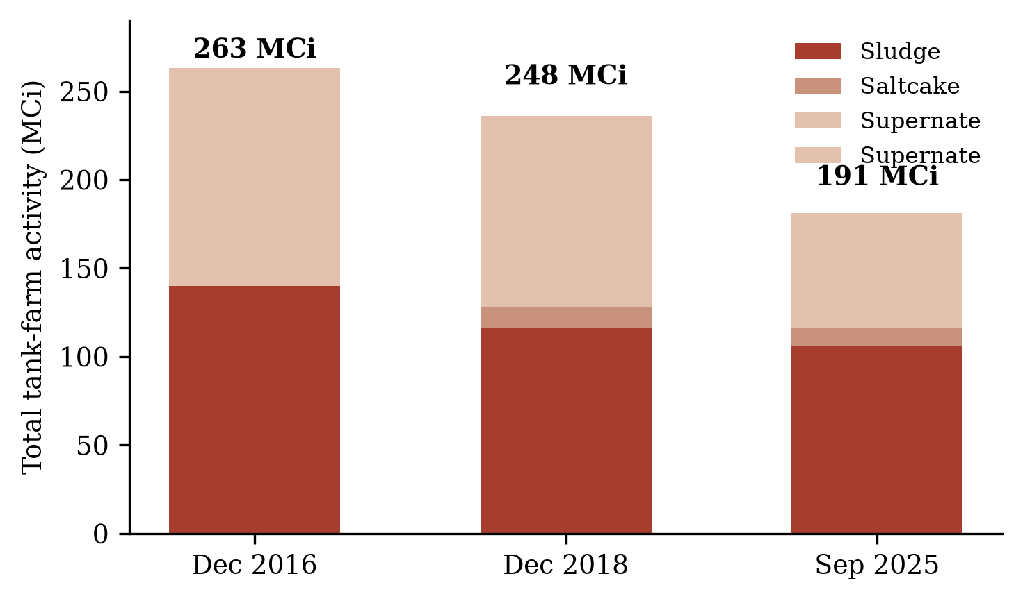
Figure 5. SRS tank-farm total activity by phase, December 2016 to September 2025, from the WCS reports in the Liquid Waste System Plan series. The 2016 salt split was not published with a supernate/saltcake breakdown; it is shown as supernate.
3. Methodology
3.1 Data sources
All data are from public documents and public APIs; no proprietary or WCS-internal data were used. The SRS side draws on twelve primary documents. Farm-level current inventories come from the SRS Liquid Waste System Plan (LWSP) Revision 24 (SRMC-LWP-2023-00001), which transmits the Waste Characterization System (WCS) Curie and Volume Inventory Report dated September 30, 2025, with historical snapshots from Revision 22 (data as of December 31, 2018) and a 2016 fact-sheet composite. Per-tank closure inventories come from the performance-assessment chain: the H-Area Tank Farm Performance Assessment Rev 1 (SRR-CWDA-2010-00128, Tables 3.4-9 and 3.4-10, the original per-tank basis), the Tank 16 Special Analysis for the HTF PA (SRR-CWDA-2014-00106, Tables 6.2-2 through 6.2-5, the currently controlling assigned basis for all 29 HTF tanks), the Tanks 5 and 6 Special Analysis for the FTF PA Rev 1 (SRR-CWDA-2012-00106, Tables 6.1-1 and 6.1-2, the revised basis for all 22 FTF tanks), and the Tanks 18 and 19 Special Analysis plus Closure Module (SRR-CWDA-2010-00106 and SRR-CWDA-2010-00003) for measured actual residuals. Section 3116 basis documents for both farms (DOE/SRS-WD-2013-001 draft and DOE/SRS-WD-2012-001) provide the regulatory context. Measured current-waste composition comes from seven SRNL qualification reports (SRNL-STI-2024-00492, -2024-00240, -2024-00436, -2025-00489, -2025-00012, OSTI 2473257, and SRNL-STI-2024-00506) covering Sludge Batch 10 and 11, SWPF Salt Batches 8 through 14, and PRFT batches.
The Hanford side is the Best-Basis Inventory as served by the PNNL PHOENIX TankFarmService API (BBIWaste and BBIVolume endpoints), pulled per tank for all 177 tanks. Each tank carries its own effective date (the date its BBI snapshot was computed), ranging from 2015-10-01 to 2026-05-01 across the fleet, with the bulk of tanks on 2022 through 2026 snapshots; 139 tanks are decayed to 2022-01-01 and 38 tanks, mostly older single-shell tanks with legacy estimates, to 2015-07-01. The BBI reports 50 radionuclides in curies and 140 chemicals in kilograms per tank, split by waste phase, with data-quality qualifiers (5,558 of the 46,600 rows carry a less-than qualifier). Upstream of PHOENIX, the BBI is maintained in TWINS, and its official tabulation is the Waste Information Data System (WIDS) report HNF-EP-0182.
3.2 Parsing and assembly pipeline
The pipeline is fully scripted and reproducible from the repository. PDF text extraction (pdftotext layout-preserving mode) feeds hand-verified table parsers for each document's table format. The PA and SA tables are wide-format matrices (nuclide or chemical rows, tank columns) and are parsed positionally: each row is split into exactly as many value cells as the table has tank columns, with not-determined (ND) and not-established (NE) tokens retained as cells rather than skipped, because skipping them shifts every subsequent value one column to the left. The SRNL batch reports use several distinct table layouts (element tables, anion tables, radionuclide tables with dual units, waste-acceptance-criteria tables); a dedicated parser handles each layout and records the unit, matrix (slurry, supernate, filtrate, dried solids), and report provenance on every row. Hanford data required no parsing: the API returns structured JSON that loads directly into the database.
Every row in the database carries a dataset label, a basis description, and a source pointer into a document registry, so that current, assigned-closure, PA-original, annulus, and measured-actual bases can be selected or excluded explicitly in any query. The database schema mirrors the BBI's tank, analyte, phase, value, unit structure so cross-site queries stay symmetric.
3.3 Normalization decisions
Four decisions matter for anyone reusing the data. First, volumes: Hanford BBI volume rows include drained-void and retained-gas buckets (9,539 kL across 39 rows at the latest snapshots) that are not physical waste; these are excluded from all volume totals here, which is why the site total is 53.0 Mgal rather than the 55.5 Mgal a naive sum gives. Second, aggregates: the BBI includes combined-analyte rows (239/240Pu, 243/244Cm, 144Ce/Pr) and gross measures (TotalAlpha); these are excluded from radionuclide sums to avoid double counting, which changes the Hanford activity total by less than 0.05 percent. Third, daughter products: both sites count Y-90 with Sr-90 and Ba-137m with Cs-137; the comparisons in this paper keep those pairs together and treat them as single inventory families. Fourth, per-tank snapshots: Hanford BBI rows are summed per tank on each tank's own latest effective date; no single site-wide snapshot date exists, and pretending otherwise would drop tanks whose latest revision post-dates the chosen date.
3.4 The assigned-closure basis and its conservatisms
The SRS assigned-closure values deserve their own description because they are the SRS public data most similar to a per-tank inventory, and they are conservative in specific, documented ways. The HTF assignment (Tank 16 SA Table 6.2-2) groups the 29 tanks into waste-type groups and assigns every tank in a group the maximum inventory estimated for any tank in that group: all seven Type I and II tanks (9 through 15, minus 16) receive identical 49.6 kCi totals, and the 16 Type III/IIIA tanks (29 through 51, minus 32 and 36) all receive identical values. This is deliberate: performance assessment needs a defensible upper bound for tanks that will not be individually characterized at closure. The FTF revision (Tanks 5 and 6 SA Table 6.1-1) instead carries per-tank projected values for operating tanks and measured actuals for the closed tanks. The assignment basis decays all values to 2032, the assumed closure horizon. For the two tanks where both bases exist, the agreement is exact: Tanks 18 and 19 carry 25.1 and 8.2 kCi on both the assigned and measured-actual bases. Chemical assignments mirror the radionuclide tables with the same grouping.
One parsing defect found and fixed during this work illustrates why the validation discipline matters. In the original parse of FTF Table 6.1-1, ND tokens in a row were skipped rather than counted as cells, shifting values leftward for tanks 17 through 20; on the Zr-93 row the parser then consumed a value from the table's total row, assigning 290 kCi of Zr-93 to Tanks 19 and 20 and inflating those tanks' totals by factors of 36 and 2,400 respectively, and the all-51-tank closure total from 5.80 to 6.38 MCi. The re-parse treats ND and NE as real cells and validates every tank's nuclide sum against the source table's own Total Curies by Tank row (22 of 22 tanks match within the table's two-significant-figure rounding). The corrected values reproduce the measured actuals for Tanks 18 and 19 exactly, which the corrupted values did not. All numbers in this paper are computed from the corrected dataset.
3.5 Validation summary
Validation rests on internal consistency checks and cross-document agreement. Internal: per-tank nuclide sums reproduce each source table's printed totals for all 22 FTF tanks (within two-significant-figure rounding) and the HTF grouped assignments are internally consistent with the SA's reported farm totals (HTF 3.11 MCi, FTF 2.70 MCi). Cross-document: Tanks 18 and 19 residuals agree between the Special Analysis and the Closure Module; Tank 16 actual residuals (18.8 kCi) match between its SA Tables 5.0-1 and the assigned table; HTF assigned values match the earlier PA Rev 1 Table 3.4-9 for tanks whose grouping did not change. Hanford totals were checked against the published BBI summary: the 122.5 MCi site total computed here from per-tank nuclide sums is consistent with the 122.6 MCi reported in the latest HNF-EP-0182 revision, the small difference being aggregate-row treatment and per-tank snapshot dates.
4. Discussion
4.1 Basis asymmetry and what it permits
The central limitation of any SRS-Hanford comparison is that the public data models are not the same object. Hanford's BBI is a current inventory: what is in each tank now, by phase, maintained for operations. The SRS per-tank public data are closure residuals: what regulators assume will remain after the tanks are emptied and cleaned. Comparing them directly mixes a snapshot with a forecast, and the direction of the resulting error is predictable: it always understates SRS. The SRS current farm total is 191 MCi; the assigned-closure total is 5.80 MCi, a 33-fold difference. Any figure that mixes the two will be wrong by an order of magnitude or more.
The comparison is still tractable if each question is mapped to the basis that can answer it. Current-versus-current questions (how much waste is left, how hot is it per gallon, which phases hold the activity) use the SRS farm totals against Hanford BBI sums, and accept that SRS answers are farm-level only. Closure-versus-closure questions (what will remain after cleanup) use the SRS assigned residuals against a Hanford residual estimate, though Hanford publishes no per-tank closure residual, so this direction of comparison is actually the harder one and the SRS data are the richer public source. Composition questions (what is the waste made of) use the SRNL batch measurements for SRS and the BBI chemicals for Hanford, accepting that one is a process-stream view and the other a tank-average view. Machine-learning work that ignores this mapping will learn the basis differences, not the waste differences.
4.2 Why the activity densities differ
The 2.5-fold activity-density difference (5.8 versus 2.3 MCi/Mgal) has three identifiable drivers. First, decay: Hanford's waste is older. The bulk of Hanford's curies were generated in the 1950s through 1970s and the BBI decays most tanks to 2022; SRS reprocessed fuel through the late 1980s and its inventory is correspondingly younger per curie of Cs-137 and Sr-90. But decay alone cannot produce a factor of 2.5 in 10 to 30 years for 30-year half-lives; the larger drivers are structural. Second, cesium management: SRS evaporated supernate to saltcake and kept the cesium in the tank system, with the salt phase carrying 45 percent of site activity in 91 percent of volume; Hanford's cesium left the tank system in ways SRS's did not, through documented single-shell tank leaks and the B-Plant cesium-recovery campaigns of the 1970s, leaving proportionally less cesium per remaining gallon. Third, strontium partitioning: Hanford's sludge fraction is larger and holds 91 percent of its Sr-90, while SRS's sludge volume is small (8 percent) so its Sr-90 concentrates in fewer gallons; per-gallon sludge activities at the two sites are actually similar (SRS Sludge Batch 10 measures 5,870 uCi/g dried solids Sr-90), and the density difference comes mostly from how much sludge each site retains per gallon of total waste.
A practical implication follows for vitrification planning. The waste that dominates SRS's remaining mission is a well-characterized, high-cesium brine and saltcake stream that the site already knows how to decontaminate (SWPF) and grout (Saltstone). The waste that dominates Hanford's remaining mission is a strontium- and actinide-bearing sludge inventory spread across 149 aging single-shell tanks plus 28 DSTs whose supernatants await treatment. The sites' feed-composition problems differ accordingly: SRS's binding constraints are mercury control in DWPF offgas and I-129 and Tc-99 management in the salt system, while Hanford's are aluminum dissolution, chromium in LAW glass, and the sheer tank count for retrieval.
4.3 What the batch measurements add
The SRNL qualification data are the only public SRS numbers that measure current waste composition analyte by analyte, and they carry three observations that neither the closure tables nor the farm totals provide. First, the SRS sludge system is a stable, well-mixed composition: Sludge Batch 11 elementals (16,600 ug/g Fe, 15,500 ug/g Al, 6,010 ug/g U, 4,710 ug/g Hg) are consistent batch to batch, meaning DWPF glass models can be trained on a tight composition manifold rather than a wide one. Second, the SRS salt system is running close to its WAC envelope on the long-lived mobile nuclides: Salt Batch 14 measured 1.15e5 pCi/mL Tc-99 (54 percent of WAC) and 103 pCi/mL I-129, slightly above the 100 pCi/mL limit, and SRNL notes batches 11 and 12 also exceeded the I-129 limit; this is a live process-control signal, not a hypothetical. Third, actinide decontamination in the salt path is deep: batch Pu-241 at 0.6 percent of WAC and Cm-244 at 0.02 percent, confirming that the SWPF decontamination factor keeps the grout feed actinides far below regulatory concern and that the salt system's radiological risk is concentrated in Cs-137, Tc-99, and I-129.
4.4 Data-model implications for machine learning
For ML work the two datasets have complementary strengths. The Hanford BBI is dense and current (177 tanks, 50 nuclides, 140 chemicals, phase-resolved) but has no closure-residual analogue, so models trained on it learn operational-state features. The SRS closure matrix is smaller (51 tanks, 54 nuclides, 27 chemicals) but is the only public dataset with a full per-tank closure-residual field, and it comes with ground truth for three tanks (the measured actuals), which is exactly the held-out-validation structure an ML pipeline needs: train on assigned values, validate against measured residuals. The batch-qualification table (607 rows, 14 samples, analyte-by-matrix) provides the measured-composition anchor for the SRS side. A concrete workflow that respects the bases: predict closure residuals from tank attributes using the SRS matrix; predict current phase compositions from BBI features on the Hanford side; and use the SRNL measurements as the transfer-learning bridge between SRS closure chemistry and current chemistry, since the same analytes (Fe, Al, Hg, U, NO3, NO2) appear in both.
Two cautions from this assembly effort itself. The ND left-shift defect inflated SRS closure totals by 10 percent and would have produced a confidently wrong paper had validation against the source tables' own totals not caught it; any pipeline consuming wide-format PDF tables should assert row sums against printed totals as a matter of course. And the Hanford BBI's per-tank effective dates mean site-level aggregates are sums of snapshots, not a snapshot of sums; analyses sensitive to time (decay, retrieval progress) must carry the per-tank date vector, which the database retains on every row.
5. Conclusions
This paper assembled a unified, per-analyte database of the two largest remaining U.S. tank-waste inventories and used it to compare the Savannah River and Hanford tank farms on a like-for-like basis where one exists and on documented bases where it does not. The findings: SRS holds 33.2 Mgal and 191 MCi (September 2025), 63 percent of Hanford's 53.0 Mgal but 156 percent of its 122.5 MCi, a 2.5-fold activity-density gap driven by cesium retention in SRS salt waste, Hanford's older decayed inventory, and strontium partitioning into Hanford's larger sludge fraction. Sludge holds 55 percent of activity at both sites, but SRS carries nearly half its activity in mobile liquid phases against Hanford's quarter. Hanford's inventory is heavy-tailed (eight tanks hold 38 percent of activity) while SRS's assigned-closure distribution is deliberately flat. Chemically, Hanford is a 150,200-tonne sodium-nitrate-nitrite system with a 566 t chromium legacy; SRS's residual solids total 299 t dominated by Fe, Al, Hg, and U, and its live process risks are mercury in DWPF offgas and I-129 and Tc-99 near SWPF waste-acceptance limits.
The methodological finding is as important as the numeric one. The public data models of the two sites are structurally different: Hanford publishes a current per-tank Best-Basis Inventory, SRS publishes conservative closure residuals per tank plus farm-level current totals plus batch qualification measurements. A cross-site dataset that does not encode that difference, with dataset labels, basis descriptions, and per-row provenance, will silently mix bases and produce errors measured in orders of magnitude. The database released with this paper encodes the basis on every row, includes the validation record (22 of 22 FTF tanks reproduce their source-table totals; Tanks 18 and 19 assigned values equal their measured actuals), and exposes the SRS closure matrix with three-tank ground truth as the only public per-tank closure-residual dataset suitable for held-out validation of inventory-prediction models. The two inventories, read carefully, are complementary rather than parallel: one site's public data describe where it is going, and the other's describe where it must not end up.
References
[1] Savannah River Mission Completion, SRS Liquid Waste System Plan, Revision 24, SRMC-LWP-2023-00001, January 2026. (Farm-level WCS inventory data as of 2025-09-30.)
[2] Savannah River Remediation, SRS Liquid Waste System Plan, Revision 22, SRR-LWP-2009-00001, 2019. (Data as of 2018-12-31.)
[3] Savannah River Remediation, Tank 16 Special Analysis for the H-Area Tank Farm Performance Assessment, Revision 1, SRR-CWDA-2014-00106, 2015. (Assigned closure inventories, Tables 6.2-2 through 6.2-5; Tank 16 actuals, Tables 5.0-1 through 5.0-3.)
[4] Savannah River Remediation, Tanks 5 and 6 Special Analysis for the F-Area Tank Farm Performance Assessment, Revision 1, SRR-CWDA-2012-00106, January 2013. (Revised FTF inventories, Tables 6.1-1 and 6.1-2.)
[5] Savannah River Remediation, Special Analysis for Tanks 18 and 19, SRR-CWDA-2010-00106, 2011. (Measured residual inventories, Tables 5.0-1 and 5.0-2.)
[6] Savannah River Remediation, Industrial Wastewater Closure Module for Tanks 18 and 19, Revision 1, SRR-CWDA-2010-00003, 2011. (Tables 4.3-3 and 4.3-4.)
[7] U.S. Department of Energy Savannah River Operations Office, Basis for Section 3116 Determination for Closure of H-Tank Farm, DOE/SRS-WD-2013-001, Rev. 0 draft, 2013.
[8] U.S. Department of Energy Savannah River Operations Office, Basis for Section 3116 Determination for Closure of F-Tank Farm, DOE/SRS-WD-2012-001, Rev. 0, 2012.
[9] Savannah River Remediation, Performance Assessment for the H-Area Tank Farm at the Savannah River Site, Revision 1, SRR-CWDA-2010-00128, 2012. (Original per-tank closure inventories, Tables 3.4-9 and 3.4-10.)
[10] Savannah River Site, SRS High Level Waste Tank Facts, fact sheet with farm composite inventory as of 2016-12-31, 2017.
[11] Savannah River Nuclear Solutions, Operational Closure of Radioactive Liquid Waste Tanks, fact sheet on tank closure history, 2020.
[12] Ostwald, J. et al., Waste Tank Historical Review, OSTI 2549244, 2024. (Layered saltcake and sludge histories for Tanks 14H, 26F, 28F, and 44F.)
[13] Savannah River National Laboratory, Tank 51H Sludge Batch 11 Qualification Sample Characterization, SRNL-STI-2024-00492, 2024.
[14] Savannah River National Laboratory, DWPF Sludge Batch 10 Radionuclide Determination, SRNL-STI-2024-00240, 2024. (Tank 40 sample.)
[15] Savannah River National Laboratory, SWPF Salt Batch 8 and 9 Qualification Summary, SRNL-STI-2024-00436, 2024.
[16] Savannah River National Laboratory, SWPF Salt Batches 10 through 13 Qualification Summary, SRNL-STI-2025-00489, 2025.
[17] Savannah River National Laboratory, Salt Batch 14 Qualification Sample Analytical Results, SRNL-STI-2025-00012, 2025. (Tank 21H.)
[18] Savannah River National Laboratory, PRFT Batches 15, 22, and 26 Slurry and Solids Characterization, OSTI 2473257, 2025.
[19] Savannah River National Laboratory, Tank 38 Washed and Dried Solids Chemical and Radionuclide Analyses, SRNL-STI-2024-00506, 2024.
[20] Pacific Northwest National Laboratory, Tank Waste Information Navigator System (TWINS) and the Best-Basis Inventory, as served by the PNNL PHOENIX TankFarmService API (BBIWaste, BBIVolume), accessed October 2026. Per-tank effective dates 2015 through 2026; decay dates 2022-01-01 and 2015-07-01.
[21] Hanford Site, Waste Information Data System (WIDS) Tank Waste Information Network, Tank Farm Waste Inventory Report, HNF-EP-0182, latest revision. (Official tabulation of the Hanford BBI.)
[22] National Defense Authorization Act for Fiscal Year 2005, Section 3116, Ronald W. Reagan National Defense Authorization Act, Pub. L. 108-375, 2004. (Statutory basis for tank-farm closure determinations in South Carolina and Idaho.)

