Machine-Led Analog Search Across the Hanford and Savannah River Tank Farms: An Unsupervised Taxonomy of Tank Waste Compositions
How a cluster model built from Hanford Best-Basis inventories screens Savannah River current waste for Hanford analogs: results, mathematics, and interpretation
October 2026

Executive Summary
This paper documents an unsupervised-learning analysis that organizes the remaining high-level radioactive tank waste at the Hanford Site into data-driven families, and then asks a single practical question for each current Savannah River Site (SRS) waste stream: does anything like this already exist at Hanford, and how close is the nearest match? The model was built from 433 Hanford tank-by-phase compositions in the Best-Basis Inventory (BBI), expressed in three separate feature spaces: 25 sludge-deposition elements, 15 salt-cage anions and cations, and 41 radionuclides. No labels, no site tags, and no processing history were supplied to the algorithm; the structure was learned from composition alone using Ward hierarchical clustering, with KMeans, HDBSCAN, and UMAP used for model selection, anomaly flagging, and visualization. Seventeen measured SRS samples from Savannah River National Laboratory (SRNL) qualification reports (sludge batches, post-retrieval filter follows, and Salt Waste Processing Facility salt batches) plus 51 SRS closure-residual vectors were then projected into the Hanford-fitted taxonomy.
The screening outcome is concrete. Every projected SRS current-waste stream lands near a real Hanford composition, and the nearest-analog distances span 1.4 to 11.4 in shared-support Aitchison distance, a scale where 1 to 3 is typical of two Hanford tanks from the same cluster. In radionuclide space, SWPF salt batches 10 through 13 find Hanford supernatant analogs at distances of 2.6 to 3.4 (with 3 to 9 shared nuclides), comfortably inside Hanford's own same-cluster neighbor spread (median 3.1, 90th percentile 8.9): these are genuine compositional analogs. Salt batches 8 and 9 sit farther out (5.4 to 6.7, but with 19 shared nuclides supporting the comparison), and post-retrieval filter-follow sludges (PRFT batches 15, 22, 26) have no real Hanford analog in element space, driven by monosodium titanate at 12,200 to 16,225 micrograms per gram of dried solids, an engineered sorbent that no Hanford tank contains. Tank 40 Sludge Batch 10 slurry cannot be projected into the element space at all because its report omits every one of the 25 panel elements.
The model quality numbers are deliberately modest and should shape how the results are used. Best silhouette scores run 0.19 to 0.29 across the three panels, Ward-versus-KMeans adjusted Rand indices run 0.71 to 0.79, and cophenetic correlations run 0.59 to 0.68. In other words: cluster boundaries are fuzzy, the hierarchy is only moderately tree-like, and individual assignments should never be treated as ground truth. The taxonomy's value is as a screening and ranking instrument: it turns the question 'is there a Hanford analog?' into a ranked list with explicit distances, support sizes, and cluster contexts, which a subject-matter expert can then verify analytically. It is a hypothesis generator and a coverage map, not an oracle.
One result doubles as a data-basis audit. All 51 SRS closure-residual compositions, the conservative per-tank source terms decayed to a 2032 horizon that SRS publishes, land at or beyond the 95th percentile of their assigned Hanford clusters in both the element and radionuclide panels (and cannot be projected into the salt panel at all, because the closure basis does not report the salt anion suite). That is a quantitative confirmation of what the companion white paper argued qualitatively: closure residuals are compositionally unlike current tank contents, and mixing the two bases will corrupt any cross-site comparison. The unsupervised model detects the basis difference on its own, with no site labels, which is exactly the behavior one wants from an audit instrument.
Section 2 presents the taxonomy and all cross-site projections. Section 3 explains the mathematics (compositional data, the centered log-ratio transform, the Aitchison geometry, and the neutral-point treatment of below-detection values) in enough depth to interpret the distances. Section 4 details the full method. Section 5 converts the results into usage guidance: how to read a projection, when to trust an analog, and how to run the same screen for future SRS batches. Section 6 is a caveat ledger. The accompanying dashboard (dashboard/unsupervised_app.py) exposes every number in this paper interactively.
1. Introduction
1.1 The analog question
Hanford has spent two decades characterizing its 177 tanks: the Best-Basis Inventory assigns every tank a current, best-estimate composition by waste phase, and the site's process history (bismuth phosphate, REDOX, PUREX, and the scavenging and washing campaigns that followed) is documented tank by tank. SRS has 51 tanks, a shorter and more homogeneous reprocessing history, and a current-waste characterization program that reports measured compositions only for processing batches: sludge batches qualified for the Defense Waste Processing Facility, post-retrieval filter follows, and salt batches qualified for the Salt Waste Processing Facility. When SRS engineers ask 'has anyone processed waste like this?', the natural reference library is Hanford's, and until now the lookup had to be done by hand, from memory, or not at all.
This paper builds that lookup as an explicit statistical object. The idea is to let the compositions organize themselves into families (a taxonomy), to place every Hanford tank-phase in that taxonomy, and then to drop each SRS stream into the same space and report: which family it joins, how far it sits from that family's center, whether its distance is unusual by Hanford standards, and which specific Hanford tank-phases are its nearest neighbors. Nothing in the pipeline knows which site a composition came from during taxonomy construction; SRS material only enters afterward as transformed coordinates. The structure is therefore Hanford's own, and every SRS placement is a measurement against it.
1.2 Why unsupervised
No training labels exist for the question being asked. Nobody has published a curated set of 'equivalent waste streams' across the two sites, and any such set would embed someone's judgment about what equivalence means. Unsupervised learning sidesteps the problem: the model finds structure in the Hanford data alone, and equivalence is then measured as distance in a defined geometry rather than asserted. This also keeps the audit property: if the model had access to site labels, its clusters could quietly encode the labels rather than chemistry. The price is interpretive care, and Section 5 is devoted to it: an unsupervised placement is evidence about compositional similarity, not about processability, safety, or treatability, all of which depend on properties (rheology, organic content, heat load per unit volume, particle size) that no public dataset carries at tank resolution.
The analysis is a companion to the site-comparison white paper released with the same database, which compared total inventories, phase splits, and activity densities. Where that paper asked 'how much waste does each site hold', this one asks 'what kinds of waste exist, and where does each SRS stream sit among them'. The two questions share the assembled database (56,700 rows across nine tables, including 46,600 Hanford BBI rows and 607 measured SRS sample rows) but almost nothing else: the present work is per-composition, multi-space, and geometric.
2. Results
2.1 The Hanford taxonomy: three panels, three structures
The model was fitted separately in three feature spaces (panels), because sludge deposition chemistry, salt-cage chemistry, and radionuclide inventory answer different questions and are reported by different subsets of tanks. The sludge-elements panel uses 158 Hanford points (the tank-phases that report the element suite) over 25 elements retained by a presence filter; the salt panel uses 258 points over 15 species; the radionuclide panel uses 415 points over 41 nuclides. Points reporting fewer than two panel features are excluded from that panel (17 in salt, 18 in radionuclides). Figure 1 shows the fitted UMAP projections with every SRS sample placed on top; Figure 2 gives the mean composition of each cluster.
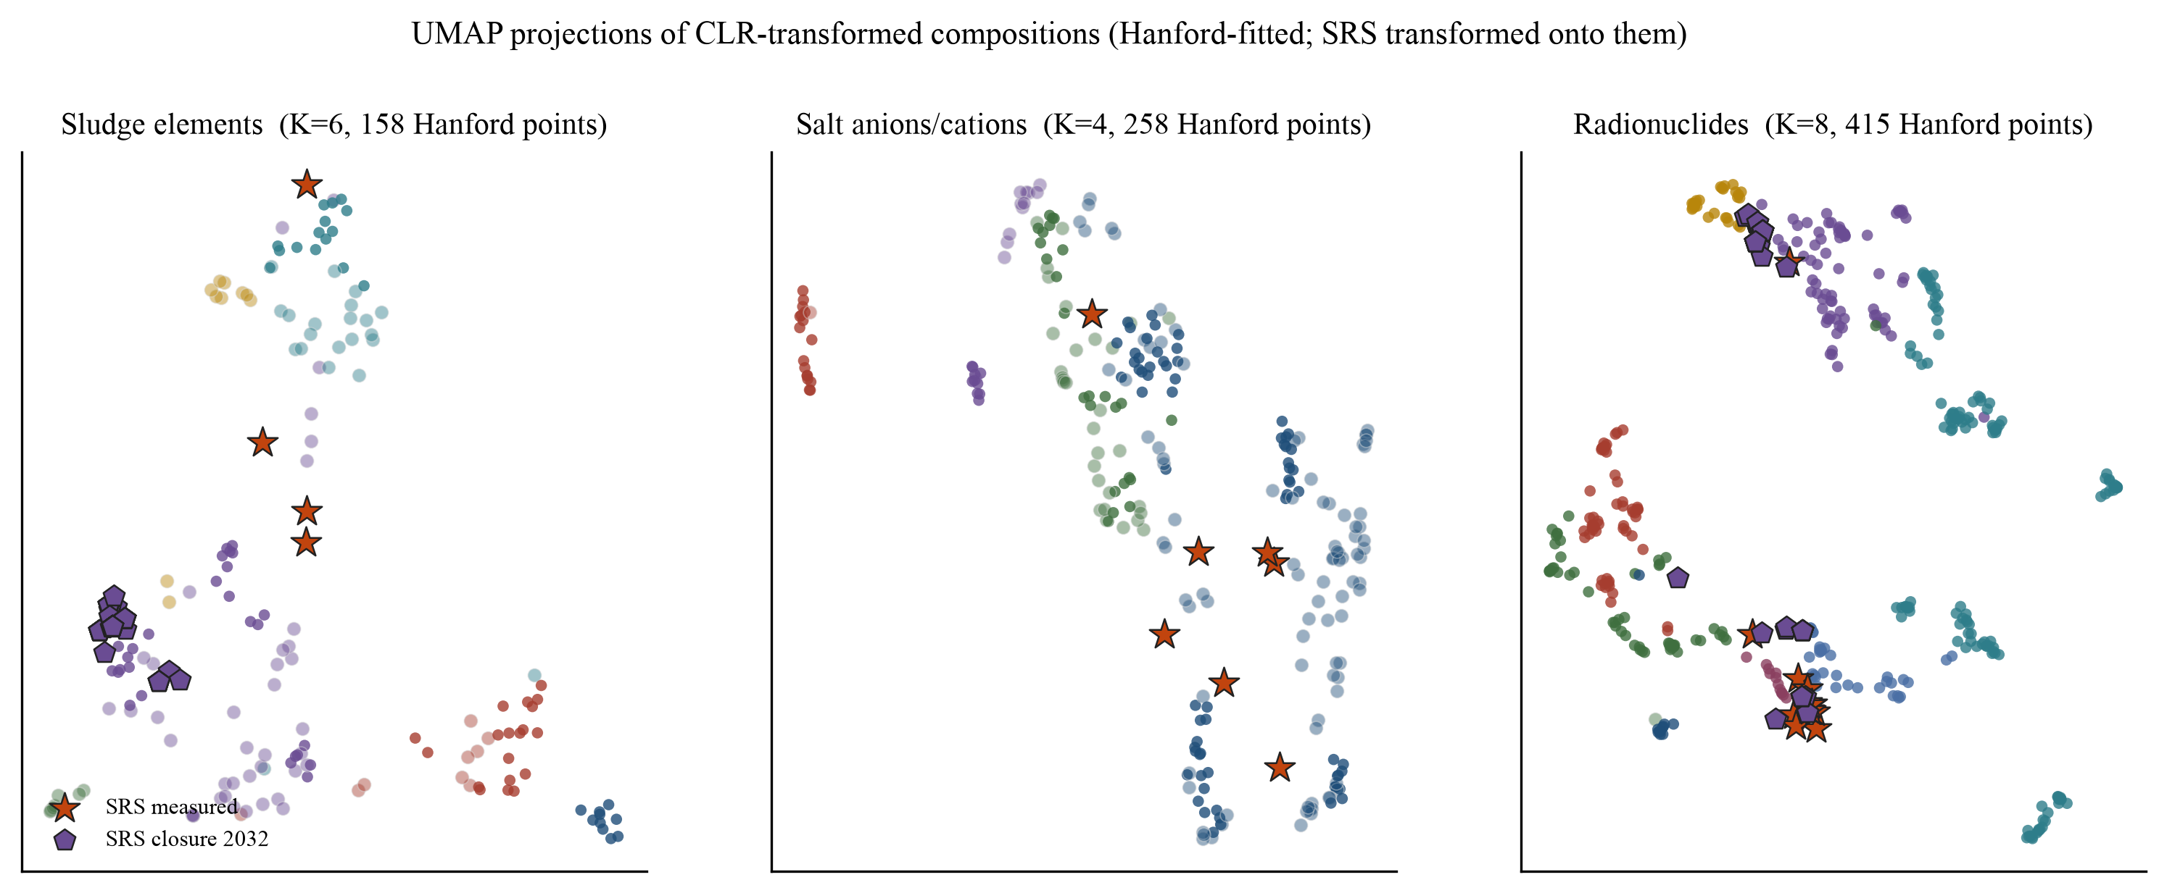
Figure 1. UMAP projections of the CLR-transformed Hanford compositions (small circles, colored by Ward cluster), with SRS measured samples (stars) and closure residuals (pentagons) transformed onto the Hanford-fitted embeddings. HDBSCAN outlier-score rings appear around high-scoring points. Left: sludge elements (K=6). Center: salt species (K=4). Right: radionuclides (K=8).
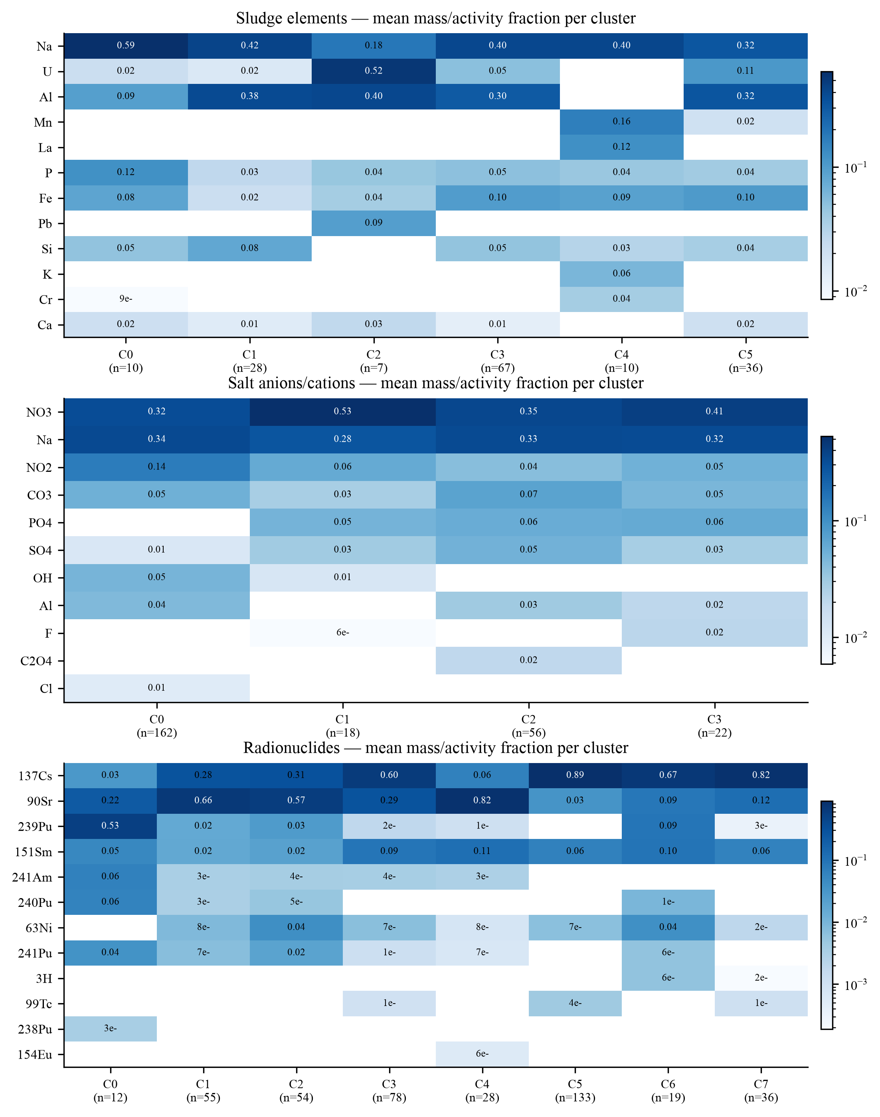
Figure 2. Mean closed mass (or activity) fraction of the twelve most discriminant features per cluster, in each panel. Cell values are fractions on the closed composition (rows sum approximately to 1 across all features, not just those shown).
The three structures are chemically legible. In the sludge panel, Ward's six clusters separate a sodium-phosphate group (C0), an aluminum-rich group with high silicon (C1), a small uranium-lead group (C2, n=7), a large general Na-Al-Fe group (C3, n=67), a manganese-lanthanum group (C4, n=10) that reads as decontamination chemical waste, and a mixed Al-U-Fe group (C5, n=36). The radionuclide panel (K=8) resolves along the activity-partition axis the raw data already showed: from a plutonium-dominant cluster (C0, 239Pu mean activity fraction 0.53), through strontium-dominant (C1, C4) and balanced Sr/Cs clusters (C2), to cesium-dominant supernatant clusters (C3, C5, C7), with one small mixed Cs-Pu cluster (C6, n=19) whose members carry residual plutonium on top of a cesium-dominated background. The salt panel (K=4) separates nitrate/nitrite supernate (C0, n=162) from nitrate-rich (C1), carbonate/phosphate/sulfate-bearing (C2), and phosphate-bearing (C3) variants. These are families of composition, not official waste types; their boundaries are model artifacts of real chemical continua, and Section 3 explains why the continua are inherent.
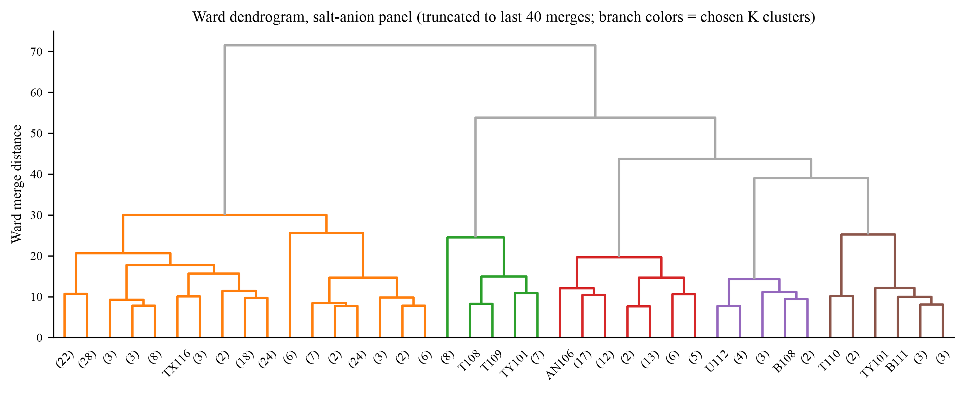
Figure 3. Ward dendrogram for the salt panel, truncated to the last 40 merges, colored by the four selected clusters. The low cophenetic correlation (0.59) warns that this tree is a compression of a blobby space, not a genealogy.
Model-selection evidence for the chosen K values is summarized in Table 1. The silhouette curve (Figure 4) is nearly flat between k=4 and k=9 in every panel; the chosen K maximizes silhouette within the interpretable window, but the honest statement is that Hanford waste is a continuum with a few dense islands, and any K in that window is defensible. Ward and KMeans agree substantially (adjusted Rand index 0.71 to 0.79), which is the internal consistency check that matters most for downstream use: the partition is not an artifact of one algorithm's link function.
Panel | Points | Features | K | Silhouette | ARI | Coph | HDBSCAN | Noise | Coverage (HF/SRS)
Sludge elements | 158 | 25 | 6 | 0.25 | 0.79 | 0.68 | 7 clusters | 73 | 0.62 / 0.37
Salt species | 258 | 15 | 4 | 0.29 | 0.75 | 0.59 | 7 clusters | 123 | 0.93 / 0.77
Radionuclides | 415 | 41 | 8 | 0.19 | 0.71 | 0.61 | 4 clusters | 153 | 0.60 / 0.25

Table 1. Model quality per panel. K = chosen Ward cluster count (largest KMeans silhouette within k = 4-9); ARI = adjusted Rand index, Ward vs KMeans at K; coph = cophenetic correlation of the Ward tree; HDBSCAN columns report its own partition and noise count (not used downstream). Coverage = mean fraction of panel features reported, Hanford / SRS measured.
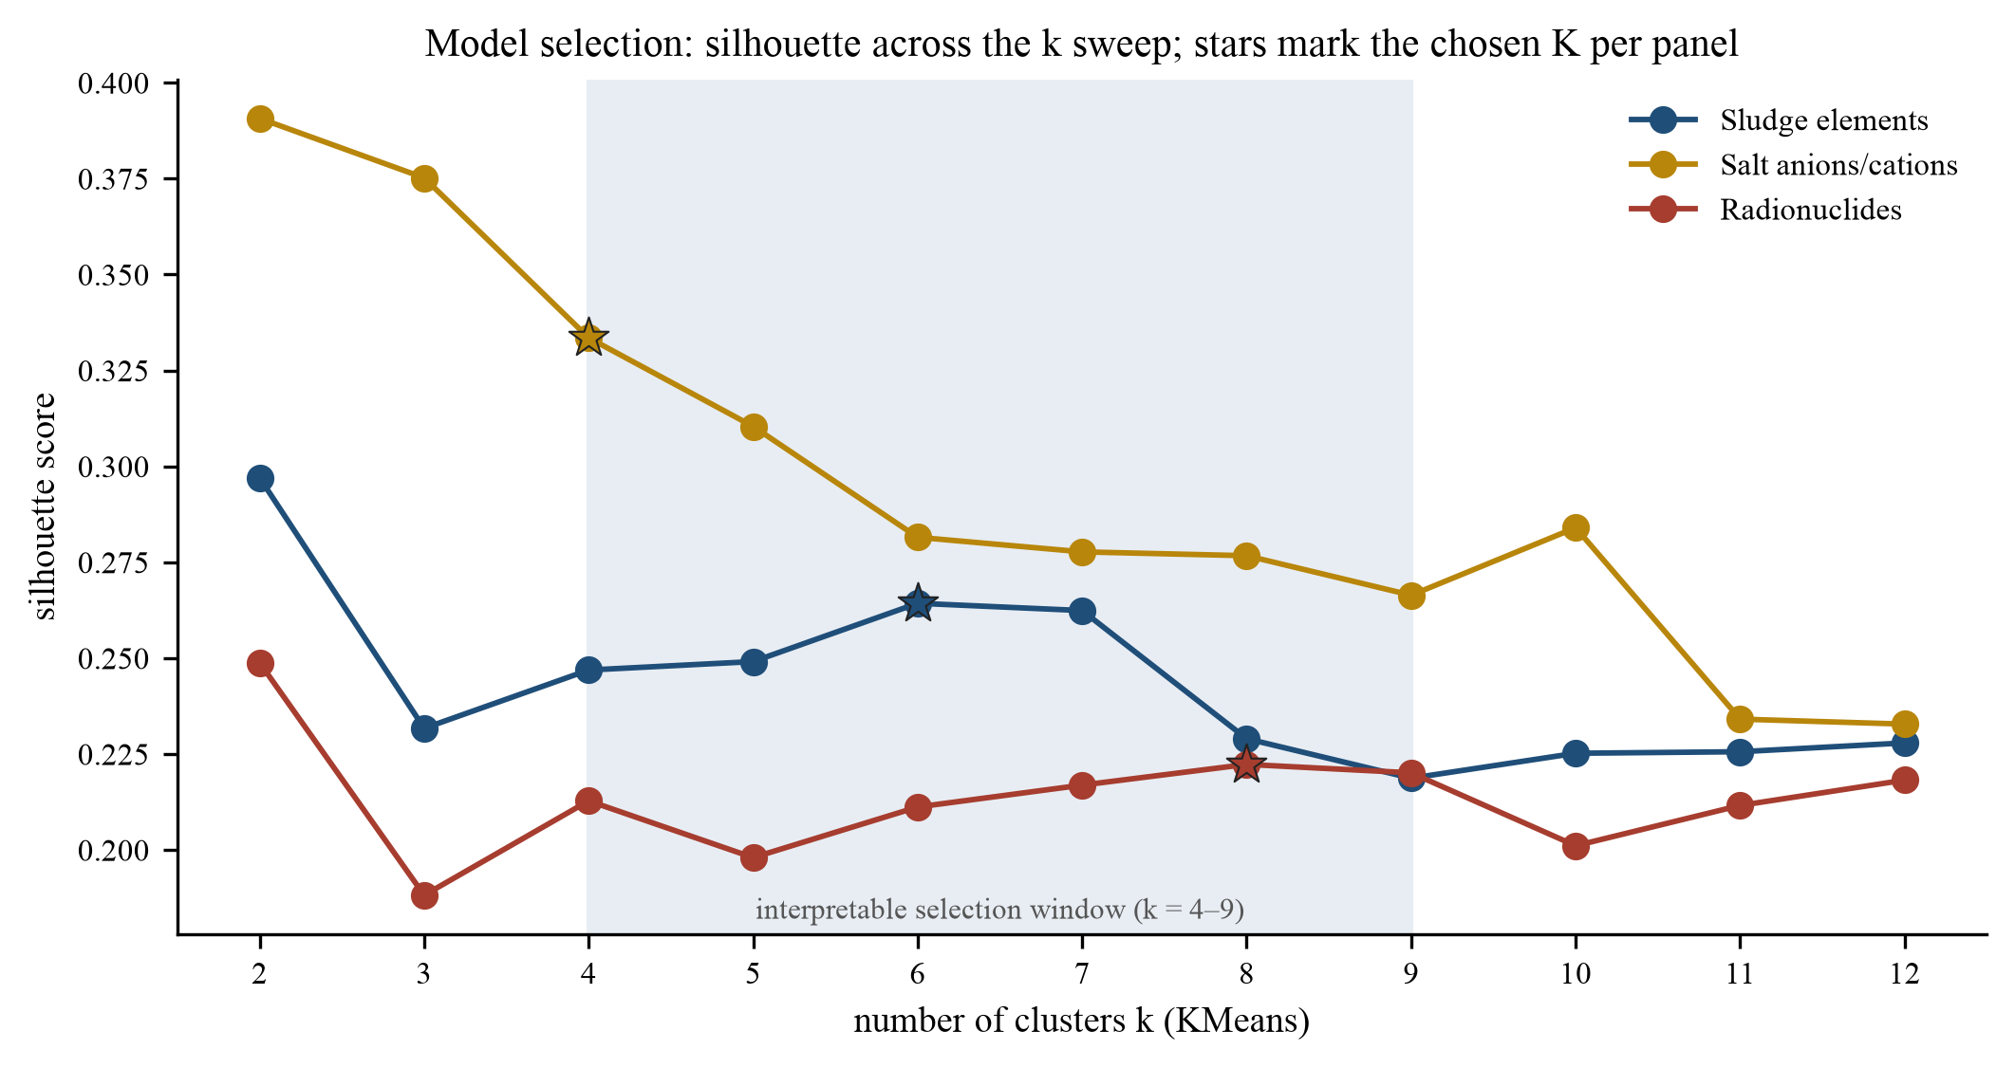
Figure 4. KMeans silhouette scores across the k sweep for each panel. Stars mark the chosen K (largest silhouette within the k = 4-9 interpretability window). The flatness of each curve is the quantitative expression of a continuum with islands.
2.2 Where the SRS streams land
Seventeen measured SRS samples were transformed into each panel's space and assigned to the nearest Ward cluster centroid (9 sludge-basis, 8 salt-basis, 17 radionuclide-basis; a sample projects into a panel only if it shares at least two reportable features with it). Figure 5 shows the full set of placements as distance percentiles within the assigned cluster; Table 2 lists the numbers. Three findings organize the table.
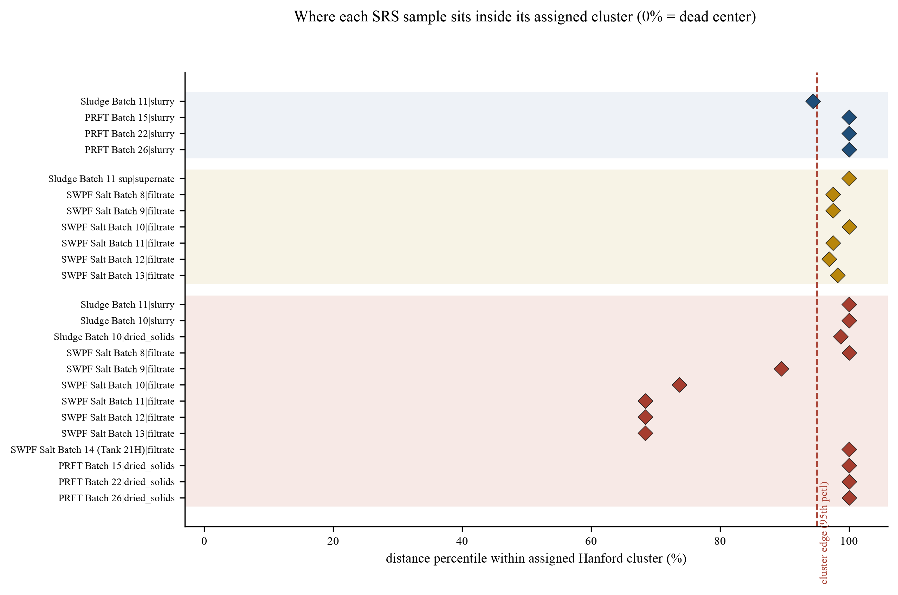
Figure 5. Distance percentile of each projected SRS sample within its assigned Hanford cluster (0 = at the cluster centroid, 100 = beyond every member). Shaded bands group the three panels; the dashed line marks the 95th-percentile cluster edge.
First, the salt batches split by vintage. In radionuclide space, batches 10 through 13 (SWPF-AL era) find analogs at 2.6 to 3.4 shared-support Aitchison distance with 7 to 9 shared nuclides: inside the range where two Hanford tanks of the same cluster sit (median same-cluster nearest-neighbor distance 3.1, 90th percentile 8.9). Their nearest analogs are Hanford supernatants and mixed-phase wastes (AN104, B201, C108, S112), and their centroid distances place them at the 68th to 74th percentiles of cluster C6, i.e., inside the cluster's own spread, not on its rim. Batches 8 and 9 (SRNL-filtered, Tank 40) land at 5.4 to 6.7 with 19 shared nuclides, at the 90th percentile of C6; the comparison is on firmer numerical footing (more shared nuclides) but the analog is weaker. In salt-chemistry space the same batches sit at 3.8 to 5.4 from their centroids against a Hanford neighbor median of 1.45 and 90th percentile of 3.93: compositionally adjacent to the Hanford nitrate/nitrite mainline (C0 or C2), but at the edge, consistent with these being qualified processing streams rather than stored waste.
Second, the engineered-sorbent streams are correctly flagged as novel. The post-retrieval filter follows (PRFT batches 15, 22, 26) project at 11.8 to 12.2 in the sludge panel, at or beyond the worst same-cluster Hanford neighbor distance in that panel (10.7), and their driving analyte is titanium at 12,200 to 16,225 micrograms per gram: monosodium titanate added during actinide/strontium removal. No Hanford tank contains an added sorbent, so the model is reporting a true chemistry gap, not a data gap. The same streams cannot be projected into the radionuclide panel on their slurry basis at all (insufficient shared features), which is itself informative: after decontamination the filtrands are element-chemistry objects, not radionuclide-chemistry objects.
Third, one sample is missing rather than outlying: Tank 40 Sludge Batch 10's slurry report contains none of the 25 sludge-panel elements, and its dried-solids basis projects only in radionuclide space (cluster C3 at the 98.7th percentile, analog T204 at distance 11.3, a weak analog on 10 shared nuclides). Sludge Batch 11's slurry, by contrast, projects at the 94th percentile of sludge cluster C5 with U104 sludge solid as the nearest analog (distance 5.3 on 4 shared elements, a numerically fragile comparison that should be treated as indicative only). The lesson for practitioners is that analog search exposes reporting gaps as immediately as chemical novelty.
Panel | SRS sample | Cluster | Centroid d | Pctl | Top analog | d | k
Rad | SB11 slurry (Tank 51) | C6 | 18.3 | 100 | U-204 supernatant | 3.0 | 3
Rad | SB10 slurry (Tank 40) | C6 | 17.1 | 100 | T-201 supernatant | 9.6 | 12
Rad | SB10 dried solids | C3 | 18.0 | 98.7 | T-204 supernatant | 11.3 | 10
Rad | Salt Batch 8 (Tank 40) | C6 | 17.6 | 100 | AP-108 supernatant | 6.7 | 19
Rad | Salt Batch 9 (Tank 40) | C6 | 16.5 | 89.5 | AZ-102 supernatant | 5.4 | 19
Rad | Salt Batch 10 | C6 | 15.7 | 73.7 | S-112 sludge (L+S) | 2.8 | 7
Rad | Salt Batch 11 | C6 | 15.0 | 68.4 | B-201 supernatant | 2.8 | 3
Rad | Salt Batch 12 | C6 | 14.9 | 68.4 | AN-104 supernatant | 2.6 | 9
Rad | Salt Batch 13 | C6 | 15.0 | 68.4 | C-108 sludge (L+S) | 3.4 | 8
Rad | Salt Batch 14 (Tank 21H) | C6 | 21.1 | 100 | T-204 supernatant | 4.0 | 3
Rad | PRFT Batch 15 dried | C6 | 17.6 | 100 | T-201 supernatant | 11.2 | 9
Rad | PRFT Batch 22 dried | C6 | 18.1 | 100 | T-201 supernatant | 11.2 | 9
Rad | PRFT Batch 26 dried | C6 | 18.6 | 100 | T-201 supernatant | 11.4 | 9
Salt | SB11 supernate (Tank 51) | C0 | 9.8 | 100 | B-108 supernatant | 5.1 | 9
Salt | Salt Batch 8 (Tank 40) | C0 | 7.9 | 97.5 | B-108 supernatant | 4.2 | 9
Salt | Salt Batch 9 (Tank 40) | C0 | 7.9 | 97.5 | B-108 supernatant | 4.3 | 9
Salt | Salt Batch 10 | C2 | 8.6 | 100 | BX-104 supernatant | 5.4 | 11
Salt | Salt Batch 11 | C0 | 8.0 | 97.5 | B-108 supernatant | 4.0 | 8
Salt | Salt Batch 12 | C0 | 7.7 | 96.9 | BX-104 supernatant | 4.0 | 11
Salt | Salt Batch 13 | C2 | 6.8 | 98.2 | BX-104 supernatant | 3.8 | 10
Sludge | SB11 slurry (Tank 51) | C5 | 9.1 | 94.4 | U-104 sludge solid | 5.3 | 4
Sludge | PRFT Batch 15 slurry | C3 | 11.8 | 100 | U-104 sludge solid | 4.8 | 4
Sludge | PRFT Batch 22 slurry | C3 | 12.1 | 100 | U-104 sludge solid | 4.7 | 4
Sludge | PRFT Batch 26 slurry | C3 | 12.2 | 100 | AN-106 sludge (L+S) | 4.7 | 14

Table 2. All SRS projections. Percentile = distance percentile within the assigned Hanford cluster (100 = beyond every member). Analog = nearest Hanford tank-phase; d = shared-support Aitchison distance; k = features supporting that comparison. Distances to analogs and centroids are computed on the analog's or centroid's shared support with the sample and are not directly comparable to each other.
Note: Not projected: SB10 slurry and PRFT 15/22/26 slurry into the element panel (report lacks all 25 panel elements); SB11 supernate and PRFT slurries into the radionuclide panel (insufficient shared features); SB14 into the salt panel. All 51 closure residuals projected only in the element and radionuclide panels, all at p95 or beyond.
2.3 How good are these analogs? A calibration the model provides for free
A distance number means nothing without a null distribution, and the Hanford data supplies one: for every Hanford point, its nearest same-cluster neighbor distance. Figure 6 plots those distributions against the SRS analog distances. The sludge panel's SRS analogs (4.8 to 5.3) sit above the Hanford median (3.3) but below the 90th percentile (6.4), so they are ordinary-by-context but not close; the salt panel's SRS analogs (3.8 to 5.4) sit at or beyond the 90th percentile of a much tighter distribution (median 1.45); and the radionuclide panel spans both regimes, with the batch 10-13 analogs (2.6 to 3.4) better than typical and everything else at or past the 90th percentile (8.9). This plot is the single most important interpretive aid in the paper: it converts each analog claim from an absolute number into a statement about how unusual that distance would be between two Hanford tanks.
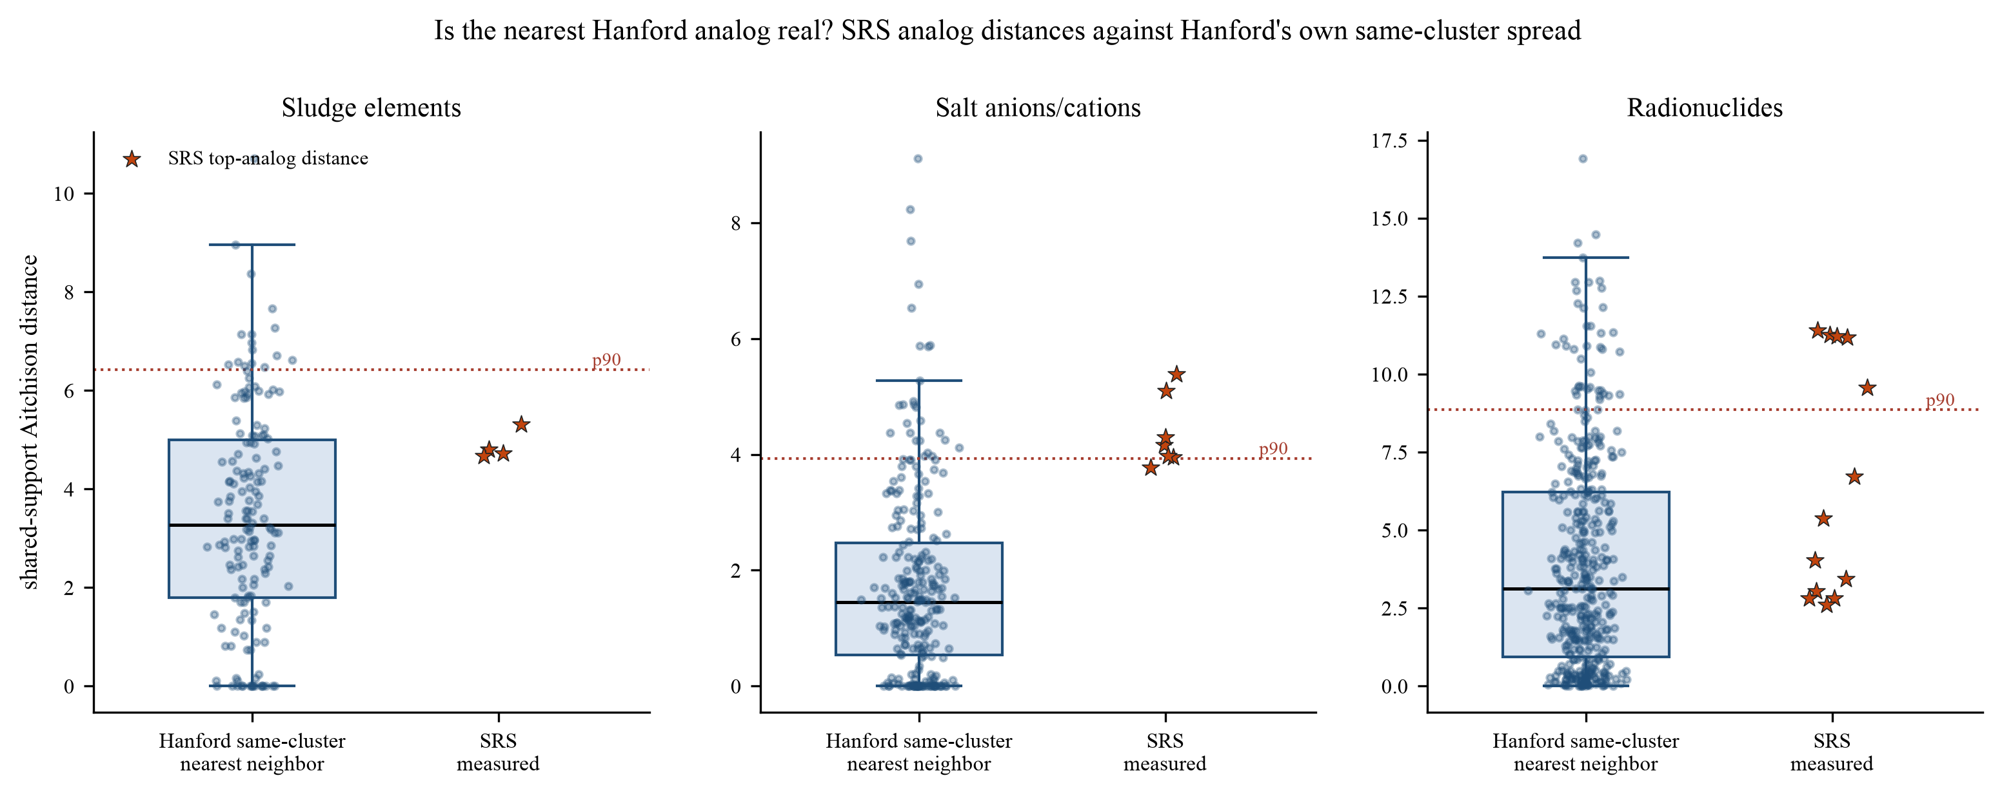
Figure 6. Calibration of analog quality. Box plots: distribution of nearest same-cluster neighbor distances among Hanford points themselves (the null context). Stars: the best-analog distance for each projected SRS sample. An SRS star inside the Hanford box indicates an analog as close as Hanford tanks get to each other; a star beyond the 90th-percentile line indicates a weaker, context-dependent match.
Support size (the number of features shared by the SRS sample and the candidate analog, k in the tables) modulates every distance. Distances computed on k=3 features are geometrically shallower than distances on k=19: fewer shared features give the pair more chances to agree by omission. The tables therefore report k alongside every distance, and Section 5 makes the reading rule explicit: an analog at moderate distance with large k beats a closer analog on small k. This is also why the same sample can carry different analog distances in different panels: each panel is a different slice of chemistry with its own support.
2.4 Anomalies
HDBSCAN's outlier scoring (GLOSH) behaves differently in the three panels, and the difference is instructive. In the radionuclide panel, exactly one Hanford point exceeds the 0.85 flag threshold: AW-104 sludge solid (score 0.850), followed by TX-105 (0.835), AZ-102 supernatant (0.832), T-111 (0.821), and C-103 (0.820). These are plausible candidates for compositional peculiarity (AW-104's radionuclide vector is sparse and Pu-tilted relative to its cluster), and they are the right starting points for a data-quality or history review. In the element panels, however, GLOSH flags 87 of 158 sludge points and 138 of 258 salt points at the same threshold. That is not 55 percent of Hanford being anomalous; it is a known artifact of GLOSH in sparse, high-entropy data, where missing-feature uncertainty inflates local density estimates. The correct interpretation is asymmetric: a high GLOSH score in the radionuclide panel is evidence of anomaly; a high score in an element panel is only a prompt to inspect the point. Section 4.3 explains the mechanism; the dashboard exposes the scores either way.
Rank | Hanford point | GLOSH | Cluster
1 | AW-104 sludge solid | 0.850 | C2
2 | TX-105 sludge (L+S) | 0.835 | C2
3 | AZ-102 supernatant | 0.832 | C5
4 | T-111 sludge (L+S) | 0.821 | C0
5 | C-103 sludge (L+S) | 0.820 | C1
6 | C-201 sludge solid | 0.819 | C2

Table 3. Highest-GLOSH Hanford points, radionuclide panel (the panel where the scores are interpretable as evidence). Flag threshold 0.85; exactly one point crosses it.
2.5 The closure residuals audit themselves
All 51 SRS closure-residual vectors were projected through the same pipeline. In the sludge panel, all 51 land in a single cluster (C3) at the 95th percentile or beyond of that cluster's member distances; in the radionuclide panel they split across three clusters (C4: 33, C6: 16, C0: 2) but again all 51 land at or beyond the 95th percentile; in the salt panel none can be projected, because the closure basis reports none of the salt anion suite. Read together: the conservative residual source terms are compositionally unlike anything in the Hanford current-inventory library, the model assigns them to the rim of whatever cluster is least unlike them, and the salt comparison is impossible on that basis. This is the quantitative version of the first white paper's central basis warning, obtained without ever labeling a single row by site or basis.
3. Method and mathematics
3.1 Compositional data and why ordinary statistics fail on it
Tank-waste compositions are compositional data: each sample is described by the relative amounts of a set of constituents, and the information lives in the ratios between constituents, not in any absolute amount. A sludge reported as 40 percent iron and 10 percent aluminum carries the same compositional information as one reported as 400 and 100 grams per kilogram, or 4 and 1 pounds per cubic foot. Formally, a composition is a point on the simplex, the set of positive vectors whose parts sum to a constant (conventionally 1 or 100 percent). Three consequences follow, and each one invalidates a naive approach. First, closure: because the parts sum to a constant, every part is determined by all the others, which makes raw component values structurally negative-correlated; the correlation between two analytes across tanks is distorted by the sum constraint before any chemistry is expressed. Second, the parts-whole relationship: increasing one component necessarily decreases all others even if nothing else changed, so distance measures computed on raw fractions respond to dilution (how much water is in the tank) rather than to chemistry. Third, Euclidean geometry is the wrong geometry: fractions live between 0 and 1, differences near 1 are bounded while differences near 0 are unbounded in ratio terms, and a change from 0.5 percent to 0.6 percent (a 20 percent relative change, chemically large) is numerically identical to a change from 50.0 to 50.1 percent (a 0.2 percent relative change, chemically trivial). Mixing units makes this worse: kilograms of sodium, curies of cesium, and micrograms per gram of titanium are mutually incommensurable, so any Euclidean distance over raw columns is an arbitrary weighting of units.
The standard remedy, established by Aitchison in the 1980s, is to work in log-ratio coordinates, where ratios become differences and scale factors cancel exactly. Because log of a ratio is invariant to multiplying both numerator and denominator by any constant, converting compositions to log-ratios removes the unknown density, moisture, and unit scale that would otherwise dominate a cross-site comparison. All distances in this paper are computed after such a transform.
3.2 The centered log-ratio transform
Let a sample have closed fractions f_j over features j (each feature divided by the sample's total across panel features, so the fractions sum to 1). The centered log-ratio (CLR) transform maps the composition to a vector of the same dimension:
CLR_j = ln f_j - (1/D) \Sigma_k ln f_k, j = 1..D
that is, each log fraction minus the mean log fraction, which is the log of the geometric mean g of the fractions: CLR_j = ln(f_j/g). Figure 7 shows the transform on real data: Sludge Batch 11 supernate closed over its salt-panel species, before and after. The CLR vector has a constraint (its entries sum to exactly zero) and a singularity (any zero fraction gives minus infinity), which drive the two design choices below. The zero-sum constraint means CLR coordinates live in a D-minus-1-dimensional hyperplane through the origin; distance computations that center differences on the mean of the difference (as ours do, below) are insensitive to this constraint. The singularity is the practical problem: tank-waste data is full of non-detects, and the transform must be combined with a principled treatment of zeros.
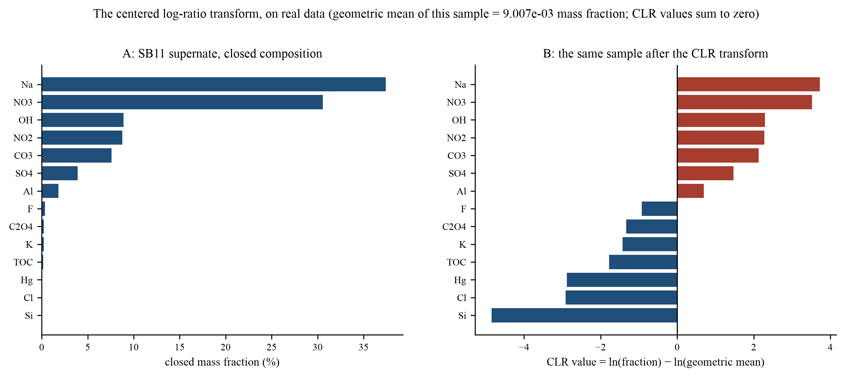
Figure 7. The CLR transform on real data: Sludge Batch 11 supernate closed over the salt-panel species (A), and the same sample in CLR coordinates (B). The geometric mean of the closed fractions sets the zero line; a species' CLR value is how many times (in log terms) its fraction exceeds that mean. Large negative bars are species barely above the closure floor, not absent species: true zeros cannot be transformed at all, which is why the pipeline never lets them in.
Why not alternatives: an additive log-ratio (ALR) transform takes logs of ratios to one chosen reference part, which is simpler but makes distances depend on which part is chosen as the reference; an isometric log-ratio (ILR) transform builds orthonormal coordinates that preserve geometry exactly, at the cost of coordinates that no longer correspond one-to-one to analytes, which would destroy per-analyte interpretation of cluster differences. CLR is the standard compromise: coordinates remain analyte-wise interpretable, and its only geometric defect (a slight distortion from the zero-sum constraint) is irrelevant for the centroid-based and nearest-neighbor comparisons used here because our distance explicitly recenters differences.
3.3 Non-detects, the neutral point, and the presence floor
A reported zero in tank-waste data almost never means 'this substance is absent'; it means 'not measured, or below the detection limit of the method'. Substituting zero into a log-ratio is catastrophic (minus infinity); substituting a small arbitrary value distorts every distance by an amount that depends on the arbitrary choice. The pipeline instead uses a neutral-point imputation: an unreported analyte is treated as if its fraction equalled the geometric mean of the analytes that were reported. The rationale is exact in CLR space: a neutral point contributes exactly zero to the CLR vector, so an unmeasured analyte pulls neither toward nor away from any comparison; it is the 'no information' element of the log-ratio geometry. This is the correct null when the analyst's state of knowledge is 'unknown' rather than 'zero'.
Two safeguards complete the treatment. A presence floor requires an analyte to be reported by at least a fraction of Hanford points (0.40 for sludge, 0.70 for salt, 0.50 for radionuclides) to enter the panel at all; analytes kept alive by a handful of reports would otherwise manufacture clusters of convenience. Figure 8 shows how the feature count falls as the floor rises, and that the chosen floors sit on the flat shoulder of each curve rather than at a cliff edge. A sample may enter a panel only if it shares at least two reportable features with it (the minimum needed to center and compare a difference vector); this rule is what makes 'cannot be projected' a meaningful output rather than an error.
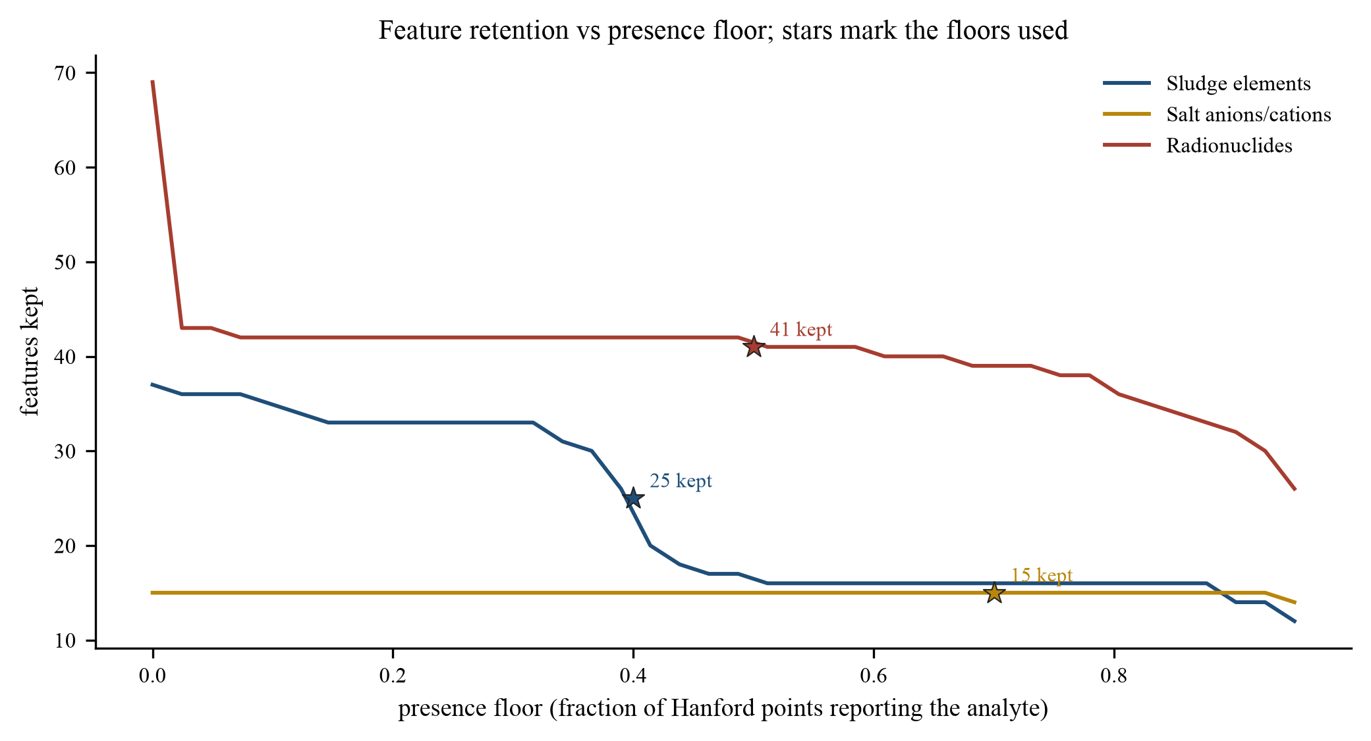
Figure 8. Feature retention versus presence floor. Stars mark the floors used (0.40 sludge, 0.70 salt, 0.50 radionuclides). The chosen floors sit on gentle slopes, so small changes in floor choice would not materially change the panels.
3.4 Distances: Aitchison and the shared-support variant
The natural distance between two CLR vectors x and y is the Aitchison distance, which in CLR coordinates reduces to the Euclidean distance after removing the component along the all-ones direction (which the zero-sum constraint already fixes): d_A(x,y) = ( \Sigma_j ( (x_j - y_j) - m )^2 )^{1/2} with m the mean of the differences. The pipeline uses a shared-support variant: for a pair of samples where one lacks some of the other's panel features, the difference vector is formed only over the features both report (the shared support, size k), centered on its own mean, and summed. This is what makes cross-site distances legitimate at all: an SRS filtrate reporting 9 nuclides and a Hanford supernatant reporting 21 can still be compared on their 9 common features, with k reported alongside the distance as its own quality flag. The geometric meaning is the same (a path length in log-ratio space); the caveat is that distances computed on different supports are not strictly commensurable, which is why k travels with every distance in every table, and why an analog at moderate distance on large k outranks a closer analog on small k.
Two properties make this the right family of distances for the audit purpose. Scale invariance: multiplying a sample's reported values by any constant (a density correction, a unit conversion, a reporting convention) leaves every distance unchanged, which removes the largest source of cross-site bookkeeping error. Subcompositional coherence: comparing samples on a subset of features is internally consistent with comparing them on the full set, so a panel boundary (sludge versus salt chemistry) is a legitimate analysis choice rather than a distortion.
3.5 Clustering, model selection, and the honesty metrics
Ward's method (Ward 1963) is agglomerative hierarchical clustering with a specific merge cost: at each step, merge the pair of clusters whose fusion increases the within-cluster sum of squared distances the least. On CLR coordinates it behaves like a variance-minimizing, roughly spherical-partition method, which suits compositional continua with islands. It produces a full dendrogram; cutting it at K merges gives the taxonomy. Three diagnostics accompany it. The cophenetic correlation (Sokal and Rohlf 1962) is the correlation between the pairwise distances in the original space and the heights at which pairs merge in the tree; values run 0.59 to 0.68 here, meaning the tree is a moderate compression of a blobby space, a caution against reading the dendrogram's exact branching as genealogy. The silhouette score (Rousseeuw 1987) places each point between -1 and 1 by comparing its mean distance to its own cluster against its mean distance to the nearest other cluster; means of 0.19 to 0.29 indicate overlapping clusters, real structure but soft boundaries. The adjusted Rand index (Hubert and Arabie 1985) measures agreement between two partitions of the same points (here Ward's K clusters against KMeans' on the same K), corrected for chance; values of 0.71 to 0.79 mean the two very different algorithms recover substantially the same families, which is the strongest internal evidence the taxonomy has.
KMeans (Lloyd's algorithm, k-means++ initialization, 50 restarts) serves two roles: as the agreement check just described, and in a sweep over k = 2 to 12 whose silhouette scores select K. The sweep is constrained to the interpretable window k = 4 to 9, because the goal is a taxonomy a human can reason about cluster by cluster, and because the silhouette differences within the window are small enough that interpretability should break the tie. HDBSCAN (Campello et al. 2013) is fit not for its partition (its cluster counts, 4 to 7 per panel, are reported but not used downstream) but for its density estimates; UMAP (McInnes et al. 2018) is used only for the figures.
3.6 Density anomaly scoring and its failure mode here
HDBSCAN builds a density estimate from the mutual reachability distance between points, persists clusters across density levels, and scores each point with GLOSH (Global-Local Outlier Score from Hierarchies, Campello et al. 2015): the estimated probability that a point is an outlier, 0 to 1, high values meaning the local density around the point is much lower than the density of the cluster it would belong to. In the radionuclide panel, where feature coverage is decent and one dense supercluster dominates, the scores behave as designed and exactly one point crosses the 0.85 flag line. In the element panels, however, 55 percent of points cross it, and the reason is a known interaction between GLOSH and sparse high-dimensional data: when most points are missing most features (imputed to the neutral point), a point's effective neighborhood is defined by whichever few features it reports, local densities become individually calibrated, and the outlier score partly measures 'how unusual my missing-data pattern is' rather than 'how unusual my chemistry is'. The correct operational stance is asymmetric trust, stated in Section 5 as a rule: radionuclide-panel flags are evidence; element-panel flags are prompts.
3.7 UMAP and what its pictures do and do not show
UMAP constructs a fuzzy graph of k-nearest-neighbor relationships in the high-dimensional space and optimizes a low-dimensional layout to preserve that graph. In these figures it is fitted on the Hanford CLR matrix of the relevant panel, and the SRS samples are then mapped with the fitted model (the transform operation, not a refit), so an SRS star's position is the location the Hanford structure assigns it, which is exactly the audit we want. Three warnings attach to every such figure, and they apply here. Distances between well-separated groups in a UMAP plot are not meaningful (only local neighborhoods are approximately preserved); relative point sizes and gaps within a cluster can exaggerate density differences; and the same dataset gives different-looking maps under changed random seeds, which is why every quantitative statement in this paper references CLR-space distances and percentiles, never pixel distances in Figure 1. The plots are for orientation; the numbers are for decisions.
3.8 The projection operation, precisely
For each SRS sample and panel, projection means: (1) close the sample over the panel's kept features; (2) impute unreported features to the neutral point; (3) take CLR coordinates; (4) compute the shared-support Aitchison distance to each Ward cluster centroid, over the features the sample reports; (5) assign the sample to the nearest centroid's cluster; (6) report the distance percentile of the sample within that cluster's own members (same shared-support metric, per member); (7) rank all cluster members as candidate analogs by shared-support distance and list the top five with their k. Closure residuals pass through the identical steps. No Hanford or SRS label ever enters steps 1 through 7; the only site-aware step is the decision to run an SRS sample through a Hanford-fitted taxonomy, which is the paper's premise.
4. How to use the results
4.1 Reading a projection
Every SRS row in Table 2 carries five numbers, and each answers one question. Which cluster: the family of Hanford compositions the stream most resembles overall; treat it as a pointer to a group of tanks to read about, not as a classification. Centroid distance: how far the stream sits from that family's center in log-ratio terms; interpret it against the calibration below, never in the abstract. Percentile within cluster: the same distance expressed against the cluster's own members; below 95 means inside the spread Hanford itself displays, above 95 means on the rim or outside. Top-analog distance and support k: the distance to the single closest Hanford tank-phase and how many features that comparison rests on. The reading order is: k first (is the comparison even adequately supported?), then the percentile (is this distance ordinary for this cluster?), then the identity of the analog (does its process history make chemical sense as a relative?), and only last the raw distance. A stream such as Salt Batch 13 (radionuclide panel) reads: k=8, 98th percentile of C6, top analog C-108 sludge mixed-phase at 3.4, second analog AN-104 supernatant; the conclusion is 'radiologically akin to late Hanford supernate-bearing wastes, with the nearest single-tank match in a mixed-phase tank', and the next analytical step is a targeted analyte-by-analyte comparison of those specific pairs, which the dashboard's Dataspace tab renders directly.
4.2 Calibration rules of thumb
The null context of Figure 6 gives concrete reading rules. In the radionuclide panel, an analog distance under about 3 is as close as Hanford tanks get to each other (call it a strong analog); 3 to 9 is within the range Hanford's own variety produces (a moderate analog, evaluate k and chemistry); above about 9, the analog is weaker than typical Hanford intra-cluster variation (treat as directional only). In the salt panel the same thresholds tighten to roughly 1.5 and 4; in the sludge panel to roughly 3.3 and 6.4. A distance below the panel's Hanford median with k of 7 or more is the strongest claim the method can make (Salt Batch 12 at 2.6 on k=9 is the exemplar). A distance above the 90th percentile with k under 5 is the weakest (SB11's element-panel analog at 5.3 on k=4 must be treated as indicative). Support size can rescue a moderate distance (batches 8 and 9 at 5.4 to 6.7 on k=19 are numerically better-supported than a 3.0 on k=3) but cannot make a novel stream familiar: the PRFT streams fail at 11.8 to 12.2 regardless of support because the chemistry itself (added titanate sorbent) has no Hanford referent.
4.3 What each finding is good for
The genuine-analog finding (salt batches 10-13 in radionuclide space) supports direct reuse of Hanford experience: flow-sheet precedents, ion-exchange performance expectations, and glass-composition envelope questions can be reasoned from the specific Hanford analogs listed, with the analyte-level comparison as the bridge. The edge-of-cluster findings (salt batches 8 and 9 radiologically, all projected batches in salt chemistry) support targeted characterization: the model identifies which analytes drive the excess (the dashboard lists them per sample), which is precisely where additional SRS measurement effort buys the most cross-site confidence. The novel-stream finding (PRFT titanate sludges) sets an expectation: no Hanford process history will transfer cleanly, and treatability must be established from SRS data. The audit finding (all 51 closure residuals at the rim, salt projection impossible) disqualifies a class of comparisons: any claim of the form 'SRS residual X resembles Hanford tank Y' built on closure-residual data should be presumed to be a basis artifact until proven otherwise. And the missing-data finding (SB10's slurry report lacking all 25 element-panel analytes) is an action item with a name on it: the analog screen is only as complete as the reports it consumes, and it prices each gap immediately.
4.4 Running the screen for a new batch
The pipeline is deterministic and re-runnable end to end. To screen a future SRNL qualification sample: add the report to the measured-sample loader, rebuild the feature tables (scripts/build_unsupervised_features.py), re-run the clustering script (scripts/run_unsupervised_clustering.py; the taxonomy refits deterministically on the same Hanford inputs, and results land in data_processed/unsupervised/), and open the dashboard's SRS-projections tab. The whole loop is minutes, and because Hanford's taxonomy changes only when the BBI changes, results across batches are comparable over time. Two disciplines keep the comparisons honest: never mix bases within a panel comparison (current with current, closure with closure), and always report k with every distance.
5. Caveats and limitations
The method measures compositional similarity, nothing else. Processability, rheology, organic content, hydrogen generation, criticality margins, and heat load per unit volume depend on properties absent from public tank data, and no conclusion in this paper speaks to them. The specific limitations, in descending order of practical weight: (1) Basis asymmetry: Hanford BBI values are model-and-sample estimates with their own uncertainty and effective-date spread (2015 to 2026), while SRS current-waste values are direct measurements of qualification batches; part of every cross-site distance is this estimation-versus-measurement difference, unquantifiable from public data. (2) Non-detect sensitivity: the neutral-point rule is principled but not unique; a different imputation shifts distances by amounts that grow as support k shrinks, which is a second reason k travels with every number. (3) Feature selection: the presence floors and the interpretability window K = 4-9 are documented choices, not discoveries; the flat silhouette landscape means a different defensible K changes cluster membership at the margins (the Ward-KMeans ARI of 0.71 to 0.79 bounds how much). (4) Small supports: element-panel analogs on k=3 or 4 (SB11) carry little evidential weight individually. (5) Single-report samples: an SRS stream is characterized by one report on one basis; Hanford points aggregate decades of estimates. (6) GLOSH asymmetry: element-panel anomaly flags are unreliable as evidence (Section 3.6). (7) UMAP maps: useful for orientation, never for numbers. (8) Panel non-independence: the three panels describe the same tanks, so 'analog in two panels' is stronger than 'analog in one' but is not two independent confirmations.
One meta-caveat belongs in its own sentence: the taxonomy is fitted to Hanford, so any family structure it finds is conditional on Hanford's fleet being the reference library. A taxonomy fitted jointly on both sites would produce different families, and a third site added later would change them again. The audit orientation (Hanford as library, SRS as query) is a choice that matches the question, not a claim that Hanford defines what tank waste is.
6. Conclusions
An unsupervised taxonomy of 433 Hanford tank-phase compositions, built in three chemistry panels with documented model selection, places every measured SRS processing stream somewhere specific: inside Hanford's own compositional spread in radionuclide space for the SWPF-AL-era salt batches (analog distances 2.6 to 3.4 on 7 to 9 shared nuclides), at the edge of the spread for the older filtered batches (5.4 to 6.7 on 19 shared nuclides) and for salt-chemistry comparisons generally (3.8 to 5.4 against a 1.45 median), and outside the Hanford library entirely for the titanate-bearing filter-follow sludges (11.8 to 12.2, driven by monosodium titanate at 12,200 to 16,225 micrograms per gram). The calibration the method supplies for free (each Hanford point's nearest same-cluster neighbor distance) turns these placements into calibrated statements: strong, moderate, directional, or novel.
The same machinery audits the data bases it consumes. It flags one genuinely peculiar Hanford point in radionuclide space (AW-104), exposes two SRS reporting gaps by name (Sludge Batch 10's slurry basis in element space; the closure basis in salt space), and places all 51 SRS closure residuals at or beyond the 95th percentile of their assigned clusters, a quantitative, label-free confirmation that closure residuals are not current waste and must not be compared against current inventories.
For practitioners, the operating rules are short. Read k, then percentile, then analog identity, then distance. Trust radionuclide-panel anomaly flags; treat element-panel flags as prompts. Treat a below-median, k-7-plus analog as actionable; treat an above-p90, sub-5-k analog as indicative; treat a flagged-novel stream as a no-referent stream. Re-run the screen on every new qualification report; it costs minutes and prices every new gap immediately. The dashboard ships with the repository so that every number in this paper is two clicks from its underlying table.
References
Aitchison, J. (1986). The Statistical Analysis of Compositional Data. Chapman and Hall, London.
Egozcue, J. J., Pawlowsky-Glahn, V., Mateu-Figueras, G., and Barcelo-Vidal, C. (2003). Isometric logratio transformations for compositional data analysis. Mathematical Geology 35(3), 279-300.
Ward, J. H. (1963). Hierarchical grouping to optimize an objective function. Journal of the American Statistical Association 58(301), 236-244.
Rousseeuw, P. J. (1987). Silhouettes: a graphical aid to the interpretation and validation of cluster analysis. Journal of Computational and Applied Mathematics 20, 53-65.
Hubert, L., and Arabie, P. (1985). Comparing partitions. Journal of Classification 2(1), 193-218.
Sokal, R. R., and Rohlf, F. J. (1962). The comparison of dendrograms by objective methods. Taxon 11(2), 33-40.
Campello, R. J. G. B., Moulavi, D., and Sander, J. (2013). Density-based clustering based on hierarchical density estimates. Advances in Knowledge Discovery and Data Mining (PAKDD), 160-172.
Campello, R. J. G. B., Moulavi, D., Zimek, A., and Sander, J. (2015). Hierarchical density estimates for data clustering, visualization, and outlier detection. ACM Transactions on Knowledge Discovery from Data 10(1), 5:1-5:51.
McInnes, L., Healy, J., and Melville, J. (2018). UMAP: Uniform Manifold Approximation and Projection for dimension reduction. arXiv:1802.03426.
Tank Waste Information Navigator System (TWINS), Hanford Best-Basis Inventory per-tank snapshots, accessed via the PNNL PHOENIX API, 2026.
Savannah River National Laboratory, sludge-batch and salt-batch qualification reports for DWPF and SWPF feed batches, 2015-2026 (as parsed from the public record into the companion database).
Aspen Integra (2026). Comparative Inventory Analysis of Remaining Tank Waste at the Savannah River Site and the Hanford Site. Companion white paper, srs-tank-waste-database repository.

