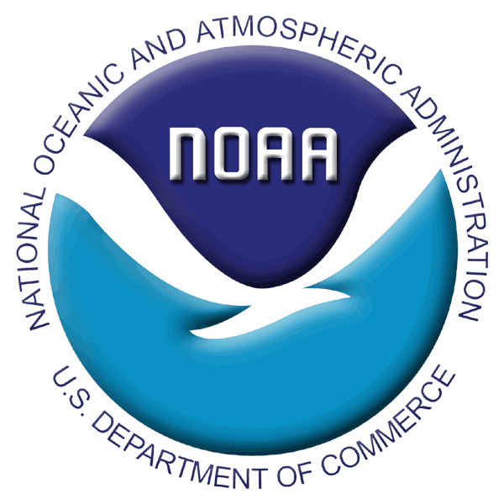

INSTRUCTIONS FOR 2007 RACE BOTTOM TRAWL SURVEYS

SPECIAL PROJECT PROPOSAL

During 2007, the RACE Division is planning to conduct two bottom trawl assessment surveys in Alaska, including the annual Bering Sea shelf crab and groundfish survey and the biennial Gulf of Alaska groundfish survey. Although the occurrence and scope of these two surveys is dependent on funding that has yet to be determined, we are planning as though both surveys will be conducted in full. Special Project proposals are required for ANY and ALL sampling beyond the standard survey sampling methodology (including Special Projects proposed by RACE survey staff or other AFSC personnel).

Surveys are conducted aboard chartered fishing vessels where scientists are under heavy workloads with limited spare time to make additional collections. However, we do our best to accommodate Special Project requests to the extent that survey data quality is not compromised. Other considerations are availability of shipboard space and personnel and ease of incorporation of the request into our standard collections.

We are now considering requests for Special Projects for the upcoming 2007 late spring and summer field season. The Special Projects program is intended to promote high-quality research by scientists who, for various reasons, have limited access to samples collected at sea along the Alaska coast. Collaborative efforts, which engage the survey team as partners in conducting research and publication of results, will be given preference in the selection process. Research conducted through the Special Projects program must be formally acknowledged, preferably by co-authorship when appropriate, in resulting reports, presentations, and publications.

All applications for Special Projects must be submitted to our survey coordinators no later than COB 30 March 2007. No Special Project applications will be accepted beyond this deadline.

Special Project requests will be reviewed once they are received and staff will work with requestors if clarification is needed. Once reviewed, they will be prioritized to determine which Special Projects can be conducted in 2007 given the number of requests received and current budgetary constraints. To reiterate, Special Projects involving collaboration with RACE survey staff as CO-PIs will be given preference. Requesters will be informed of the status of each request before 20 April 2007. Supplies for accepted projects must be received at either AFSC Seattle or the Kodiak Lab by May 1. We will coordinate with scientists whose projects are accepted to ensure that all steps in the process are properly managed.

All special collection requests should include the following information:
(A Special Project Application form is attached as a template. Please use the specified format)

- The title of the Special Project and the Principal Investigator's contact information including affiliation, postal mailing address, email address, and telephone number.

- Answers to the following questions:
  - Have you requested to do a Special Project with RACE in the past? If so, provide a citation for any publications resulting from the project.
  - How is the project relevant to NMFS mission goals or milestones?
  - Are you willing to involve RACE survey staff in this project as participants (beyond field collections)?

- General description and justification for the special collection.

- Detailed description of collection procedures and list of special forms and equipment that will be required. Be as specific as possible and include the desired sampling location(s). Applicant must provide a draft of the instructions (using the template format) for the Operations Manual, and an example of any special data forms. (NOTE: If project involves participation in the survey, describe the extent of participation and how collection procedures can be incorporated into our standard sampling methodology without compromising survey data quality).

- List of supplies. The person making the request must provide or arrange for all collection supplies, including chemicals (EtOH and Formaldehyde can be provided in small quantities, but applicants must arrange this specifically with survey coordinator(s) prior to the start of the survey).

- Hazardous Material Instructions: Provide MSDSs and Standard Operating Procedures for all hazardous materials to be used (NOTE: use of HAZMAT is discouraged because there are restrictions and limitations shipping it).

- Contacts and phone numbers of someone available 24/7 to discuss logistics and problems or authorize billings at the anticipated time of shipment (i.e., end of survey).

- Instructions on how to ship samples. The person making the request will pay for all charges associated with shipping and storage including the following: 1) completed shipping company forms with the shipping account number or a credit card number; 2) collection and shipping containers with any additional packing materials like zip lock bags; 3) if samples are frozen, coolers or commercial waxed boxes must be provided. The RACE Division, Seattle or Kodiak, must receive supplies and containers no later than May 1.

- It is the responsibility of the person making the request to obtain all the necessary permits required for the collection and shipment of specimens, and the RACE Division must have copies of the permits no later than May 1.

If you have any questions please contact the special project coordinator(s) for the survey(s) you are interested in:
Bering Sea Shelf: dan.nichol@noaa.gov Ph. (206) 526-4538
jan.haaga@noaa.gov Ph. (907) 481-1718

Gulf of Alaska: jim.stark@noaa.gov Ph. (206) 526-4155
SPECIAL PROJECT APPLICATION
2007 RACE BOTTOM TRAWL SURVEYS

(Please read attached INSTRUCTIONS for details!)

Submission Deadline: March 30, 2007

- Project Title:
Principle Investigator (PI)/Point of Contact:
Affiliation:
Address:
Email: Phone:

- History of work with AFSC RACE Division
  - Past Special Projects with RACE:
  - Priorities proposed project relates to:
  - RACE collaboration:

- General Description and Justification:

COLLECTION PROTOCOL
- Detailed collection procedures:
- List of supplies:
- Hazardous materials:

SHIPPING
- 24/7 contact:
- Detailed shipping instructions:
[NOTE: FedEx next-day shipping imposes some complications. If you are requesting this method of shipping, please make sure to plan carefully with the special project coordinator.]

PERMITS
- Permits issued or pending:

