SPECIAL PROJECT AND SCIENTIFIC COLLECTIONS APPLICATION FORM

Beaufort Sea Survey, August 2008

Submission Deadline: June 1, 2008

Project Title: Size-weight, egg and shell condition of Chionoecetes opilio and specimen collection of Hyas sp. and C. opilio caught during the 2008 Beaufort Sea survey
Principle Investigator (PI)/Point of Contact: ¹Robert Foy, ²Frank Morado
Affiliation: AFSC/RACE
Address: ¹301 Research Court
Kodiak, AK 99615

²7600 Sand Point Way NE,
Seattle, WA 98115
Email: Robert.Foy@noaa.gov Phone: 907 481-1711
Frank.Morado@noaa.gov 206 526 6572
General Description and Justification: Small numbers of C. opilio and Hyas sp were caught during the 1976-1977 trawl survey in the Northeastern Chukchi and Western Beaufort Seas. Although C. opilio were caught mainly west of the area to be surveyed this year, there is speculation that these crab are extending their range. Very little data is available for this commercially important species in Alaskan waters outside of the annually surveyed eastern Bering Sea.
Bitter Crab Syndrome is a fatal disease of decapods and is known to occur in C. opilio and Hyas spp in the eastern Bering Sea and Chukchi Sea. Previous sampling for BCS in the early 1990s indicated that the disease was present in the majority of sampled stations and that prevalences generally exceeded 30% at those positive stations. Collections of C. opilio and Hyas spp. from the Beaufort Sea will be analyzed for the presence of BCS via a DNA-based protocol. The results could support previous data on disease prevalence and may extend the known range of BCS.

COLLECTION PROTOCOL

Detailed collection procedures:

A. Remove C. opilio from the catch. Please record vessel code, cruise, station and date as well as length/width, weight, sex, shell condition, clutch size code (see additional protocols below).

The shape of the abdominal flap distinguishes sexes. In Chionoecetes crabs the female shape is round while the male shape is a truncated triangle

Female Male

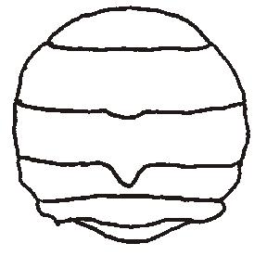
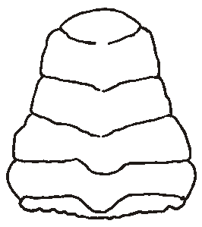

Chionoecetes

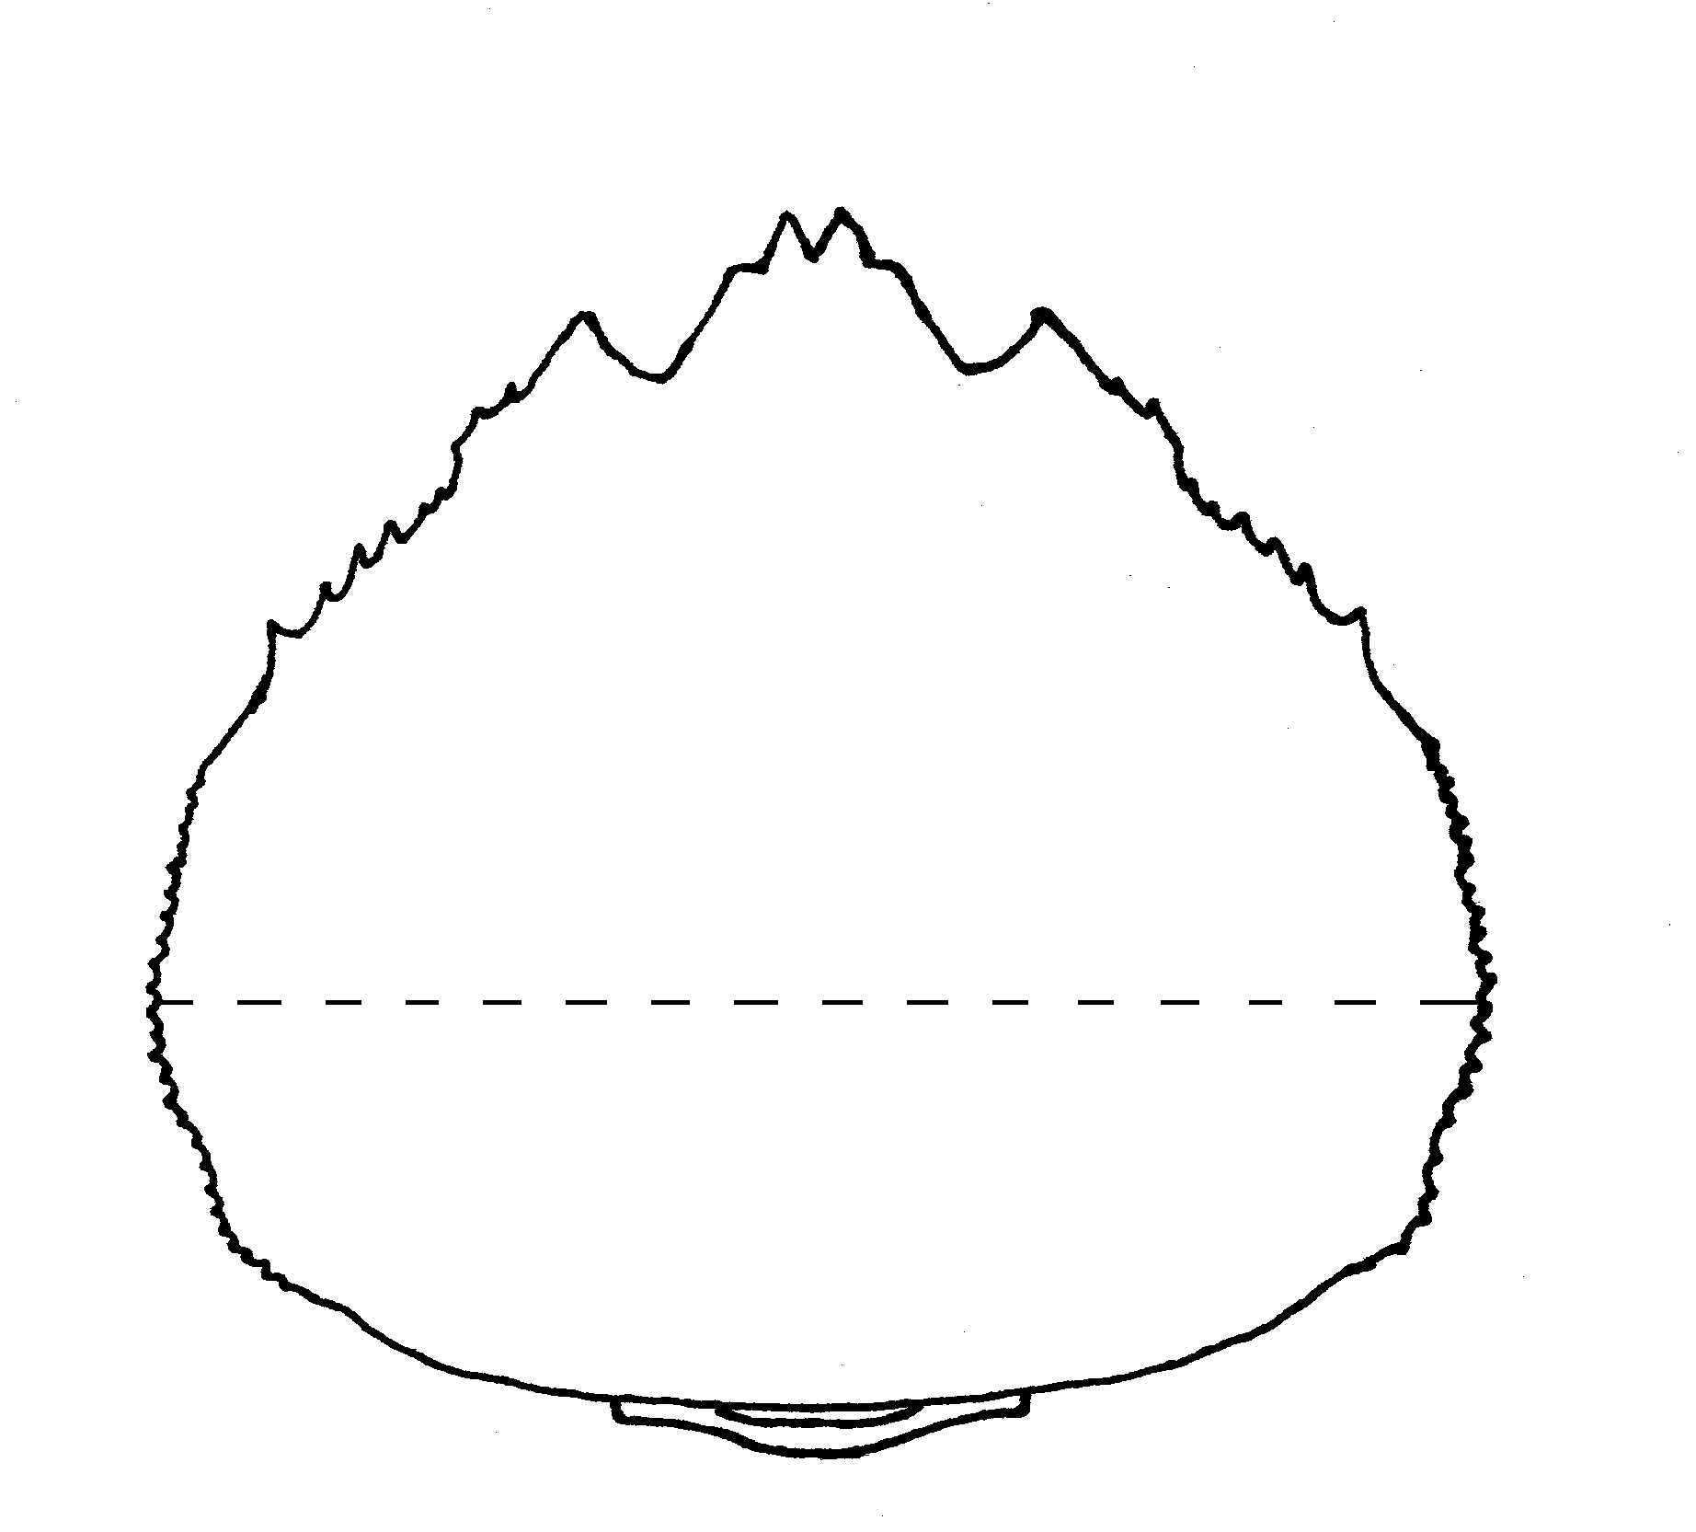
B. Width: Record carapace width measurement to nearest 0.1mm, excluding spines for Chionoecetes crabs.

C. Weights: Record individual weights to ± 2 grams, if a scale with higher resolution is available, please record to the nearest 0.1 gram and carapace measurements (in tenths of mm) from individual whole crab collected at each station. Please collect data from a wide size range of whole, live crab for these measurements; no regenerated or missing limbs. Please keep in mind consistent caliper use and taring the specimen scale after each weight are important factors towards obtaining a data set of accurate measurements.

D. Record shell condition for both male and females of each species

E. Record clutch information for females of each species, consisting of egg color, the condition of the eggs and clutch size.

F. After the data is recorded on the C. opilio, place each individual in an appropriately sized plastic ziplock bag. Crabs from the same haul can then be placed in a larger ziplock bag with a label noting haul number, vessel code, station and date, and then frozen. Collect 100 Hyas spp. and bag, label and freeze them in the same manner.

List of supplies: Data sheets
Description of shell conditions
Description of egg codes
Calipers
Ziplock bags, labels for frozen collections and waxed box(es)

Needs for Data Storage by the AFSC RACE Division: NA
Hazardous materials: None

SHIPPING
24/7 contact: Robert Foy
Frank Morado
Detailed shipping instructions:
At the end of the survey, send completed data sheets for C. opilio measurements and calipers to Robert Foy at Kodiak Lab, 301 Research Court, Kodiak, AK 99615. Send the frozen crab samples to Frank Morado via barge along with other frozen samples or Gold Streak/Alaska Airlines. Accounting details will be provided as needed.

[NOTE: FedEx next-day shipping imposes some complications. If you are requesting this method of shipping, please make sure to plan carefully with the special project coordinator.]

PERMITS
Permits issued or pending: Beaufort Sea Survey specific scientific permit

