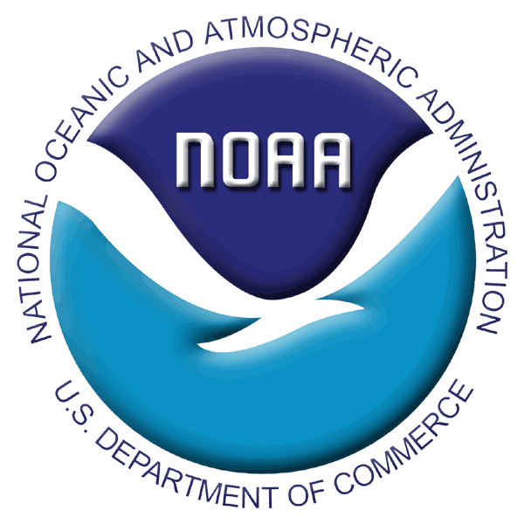
SCIENTIFIC PROJECTS AND COLLECTIONS APPLICATION FORM

2011 RACE BOTTOM TRAWL SURVEYS
AFSC REQUEST FORM

PROJECT OVERVIEW
- Project Title: Ichthyophonus in eastern Bering Sea Fishes
Principle Investigator (PI)/Point of Contact: Frank Morado
Division: AFSC/RACE
Email: Frank.Morado@noaa.gov Phone: 206-526-6572

- General Description: Ichthyophonus is a cosmopolitan parasite infecting a number of marine fish hosts. In recent years, Ichthyophonus has been connected with reduced product quality of Bering Sea walleye pollock (Theragra chalcogramma) and Pacific cod (Gadus macrocephalus), and mortalities in Prince William Sound herring and returning Yukon River salmon. Sample collections of several Bering Sea fish species will support research on the genetics of the pathogen Ichthyophonus. Collected samples will be used to distinguish genotypes within affected fish, elucidate genotype geographical distribution and investigate host effects in relation to each genotype. The targeted samples are designed to support a 2010-2011 research project funded by NPRB (#1015) where Frank Morado and FRPT are collaborators. The project relates to current NMFS Priorities: 1, Species/Population Identification and 2, Organisms/Ecosystem Health.

COLLECTION PROTOCOL
- Detailed collection procedures: Targeted samples will only be collected only where and when FRPT staff are on board. Sixty fish of six species based on a level of priority are targeted for collection, they are; Primary Species: walleye pollock, Pacific herring, arrowtooth flounder, and Secondary Species: saffron cod, rockfish complex, arctic cod. Targeted fish species will be opportunistically sampled. When target fish are encountered, the pericardial cavity will be quickly opened and a small section of heart (0.5cmx0.5cm) will be excised and placed in culture tubes containing MEM culture medium. Samples will be placed in a cooler and maintained under cold conditions by replacing ice pack on a daily basis.
- List of supplies: Culture tubes containing MEM culture medium, culture tubes racks, scalpels and scalpel blades, ice packs, coolers.
- Needs for Data Storage by the AFSC RACE Division: Non required
- Hazardous materials: MEM culture medium is not a hazardous substance
- Personnel available to help with project and overall survey mission: FRPT staff will be able to complete sample collection without assistance.
- Estimated time and resource expense: Estimate 30 minutes to process 10 fish per session.

SHIPPING
- 24/7 contact: Frank Morado, 206-526-6572
- Detailed shipping instructions: NPRB project funds will be used for shipping costs via Alaska GoldStreak. Samples collected during each leg will be shipped after each leg.

PERMITS
- Permits issued or pending: ADF&G Permit #:

