Junior Full Stack Developer Intern
Week 1 Task: Project Planning & System Architecture
Project: TaskFlow – A Team Task Management Web Application

1. Project Brief

1.1 Purpose
TaskFlow is a web-based task and project management application designed for small teams to plan, assign, track, and collaborate on work items in one shared workspace. The application replaces scattered spreadsheets and chat messages with a single source of truth for who is doing what, by when, and at what stage of completion.

1.2 Target Users
- Team leads / managers who create projects and assign tasks
- Team members who update task status and add progress comments
- Admins who manage users, roles, and overall workspace settings

1.3 Core Features
- User authentication (Sign up, Login, JWT-based sessions)
- Project and task creation, editing, and deletion
- Task assignment to specific team members with due dates and priority
- Kanban-style dashboard with To Do / In Progress / Done columns
- Comments and file attachments on individual tasks
- Email / in-app notifications when a task is assigned or updated
- Role-based access control (Admin, Manager, Member)

2. Requirements

2.1 Functional Requirements
ID | Requirement
FR-1 | Users must be able to register and log in securely
FR-2 | Managers can create projects and add tasks under each project
FR-3 | Tasks can be assigned to one or more team members with a due date
FR-4 | Users can update task status and see it reflected instantly on the dashboard
FR-5 | Users can comment on tasks and attach files
FR-6 | System sends a notification when a task is assigned or its status changes

2.2 Non-Functional Requirements
- Responsive UI that works on desktop and mobile browsers
- API response time under 300ms for standard CRUD operations
- Passwords stored using salted hashing (bcrypt); all traffic over HTTPS
- System should support at least 50 concurrent users without degradation

3. User Flow – Flowchart
The diagram below traces a typical user journey through TaskFlow: from authentication, through the dashboard, to creating and updating a task and finally collaborating via comments.
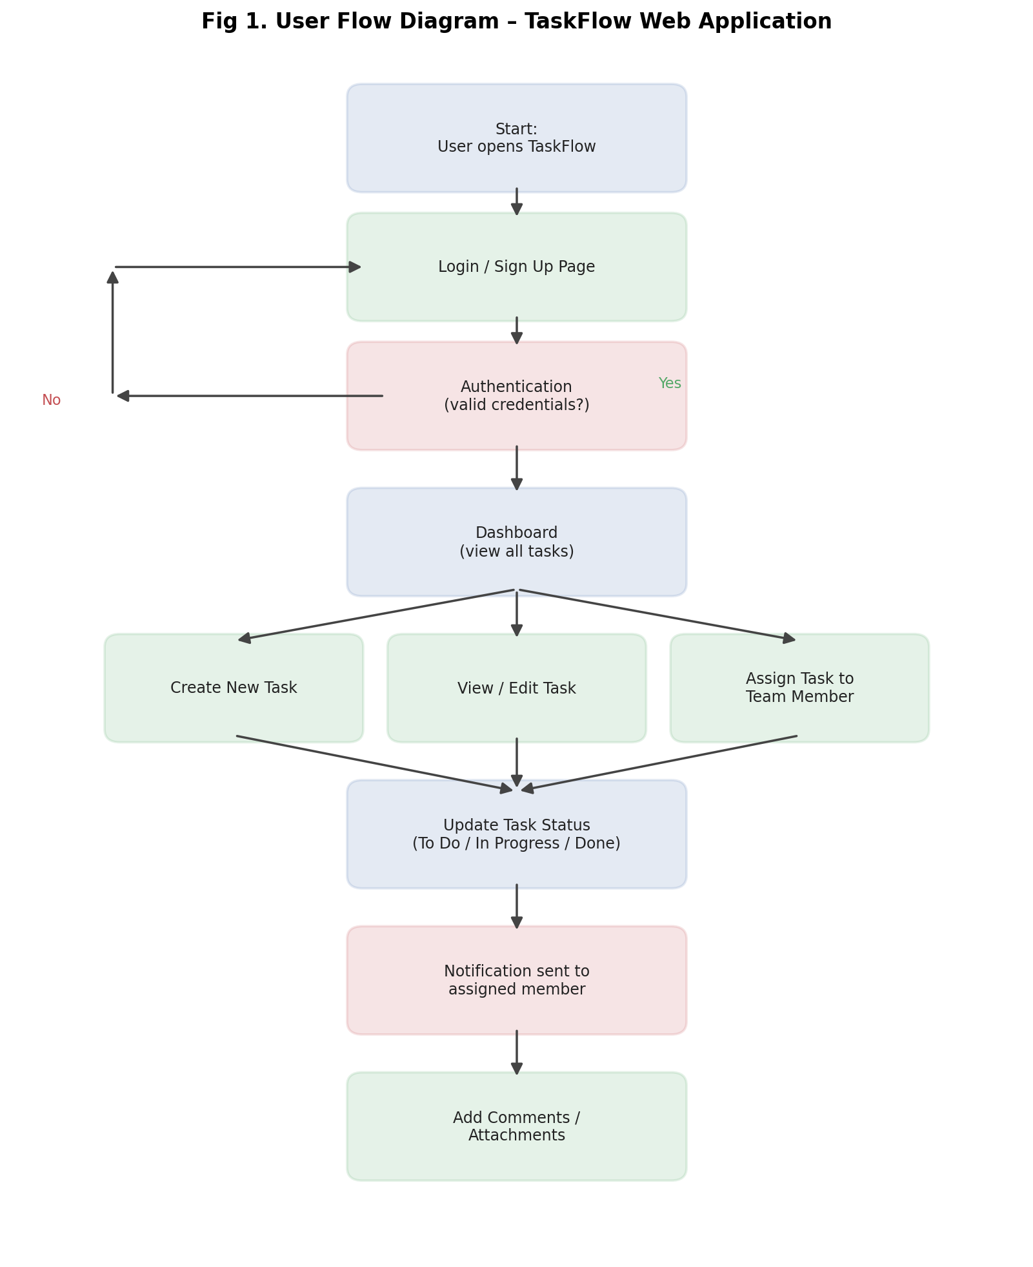
Fig 1. User flow from login to task collaboration

4. Front-End Wireframes
Three key screens were wireframed to define the front-end layout before development: the authentication screen, the Kanban dashboard, and the task detail view.
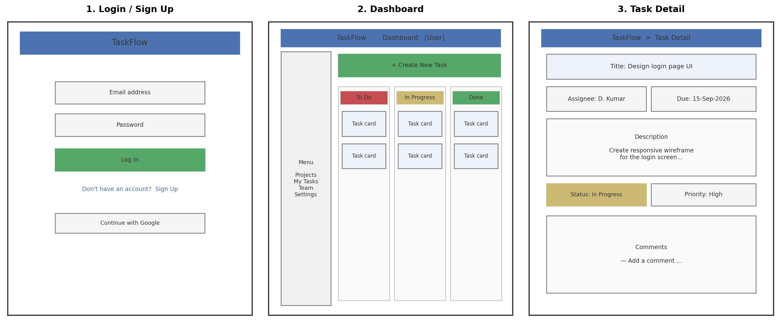
Fig 2. Wireframes – Login, Dashboard (Kanban board), and Task Detail

4.1 Screen Notes
- Login / Sign Up: minimal form with email + password, and a social login option to reduce signup friction
- Dashboard: left-hand navigation for Projects/My Tasks/Team, and a 3-column Kanban board (To Do, In Progress, Done) for at-a-glance status tracking
- Task Detail: title, assignee, due date, description, status/priority tags, and a comment thread for collaboration

5. Technical Architecture
TaskFlow follows a three-tier architecture: a React front-end client, a Python (Flask) REST API back-end, and a PostgreSQL relational database, with supporting services for authentication, notifications, and file storage.
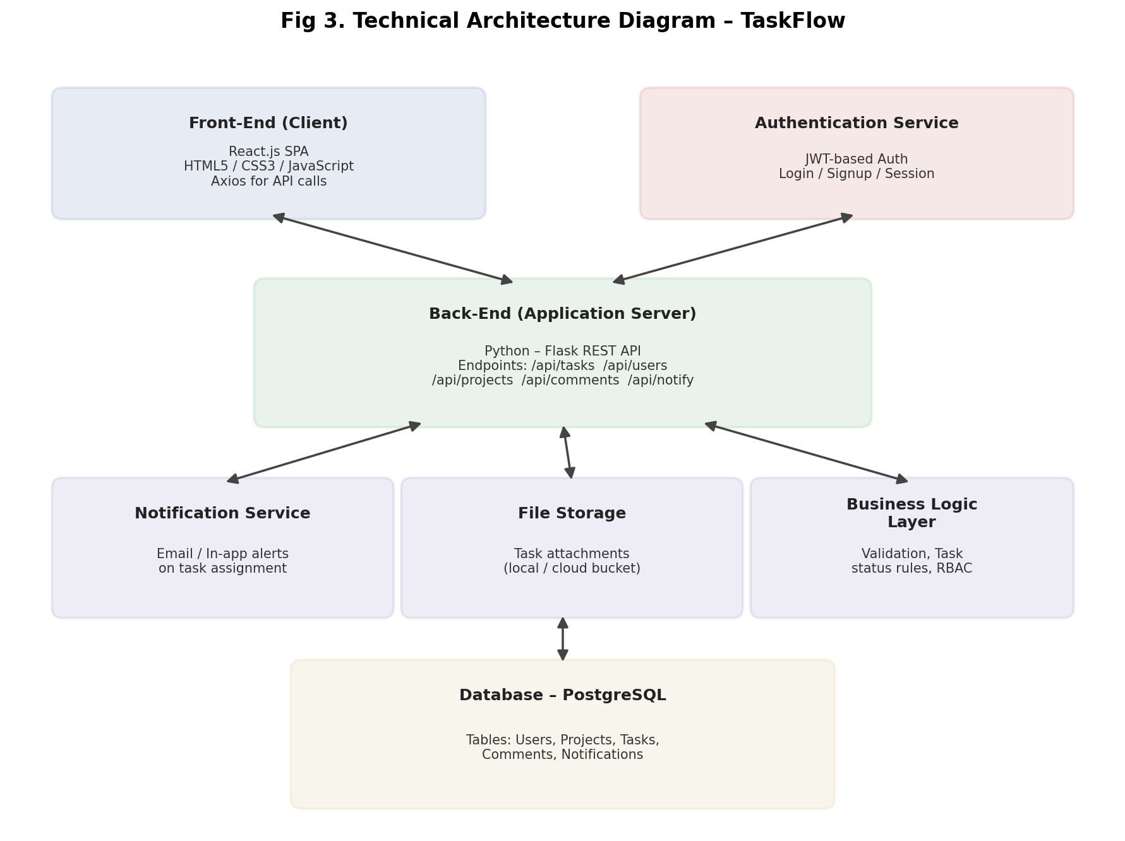
Fig 3. Technical architecture showing front-end, back-end, services, and database

5.1 Component Breakdown
Component | Details
Front-End | React.js single-page app; calls back-end via Axios over REST
Back-End | Python Flask REST API exposing /api/users, /api/projects, /api/tasks, /api/comments, /api/notify
Auth Service | JWT-based authentication; issues and verifies access tokens on each request
Database | PostgreSQL with tables: Users, Projects, Tasks, Comments, Notifications, joined by foreign keys (e.g. Tasks.project_id, Tasks.assignee_id)
Notification Service | Triggered on task assignment/status change; sends email and in-app alerts
File Storage | Stores task attachments, referenced by file URL in the Tasks/Comments tables

5.2 Database Schema (Key Tables)
- Users (id, name, email, password_hash, role)
- Projects (id, name, description, owner_id)
- Tasks (id, project_id, title, description, assignee_id, status, priority, due_date)
- Comments (id, task_id, user_id, text, created_at)
- Notifications (id, user_id, task_id, message, is_read, created_at)

6. Design Rationale
A Flask back-end was chosen to align with Python full-stack development skills and because Flask's lightweight, unopinionated structure makes it fast to define clear REST endpoints for a small-to-medium application like this. React was chosen for the front-end because its component model maps naturally onto the dashboard's repeated task-card and column elements, and its state management keeps the Kanban board responsive to status changes without full page reloads.
PostgreSQL was selected over a NoSQL store because TaskFlow's data is inherently relational — tasks belong to projects, are assigned to users, and have comments — so foreign-key constraints help guarantee data integrity (e.g. a task cannot reference a non-existent project). JWT-based authentication was chosen over server-side sessions so the API remains stateless and can scale horizontally if usage grows.
The three-column Kanban layout was chosen for the dashboard because it gives an immediate visual read of workload distribution across statuses, which is the single most common thing a team lead checks day to day. Notifications and comments were separated into their own tables/services so they can be extended later (e.g. push notifications, @mentions) without reshaping the core Tasks table.

7. Conclusion
This document captures the planning and architecture phase for TaskFlow: a clearly scoped project brief, functional and non-functional requirements, a user-flow diagram, front-end wireframes for the three primary screens, and a technical architecture diagram covering the front-end, back-end, services, and database layer. Together these artifacts provide a solid foundation to begin front-end and back-end development in the following weeks.

