JMeter Readme

This document describes steps to install JMeter and basic information on how to user JMeter.

# Installation

1. Download the latest version of JMeter from the JMeter webpage, <https://jmeter.apache.org/download_jmeter.cgi>
2. Unzip the file. I typically unzip it to a folder like ‘C:\apache-jmeter-5.0’
3. To use JMeter from any directory at the command prompt, add the ‘bin’ directory inside the JMeter folder to your system’s path variable.
4. Install the JMeter plugins manager. [Directions](https://jmeter-plugins.org/wiki/PluginsManager/)

# Run JMeter

To start JMeter in GUI mode, run the following command from the terminal. GUI mode should only be used for script development.

jmeter.bat

To start JMeter in headless mode, run the following command from the terminal. You should use headless mode whenever you want to run load tests.

jmeter.bat -n -t TestFile.jmx -l logfile_10312018_1655_100.csv

# 

# Designing JMeter Tests

## Test Plan Screen

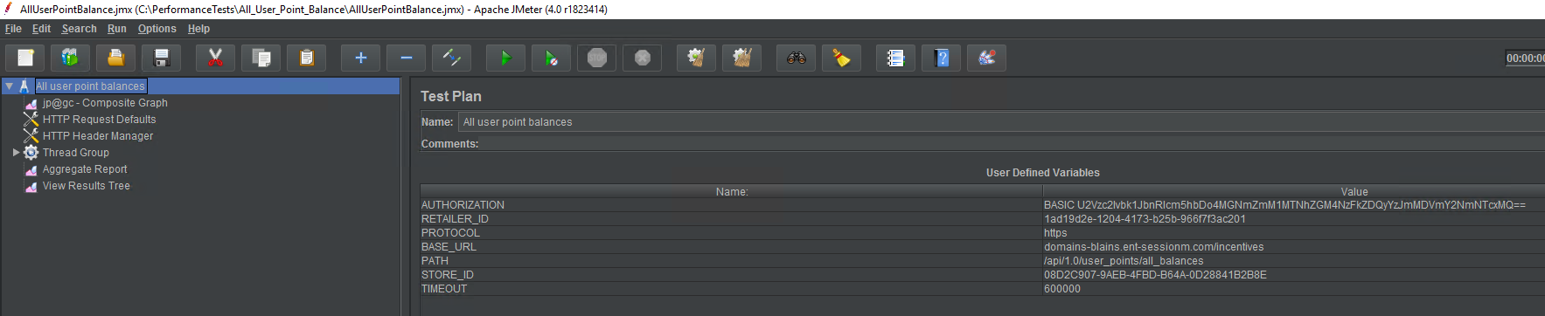

The main use of this screen is to define variables that can be used throughout the performance test. It’s a good idea to store things like URLs and retailer ids as variables. Variables can be referenced in JMeter using the following syntax.

${VariableName}

You can also get a random GUID by using this variabl syntax.

${__UUID}

## HTTP Request Defaults

It is common, when writing a performance test in JMeter, that all the HTTP requests that your test will make will share common properties. You can use the HTTP Request Defaults screen to set default properties that all your requests will use by default.

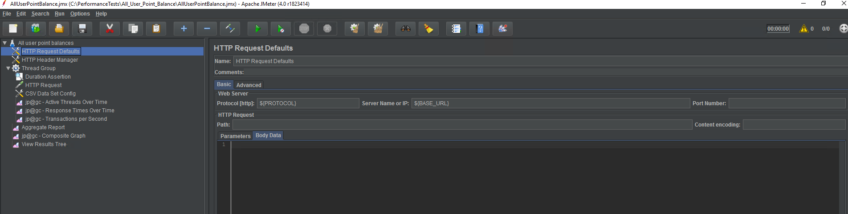

If a HTTP request has a blank field for any value that has a HTTP request default set, the default will be used. If a HTTP request’s field is not blank, the default will be overridden for that request.

## 

## HTTP Header Manager

HTTP Header Manager is similar to the HTTP Request Defaults. If requests in your test share the same request headers, defaults can be set with the HTTP Header Manager.

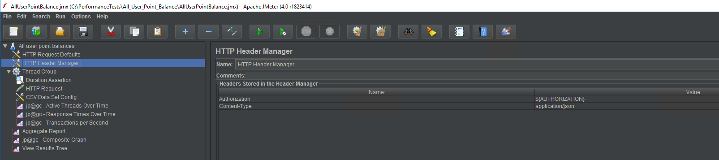

## Thread Group

The Thread Group screen is where you define the load you would like to put on the system.

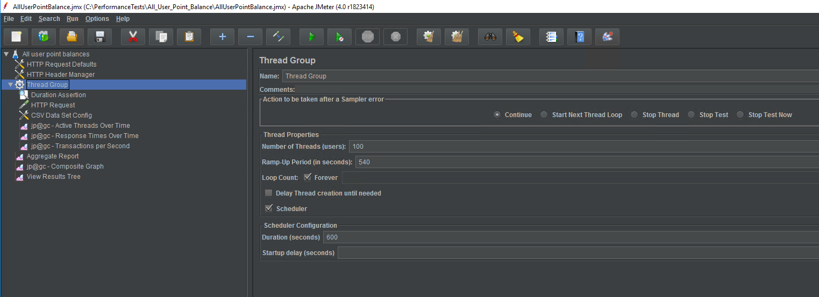

On this screen, you can define the number of threads the test will run, how long it will take the test to ramp up those threads, and the total duration of the test. In JMeter, a thread (user) is Java thread. This thread will make requests one at a time, as fast as it can.

## 

## HTTP Request

HTTP Requests are placed inside thread groups. An HTTP Request defines the properties of the request that will be sent while you JMeter test is running.

X`

## CSV Data Set Config

Sometimes HTTP requests have data dependencies. For example, the user point balance request requires a user id. In order to write a realistic test, each time the request is sent, it should request a different user’s point balance. You can compile a list of user ids by running a sql query and saving the output into a CSV file and then configure a CSV Data Set Config like this.

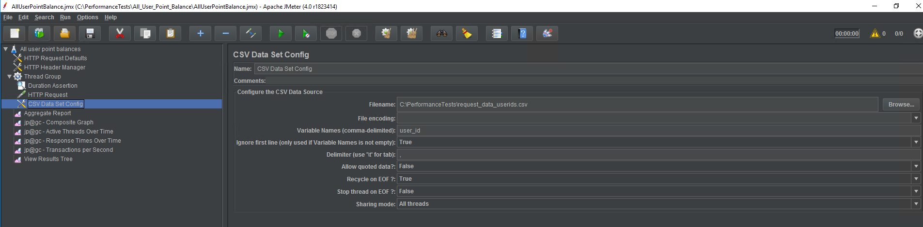

# Reports

JMeter contains functionality for generating reports and graphs. Reports and graphs are generated from the performance test CSV logs.

## 

## View Results Tree

This report allows you to view the properties of each request that was sent during the performance test and its response. When you view this report for tests that were ran in GUI mode, request and response payloads will be included. Tests run in command line mode do not include payloads.

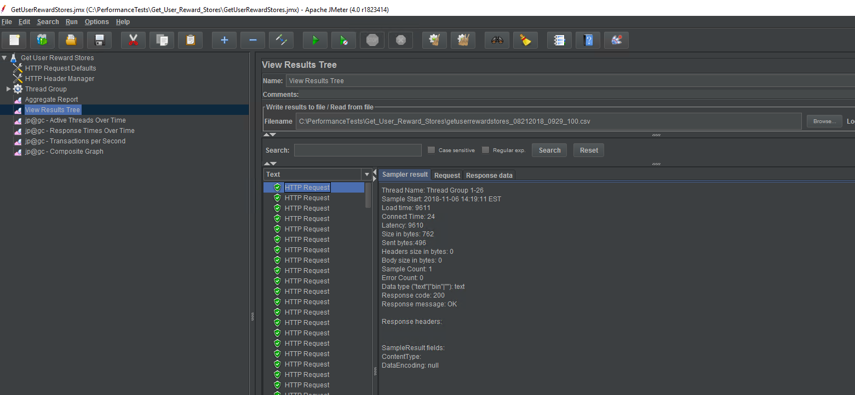

## Transactions per second

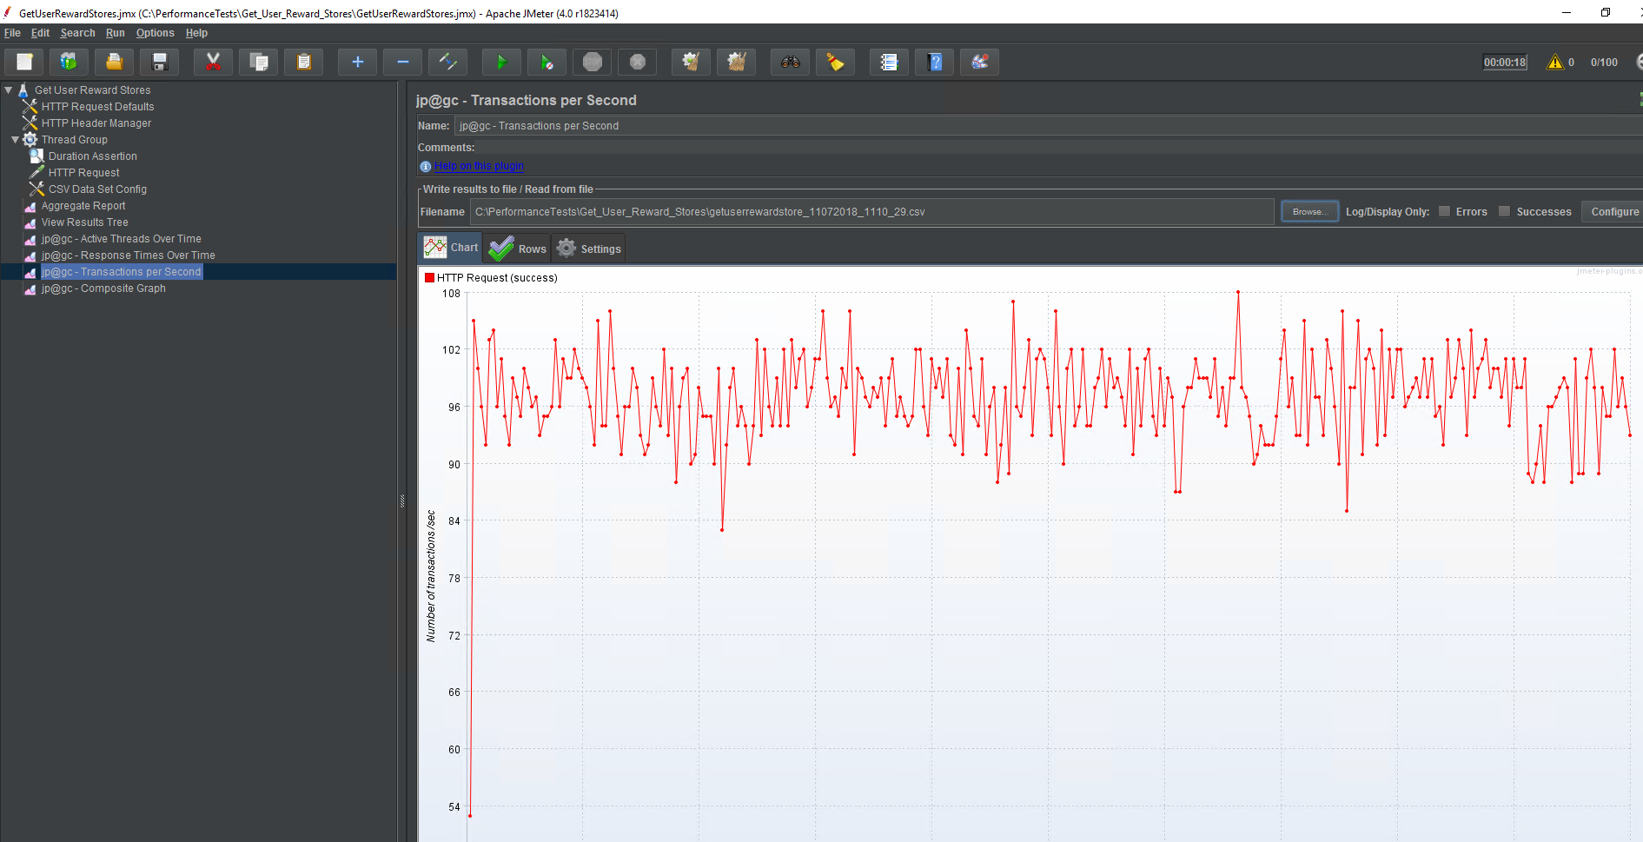

## Aggregate report

The Aggregate report is useful for viewing average, median, min, and max data about a test run.

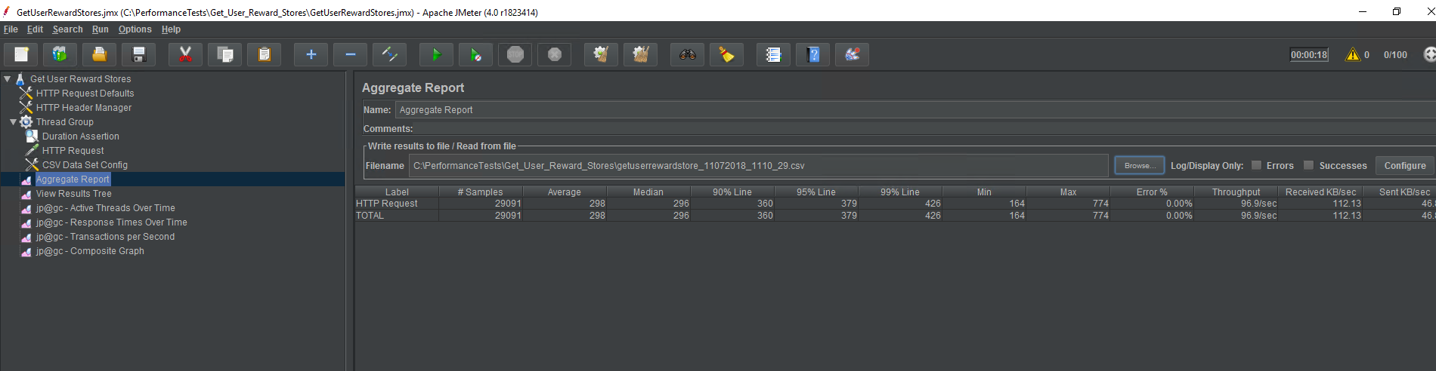

## Response times over time

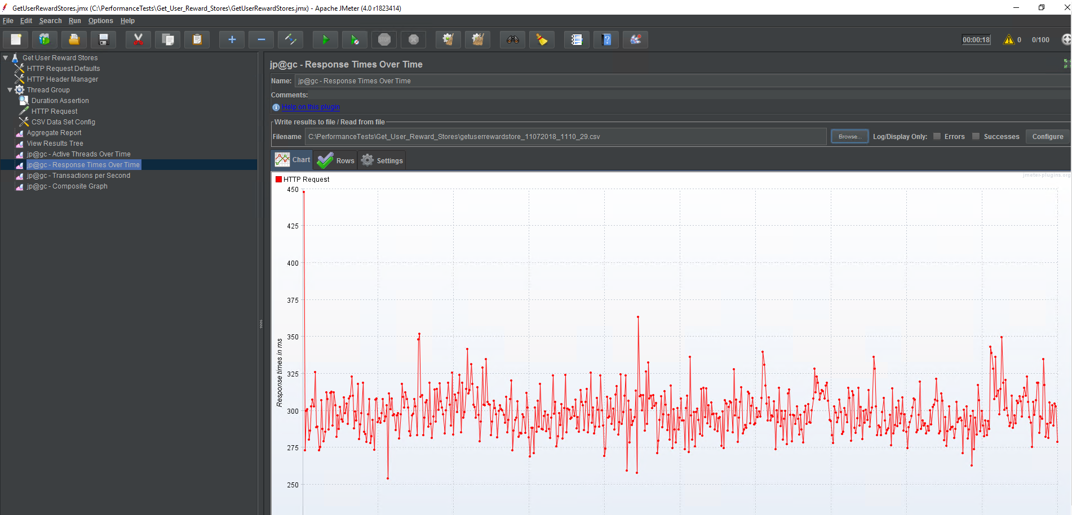

## Active threads over time

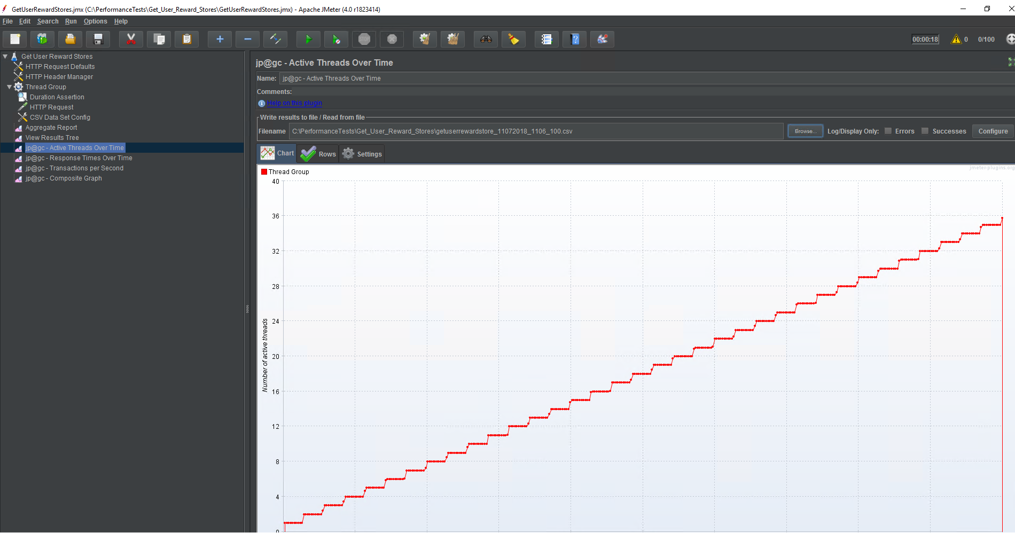

## 

## Composite graph

Some graphs, such as the active threads over time graph, is not of much use by itself. The active threads over time graph is most useful when it is graphed with the TPS graph or the response time over time graph. The composite graph allows you to plot multiple lines on the same graph.

