**Python Online Editor Sign Up**

We will be using the online IDE repl.it (http://repl.it) to write python code this semester. Below are instructions for how to sign up, name a file, create a new file, and run a program. Refer to this sheet if you are having difficulties.

Student instructions to create a repl.it account and join the Classroom.

1. To create a repl.it account to use with Python, navigate to <https://repl.it/>.
2. Create an account by clicking the "Sign Up" in the upper right corner:  
     
   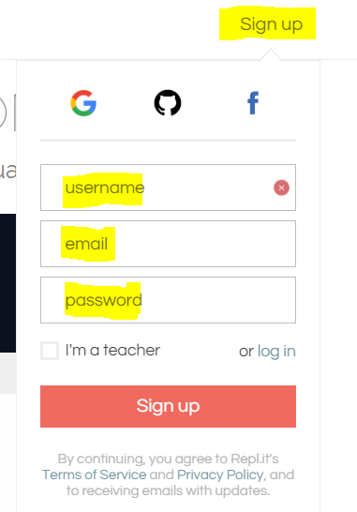
3. Enter your information for the account by filling out the "username", "email", "password", and click "Sign up"
4. Set your account setting by clicking the your username in the upper corner and selecting "Account" in the drop down list:  
     
   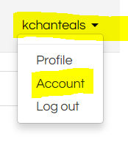
5. Fill out your profile by entering your "First Name", "Last Name", and search for your school name ____________, click "Save"  
     
   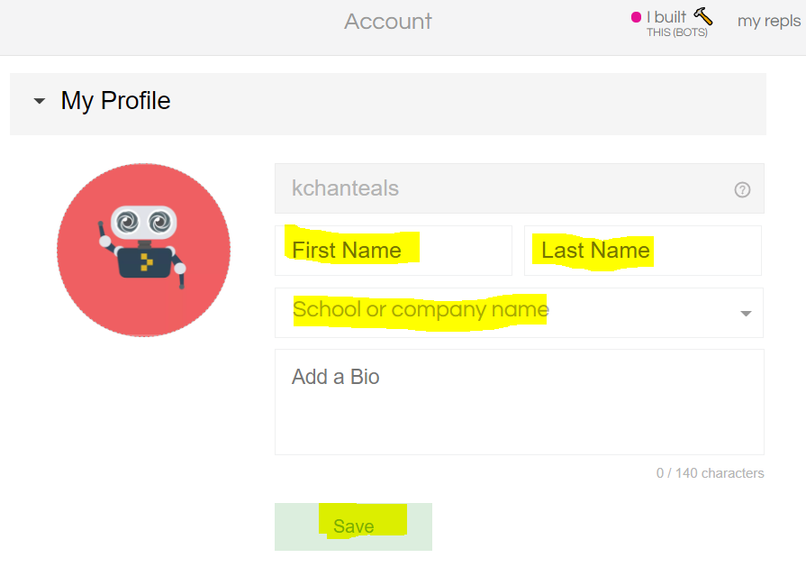

**Creating a new Python 3 Program**

1. To create a new program click "my repls" on the tool bar followed by "Start Coding Now":  
     
   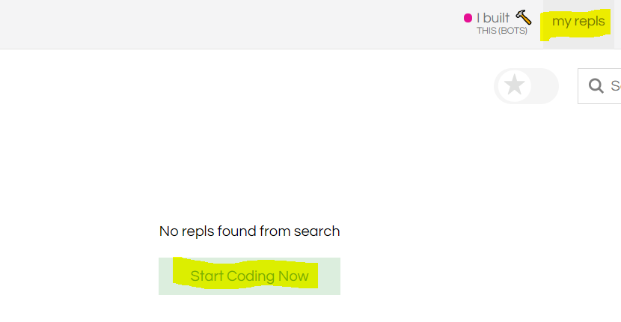
2. To create a Python program select "Python3":  
     
   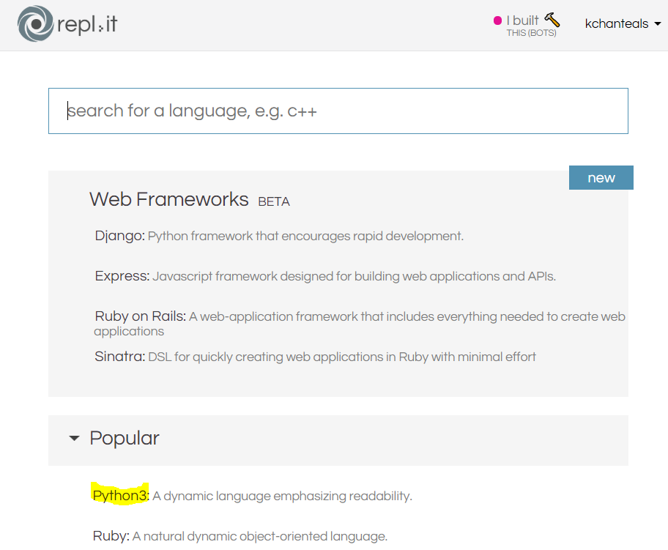
3. To continue click the "Got it" in the "Add files and folders to your project" dialog box:  
     
   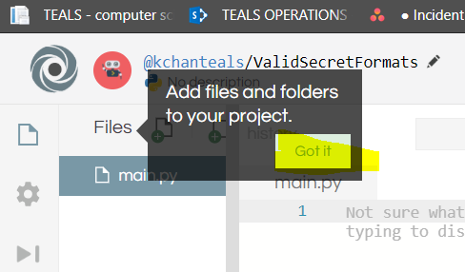
4. To test your account creating the "Hello World" program. In the center text editor panel type:  
     
    print ("Hello World")  
     
   and click "Run" in the center top menu bar. You should see the text "Hello World" displayed in the right output panel.  
     
   